Donibristle PS
School Travel Plan
2025-26



Headteacher: Miss Rennie

School address: Morlich Road
Dalgety Bay
KY11 9UE

Telephone No: 01383 602412
Social Media/Website: Website



Contents Page

3: 1.0 WHY HAVE A SCHOOL TRAVEL PLAN

3.: 2.0 BENEFITS OF HAVING A SCHOOL TRAVEL PLAN

4: 3.0 Current Travel Habits

3.1 Family Questionnaire Data

8: 3.2 Staff Questionnaire Data

10: 4.0 ROUTE AUDIT OF KEY ROUTES TO SCHOOL

4.1 Access Arrangements

11: 5.0 ACTION PLAN

12: 6.0 MONITORING AND EVALUATION

12: 7.0 DISTRIBUTION OF SCHOOL TRAVEL PLAN

13: APPENDIX 1 – ROUTE AUDIT REPORT
1.0 Why have a school travel plan

School-related traffic congestion and the risks congestion poses to the safety of the pupils, teachers, parents, residents, and motorists in and around school locations is a significant problem in communities around Fife.

The most obvious cause of traffic congestion around our schools is vehicles, and the biggest source of those vehicles is parents’ dropping off and picking up their children from school.

Statistics highlight that 1 in 4 cars during the hours of 8:30 to 9:15 and 2:30 to 3:15 is primary school traffic.

Our annual Hands Up Survey highlights that 23%, that’s 5562 primary school children are driven to the school gate each day with a further 17% opting to Park and Stride. That is an additional 4111 pupils being driven in and around the school streets.

Fife Council’s Road and Transportation Service are working with schools in Fife to develop School Travel Plans and support Junior Road Safety Officers to develop campaigns such as Walking Buses, Park n Stride sites, Parking Pledges, available routes to school maps, delivery of Bikeability as well as looking at any engineering works that may be required to make active travel to school your first choice of travel.

2.0 BENEFITS OF HAVING A SCHOOL TRAVEL PLAN?

The benefits of encouraging active travel are clear and a school travel plan can ensure that your school has a long–term vision with aid to support Junior Road Safety Officers with delivering campaigns to;-

- Improve health and well-being by reducing harmful emissions and increasing activity levels.
- Improve safety through engineering measures and increasing road safety education.
- Improve access and opportunity by developing pupils’ skills for safe and independent travel.
- Improve the environment by reducing pollution and CO2 emissions.
- Gain school accreditations such as Fresh Air Frankie STP Awards, Active School Award Eco School Award, Cycle Friendly School Award
- Have access to additional funding and support.

All work associated with School Travel Planning has been designed to fit into the Curriculum for Excellence.

3.0 CURRENT TRAVEL HABITS

Each year all Fife schools undertake the Hands Up Survey which gives a true reflection of how pupils are travelling to school and the latest results show that 67% of pupils are actively travelling to school with a further 26% being driven.

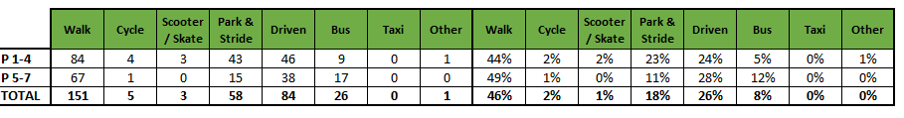
3.1 Family Questionnaire

Families answered the school travel plan online questionnaire, and the results are detailed in the graphs and text below.

What school year is your child in?

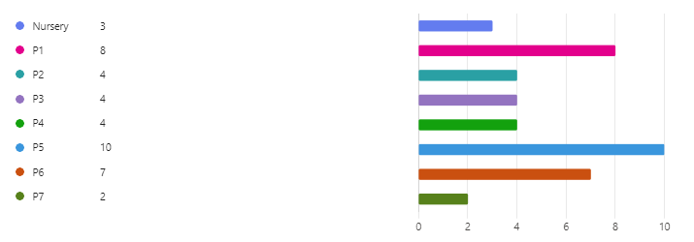

How do you normally travel to and from school?

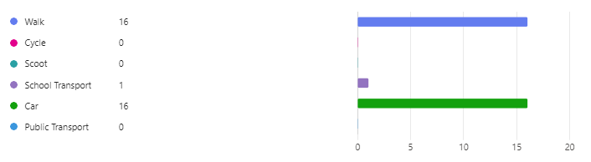

Those parents who are already actively travelling to school were asked if they would like to volunteer to help the school set up a walking bus.

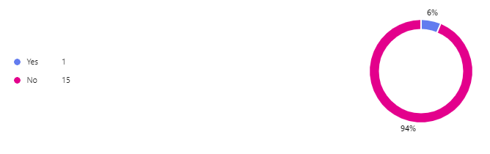

All parents who stated that they drive to school were asked if they would consider using a Park and Stride Site away from the school gate to help with congestion.



Those parents were then asked what could they do to help with safety concerns with regards to parking around the school gate?

- Child has additional needs has a blue badge. Risk near traffic no road sense. Too far to walk from home no time due to work commitments
- Nothing - unfortunately I travel from Inverkeithing, and have nursery aged children in nursery in Inverkeithing.
- We utilise the walking bus most days.
- There are no traffic lights to support children walking to school for children from areas such as The Bridges, Ross Avenue, The Inches. Traffic lights/a crossing would reassure parents and provide a level of safety for the children. For those walking up from then Link road this is in place - and Dalgety Bay Primary is better served by the zebra crossing and also the crossing lights up near the old shops for the children there.
- Closing Morlich Road to traffic between 0830 and 0900? A lot of adults dropping kids off think it is acceptable to stop on the zig zags at the gate rather than parking father away and walking to the school gate.
- I would like to see more children supported to cycle to school. If time in the morning, congestion and fears for safety are an issue there should be a provision for early drop off for active travellers.
- I think people who continue to drive/park dangerously near the school should be contacted by the school and their car registration reported to the police if they don’t take heed. It’s an accident waiting to happen.
- Encouraging parents to park a few streets away would help. Love the school. Walking bus, what a great plan!
- I don't think parking should be allowed around the school gate.
- We usually park slightly further away. We walk when we can.
- She does a lot of exercise after school
- I park further away, other parents should think of the build up at the gates too. I know that’s an obvious statement. I didn’t know there was a drop off area.
- Parking further away
- Nothing else that is the only practical way of getting my children to school safely and timely then to work
- Parents who live close to school should walk

Parents were then asked if they wanted to add anything else about their journey to school.

- 5 minutes’ walk avoiding roads – ideal
- We are very happy to have a nice safe walking route through a park.
- We are very fortunate to live only 5 minutes’ walk from Donibristle. We have a safe route that involves lots of paths staying away from the main road until the top of Morlich Crescent where other parents care while driving means that the road is can be quite dangerous to cross. I have been present when cars have driven up on to the pavement just to get past parked cars, cars have begun reversing out of where they have been parked on the junction, as I've been crossing road. Sadly I do not feel comfortable allowing my child to walk to and from school themselves because of this junction and the way drivers are behaving.
- Same repeat offenders that park in bus stop all the time. Such a busy area and a key reason I’m also not happy with my children walking by themselves
- The lack of crossing patrol on the main roads to school is concerning
- Cycling to school should be mainstream again, not enough cycling to primary and next to zero cycling to secondary or college. School system should address this (not transportation).
- Even though I have to drive my daughter to school, due to my health, I always ensure we park a little away from the school. The walking bus is a great option for her.
- A path directly around the nursery garden would be really useful. Journeys to school are linked to breakfast club / after school provision (could drop off earlier on foot once she's at school, but some days will have to drive her up to get to work on time after 9am drop off), and I've found accessible info on them really difficult.
- Passing the school bus queue has been an issue at pick up due to congestion, could school bus leave after walking children rather than before?
- We drive to Tescos and walk from there when the weather allows.
- Sometimes children get the school bus
- Walking to school is a great very social way to start the day. Kind of like a soft start, easing in from home to school.
- The parking on the corners by some cars are a real hazard.
- Inconsiderate parking. Cars parked on corners at junctions
- My child is worried about the school bus because other children are always running late out of class to catch the bus home. Seeing this makes her nervous
- The school location and design is outdated, it was appropriate for its time but now it does not have a safe drop off/pick up zone, therefore collaboration and flexibility of the school parking facilities is required in order to support the realistic needs of working parents and their children.
- It can be dangerous walking up Hillside avenue. The speed cars drive up and down the hill is scary
- We enjoy the walk, it’s only 15mins
- When you get near school the number of cars turning at school gate is very unsafe for children walking
- Cars parked and reversing at school entrance must be stopped. It's been like this at least since my daughter was at Donibristle over 8 years ago. Part of Morlich Road towards the school should be residents only. Parents who drive their cars up this road repeatedly ignore warnings from the school. Drive right up, do a U turn outside the gates and drive off. Will take an accident for anything to be done.

3.2 Staff Questionnaire

How far do you travel for work?

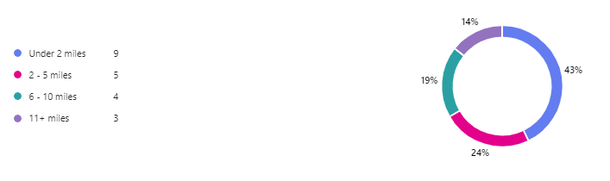

How do you travel to work?

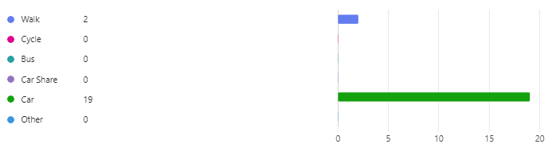

When asked what would encourage them to consider an alternative mode of transport to work, they replied.

- Depending on how heavy my work bags are, I do walk to school when I can.
- better weather, clear cycle paths
- I would walk, but sometimes I take quite a few jotters home to mark.
- Unfortunately I couldn’t consider an alternative mode of transport due to other commitments after work which require me to have my own transport.
- Would car share if lived nearer another member of staff
- Summer months
- Better public transport links. To travel to work I would need three buses and the journey time is in excess of 2 hours each way.
- Weather
- If I lived closer to work I would be able to use another mode of transport.
- Moving work closer to home.
- An incentive
- Unfortunately I need to drop my daughter off in the morning and need to drive in order to do this.

Finally, when asked are there any improvements you could make to your journey to ensure the routes to school are less congested?

- It can be difficult to enter the school car park in the morning when parents are also using the car park to drop their children off.
- I also need to bring my car so I can go home at lunch time to walk my dog. When I no longer have a dog I would be keen to walk.

4.0 MAPPING WORK AND ROUTE AUDIT
A mapping exercise was carried out within the school to identify the routes pupils travelled. These were then analysed and then categorised as active travel routes (green).

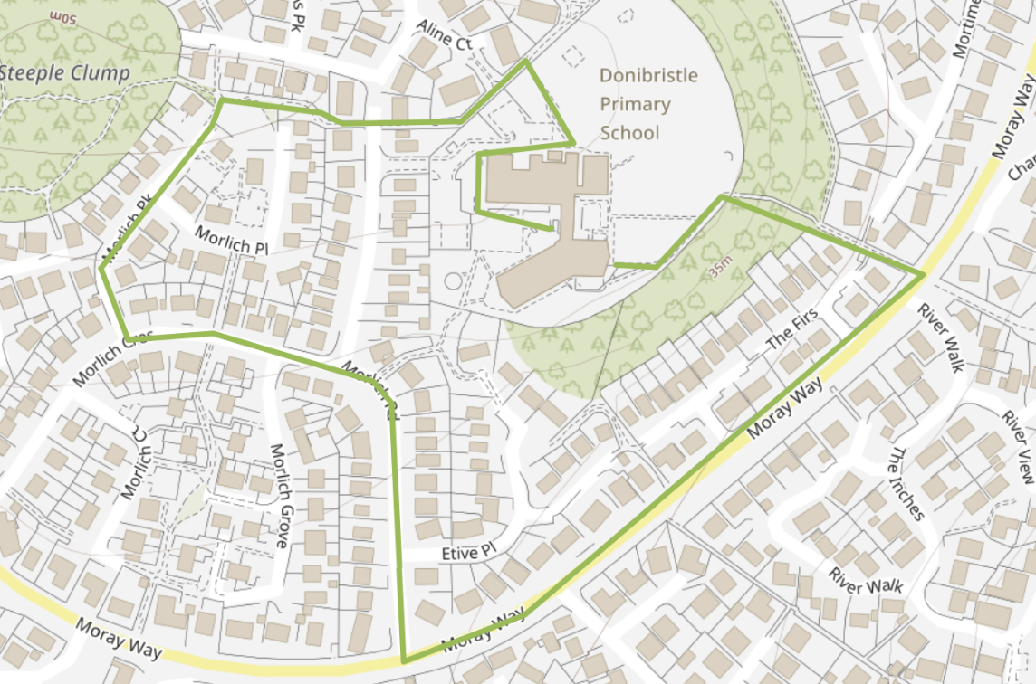

4.1 Access Arrangements

The area surrounding the school mainly consists of small private cul-de-sacs, woodland and parks. All school entrances lead on from these areas. In total there are 4.

The main entrance that leads into a staff/visitor car park is situated on Morlich Road. There are side entrances from Laxford Crescent and Aline Crescent with one further entrance from the woodland to the south of the building. There is also an entrance for those who travel by bus on Morlich Crescent.

5.0 ACTION PLAN

Action | Solution | Action Owner
Promote School Travel Plan | - Upload plan to website and social media pages  - Create a FACT notice board or story board  - Create articles for school newsletters, social media, and assemblies,  - Keep the school travel plan team updated on all work carried out to include in the Fresh Air Frankie termly newsletter. | School
Travel Tracker | - Update the travel tracker every day | School
Local and National Campaigns | Term 1  - Hands up Survey Active Travel  - Cycling Competition  - Bike Week  - Interschool Active Travel Challenge  Term 2  - Launch #dontparkhere Campaign  - Parking Letter to Parents  - Road Safety Week  - Be Bright Be Seen Competition  Term 3  - Create an active travel leaflet for the new starts that can be included in the school induction pack.  - Big Walk and Wheel  Term 4  - Walk to School Week  - Scoot to School Week  - Active Travel Treasure Hunt  - Bike to School Week | School  School/Travel Plan Team
Reduce congestion | - Continue to support parents by providing Walking Bus  - Work with Fife Council to increase pavement size at school entrance and reduce turning opportunity for cars  - Continue to discourage parents from using Morlich Road during peak times  - Continue to prohibit the use of staff car park | School/Travel Plan Team
Bikeability | Deliver Bikeability | School/Bikeability Team
Awards | Work towards gaining the Fresh Air Frankie School Travel Plan and  Active Schools Award | School/Travel Plan Team

6.0 MONITORING & EVALUATION
The JRSO will continue to meet periodically to monitor progress.
Specific progress will be monitored by participation in the “Hands Up Travel Tally” each year and a repeat of the full travel survey will take place in 2027. The school’s ongoing commitment to travel planning will be publicised in the school handbook, the school newsletters, the Parent’s notice board and through assemblies.

7.0 DISTRIBUTION OF SCHOOL TRAVEL PLAN
The following bodies will receive a copy of the School Travel Plan:
• Fife Council Roads and Transportation via the Travel Plan Team
• Fife Council Education Service
• Fife Council School Estates Team
• Parent Partnership
• Active Schools
• Copies will also be made available to the parents from the School Office and via
the school information site.

Route Audit

The Route Audit took place on Tuesday 29th November 2024 by Trudy Brown (School Travel Plan Co-Ordinator), Marta Ramage (School Travel Plan Co-Ordinator), Debbie Freeburn (Teacher), 1 staff member and 12 members of the FACT Group.

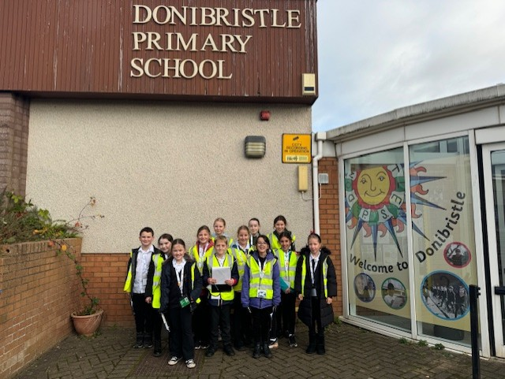

The streets that were audited were as follows:

70 Steps leading to Moray Way

Current Situation

The 70 steps leading to Moray Way is a well-lit off-road pathway, a great access route for pupils to take to school. It was highlighted that this could become slippy, however in the winter months pupils are reminded to always be safe and hold on to handrails.

Moray Way is within a 30mph zone, however the path has a grass verge separating the road from path, making it a good route for pupils to take.

Action

The School Keep Clear markings on Moray Way are in need of a refresh and there is a drain in the middle of the dropped kerb which isn’t ideal for those in wheelchairs, buggies, or bikes. The School Travel Plan Team will report this to the relevant teams.
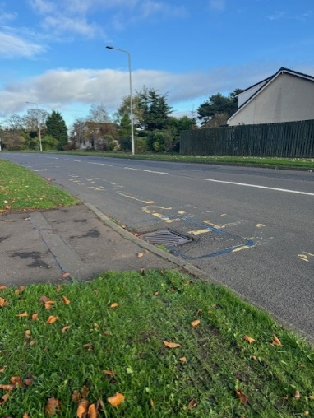

There is a trip hazard on the pathway cause by a raised access point (see picture). The school travel plan team will report this.

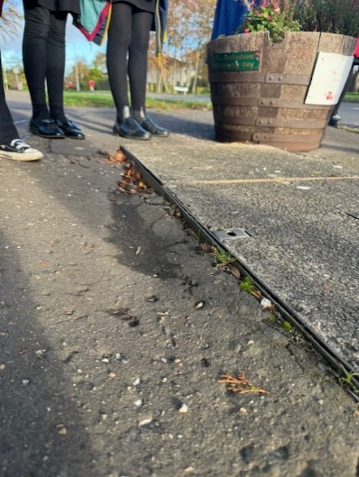

Morlich Road

Current Situation

Morlich Road sits within a 20mph zone. This can be a busy road at drop off and pick up times with it being the main vehicular access point to the school. The school bus stop is also on this road and the FACT group reported that where the access path to the school meets the bus stop, it becomes very congested with parents gathering to collect children, pupils trying to access the bus and cars parked waiting to pick up.
The main vehicle entrance to the school is at the top of Morlich Road. There is no through access and cars use this as a turning point and drop of point. Some parents are also accessing the staff carpark when this isn’t allowed.

Action

There is lack of dropped kerbs where Morlich Road meets Etive Place. School travel plan team will report this.

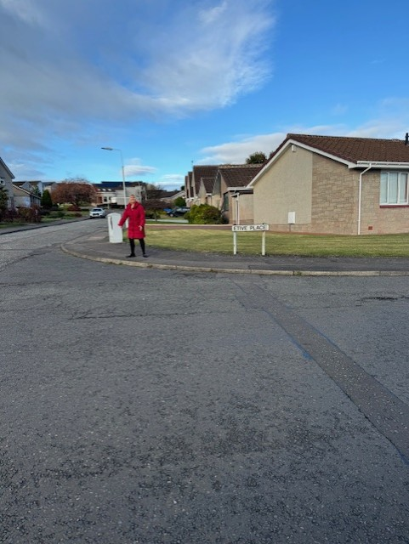

The pathway is in need of resurfacing as there is a lot of crack and trip hazards. The school travel plan team will report this.

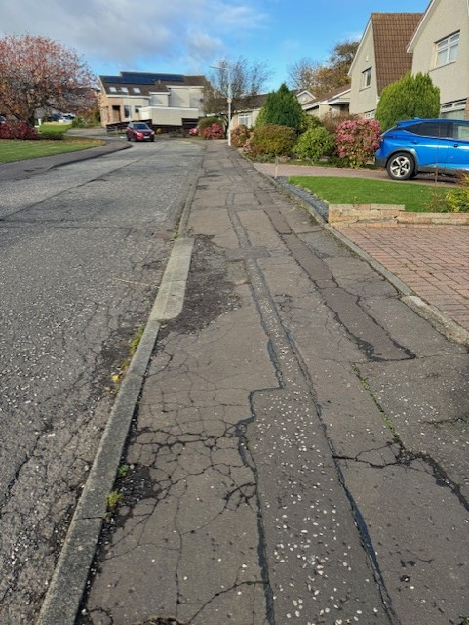
The FACT group should run a campaign to inform parents of the issues that are occurring at the bus stop and to encourage them to gather/park elsewhere.

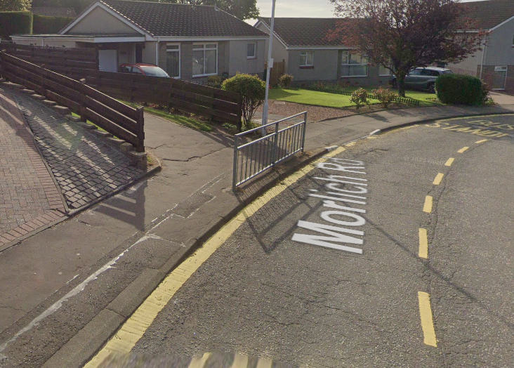

The school road sign on Morlich Road needs replacing as this is not visible. The school travel plan team will report this.

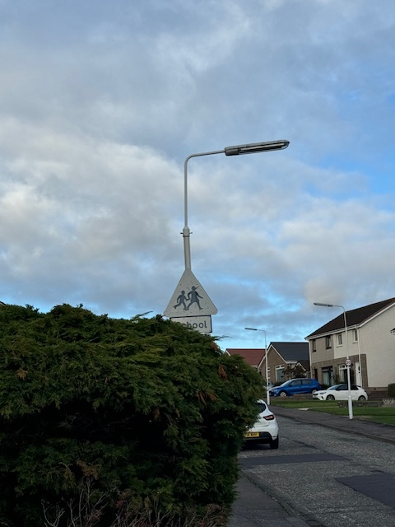

It is a recommendation that the school closes the gates to stop parents from accessing the car parks and also close this entrance to pedestrians.

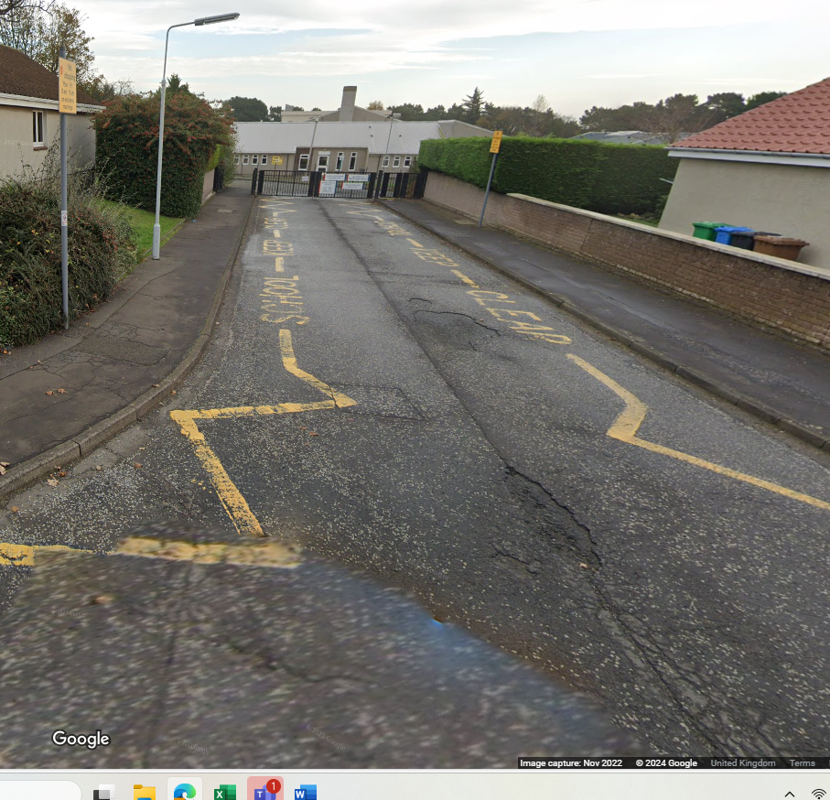

Summary

The routes audited were identified by the FACT group as being the busiest routes around the school. Issues that were raised in the Parent Questionnaire with regards to other streets will be investigated through the relevant team within Roads and Transportation.

