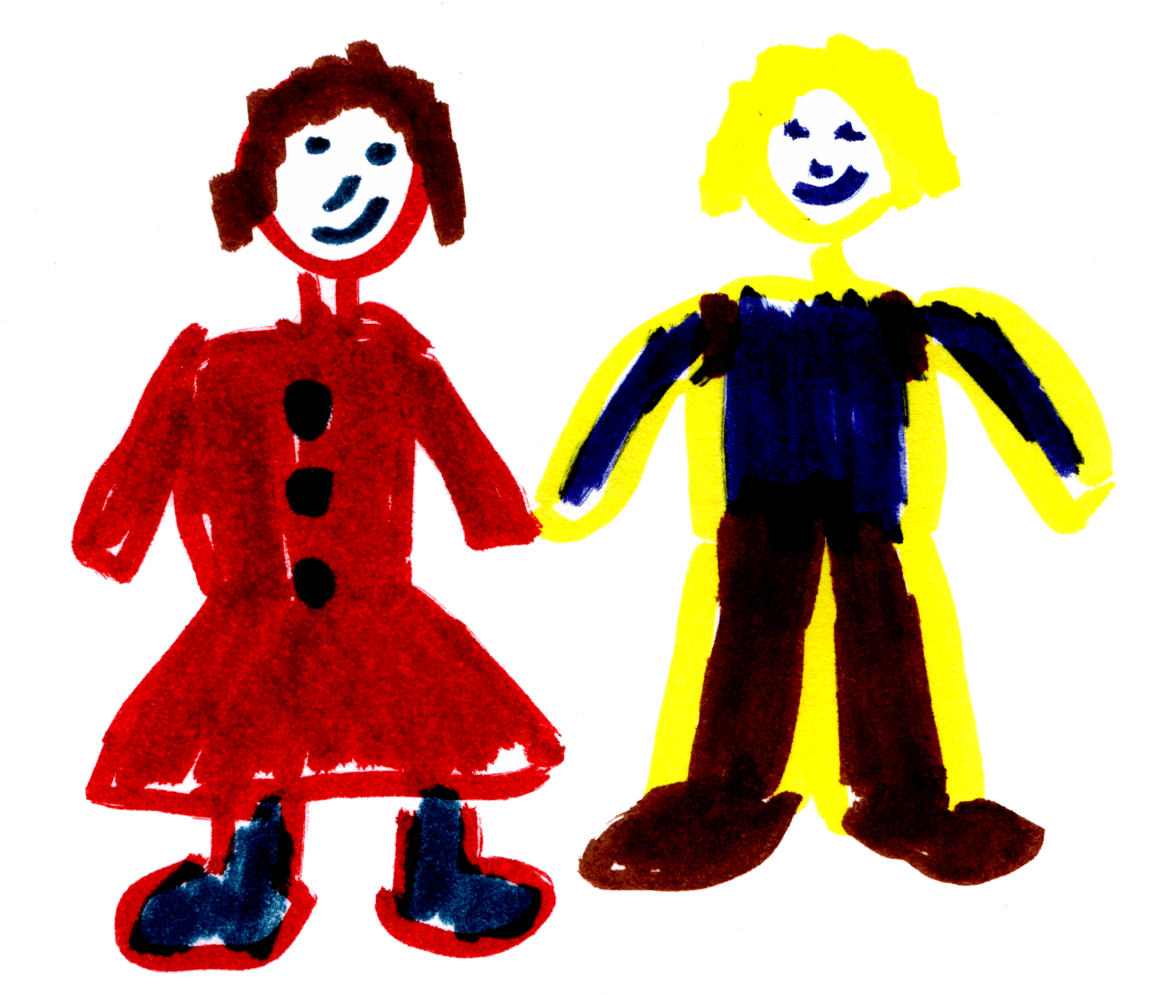
Do you want to….
Feel more in control?
Help your child succeed?
Enjoy your child more?
Meet other parents?
Pre-school IY

If you’d like a change from the routine, and a bit of fun at the same time…...
If you’d like a chance to talk things through with other parents…...
The
Incredible Years
- Coping with children!
Our Incredible Years courses run for two hours per week for 14 weeks, this will either be morning or afternoon session. The courses commence in August and January.

We also offer light refreshments/snacks.
The topics we cover include:

Promoting self-esteem and
co-operative behaviour

Helping your child to learn

Using praise and rewards to
encourage your child and teach new behaviours

Setting limits and
following through with rules
If you have a child aged 3 to 5 years….
Please feel free to discuss this further with …

