Donibristle Primary School

Promoting Positive Behaviour and Relationships

A positive school culture and ethos (sometimes described in research as ‘climate’) is essential to developing good relationships and positive behaviour in the classroom, playground and wider community.

(Developing a Positive Whole School Ethos and Culture, Education Scotland, 2018).

This policy has been written with support from;
- GTCS Professional Standards
- Fife Council, How We Work Matters Framework
- Fife Council, De-escalation Policy
- Fife Council, Positive Relationships and Behaviour Guidance (2022)
- UNCRC, Rights of the Child

Policy Statement
How Good is Our School (HGIOS 4) (2015) identifies highly effective practice:
“All stakeholders promote a climate where children and young people feel safe and secure.”
“The learning environment is built on positive, nurturing and appropriately challenging relationships which lead to high-quality learning outcomes.”

Relationships, learning and behaviour are at the heart of any successful school community. Effective learning and teaching depends on a foundation of positive relationships between learners and staff and between children themselves.

Donibristle Primary School is committed to providing a safe, supportive environment for all members of our school. Our focus on a strong, supportive ethos and positive relationships is built on a culture of respect and trust. Our shared vision; ‘Work Together, Learn Together, Shine Together’ is at the heart of working together in partnership with children, parents and carers, other agencies and the community. Children’s wellbeing is at the forefront of our school. A child’s wellbeing is influenced by everything and everyone around them and the different experiences and needs they have at different times in their lives. It is our aim to support each child to reach their full potential as an individual. We embrace a can-do attitude (growth mindset) in all that we say and do.

It is important that learners feel valued within a nurturing yet structured environment where there are high expectations to help realise their potential. Our Donibee Awards are driven by Curriculum for Excellence’s four capacities; successful learners, confident individuals, effective contributors and responsible citizens. These capacities will develop most effectively in schools where positive relationships are nurtured and developed, and which have a strong positive ethos.

What do we mean by Positive Relationships?

Nurturing positive relationships involves adults providing young people with consistent and reliable responses to their needs, where mutual respect is demonstrated. Developing positive relationships must be regarded the same as any other area of the curriculum; it needs to be assessed, planned, taught and differentiated to meet the social and emotional needs of the individual child.

Our Promoting Positive Behaviour practices, Rights Respecting School, Building Resilience and Restorative approaches all work within this framework.

Prompting Positive Behaviour Policy and Procedures
The main principles that underpin promoting positive relationships and behaviour in Donibristle Primary School are to:

- promote effective and high-quality learning and teaching
- develop positive relationships between staff, between staff and learners and with the wider community
- ensure that all learners are treated fairly, shown respect and to promote positive relationships
- support children to understand and take responsibility for their own behaviour
- enable children to support one another in seeking resolution to conflict
- have a culture of inclusion and belonging based on kindness, empathy and mutual respect and trust
- build a culture of genuine and deserved praise at all levels
- manage behaviour successfully, through implementing a positive whole-school approach to improving ethos and culture
- differentiate between the need for effective school discipline / staff and learner self-regulation and supporting wellbeing needs (which are distinct, but complementary)
- Tackle bullying behaviours throughout the school community
- work together with partners and agencies, responding to the needs of learners early and effectively, with the least intrusive level of intervention, in line with the principles within the Children and Young People (Scotland) Act (2014)

Positive relationships are supported by the principles of resilience, self-regulation, de-escalation and restorative approaches.

Resilience

Resilience is the ability to bounce back after challenges and tough times. Resilient children can recover from setbacks and get back to living life. Resilience develops when children experience challenges and learn to deal with them positively. Strong relationships are the foundation of children's resilience

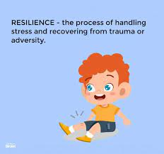
Key principles of resilience:

- Having the opportunity to take risks
- Using a growth mind-set and learning from mistakes
- Having self-belief that you can achieve
- Being able to take and reflect on praise and criticism
- Recognising stress and having strategies to cope
- Be able to persevere in times of challenge

What does this look like at Donibristle Primary School?

As a school we encourage all our young people to reflect on their choices. Staff will model and teach positive and effective coping strategies so that children have a toolkit to support them in any challenging or new situations.

Self-Regulation
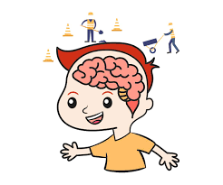
Self-regulation means being in control and having management of ourselves.
Self-regulation is a skill that many children have a difficult time learning and achieving without help. In a given day, a child (and an adult) encounters multiple situations and circumstances that require an awareness of self and others as well as the ability to have or gain self-control.
This ability to self-control relies on impulse control, working memory, and generally speaking, the ability to keep oneself “in check”. The ability to experience feelings and desires and make decisions based on those concepts requires motivation, willpower, higher level thinking. Self –regulation equips learners with essential life skills. It results in improvements in behaviour and attainment, relationships and confidence.

Key principles of self-regulation:
- To support children to regulate their emotions and respond positively when faced with any challenge
- It is dependent on warm, consistent and responsive interactions
- It can be modelled and taught
- A coaching technique is used which promotes positive self-talk and reflection

What does this look like at Donibristle Primary School?

Staff will model and teach self-regulation and emotional literacy. Pupils who are experiencing stress or anxiety resulting in a lack of self-regulation will be supported to develop coping strategies.

De-escalation

De-escalation refers to the process of diffusing difficult situations or conflicts as they begin to prevent them from getting worse. De-escalation can minimise and prevent challenging behaviour and support learners to make positive choices.

Key principles of de-escalation:

- Triggers are identified
- Staff using strategies such as remaining calm, active listening, offering positive choices, asking questions and remaining solution focused.
- Early intervention strategies are used to support pupils and prevent or limit escalation
- An action plan is created to support pupils in managing their responses
- Situations that occur are reviewed when the pupil is able to do so

What does this look like at Donibristle Primary School

Staff take time to get to know pupils and will try to defuse situations before they escalate, using strategies suitable for the child. Children are supported to review situations that occur using a ‘journey of events’. This allows time for reflection and to create an action plan to support the child.
Restorative Approaches

Restorative approaches help ensure that all learners, staff and parents are fair of a fair and transparent process whilst supporting all involved to understand the impact of their behaviour on others.

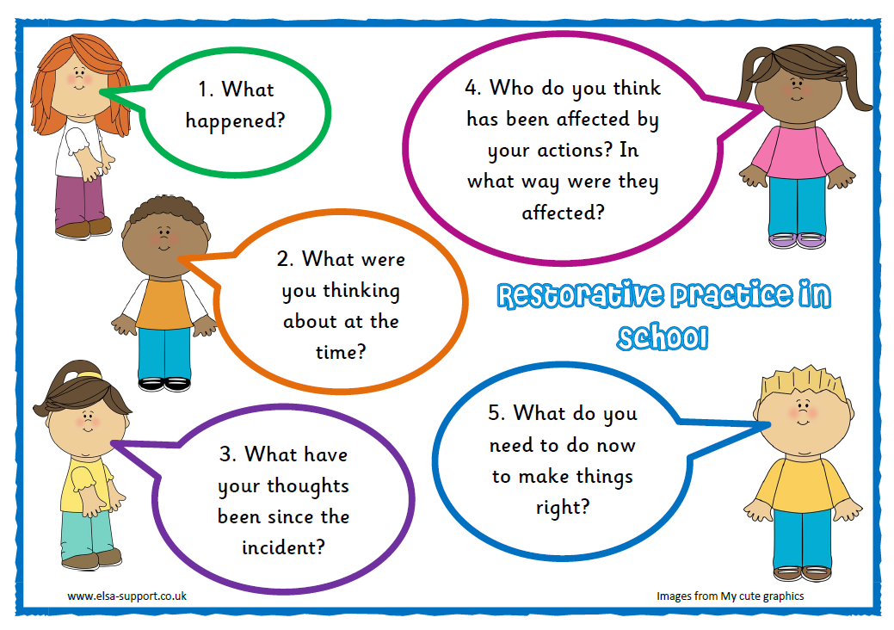
Key principles of Restorative Approaches:

- Individuals taking responsibility for their actions
- Respecting other people’s views and feelings
- Empathising with others
- Being fair
- Repair and move forward from situations

What does this look like at Donibristle Primary School?

All staff use restorative language for example asking: Tell me what happened? Who has been affected? How can we put it right and move forward?
Pupils will be supported to restore good relationships and resolve difficulties through restorative conversations.

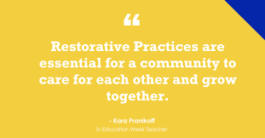

Strategies Promoted at Donibristle Primary School

Self-regulation | Restorative Approaches
Fix-it Folders (Early Years)  Anxiety Curve  Kitbag  Lego Therapy  Focussed target chart (short-term use)  THINK – before you speak  Calm time out area  Talking mats  Peer Mediation | Key Questions-  Tell me what has happened?  What were you thinking?  What were you feeling?  Who else has been effected?  What do you need help with or need to do?  What could have been done differently?  How do we move forward/repair things?
Regular class focus- teaching and modelling – use daily incidents, scenarios or stories (as and when they arise)

Journey of Events (reflection tool which identifies triggers and leads to restorative conversations and impacts on self-regulation)

Growth mindset resources – learning pit, zones of learning, staircase of success etc...

Expectations

In order to strengthen and improve relationships, it is important to have consistent expectations in terms of pupil and staff behaviour. It is important that everyone within our school community has an understanding of these.

Learners are expected to:
- Demonstrate respect and positive regard for everyone in the school community
- Act and behave in ways that develop a culture of trust and allow meaningful relationships to develop
- Uphold the school vision and values and adhere to class charters
- Support each other so that everyone feels included and safe in school

Staff are expected to:
- Promote and model positive behaviours and relationships
- Use positive and restorative language
- Praise effort and achievement
- Be caring and compassionate
- Together create a safe and secure learning environment
- Plan learning that engages, challenges and meets the needs of all learners
- Be calm and give ‘take up time’ when required
- Plan and embed social, emotional health and wellbeing within high quality learning and teaching which meets the needs of all learners
- Have high expectations of achievement and behaviour
- Use de-escalation strategies to minimise and prevent challenging behaviour
- Never ignore or walk past learners who are displaying unacceptable behaviours
- Retain ownership and engage in reflective dialogue with learners.

Leadership teams are expected to;
- Be a visible presence in school
- Build, maintain, reflect, repair and restore positive relationships; with support where needed
- Use positive and restorative language
- Praise effort and achievement
- Be caring and compassionate
- Together create a safe and secure learning environment
- Model and support restorative conversations
- Ensure staff training needs are identified and targeted
- Regularly share good practice
- Leadership teams are not expected to deal with behaviour assistance requests in isolation. Rather they are to stand alongside colleagues to support, guide and model when appropriate.

Parents/Carers are expected to:
- Support our school values, policy and procedures, including any consequences jointly agreed by home and school
- Reiterate at home the importance of appropriate choices
- When discussing incidents at home support your child to identify different ways to cope with challenging situations; this will develop their resilience
- Encourage their child to be respectful, positive members of their community
- Contact the school with any concerns

Monitoring
- This policy will be formally monitored every year.

