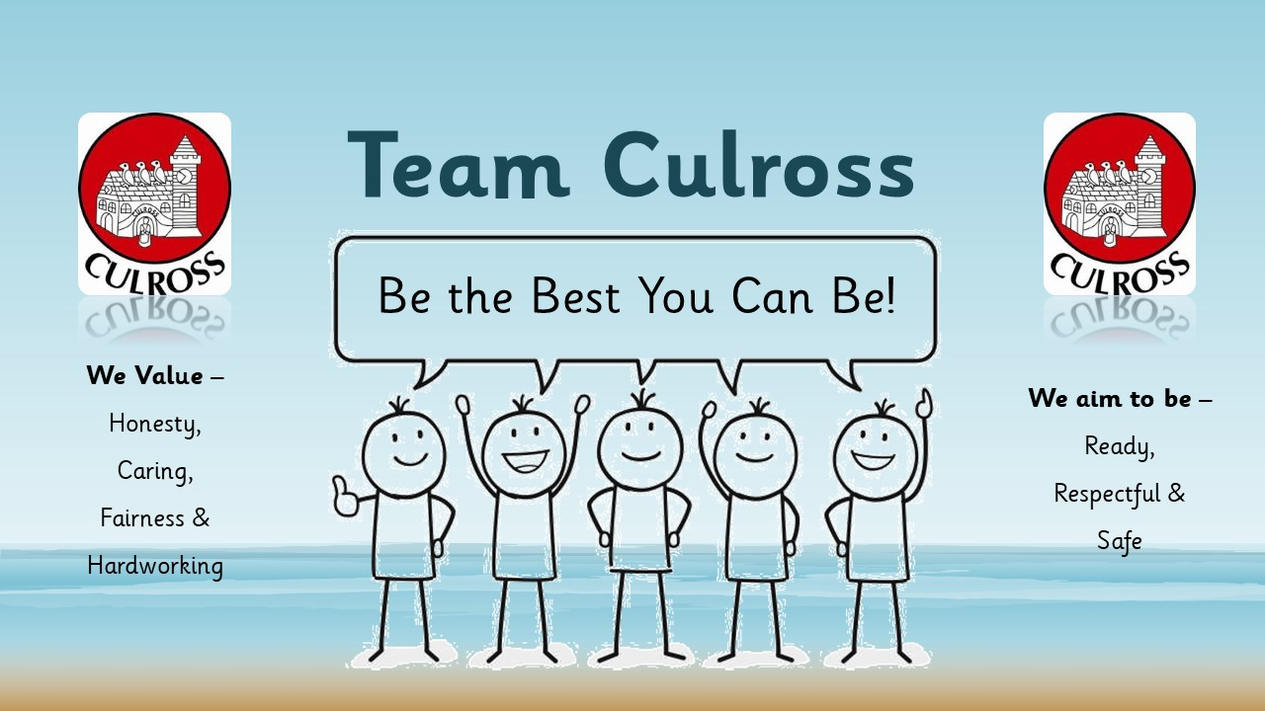

Culross Primary School Newsletter – March 2025

Already we are into March and soon will look forward to signs of Spring. It’s been a busy term so far at Culross Primary so I thought I’d recap and signpost dates for the rest of the school year ahead.

Burns Poetry Competition

In January the children enthusiastically took part in our annual Burns poetry competition. This was judged again by Maureen and Drew. They were very impressed with the high standard of presentation, actions and ability to engage the audience during the poetry recitals. Well done to all our learners.

P6 Den at Culross

Our P6 children attended a day of learning about food and farming through workshops, practical activities and talks at the Den at Culross event on 29 January. The children enthusiastically learned how cream is made and how to prepare a stir fry. Most of the children enjoyed sampling the food also!

Grow West Fife

Some groups of children will soon be participating in planting and growing sessions that will be held at Grow West Fife Garden, Blair Castle every Wednesday, starting this week.

P4/5 visit to Riverside Museum in Glasgow

As part of their recent topic P4/5 children enjoyed a visit to the Riverside transport museum in Glasgow. The children explored the exhibits in groups and also participated in a workshop in the afternoon. Many thanks to our parent helper volunteers who supported the staff and children on this visit.

P4/5 Big Sing

P4/5 have been working with Mrs Mair from the Youth Music Initiative since September on a singing project. The children performed the three songs they had learned for an audience of their parents/carers and the rest of the school on 26th February. They participated in the Big Sing along with children from other local schools in Dunfermline on Tuesday 4th March.

Folk song Project

A group of children at Culross will participate in a music writing session to write and perform a Culross folk song along with a local musician and staff. This is an interesting local project which we were keen to get involved in.

Parent Council

There will soon be another meeting of the Parent Council planned for 6pm on Wednesday 19th March in the school. All parents/carers are welcome to join us.

World Book Day

Thursday 6th March is World Book Day, this year we will have a Bedtime stories theme so children may come to school if they wish dressed in their pyjamas along with a book from home and/or a teddy bear/soft toy. This is a free event. P1-3 children will have virtual author visit with Greg Stobbs who is an author and illustrator. On Tuesday 18th March P4-7 children will join a virtual author event with Tọlá Okogwu discussing the highly acclaimed Onyeka Series.

Daffodil Tea

On Wednesday 19th March we will hold our annual Daffodil Tea event in school from 2pm. This is an opportunity for parents/carers to visit the children in school, and enjoy some light refreshments along with home baking to raise funds for the school/parent council.

Red Nose Day

Our Pupil Council has begun to plan Red Nose day at Culross on Friday 21st March. For a donation, children may come to school wearing ‘something funny for money’. The pupil council suggest children and families could be creative with either fancy dress or a funny combination of clothing, crazy hair style for the day, or even ‘dress like it’s 1985’ as that’s when Red Nose day started. We are also planning a get together to share favourite jokes and any funny talents children may have.

Parent Volunteers

We are keen to reach out to anyone who may have any skills they’d be happy to share in school with our children and staff. This may perhaps include for example leading a game of rounders in the playground or supporting any of the classes with a local history tour or perhaps even leading some baking activities. Please do get in touch with Ms Wyatt or Ms Tweedie if you have any free time you would be willing to offer. We would be delighted to hear from you.

Diary dates
19 March – Family Time - Daffodil Tea 2pm
24 March Pupil Progress Evenings 4.30-6.30pm
26 March Pupil Progress Evenings 3.30-5.30pm
21 March – Red Nose Day –Wear something funny for money (see above)
28 March – Funky Fun Friday – Dress down day for school fundraising

Term 4
21 April – Start of Term
5 May – Holiday
8 May – 6pm Family Quiz night
14 May - School sports afternoon
30 May – Family Time 9.20-10.00
30 May – Funky Fun Friday
2 June- Holiday
3 June -Inset day
11 June – P1-3 Class assembly 2.30pm
19 June -P7 Leavers Show/assembly 2pm
25, 26 27 June – P7 Transition days to Queen Anne High School
3 July - End of Term – Shorts and Shades day

Ways to contact us –
Phone – 01383 602453
Email – culrossps.enquiries@fife.gov.uk

Check out our school website –
Culross Primary School | Be the best you can be! (glowscotland.org.uk)

