**Crossford Primary School**

**School Travel Plan**

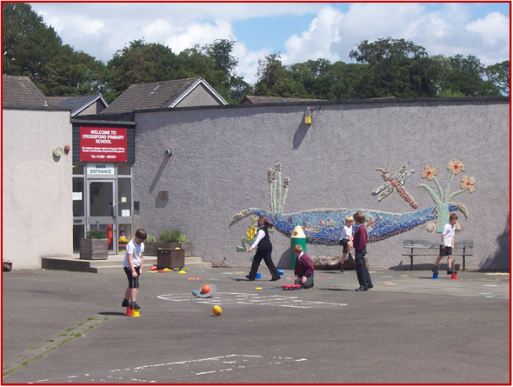



Head Teacher: Mrs Lorna Bernard

School Address: Dean Drive

Crossford

Dunfermline

KY12 8PE

Telephone No: 01383 602451

**Summary Page**

The following travel plan is a collaborative plan by parents, children, staff and stakeholders who have researched and devised the content, agreeing the actions and aims to make the overall journeys to and from Crossford PS safer, healthier and more enjoyable by:

* Reduce congestion around the school by reducing the number of cars used for the

school journey.

* Increase awareness of Active Travel and educating all about road safety.
* Improving Active Travel facilities (bike and scooter storage, helmet storage, etc.).
* Promoting alternatives to car travel (cycling, walking and scooting), increasing the

percentages of active travel.

The key issues and perception relating to journeys to and from school were identified as – inconsiderate parking around the school gate and surrounding streets, which causes problems including: -

Congestion

Blocked vision for walkers and cyclists

Blocked vision for other drivers

Low proportion of children actively travelling to school, especially in bad weather

Concerns about road safety and speed of traffic

Blocking driveways reducing access to our neighbours’ properties

**45%** of those surveyed highlighted that they lived within a 2-mile radius of the school.

Routes identified as safer routes to school are:

1. Dean Drive
2. Knowehead Drive/Kilburn Road
3. Cairneyhill Road/Main Street
4. Waggon Road Area including both Housing Estates either side

**Proposed Behavioural Actions**

Promote Active Travel School

Promote Safer Routes to School

Road Safety Education School/Parents/Fife Council

Reduce Congestion around the school gate School/Parents/Fife Council

Deliver Cycle Training School/Fife Council

This plan is valid for 6 years and will be reviewed during year 3.

**1.0 INTRODUCTION**

**1.1 School background**

Crossford Primary School is situated in the village of Crossford, which is 3 miles west of Dunfermline. The associate secondary school is Queen Anne High School. Crossford School was built in 1973. It is semi-open plan with ten teaching areas. Six of these are situated around a central circular hall and provide accommodation for the older children plus a Library and a General-Purpose Room. The four remaining areas are for the younger children and have a separate entrance and cloakroom area.

There is also an accessible ramp into the building at this entrance. The Nursery is self-contained in separate accommodation comprising a Medway building with completely enclosed garden and play areas. In addition, there is a single annexe which is presently used as a Science, Technology and Music room.

The grounds are large with a grassed football patch, hard surface netball and basketball court and trim trail. With the support of the Parent Council we have developed the playground areas and have developed a new quiet garden at the front of the school. We also have developed an outdoor classroom with support from the Parent Council.

The school has a Site Management Plan that informs users about the site rules for pedestrians and vehicles and will be displayed within the school.

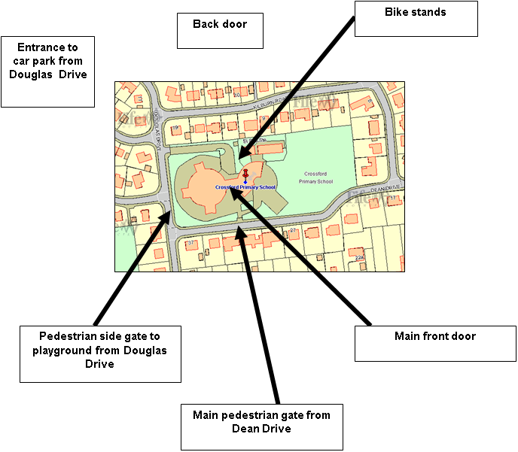

**2.0** **POLICY AND OBJECTIVES**

**2.1 Formation of Junior Road Safety Officers**

To address the issues raised with congestion around the school gate and to work on future initiatives the school formed its travel action group which consists of Junior Road Safety Officers and members of the school parent council and parent volunteers.

JRSO for 2024 are

TBC

**3. CURRENT TRAVEL PATTERNS**

**3.1 Questionnaire Surveys**

During the consultation period **127** families and **16** staff members responded, and the following analysis is based on the data from those surveys.

**3.1.1 Family Survey Data**

**84** families highlighted that walking was the main mode of travel to school followed by 41 families siting that they drive to school. Only 1 family stated that they scoot to school with no families cycling.

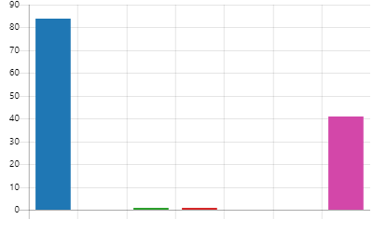

Walk 84

Cycle 0

Scoot 1

Park and Stride 1

School Bus 0

Public Transport 0

Car 41

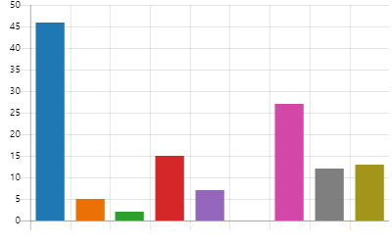**The main reasons given for travel mode choices are:**

It is good for my child's health. 46

It is good for the environment. 5

There is limited parking around the school. 2

It is the fastest. 15

It is the safest. 7

It is the cheapest. 0

It fits in with my family routine. 27

It is the only mode of travel available to us. 12

It is too far 13

According to the survey 101 families are happy with the way their child/children travel to school with only 11 families stating that they were either somewhat/very dissatisfied due to living in surrounding farms, children having health issues and safety around the park as there is a missing crossing guard.

When asked “**What is the main reason for choosing this mode of travel”** some of the common responses were:

* Good for my child's health.

It is good for the environment.

There is limited parking around the school.

It is the fastest.

It is the safest.

It is the cheapest.

It fits in with my family routine.

It is the only mode of travel available to us.

* It is too far.

Parents were also asked “**to what extent do they agree with the following statements about your child/children journey to school**”.

Disagree Neither/Nor Agree Agree

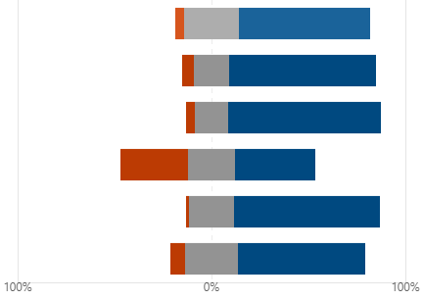

The journey to school is an opportunity to

spend quality time with your child.

It is important for children to travel actively

to school to help them get enough exercise.

Whenever possible. I think children should

not travel to school by car.

The pressures of daily life mean I have to find

the quickest way of getting my child to/from school.

There is too much traffic in the area outside the school.

Inconsiderate parking by parents raises cause for

concerns in allowing my child/children to travel

Parents then went on to state that the following factors have an impact on their decision on whether they would allow their child/children to actively travel to school.

Safe crossing facilities on busy roads. 49

Vehicle speed reducing measures. 7

Knowing that other children are walking or cycling. 5

Knowing that other children are walking or cycling. 18

More road safety for children. 21

More information on the health and environmental benefits of walking and cycling. 1

Reduction of inconsiderate parking around the school gate. 26

Finally, when asked if there was anything else that they would like to tell us about the journey to school the following concerns were raised.

Lack of lollipop person.

Parking on double yellow lines and blocking junctions is very dangerous.

Area for bikes/scooters to be kept during the school day.

Walking on pavements unsafe due to car doors opening and restricting access.

Better signs around the school.

A lot of families walk to school, but incentives may encourage more – walking bus, bike to school.

Speed in school streets.

Red light jumpers.

**4.0** **MAPPING WORK**

A mapping exercise was carried out within the school to identify the routes pupils travelled. These were then analysed and the four main routes to school were identified.

**Final Map and identified routes**

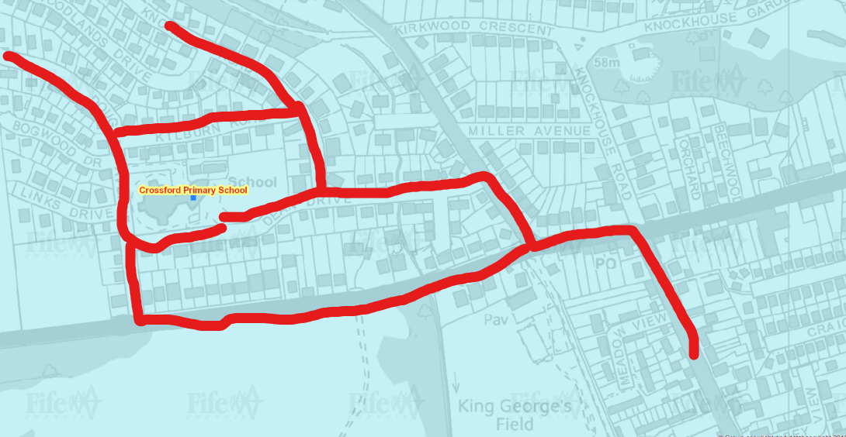

**5.0 ROUTE AUDIT OF KEY ROUTES TO SCHOOL**

A site visit of the above key routes was carried out on the 6th December at 11am The weather conditions were cold but bright and sunny.

Due to the Covid Restrictions the JRSO’s were not in attendance, however, a member of the parent council walked the routes and pointed out areas of concern.

These areas or issues were predominately due to parent/staff behaviour and the lack of a school crossing patrol officer and not those of traffic management or engineering. The full audit report can be found in appendix 1 of this document.

**6.0 STAFF DATA**

Members of staff undertook an online survey on how they travel to school and the impact this has on the school run. The following analysis highlights their mode of travel.

**How far do you travel for work?**

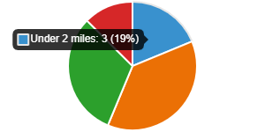

Under 2 miles 3

2 - 5 miles 6

6 - 10 miles 5

11+ miles 2

Majority of staff cited that they drove to school and parked within the school grounds. However, some stated that they parked in the streets around the school. When asked what would encourage them to consider alternative modes of transport majority stated that nothing as they have other commitments outside school. Some stated that they would consider cycling if there was a bike shelter.

**7.0 BEHAVIOURAL ACTION PLAN**

|  |  |  |  |
| --- | --- | --- | --- |
| **Action** | **Solution** | **Action Owner** | **Target Date 2023/24** |
| Promote Active Travel | Take part in Active Travel Months      Take part in Bike Week    Take part in the SUSTRANS BIG PEDAL    Walk to school week | School/TAG      School/TAG    School/TAG    School/TAG | Term 2 & Term 4    Term 4    Term 3    Term 2 |
| Promote Safer routes to school | Upload map to website    Put information board up at parents nights    Articles in school newsletters, social media and assemblies | School    School/TAG      School/TAG | Term 1    Term 2  Term 4    Ongoing |
| Road Safety Education | Run poster campaigns    Take part in Road Safety Week. | School/TAG | Ongoing    Term 2 |
| **Reduce congestion around school gate** | Develop the following:     Parking Pledge  Park N Stride Site | School/TAG | Ongoing |
| Bikeability | Offer cycle training to all P6 and P7 pupils – look at moving cycle parking to front of the building. Apply for cycle parking fund and investigate becoming a Cycle Friendly school. | School | Ongoing |

 8.0 **Physical Measures**

|  |  |  |
| --- | --- | --- |
| **Action** | **Action Owner** | **Target Date** |
| Investigate missing barrier | Fife Council | Short Term |
| Request refresh of school keep clears | Fife Council | Long Term |

**9.0 MONITORING & EVALUATION**

The JRSO’s will continue to meet periodically to monitor progress and will review the Travel Plan on an annual basis.

Specific progress will be monitored by participation in the “Hands Up Travel Tally” each year and a repeat of the full travel survey will take place 6 years after initial launch.

The school’s ongoing commitment to travel planning will be publicised in the school handbook, the school newsletters, the Parent’s notice board and through assemblies.

**10. DISTRIBUTION OF SCHOOL TRAVEL PLAN**

The following bodies will receive a copy of the School Travel Plan:

* Fife Council Assets, Transport and Environment via the Travel Plan Team
* Fife Council Education Service
* Fife Council School Estates Team
* Parent Partnership
* Active Schools
* Copies will also be made available to the parents from the School Office and

via the school information site.

**FIFE COUNCIL**   
**ASSETS, TRANSPORTATION & ENVIRONMENT**

**DULOCH PRIMARY SCHOOL, DUNFERMLINE**

**ROUTE SAFETY AUDIT**

**INTRODUCTION**

This report results from an Audit of key routes undertaken at Crossford Primary School at the request of the school to facilitate their School Travel Plan.

The school is situated within a 20 mph zone at the end/beginning of Dean Drive in Crossford. All pupils enter the school site from the front of the building on Dean Drive and there is an additional entrance for the staff car park to the rear of the school building.

A site visit of the key routes was carried out on the morning of 6h December 2021. The weather conditions were cold but bright and sunny. The audit team consisted of:

Marta Ramage – School Travel Plan Coordinator

Donna Morton = Parent Council

The key routes audited were:

Dean Drive

Douglas Drive

Knowehead Drive/Kilburn Road

Cairneyhill Road/Main Street

Waggon Road Area including both Housing Estates either side of the road

**Findings and Recommendations**

**Dean Drive**

Issues

The site is the main drop off point for those driving pupils to school and at times is very congested with parents parking over neighbours’ drives. The street is marked with school keep clears and evidence of traffic calming measures can be seen.

Proposed Solution

Request refresh of school keep clears and school to work with parents and neighbours to reduce the amount of congestion in the area by developing school campaigns that can be promoted through social media as well as school newsletters.

Recommendations

The safe walking routes identified during the audit should be highlighted as part of the STP and promoted to parents.

**ROUTES AROUND KNOWHEAD ROAD, KILBURN ROAD AND DOUGLAS DRIVE**

The walking routes around the school area are within a 20mph zone and well connected with internal routes adjoining streets together. No immediate issues were raised although at the time of undertaking the route audit temporary engineering works were causing some congestion issues.

Recommendations

During such times of ongoing engineering works it would be beneficial for the school to remind parents of the works and to take into consideration the disruption these may cause when planning their school run.

**ROUTE FROM WAGGON ROAD AREA AND ADJOINING HOUSING ESTATES**

It was noted that the majority of pupils travel from this area and although the connection between the school and the housing estate is deemed a safe route parents noted that the lack of cycle parking within the school prevents them from allowing pupils to cycle this route to school.

Recommendations

Investigate the possibility of moving existing cycle parking within school to the front of the school and parent council to investigate applying for Sustrans Cycle parking funding.

**CAIRNEYHILL ROAD/MAIN STREET**

This is the main traffic route through the village and at times can be perceived as being very busy, however, during the route audit it was noted that pupils who use this as a safer route to school cross at the traffic lights which is normally manned by a school crossing patrol officer. At the time of the audit the SCPO had retired, and a replacement was being sought. There was no evidence of any improvements required at this time.

**SUMMARY**

Crossford Primary school is well served by existing crossing points, footways and cycleways.

The challenge at Crossford will be encouraging parents to change their behavioural patterns and introduce active travel into their daily routine.

This will help reduce congestion and improve safety around the school gate and improve relations with the school’s neighbours. Promoting safe walking routes and seeking the implementation of the recommendations should make the trip to school more enjoyable and encourage more participation in active travel.