Weekly Update – Term 3 – 27 March 2023

News
Well done to everyone who supported Red Nose Day last week. A special thank you to the Primary 7s who organised everything. In total we raised £351.22!

Five of our Primary 7 children represented Crossford Primary School at the West Fife Rotary Quiz. Innes, Ava, Olivia and Frazer (supported by Brooke) were amazing and scored 94/120 points over 10 rounds of questions. Well done. We are very proud of you.
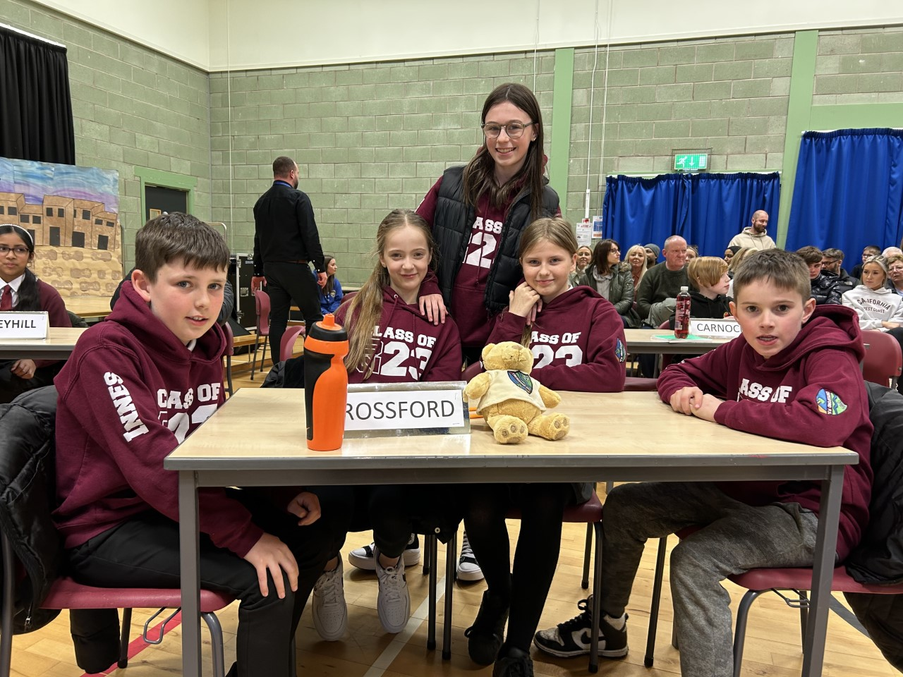

Dogs Trust
Louise and Donna from the Dogs Trust visited our school. They spoke with the children about their work during assemblies and led workshops for children in Primary 6 and Primary 7.
One of the main discussion points was ‘5 Happy Dog Rules’ to help children stay safe. They are
- When your dog is resting, leave them alone.
- When your dog is eating, leave them alone.
- We should be quiet around dogs. They don’t like loud noises.
- Dogs don’t like hugs. They prefer a gentle stroke.
- If a dog takes your toys, tell an adult.

Star Listeners
Each week we will be recognising and celebrating good listening skills
- Sitting still
- Being quiet
- Looking at the person who is talking
- Listening to all of the words.
Our star listeners last week were:-
Primary 1 - Holly
Primary 1/2 – Lola
Primary 2 – Catalina
Primary 3 – Jaxon
Primary 4 – Dominik
Primary 7 – Euan
Well done and thank you!

Star Writers
Each week we will be recognising Star Writers in each class at assembly. Star Writer for this week is:-
Primary 1 – Aidan – for using knowledge of phonics to write words and sentences during play activities.
Primary 1/2 – Alexis – for using vocabulary she has learned about castles and great adjectives to describe a castle.
Primary 2 – Harris – for sounding out spellings for adjectives to describe the Three Billy Goats Gruff.
Primary 3 – Hannah – writing a very polite, formal letter and remembering to include question marks.
Primary 4 – Emilia & Vivien – for being able to use bullet points to provide a huge amount of knowledge about the Victorians
Primary 6 – Sam & Olivia - for achieving all of the success criteria during formal letters writing – penpal letters to Hong Kong.
Primary 7 – Brooke – becoming more fluid when adding figurative language to her writing.

ELC Public Consultation 2023
Under section 50(1)(a) of the 2014 Children and Young People Act, Education Authorities must consult with persons who appear to be representative of parents and carers of children under school age in their area, about how they should make early learning and childcare available. This consultation must be carried out at least once every 2 years. Our last consultation took place in 2021.
Under Section 50(1)(b) of the 2014 Act, Education Authorities must have regard to the views expressed in the consultation and, in moving forward, they should indicate how they intend to make early learning and childcare available. The outcome of this consultation will inform how we do this.
This public consultation will be open for a six-week period from 13th March 2023 - 28th April 2023.
The consultation link can be found at https://bit.ly/ELCConsultation2023

Consultation on the Local Transport Strategy for Fife 2023-2033
Fife Council is consulting on the Local Transport Strategy for Fife 2023-2033. We invite you to have your say on our priorities and ambitions by completing our survey.

The Local Transport Strategy sets out our vision for fair, sustainable access for all and a proposed action plan for the next ten years.

Details of the consultation events, as well as a link to the survey, are on our web page: www.fife.gov.uk/transportstrategy
Paper copies are available at Fife Council Customer Service Centres
Consultation closes Sunday 2 April

PE Kit
PE kit should be worn for all PE sessions. We recommend:-
Indoor PE – plain t-shirt, shorts/leggings, indoor PE shoes (trainers or plimsoles)
Outdoor PE – warmer weather - plain t-shirt, shorts/leggings, outdoor trainers or plimsoles
Outdoor PE – colder weather – plain t-shirt, hoodie, joggers, outdoor trainers or plimsoles
No football strips please.

Drop Everything and Read
Our reading ambassadors are introducing weekly ‘drop everything and read’ (DEAR) sessions on a Monday afternoon. All children and staff will have some time where everyone stops what they are doing has some time (around 20 minutes) to read any text of their choice. Children can bring in their own book from home for these sessions or choose a book from the classroom libraries.

Dropping off and picking up times
Whenever possible we encourage children and families to walk to school. This is good for our health and eases congestion around the school grounds at these busy times of day. It also makes walking safer if there are less vehicles around the school grounds. If you do need to drive children to school please consider parking away from the school gates and be mindful of children crossing the road particularly as you approach the school gates.
We would also ask that children and adults do not climb over the wall or the fences to access or leave the playground. Everyone using the gates to enter and leave the school grounds supports our children to be safe. If you are running a little bit late, we would rather everyone got to school safely by using the gates. Thank you for your support with this.

Child Protection & Safeguarding

Our current child protection co-ordinators are:-

Mrs Lorna Bernard – lorna.bernard@fife.gov.uk

Mrs Sharon Logie – sharon.logie-qh@fife.gov.uk

If you are ever concerned about the immediate safety of a child then do not hesitate to contact Police Scotland on 999.

If you need to share any concerns outwith school working hours, please contact Fife Social Work using the contact details below:-

Social Work Contact Centre – 03451 551503

Out of hours Social Work (evenings and weekends only) – 03451 550099

Thank you
A very big thank you to all of the parents, carers and family members who have supported the school this term – outdoor learning, class trips, revamping our outdoor classroom, attending and providing transport for sports festivals, coming to shared learning sessions, attending assemblies, donations for fundraising and being a huge part of our school community.
Week beginning 27 March 2023

There are some changes of PE days this week. Please see below. PE will return to the usual days at the start of next term.
Monday | - Primary 4 outdoor learning  - Drop Everything And Read  - 2:00 – Easter Assembly for P5 and P6 families
Tuesday | - Primary 1 outdoor learning  - PE – P1/2, P2, P3, P5 & P6
Wednesday | - Primary 5 outdoor learning  - PE – P1, P2, P3, P4 & P7
Thursday | - Primary 6 outdoor learning  - PE – P1, P1/2, P5 & P7  - Last day of term – School closes at 3pm and reopens at 9am on 17 April

