Weekly Update – Term 3 – 20 March 2023
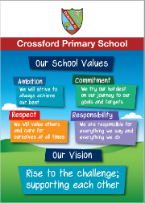

School Milk
The milk fund will be open on iPay until Friday 24 March if you would like to order milk for your child in term 4.

What Matters To You Family Survey
Over the next 3 years Fife Council Education Service will receive additional funding to support us to undertake strategic approaches to achieve the mission of the Scottish Attainment Challenge, with a clear focus on delivering equity through improving outcomes for learners impacted by poverty.
The funding should be focused on resources, activities and approaches focussed on learners impacted by poverty, which will lead to improvements in literacy, numeracy and support health and wellbeing.
To help us identify areas of focus we would like to know your thoughts on what matters to you. What do you feel this additional funding should be used to support to ensure the best outcomes for our children and young people across Fife? Please click on the link below to access the survey.
This short survey should take no longer than 5 minutes to complete and will help us determine our direction of travel over the next 3 years.
Many thanks for your input and time.

https://forms.office.com/Pages/ResponsePage.aspx?id=oyzTzM4Wj0KVQTctawUZKa6K-6MytolDrZ3-EIANCiBUNDZISDk2MUwwVUpSNTZTUU1GWEpFWVk3Ny4u

Red Nose Day 2023
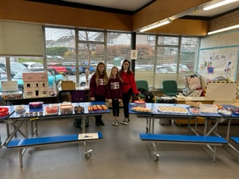 Thank you to everyone who donated baking, cakes and biscuits for the bake sale to raise money for Comic Relief. Brooke, Nyla and Carmel did an amazing job all morning and raised a total of just over £178! Well done everyone.
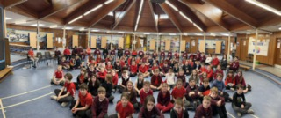
Soak-a-Seven was very popular and very successful! Primary 7 raised £164.40! Well done and thank you to everyone involved.
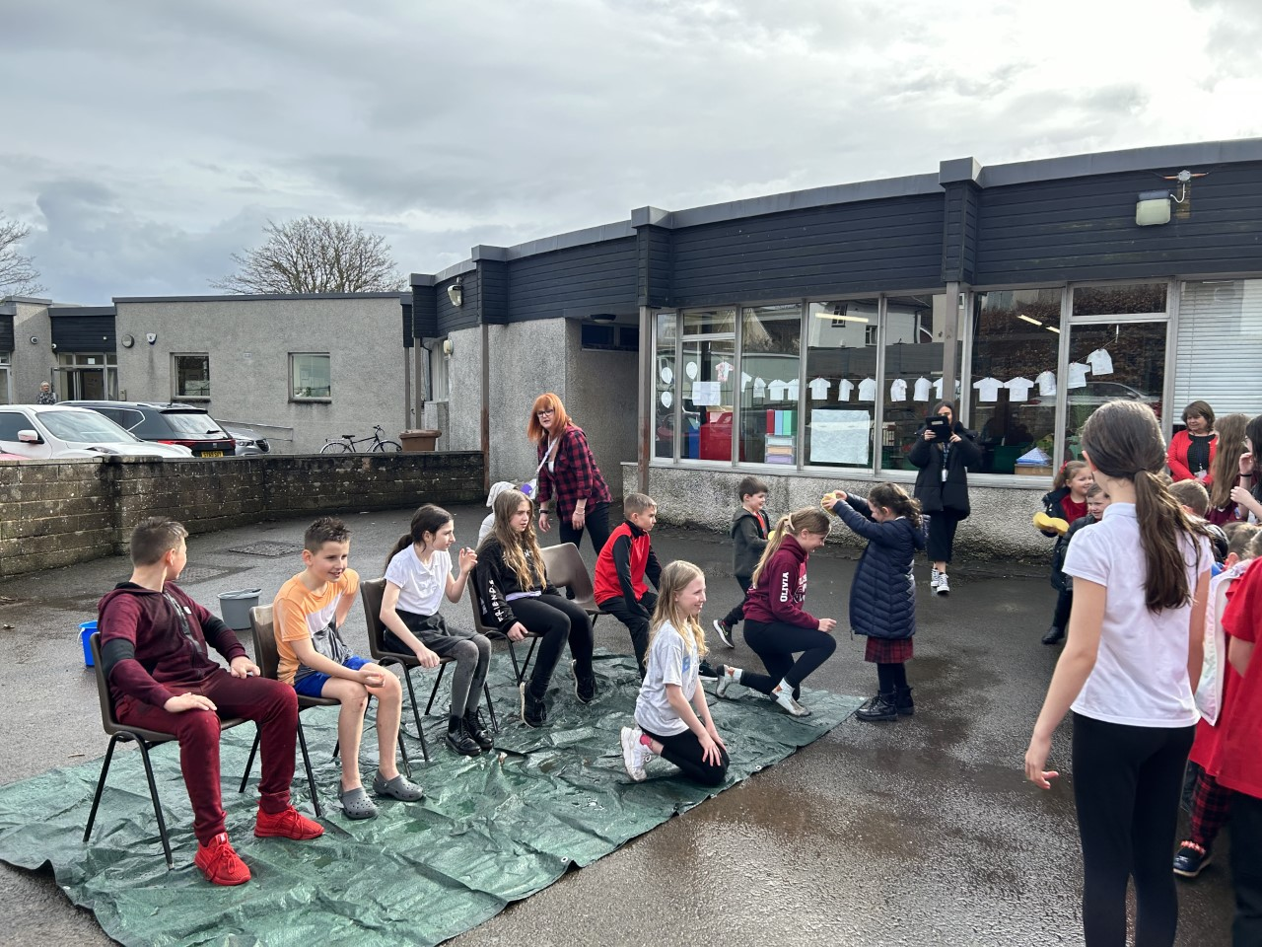

Primary 4 – Victorian Day
Children in Primary 4 were immersed in a day of being a Victorian school pupil. Many of the children wore Victorian dress. The children sat in rows and stood to greet visitors to their classroom. The children really seemed to enjoy their day and discussed which aspects of their day they might like to keep for the rest of the week or even beyond. Thanks to Miss Booth and all of the children and families who helped make the day a success.
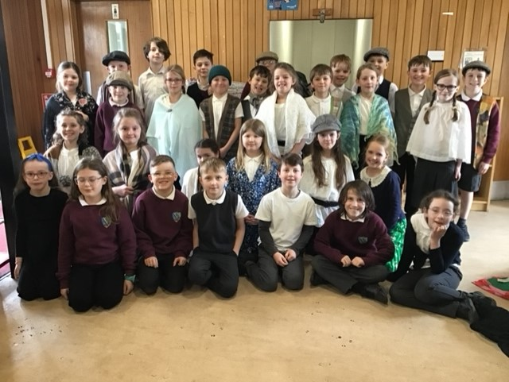

School Grounds Committee
On Wednesday the School Grounds Committee planted potatoes as part of ‘Grow your own potatoes’ initiative. This is a hands-on growing project for primary schools in Great Britain. It teaches children aged 5 – 11 all about potatoes; where they come from, how they grow and how they fit into a healthy balanced diet. The committee will update us on their progress next term.

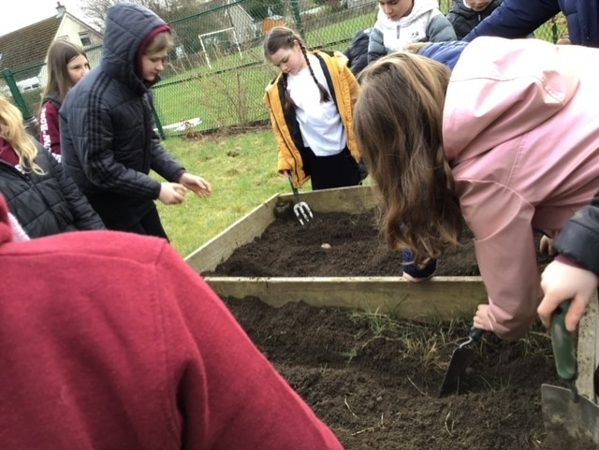

Reading Ambassadors
This week the reading ambassadors agreed the new rota of volunteers to read to children in our nursery each Monday. The nursery children really enjoy listening to older children read to them and the Reading Ambassadors enjoy sharing their love of reading with others.
They also worked in small groups to complete ‘Author of the Month’ displays. Author of the Month for March is Liz Pichon who is best known for Tom Gates series.
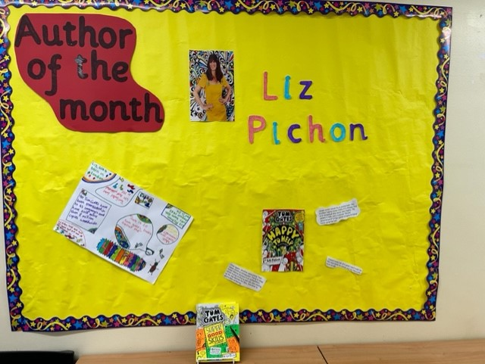

Fife Libraries
Please find below link to the new Sway from OnFife Libraries Young People's Team. It outlines the new home for our online content as well as our Easter Holiday offering across Fife!
Sway (office.com)
Star Listeners
Each week we will be recognising and celebrating good listening skills
- Sitting still
- Being quiet
- Looking at the person who is talking
- Listening to all of the words.
Our star listeners last week were:-
Primary 1 - Euan
Primary 1/2 – Millie
Primary 2 – Oscar
Primary 3 – Rudi
Primary 4 – Maia
Primary 5 – Isabella
Well done and thank you!

Star Writers
Each week we will be recognising Star Writers in each class at assembly. Star Writer for this week is:-
Primary 1 – Poppy – for using a describing word in her sentence and remembering finger spaces.
Primary 1/2 – Sophia – for using more than one adjective in her sentence this week.
Primary 2 – Sophie – for including adjectives in her character description of the Gingerbread Man.
Primary 3 – Rosie – for writing a brilliant invitation to Rouge the Red Squirrel.
Primary 4 – Vivien – for a detailed set of instructions explaining how to brush your teeth.
Primary 5 – Katie – for a detailed letter using a range of punctuation and interesting adjectives.
Primary 6 – Kate – for transferring skills developed in daily write successfully into extended writing to produce a lively and descriptive piece of writing.
Primary 7 – Jaden – most improved piece of daily write including descriptive detail.

ELC Public Consultation 2023
Under section 50(1)(a) of the 2014 Children and Young People Act, Education Authorities must consult with persons who appear to be representative of parents and carers of children under school age in their area, about how they should make early learning and childcare available. This consultation must be carried out at least once every 2 years. Our last consultation took place in 2021.
Under Section 50(1)(b) of the 2014 Act, Education Authorities must have regard to the views expressed in the consultation and, in moving forward, they should indicate how they intend to make early learning and childcare available. The outcome of this consultation will inform how we do this.
This public consultation will be open for a six-week period from 13th March 2023 - 28th April 2023.
The consultation link can be found at https://bit.ly/ELCConsultation2023

Consultation on the Local Transport Strategy for Fife 2023-2033
Fife Council is consulting on the Local Transport Strategy for Fife 2023-2033. We invite you to have your say on our priorities and ambitions by completing our survey.

The Local Transport Strategy sets out our vision for fair, sustainable access for all and a proposed action plan for the next ten years.

Details of the consultation events, as well as a link to the survey, are on our web page: www.fife.gov.uk/transportstrategy
Paper copies are available at Fife Council Customer Service Centres
Consultation closes Sunday 2 April

PE Kit
PE kit should be worn for all PE sessions. We recommend:-
Indoor PE – plain t-shirt, shorts/leggings, indoor PE shoes (trainers or plimsoles)
Outdoor PE – warmer weather - plain t-shirt, shorts/leggings, outdoor trainers or plimsoles
Outdoor PE – colder weather – plain t-shirt, hoodie, joggers, outdoor trainers or plimsoles
No football strips please.

Parent Club

Drop Everything and Read
Our reading ambassadors are introducing weekly ‘drop everything and read’ (DEAR) sessions on a Monday afternoon. All children and staff will have some time where everyone stops what they are doing has some time (around 20 minutes) to read any text of their choice. Children can bring in their own book from home for these sessions or choose a book from the classroom libraries.

Dropping off and picking up times
Whenever possible we encourage children and families to walk to school. This is good for our health and eases congestion around the school grounds at these busy times of day. It also makes walking safer if there are less vehicles around the school grounds. If you do need to drive children to school please consider parking away from the school gates and be mindful of children crossing the road particularly as you approach the school gates. Thank you for your support with this.

Child Protection & Safeguarding

Our current child protection co-ordinators are:-

Mrs Lorna Bernard – lorna.bernard@fife.gov.uk

Mrs Sharon Logie – sharon.logie-qh@fife.gov.uk

If you are ever concerned about the immediate safety of a child then do not hesitate to contact Police Scotland on 999.

If you need to share any concerns outwith school working hours, please contact Fife Social Work using the contact details below:-

Social Work Contact Centre – 03451 551503

Out of hours Social Work (evenings and weekends only) – 03451 550099

Week beginning 20 March 2023

Health and Wellbeing Survey for Primary 5, Primary 6 and Primary 7 children takes place week beginning 20 March.
Monday | - Primary 7 outdoor learning  - Drop Everything And Read
Tuesday | - Primary 1/2 outdoor learning  - Primary 2 outdoor learning  - PE – P7, P6, P5, P4, P3 & P2
Wednesday | - Primary 5 outdoor learning day postponed to 29 March.  - PE – P1, P1/2, P2 & P3  - Parents Evening  - 7:00 – Primary 7 Rotary Quiz at Inzievar Primary School
Thursday | - Primary 3 outdoor learning  - PE – P4, P5, P7, P6, P1/2 & P1
Friday | - Assemblies including input from Dogs Trust  - Primary 6 and Primary 7 Dogs Trust workshops  - Primary 3 sharing learning session at 2pm

