Weekly Update – Term 2 – 25 October 2022
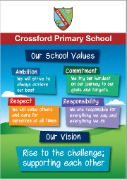

News
Fife Council Active Travel Month starts today. The focus this year is parking around the school gate, the congestion it causes and how it makes other feel. Please click on the link below for more information.
Don't Park Here - Kingdom FM
Ms Morton, Vivien and Lexi’s mum, very kindly came into school to deliver exciting science experiments with Primary 4 and Primary 7 children.
Pumpkin Lantern Competition
Thank you to everyone who took the time to create a decorative pumpkin lantern to bring into school on Monday. There were very many creative entries and our nursery had a very tricky time trying to choose a winner from each class. Well done everyone. Here are the winners.

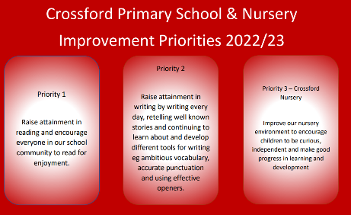
School Improvement Priorities
Our improvement priorities for this year are
- Raise attainment in reading and encourage everyone in our school and nursery community to read for enjoyment.
- Raise attainment in writing by writing every day, retelling well known stories and continuing to learn and develop different tools for writing eg ambitious vocabulary, accurate punctuation and using effective openers.
- Improve our nursery environment to encourage children to be curious, independent and make good progress in learning and development.
Please do not hesitate to get in touch if you have any ideas to support us in our improvement journey.

Part of our plans for improvement in reading for enjoyment is participation in Reading Schools award. We need to gather information for baseline data about current levels of reading for enjoyment in our school community – children, parents/carers and staff. Our Reading Ambassadors would be grateful if you could please spend a few minutes completing the survey for parents/carers using the link below. Thank you for taking the time to support our Reading Ambassadors with this.

https://forms.office.com/Pages/ResponsePage.aspx?id=oyzTzM4Wj0KVQTctawUZKf_mRrx2NUhFrRRJdLEZNQRUODUyQktMVUxCSlBQNlFJRlVLODJUMUxaMC4u

Parents’ Evening
Parents’ evenings are a 10 minute appointment with your child’s class teacher to discuss their strengths, next steps and general wellbeing and engagement in school. This year we are able to return to in person appointments. They will take place on

- Monday 7 November
- Thursday 10 November
- Wednesday 16 November
We should have received information on how to book an appointment via groupcall email very soon. Please contact Mrs Jones or Mrs Gillespie if you have any issues with the booking system.

Child Protection & Safeguarding

Our current child protection co-ordinators are:-

Mrs Lorna Bernard – lorna.bernard@fife.gov.uk

Mrs Sharon Logie – sharon.logie-qh@fife.gov.uk

If you are ever concerned about the immediate safety of a child then do not hesitate to contact Police Scotland on 999.

If you need to share any concerns outwith school working hours, please contact Fife Social Work using the contact details below:-

Social Work Contact Centre – 03451 551503

Out of hours Social Work (evenings and weekends only) – 03451 550099

Primary 3 – 7 Christmas Sing-a-long

Due to unforeseen circumstances we need to move our Christmas sing-a-long to Wednesday 14 December. We apologise for any inconvenience this causes and hope that you can still join us.

Crossford Calendar

You should have received an email from Crossford Enquiries last week regarding our plans for a Crossford Calendar which should be on sale during Christmas Fayre. Our plan is for everyone to have a group photo taken for their birthday month. If you do not wish your child to be included please contact the school office before 10 November.

We plan to take the photos throughout the morning of 10 November. Can children please wear school uniform for the photos even though it is a PE day?

Monday | - P4 outdoor learning in Dunfermline  - Parents’ evening 3:30 – 5:30
Tuesday | - PE – P2, P3, P4, P5, P6 & P7  - Primary 1 health screening
Wednesday | - PE – P1, P1/2, P2 & P3
Thursday | - PE – P1, P1/2, P4, P5, P6 & P7  - Calendar photos being taken  - Parents’ evening 5:30 – 7:30
Friday
Next week – Week beginning 7 November 2022
Reminders!
- Please ensure your child has a gym kit which can be kept in school.

- Please ensure ONLY water in bottles.

- Keep up to date with class work and pictures through SeeSaw

