Weekly Update – Term 2 – 25 October 2022
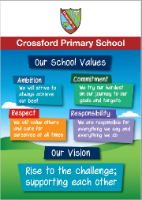

Welcome back
It has been lovely to welcome all of our children and families back to Crossford Primary and Nursery for the start of the new term. It is going to be very busy with lots of learning and fun over the next 8 weeks.
Primary 7 children shared the excitement of their week at Ardroy Outdoor Centre with children during assemblies. It was really good to hear about all of the exciting activities that they had taken part in over the week and how much they enjoyed themselves. All of the children who presented said that they’d love to go back. Their powerpoint presentations and posters were very good. It was clear that they had put a great deal of effort into them.
Children also shared their achievements during assemblies. We make a note of all of their successes and add them to our achievements board in the hall.
We reminded children that they should remember to bring a coat to school now that it is Autumn and we are moving into Winter. Children will almost always be outdoors for intervals unless the weather is very wet or windy and unsafe.

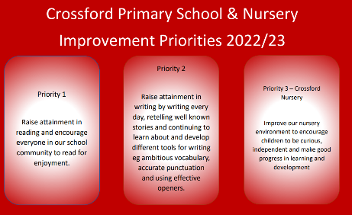
School Improvement Priorities
Our improvement priorities for this year are
- Raise attainment in reading and encourage everyone in our school and nursery community to read for enjoyment.
- Raise attainment in writing by writing every day, retelling well known stories and continuing to learn and develop different tools for writing eg ambitious vocabulary, accurate punctuation and using effective openers.
- Improve our nursery environment to encourage children to be curious, independent and make good progress in learning and development.
Please do not hesitate to get in touch if you have any ideas to support us in our improvement journey.

Hallowe’en Pumpkin/Turnip Lantern Competition
We’d like to invite children to bring in their pumpkin/turnip lanterns on Monday 31st October. Our nursery children will vote for their favourite one in each class and the winner will receive a Hallowe’en related prize. We will also use the pumpkins/lanterns as a stimulus for writing that day. The lanterns will be brought home at the end of the day. This is a voluntary activity and children will be able to write about any pumpkin/turnip lanterns in their class.

School Committees
During the final week of last term children in Primary 4 to 7 took part in the first meeting of our school committees. This year our committees are:-
- School leaders – how can we contribute and support making our school better for everyone?
- Reading Ambassadors – How can we help everyone in our school to enjoy reading, make choices about reading and talk about what we have read?
- Sustainability – How can we take responsibility for our environment and the impaction of our actions and decisions?
- School Grounds – How can we help to make the most of our school grounds so that everyone can enjoy them?
- Our Minds Matter – How do week encourage everyone to be healthy?
- UNCRC – What are UNCRC and how can we raise awareness of UNCRC with all children, parents and carers, staff and the wider school community?

Committees will meet every 4-6 weeks. We will share more about this throughout the year.

Child Protection & Safeguarding

Our current child protection co-ordinators are:-

Mrs Lorna Bernard – lorna.bernard@fife.gov.uk

Mrs Sharon Logie – sharon.logie-qh@fife.gov.uk

If you are ever concerned about the immediate safety of a child then do not hesitate to contact Police Scotland on 999.

If you need to share any concerns outwith school working hours, please contact Fife Social Work using the contact details below:-

Social Work Contact Centre – 03451 551503

Out of hours Social Work (evenings and weekends only) – 03451 550099
Monday | - Pumpkin/turnip lantern competition
Tuesday | - PE – P2, P3, P4, P5, P6 & P7
Wednesday | - PE – P1, P1/2, P2 & P3
Thursday | - PE – P1, P1/2, P4, P5, P6 & P7  - Family Finish 2:10 – 2:55 – Primary 1 (Miss Cuthbert’s class) will be taking part in Scottish Country Dancing during PE.
Friday | - P6 and P7 Golf Session at Dunfermline Golf Club
Next week – Week beginning 31 October 2022
Reminders!
- Please ensure your child has a gym kit which can be kept in school.

- Please ensure ONLY water in bottles.

- Keep up to date with class work and pictures through SeeSaw

