**Weekly Update – Term 4 – 21 April 2023**





**News**

**Nursery –** every Monday from 24 April nursery children who will be starting school in August 2023 will have the option of visiting the lunch hall for lunch to help familiarise them with the setting.

**Football during breaks –** there will be a timetable in place for all children who want to play football at lunchtimes in an area of the playground and on the pitch (weather permitting). This will allow other children who do not want to play football space to play in the other areas of the playground safely. Some of our Primary 7 children have volunteered to referee games for younger children. **The school will provide footballs and bibs**. Children do not need to bring in their own footballs.

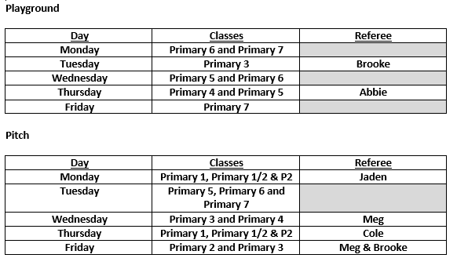

**Rugby Festival –** this was postponed last term due to bad weather. This has been rescheduled for the morning of Thursday 27 April. Thank you to those parents who are supporting with transport etc.

**St Margaret’s Cup Football Festival –** this will take place on Friday 28 April for a group of children . Thank you to those parents who are supporting with transport etc.

**Fife Young Carers –** Fife Young Carers will be sharing their work with staff on 3 May and delivering workshops for children in Primary 4 – 7 on Thursday 4 May.

**Parent Council –** next meeting is at 7pm in school on Tuesday 2 May.

**Royal Highland Show – Design a sheep competition**

Children in Scotland are invited to take part in a competition to design a sheep for this year’s flock. More information can be found using the link below. Children could look at current designs using this link. Class teachers have copies of the design template that children can ask for. The competition closes on 5 May.

[Royal Highland Show](https://www.royalhighlandshow.org/flock-to-the-show/meet-the-flock/)



**Star Listeners**

Each week we will be recognising and celebrating good listening skills

* Sitting still
* Being quiet
* Looking at the person who is talking
* Listening to all of the words.

Our star listeners last week were:-

Primary 1 - Blair

Primary 1/2 – Beatrix

Primary 2 – Theo

Primary 3 – Lottie

**PE Kit**

PE kit should be worn for all PE sessions. We recommend:-

Indoor PE – plain t-shirt, shorts/leggings, indoor PE shoes (trainers or plimsoles)

Outdoor PE – warmer weather - plain t-shirt, shorts/leggings, outdoor trainers or plimsoles

Outdoor PE – colder weather – plain t-shirt, hoodie, joggers, outdoor trainers or plimsoles

**No football strips please.**

**Drop Everything and Read**

Our reading ambassadors are introducing weekly ‘drop everything and read’ (DEAR) sessions on a Monday afternoon. All children and staff will have some time where everyone stops what they are doing has some time (around 20 minutes) to read any text of their choice. Children can bring in their own book from home for these sessions or choose a book from the classroom libraries.



**Dropping off and picking up times**

Whenever possible we encourage children and families to walk to school. This is good for our health and eases congestion around the school grounds at these busy times of day. It also makes walking safer if there are less vehicles around the school grounds. If you do need to drive children to school please consider parking away from the school gates and be mindful of children crossing the road particularly as you approach the school gates.

We would also ask that children and adults do not climb over the wall or the fences to access or leave the playground. Everyone using the gates to enter and leave the school grounds supports our children to be safe. If you are running a little bit late, we would rather everyone got to school safely by using the gates. Thank you for your support with this.

**Social Security Scotland**

Please find attached information documents regarding benefits and supports available for individuals and families.

**Child Protection & Safeguarding**

**Our current child protection co-ordinators are:-**

**Mrs Lorna Bernard –** [lorna.bernard@fife.gov.uk](mailto:lorna.bernard@fife.gov.uk)

**Mrs Sharon Logie –** [sharon.logie-qh@fife.gov.uk](mailto:sharon.logie-qh@fife.gov.uk)

**If you are ever concerned about the immediate safety of a child then do not hesitate to contact Police Scotland on 999.**

**If you need to share any concerns outwith school working hours, please contact Fife Social Work using the contact details below:-**

**Social Work Contact Centre – 03451 551503**

**Out of hours Social Work (evenings and weekends only) – 03451 550099**

**Thank You!**



**We’d like to say a very big thank you to Mr Van Der Westhuiten and all of the other parents and carers who have put a huge amount of time and resources into revamping our outdoor classroom. It is looking amazing and we are incredibly grateful.**

The group are looking for donations for loose parts play eg buckets, spouts, metal or plastic pipes, old pots and pans, metal or wooden spoons, wind chimes, xylophones, outdoor thermometer, weather vane and road traffic signs.

**Week beginning 24 April 2023**

**There are some changes of PE days this week. Please see below. PE will return to the usual days at the start of next term.**

|  |  |
| --- | --- |
| **Monday** | * Drop Everything And Read |
| **Tuesday** | * PE – P1/2, P2, P3, P5 & P6 |
| **Wednesday** | * PE – P1, P2, P3, P4 & P7 * P4-7 committees |
| **Thursday** | * PE – P1, P1/2, P5 & P7 * Primary 1 and Primary 7 dental inspections * Primary 6/7 Rugby Festival |
| **Friday** | * St Margaret’s Cup Football Festival |