Weekly Update – Term 4 – 19 May 2023

Playground
We have had several queries regarding dogs in the playground and nursery garden and children scooting or cycling the playground at the start and end of the school day.
Dogs on a lead are welcome in the playground. Please be aware that some children and adults are nervous around dogs. Please keep dogs out of the nursery garden as this is a much smaller space and children have access to the garden to play from drop off to pick up times.
Please ask your child not to scoot or cycle in the playground to avoid collisions and injuries. We are currently investigating how to relocate our bicycle rack so that bikes and scooters can be kept securely in the playground during the school day.
We will be sharing this information with children at assemblies.

Have Your Say………..where do you hang out or play? Survey
Finding out more about where and how children and teenagers hang out or play outdoors will help us to understand how good or bad Fife’s open spaces and play areas are. This information will help us to decide which areas need to be improved or where new spaces are needed in the future. The feedback will be used as part of an assessment we are making of outdoor spaces in Fife – called a Play Sufficiency Assessment.
Your child can have their say using this link
https://www.fife.gov.uk/consultations/consultation-diaries/have-your-say...where-do-you-like-to-hang-out-or-play-

Parents and carers can have their say using this link
https://www.fife.gov.uk/consultations/consultation-diaries/have-your-say-...-on-fifes-play-and-openspaces

Parents/Carers of P7 – S6
Please find attached a letter from Fife Health and Social Care Partnership.

Queen Anne High School P7 – S1 Transition
Please use the link below to view this week’s transition SWAY.

https://sway.office.com/AczULwWh8wZypqIl?ref=Link
Please note the P7 Parent/Carer Information Evening, which is in the calendar for Thursday the 8th of June, will be an in-person event at Queen Anne from 6pm-8pm.
You can sign up using this link
https://forms.office.com/e/eA6yJQvnFB
Link closes Sunday 4 June.

Badminton Summer Camp
Please see attached flyer with information about Badminton Summer Camp.

Crossford Children’s Gala
The Gala committee invited children to submit a design for the front and back covers of this year’s programme and to design a logo for the Children’s Gala Committee.
They are delighted to announce the following winners and runners up…
Gala Programme Front Cover Winner – Masha Kostikova
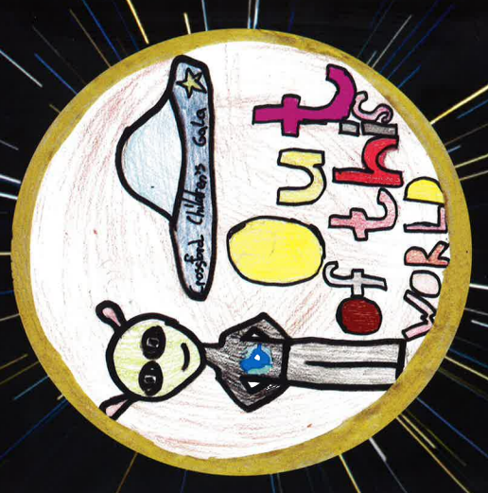

Gala Programme Back Cover Winner – Kate Wylie
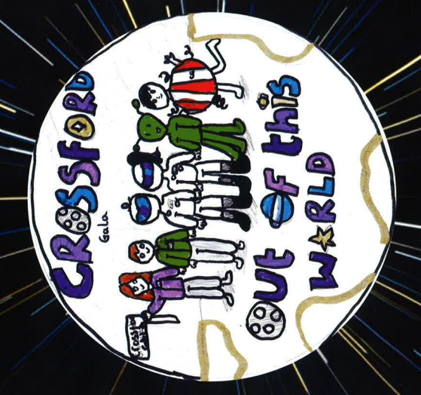
Programme art competition runners up

Front cover second place – Mason Goldie
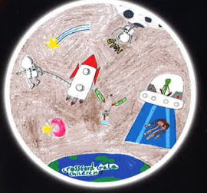

Front cover third place – Addison Fenton
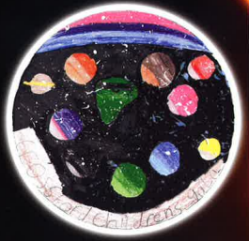

Back cover second place – Oliver Imrie

Back cover third place – Millie Imrie
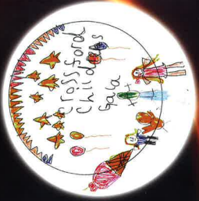

Gala Logo Winner – Katie Hopkin

Logo second place – Poppy Kendall

Logo third place – Isla Paton

Well done to everyone who entered the competitions.
Star Listeners
Each week we will be recognising and celebrating good listening skills
- Sitting still
- Being quiet
- Looking at the person who is talking
- Listening to all of the words.
Our star listeners last week were:-
Primary 1 – Aurora
Primary 1/2 – Olive
Primary 2 – Jack
Primary 3 – Leo
Primary 4 – Isla
Primary 5 – Isabella
Primary 6 – Logan
Primary 7 - Ava
Star Writers
Each week we will be recognising Star Writers in each class at assembly. Star Writers for this week are:-
Primary 1 – Mikey – for working hard to write his letters the correct size and writing 3 super sentences.
Primary 1/2 – Archie – for working really hard to form letters correctly.
Primary 2 – Alex – for including detailed sentences about a trip to the beach and working sensibly with P7 helper.
Primary 3 – Olive – for excellent sentence structure and showing the reader emotion using description.
Primary 4 – Evan – for doing great diary entry based on a character from the class novel.
Primary 5 – Vaughan – for a great description of a story setting.
Primary 6 – Olivia – for working hard on improving the quality of daily writing and challenging herself to use more ambitious words and descriptive phrases.
Primary 7 – Frazer – for working hard to improve the quality of daily writing by uplevelling sentences.
&
Primary 7 – Meg – for showing great use of descriptive and interesting language in daily writing.

PE Kit
PE kit should be worn for all PE sessions. We recommend:-
Indoor PE – plain t-shirt, shorts/leggings, indoor PE shoes (trainers or plimsoles)
Outdoor PE – warmer weather - plain t-shirt, shorts/leggings, outdoor trainers or plimsoles
Outdoor PE – colder weather – plain t-shirt, hoodie, joggers, outdoor trainers or plimsoles
No football strips please.

Drop Everything and Read
Our reading ambassadors are introducing weekly ‘drop everything and read’ (DEAR) sessions on a Monday afternoon. All children and staff will have some time where everyone stops what they are doing has some time (around 20 minutes) to read any text of their choice. Children can bring in their own book from home for these sessions or choose a book from the classroom libraries.

Dropping off and picking up times
Whenever possible we encourage children and families to walk to school. This is good for our health and eases congestion around the school grounds at these busy times of day. It also makes walking safer if there are less vehicles around the school grounds. If you do need to drive children to school please consider parking away from the school gates and be mindful of children crossing the road particularly as you approach the school gates.
We would also ask that children and adults do not climb over the wall or the fences to access or leave the playground. Everyone using the gates to enter and leave the school grounds supports our children to be safe. If you are running a little bit late, we would rather everyone got to school safely by using the gates. Thank you for your support with this.

Child Protection & Safeguarding

Our current child protection co-ordinators are:-

Mrs Lorna Bernard – lorna.bernard@fife.gov.uk

Mrs Sharon Logie – sharon.logie-qh@fife.gov.uk

If you are ever concerned about the immediate safety of a child then do not hesitate to contact Police Scotland on 999.

If you need to share any concerns outwith school working hours, please contact Fife Social Work using the contact details below:-

Social Work Contact Centre – 03451 551503

Out of hours Social Work (evenings and weekends only) – 03451 550099

Week beginning 22 May 2023
Monday
Tuesday | - PE – P7, P6, P5, P4, P3 & P2  - 2:10 – 2:55 – Family Finish
Wednesday | - PE – P1, P1/2, P2 & P3
Thursday | - PE – P4, P5, P7, P6, P1/2 & P1  - Primary 6 hockey taster session 1  - Fife Primary Schools Cross Country Championship at Beveridge Park
Friday | - Primary 6 hockey taster session 2  - Assemblies  - Primary 7 photo for Courier  - Primary 1 sharing learning session at 2pm

