Weekly Update – Term 4 – 2 June 2023

School Sports & Book Swap
At time of writing our school sports for our younger children is getting underway.
We’d like to say a huge thank you to Mr Denholm and Sports Committee for organising the events today and to our Parent Council who provided refreshments and organised the book swap. We have been overwhelmed by how many books have been donated and hope that the children who take a book home enjoy reading.
Ice Poles!
From next week until the end of term, Primary 6 will be selling ice poles for children to buy during breaks. As our school roll is quite big they have decided that pupils in P4-7 can buy an ice pole on Wednesday, P1-3 on Thursday and then everyone on Friday. They will review sales at the end of the week and will let you know what the plan is for week beginning 12 June.
Ice poles will cost 20p each and are limited to one per child per day to ensure stocks last.

Primary 6 and Primary 7 – Voices Of The World Collaborative Song
Over the last few weeks children in Primary 6 and Primary 7 have been learning how to sign ‘Yellow’ by Coldplay using Makaton signing. This has been in collaboration with children around the world. Please click on the link below to watch the video of the collaboration.
https://youtu.be/YazX8hGz_Yo
We are very proud of them all.

Royal Highland Show – Design a sheep competition
We’re delighted to share that out of around 1600 amazing entries one of the entries from Crossford was chosen in 3rd place.
Well done to Emilia who has won a RHET classroom talk for her class next term.
Here’s Emilia’s entry.
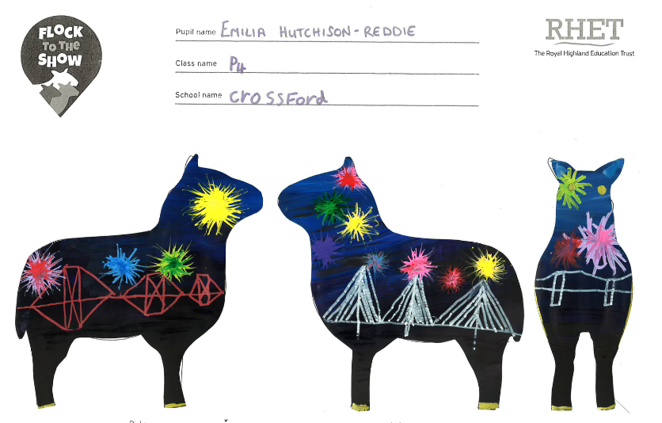

Well done to everyone who submitted an entry. It must have been a really tricky job to choose winning designs.
School and Nursery Improvement Priorities
This session our improvement priorities have been
- Raise attainment in reading and encourage everyone in our school and nursery community to read for enjoyment.
- Raise attainment in writing by writing every day, retelling well known stories and continuing to learn and develop different tools for writing eg ambitious vocabulary, accurate punctuation and using effective openers.
- Improve our nursery environment to encourage children to be curious, independent and make good progress in learning and development.
We’d love to hear your views on our progress with these and what you think we should focus on next session. Please take a few minutes to complete the form using the link below.
https://forms.office.com/Pages/ResponsePage.aspx?id=oyzTzM4Wj0KVQTctawUZKf_mRrx2NUhFrRRJdLEZNQRUNTNKTVVKS1ZVMkc2QUcxQTZNWksyUFNGMy4u
Thank you to everyone who has already shared their views.
Young Person's Free Bus Travel Scheme
Transport Scotland are conducting an evaluation of the Young Person's Free Bus Travel Scheme, with a survey available for parents/carers of children aged 5-23, and young people themselves aged 12-23. Feedback is being sought from both those with experience of using the Young Person's Free Bus Travel, and those that do not use it in order to find out why.
The survey seeks to understand use of the scheme and any benefits or challenges that have been experienced since its introduction. It should take about 10 minutes to complete, and there is the opportunity to enter a free prize draw to win up to £250 in One4All vouchers.
The survey can be accessed here: https://online1.snapsurveys.com/Yr1-YPFreeBusTravel
The closing date for all responses is 9th July 2023.
If you have any difficulties in accessing or completing the survey, or any questions about the work, you can contact the project manager at elaine@wellsideresearch.co.uk.

Queen Anne High School
Please click on the link below to view this week’s transition SWAY from Queen Anne High School.
https://sway.office.com/T7h1nRvk2g5Pgo30?ref=Link
School Uniform
You can use the link below to order ‘Crossford Primary School’ branded school uniform.
https://www.border-embroideries.co.uk/schools/crossford-primary-school.html
Please note that there is no requirement for children to wear branded school uniform. Maroon, grey or black jumpers, sweatshirts and cardigans are acceptable with a white polo shirt and grey or black trousers, skirts or shorts.

PE Kit
PE kit should be worn for all PE sessions. We recommend:-
Indoor PE – plain t-shirt, shorts/leggings, indoor PE shoes (trainers or plimsoles)
Outdoor PE – warmer weather - plain t-shirt, shorts/leggings, outdoor trainers or plimsoles
Outdoor PE – colder weather – plain t-shirt, hoodie, joggers, outdoor trainers or plimsoles
No football strips please.

Drop Everything and Read
Our reading ambassadors are introducing weekly ‘drop everything and read’ (DEAR) sessions on a Monday afternoon. All children and staff will have some time where everyone stops what they are doing has some time (around 20 minutes) to read any text of their choice. Children can bring in their own book from home for these sessions or choose a book from the classroom libraries.

Dropping off and picking up times
Whenever possible we encourage children and families to walk to school. This is good for our health and eases congestion around the school grounds at these busy times of day. It also makes walking safer if there are less vehicles around the school grounds. If you do need to drive children to school please consider parking away from the school gates and be mindful of children crossing the road particularly as you approach the school gates.
We would also ask that children and adults do not climb over the wall or the fences to access or leave the playground. Everyone using the gates to enter and leave the school grounds supports our children to be safe. If you are running a little bit late, we would rather everyone got to school safely by using the gates. Thank you for your support with this.

Child Protection & Safeguarding

Our current child protection co-ordinators are:-

Mrs Lorna Bernard – lorna.bernard@fife.gov.uk

Mrs Sharon Logie – sharon.logie-qh@fife.gov.uk

If you are ever concerned about the immediate safety of a child then do not hesitate to contact Police Scotland on 999.

If you need to share any concerns outwith school working hours, please contact Fife Social Work using the contact details below:-

Social Work Contact Centre – 03451 551503

Out of hours Social Work (evenings and weekends only) – 03451 550099

Week beginning 5 June 2023
Monday | - School closed – public holiday
Tuesday | - School closed to children – in-service day
Wednesday | - PE – P1, P1/2, P2 & P3  - P4-7 committees
Thursday | - PE – P4, P5, P7, P6, P1/2 & P1  - Zoolab visiting P1, P1/2 and P2  - Primary 7 Parent/Carer information session at Queen Anne High School
Friday | - Nursery trip to Limekilns beach  - George Beveridge Cup  - Learning Journey jotters home

