Weekly Update – Term 1 – 25 August 2023

Parkinsons Charity Walk
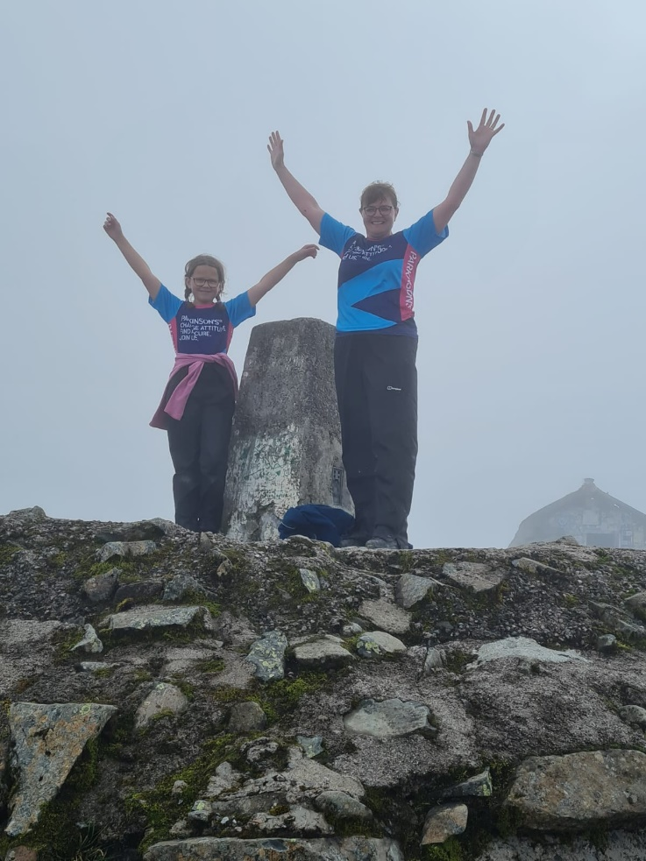
Martha, in Primary 7, and her Mum took part in a charity walk to raise money for Parkinsons during the summer holidays. This involved climbing Ben Nevis. This, in itself, is a huge achievement and they raised £1,016 to help contribute towards research for treatment for Parkinsons, which Martha's Grandad has. They would like to thank everyone who made a donation. Well done Martha and Mrs Paton!

Playground
We are delighted that children choose to stay in our playground at the end of the school day to play. We would be grateful if adults with the children could encourage the children to play safely whilst in the playground including not climbing and swinging on the goalposts as we are concerned that they may break and children are injured. We will remind children of this during weekly assembly.
Please also keep dogs on leads whilst in the playground at all times.
Thank you for your support with this.

Absence
Can parents please call/text/email the school office by 9.30am each day if your child won't be attending school. The phone number is 01383 602451. Alternatively you can text the school on 07860003707. Please phone/text/email every day they will be off.

Online Safety
PC Ian McArthur will be hosting a workshop for parents and carers exploring online safety at Carnock Primary School on Monday 4 September at 6pm. All parents and carers from Crossford are welcome to attend.

Home Start
About Home-Start Dunfermline
Home-Start Dunfermline is a local community network of trained volunteers and expert support, helping families with young children through their challenging times. Home-Start Dunfermline’s team of trained volunteers make sure a child’s early years count, so that no child’s future is limited. By volunteering a few hours each week, you could transform the lives of young children and their parents in our community. Volunteers are central to our work and provide invaluable friendship, emotional and practical support to parents in need.
Become a Volunteer
- Parenting experience?
- Friendly and understanding?
- 2 hours to spare per week?
We have a volunteer preparation course starting in September, contact us for more information, admin@hsdunfermline.co.uk Tel: 01383 621 349
Or explore our website to find out more about how you can get involved in our work as a volunteer or a trustee, www.home-start-dunfermline.org.uk
We look forward to hearing from you.

Dropping off and picking up times
Whenever possible we encourage children and families to walk to school. This is good for our health and eases congestion around the school grounds at these busy times of day. It also makes walking safer if there are less vehicles around the school grounds. If you do need to drive children to school please consider parking away from the school gates and be mindful of children crossing the road particularly as you approach the school gates. Thank you for your support with this.
Attend to Achieve!

Regular attendance at school is an important part of a child’s academic journey. Children who attend school regularly are less likely to fall behind.

Regular attendance gives your child the opportunity to:
- Learn new things daily
- Develop and practise skills
- Make friends and feel included
- Increase their confidence and self esteem
- Improve their social skills
- Increase their attainment and achievement
- Achieve their potential and fulfil their aspirations and ambitions
- Have a good daily routine

Every Day Matters!
In an average school year there are 190 school days.
So, at the end of the school year –

If your child’s attendance is | Days of school missed | Weeks of school missed
95% | 9 ½ days | Almost 2 weeks of learning missed
90% | 19 days | Almost 4 weeks of learning missed
85% | 28 ½ days | Almost 6 weeks of learning missed
80% | 38 days | Almost 8 weeks of learning missed
75% | 47 ½ days | 9 ½ weeks of learning missed
70% | 57 days | Over 11 weeks of learning missed
65% | 66 ½ days | Over 13 weeks of learning missed
60% | 76 days | Over 15 weeks of learning missed

Help your child get the most out of their education by helping them come to school every day.

Learning’s great…so don’t be late!
Children who arrive on time settle quickly and feel included in the routines of the school day and get the full benefit of all the teaching and learning in their classroom environment.
- A child who is 10 minutes late every day has lost nearly an hour of school a week. Over a year this adds up to losing over a week of school time.
- Late children miss the introduction of their day and the first part of teaching of the morning.
- Lateness causes disruption to the whole class as well as the child who is late.
- Arriving late can often be embarrassing or stressful to the child involved.

We’re here to help.
If there is anything we can do as a school to support you with your child’s attendance please contact us through Seesaw, crossfordps.enquiries@fife.gov.uk or by phoning 01383 602451.

Term time holidays
We are unable to authorise term time holidays. Please think carefully before arranging holidays. Up to date school holiday dates can be found on our website or by searching for Fife School holidays online.

Child Protection & Safeguarding

Our current child protection co-ordinators are:-

Mrs Lorna Bernard – lorna.bernard@fife.gov.uk

Mrs Sharon Logie – sharon.logie-qh@fife.gov.uk

If you are ever concerned about the immediate safety of a child then do not hesitate to contact Police Scotland on 999.

If you need to share any concerns outwith school working hours, please contact Fife Social Work using the contact details below:-

Social Work Contact Centre – 03451 551503

Out of hours Social Work (evenings and weekends only) – 03451 550099

Monday
Tuesday | - PE – P1, P2/3, P4, P5, P6 and P7
Wednesday | - PE – P1, P1/2, P2/3, P3, P4 and P5  - Meet the teacher 3:15 – 4:00
Thursday | - PE – P1/2, P3, P6 and P7
Friday | - Tempest photography – school and nursery photos  - Assemblies
Next week – Week beginning 28 August 2023
Reminders!
- Please ensure your child has a gym kit which can be kept in school.

- Please ensure ONLY water in bottles.

