Diversity and Equalities Policy

Crail
Primary School



Policy Outline

Name of Policy | Equalities Policy  Crail Primary School
Description of Policy | This policy sets out the commitment and procedures for the school to meet the standards for equality set out in law by the Equalities Act of 2010
Status of Policy | New policy

Author | Sarah Forsyth  Natalie Young
Approver | Natalie Young
Approval date | June 2023
Affective date | August 2023
Review Date | August 2024
Review Frequency | yearly

Related legislation, policies and guidelines | Equality Act 2010  GTCS Standards 2021  Children’s Services Plan 2021-23  Achieving Excellence and Equity2022 National Improvement Framework and Improvement Plan  Fife Council Equalities Service - Equalities Guidance Note for Schools Feb23  Getting it Right for Every Child Policy Update 2017  UNCRC



Background to Equalities legislation and policy
Equalities Act 2010

Local authorities and schools are subject to equalities duties, through the Equality Act 2010, which should be considered in all aspects of school life. Under the Equality Act, it is against the law to discriminate against someone or a group, on the basis of 9 protected characteristics.

These are:
• age
• disability
• gender reassignment
• marriage and civil partnership
• pregnancy and maternity
• race
• religion or belief
• sex
• sexual orientation

Our commitment:
At Crail Primary School, all staff will make a commitment to understand the barriers faced by people or groups who identify with any of the above characteristics in order to foster a more equal, respectful and tolerant ethos in our school and wider community. Our staff will endeavour to treat all colleagues, pupils and families equally and fairly.

GTCS Refreshed Standards 2021

With reference to the refreshed standards, GTCS states:

“The refreshed and restructured Professional Standards now include a section called ‘Being a teacher in Scotland’ which highlights the professional values of social justice, trust and respect and integrity as being at the heart of what it means to be a teacher in Scotland. Having a strong focus on professional values helps teachers develop their professional identity and underpins a deep commitment to all learners’ cognitive, social and emotional growth and wellbeing. They are integral to, and demonstrated through, teachers’ professional relationships, thinking and actions in their professional practice.
Commitment to reflecting on the connections between values and actions and career-long professional learning is a critical part of developing teacher professionalism.”

● Valuing, as well as respecting, social, ecological, cultural, religious, and racial diversity and promoting the principles and practices of sustainable development and local and global citizenship for all learners.
● Promoting and engendering a rights respecting culture and the ethical use of authority associated with one’s professional roles.
● Critically examining professional beliefs, values and attitudes of self and others in the context of collegiate working.”

The refreshed standards place a focus on the above for practitioners at all levels of education including the standards for headship. A link to all professional standards can be found in the further reading section.

Our commitment:
Staff at Crail Primary School including the management team, will become familiar with the refreshed standards and consider these as a focus for future professional development.

Scottish Government Vision 2030+

The Scottish Government has indicated its commitment in supporting equality in their vision of Scottish education from the period of 2015 – 2030.

The government states:
“By 2030 ensure all learners acquire knowledge and skills needed to promote sustainable development, including among others through education for sustainable development and sustainable lifestyles, human rights, gender equality, promotion of a culture of peace and non-violence, global citizenship, and appreciation of cultural diversity and of culture’s contribution to sustainable development.”

The Vision 2030+ document can be found in the further reading section.

A focus on equality through the Sustainable Development Goals
The Sustainable Development Goals were formed as a successor to the Millennium Development Goals which targeted individual nations. The SDGs have a focus on all nations of the world to work together to achieve its 17 global goals to make the world a fairer and more equal place for all.
Through the embedding of the SDGs in our school ethos and daily teaching, harmful stereotypes against members who belong to the protected characteristics can be challenged.

Our commitment:
At Crail Primary School, our staff at all levels will endeavour to learn more about the
SDGs and look to incorporate these values into our daily school life and classroom experiences. This can be done through a regular focus in assemblies, through linking with the social studies framework and through initiatives such as learning for sustainability, developing the young force and eco schools. Our staff can also engage in professional learning or peer to peer learning to develop skills and knowledge.

Fife Council Commitment to Equality

Fife Council has made a commitment to address inequality across our education service. This commitment includes addressing the lack of diversity across all level of our education workforce, to tackling equality based bullying and discriminatory incidents effectively and diversifying our curriculum and resources.

Education Directorate has highlighted the following as priority areas:
Our vision for education in Scotland
- Excellence through raising attainment and improving outcomes: ensuring that every child and young person achieves the highest standards in literacy and numeracy, as well as the values, attitudes, knowledge and skills necessary to shape a sustainable future as successful learners, confident individuals, responsible citizens, and effective contributors.
- Achieving equity: ensuring every child and young person has the same opportunity to succeed, no matter their background or shared protected characteristics, with a particular focus on closing the poverty related attainment gap.
Key priorities of the National Improvement Framework
- Placing the human rights and needs of every child and young person at the centre of education
- Improvement in children and young people's health and wellbeing
- Closing the attainment gap between the most and least disadvantaged children and young people
- Improvement in skills and sustained, positive school-leaver destinations for all young people
- Improvement in attainment, particularly in literacy and numeracy.

Our commitment:
At Crail Primary School, management will ensure that all staff understand the need for developing better racial literacy, cultural competency and reflect on our own biases in order to ensure all colleagues, pupils and families are treated fairly and free from discrimination and stereotyping. As a whole staff team we will review our equality policies and procedures on an annual basis.

TIE Campaign
The TIE campaign is a movement that has highlighted the inadequate focus on LGBT education in Scotland’s schools. In 2018 the Scottish Government confirmed that LGBT education should be included in the Curriculum for Excellence to tackle the prejudice and discrimination faced by those who identify with these characteristics.

Our Commitment:
At Crail Primary School, all our staff will familiarise themselves with the principles of the TIE campaign and look to embed resources on an interdisciplinary basis across daily teaching and learning. Our staff will also commit to receiving appropriate training where necessary.

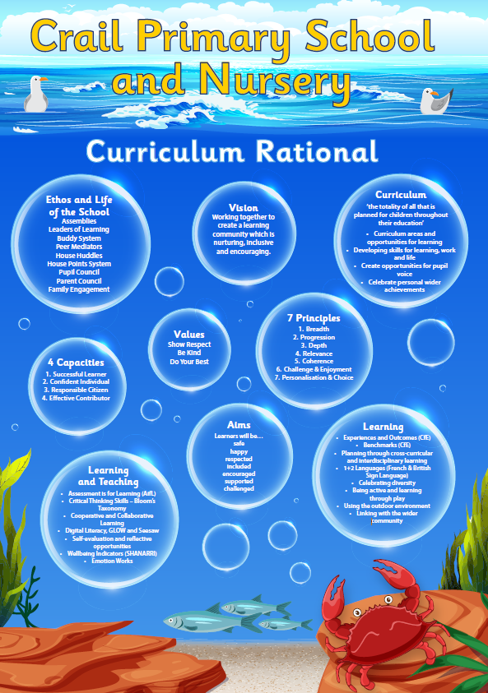

At Crail Primary School we have a vision to nurture a positive ethos, which encourages all children to achieve their full potential and to develop as successful learners, confident individuals, responsible citizens and effective contributors. We strive to build strong partnerships with all our parents and create equal opportunities for staff, pupils and families to get involved in the life of the school.

Our school values will be realised through the fostering of mutual respect and tolerance, while celebrating the diverse background of our staff, pupils and families. We will endeavour to involve staff, pupils and families in our equality processes to encourage participation in our decision-making procedures. This policy also recognises the inequality that can result from poverty and neglect. At (school name), all staff will work towards recognising the barriers to learning and participation that this can cause and work collaboratively with families, carers and pupils to build support networks and procedures.

Leadership and Professional Learning

In order to nurture an ethos that values equality and diversity in our school, it is imperative that the responsibility is recognised among all members of staff. In order to achieve equality and fairness it is vital that staff at all levels are aware of barriers to learning and participation pupils and families face as a result of prejudice and discrimination and how to effectively combat this. It is also important to realise that members of staff can also face prejudice and discrimination based on one or more protected characteristics.

Our commitment:
• To recognise that to treat someone or a group of people unfairly as a result of prejudice or discrimination infringes on their human rights.
• To ensure all members of staff complete equality and diversity training on an annual basis.
• To encourage GTCS registered members to focus on the standards of social justice as well as in other areas.
• To promote opportunities to engage in Equality and Diversity based professional learning, in order to build knowledge and skills to implement these values in the classroom.
• To encourage contribution from colleagues, pupils and families with protected characteristics in the development of professional learning materials.
• To take on board feedback from staff, pupils and families on an annual basis, in line with HGIOS, in assessing our performance on equality matters.
• Our school management will take on full responsibility for ensuring the implementation and review of this equalities policy.

Curriculum reform
In order to ensure that the curriculum and learning experiences we offer to our pupils encourage equality and diversity, we must review the topics we teach and how they are taught. This involves reviewing the diverse nature of our topics.

Questions to ask:
• Do topics at all stages, represent the diverse make up of Scotland’s society in the 21st century?
• Are the historical topics we teach from the perspective of one dominant group or region of the world?
• Do we represent cultures and languages in our teaching and school in a manner that encourages harmful stereotypes?
• How do we represent the views and experiences of those people or groups who identify with the protected characteristics set out in the Equality Act?

Our commitment:
• Continue to use an Equalities calendar to highlight local and global events, however, inclusion of these through inter-disciplinary learning approaches instead of through stand-alone lessons, should be encouraged.
• Encourage the adoption of inter-disciplinary learning approaches that incorporate diverse resources, stories, examples and individuals from around the world and throughout history across the curriculum.
• Aim to move away from only representing cultures through the lens of RME.

For example:
- Teaching tessellation in Maths through Islamic geometry.
- Using foods from different parts of the world when learning about the food plate and food categories in HWB.
- Comparing great empires such as the Romans to the contributions of the Persians who lived at the same time in Social Studies.
- When studying different patterns in Art and Design, incorporate traditional patterns from about the world.
- Widening knowledge of WWI and II by inclusion of colonised armies.

• Review our use of texts and aim to diversify our classroom libraries and novel studies to include books by authors from diverse backgrounds, and main characters who are also multicultural, disabled or belong to the LGBT community.
• Include the voices and lived experiences of our pupils and families when planning and resourcing for topics or lessons to include relevance and a wider perspective of knowledge in our teaching and learning.

Parental Engagement

It is a challenge for any school to achieve 100% participation and engagement from families. However, at (school name) we will do our very best to ensure that we include the beliefs and opinions of our families when shaping our school’s policies and procedures.

Our Commitment:
• To work as a whole staff team to understand the barriers parents and carers may face in engaging with us.
• To endeavour to work with families to break down barriers to engagement and support them in increasing their participation in our school life.
• To work with our Parent Council to support them to increase representation of families belonging to any of the protected characteristics.
• To keep improving our methods of communication with parents, ensuring families from different backgrounds or protected characteristics such as disabilities, are able to access information and approach us for support easily.
• To ensure that events we plan in school are inclusive and accessible to all, and are respectful of the beliefs and views of our families.

Reporting and management of incidents
In order to foster an environment within which staff, pupils and families feel safe and respected, we must ensure that we recognise and manage incidents around equality-based discrimination effectively.

Our commitment:
• To develop an understanding of the difference between bullying and equality-based discrimination by offering learning opportunities for staff at all levels.
• To offer similar teaching and learning opportunities to pupils to develop their ability to recognise prejudice and discrimination and the harms associated with both.
• To maintain a separate database for recording of incidents around equality-based discrimination.
• To develop a process of restorative discussion and learning required to address equality-based discrimination.
• To review our reporting and management processes of equality-based discrimination on an annual basis.

Guidance on language of equalities
Equality based discrimination may occur directly or indirectly and may be intentional or unintentional. It is important to understand the terms associated within an equality
framework to help combat prejudice and discrimination.

Intersectionality refers to the oppression and discrimination resulting from the
overlap of an individual’s various social identities.
Direct discrimination is when someone is treated less favourably because of one of the protected characteristics set out above. An example of direct discrimination would be refusing to employ a woman because she is pregnant.

Indirect discrimination is where someone is disadvantaged by an unjustified provision, criterion or practice that also puts other people with the same protected characteristic at a particular disadvantage.

Associative discrimination is where someone is directly discriminated against or harassed for association with another person who has a protected characteristic.

Perceptive discrimination is where someone is directly discriminated against or harassed based on a perception that they have a particular protected characteristic when they do not in fact have that characteristic.

Bias is a prejudice in favour of or against one thing, person, or group compared with another usually in a way that is considered to be unfair. Bias is not limited to ethnicity alone and can be towards a social group or members with any of the protected characteristics.

Conscious bias is also known as explicit bias.

Unconscious biases (also known as implicit bias) are social stereotypes about certain groups of people that individuals form outside their own conscious awareness. Everyone holds unconscious beliefs about various social and identity groups, and these biases stem from one’s tendency to organize social worlds by categorizing.

Harassment is unwanted conduct that has the purpose or effect of violating a person’s dignity, or creating an intimidating, hostile, degrading, humiliating or offensive environment for them.

Victimisation is the less favourable treatment of someone who has raised or supported a complaint or raised a grievance on the grounds of discrimination or harassment or because they are suspected of doing so.

Incident Reporting

In the first instance, all incidents should be reported to our Child Protection or Depute Child Protection Co-ordinators (please see contact details below). Incidents will then be logged centrally and follow-up actions will be taken where necessary.

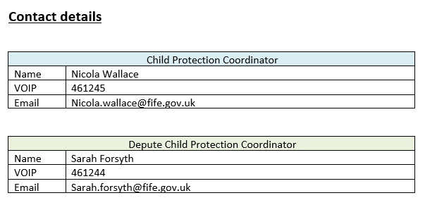

References and further reading

The Equality Act 2010 - https://www.legislation.gov.uk/ukpga/2010/15/contents
GTCS Refreshed Standards 2021: Standards for CLPL - http://www.gtcs.org.uk/web/FILES/Professional-Standards2021/2021-Standard-forCareer-Long-ProfessionalLearning.pdf
Standards for Middle Leadership - http://www.gtcs.org.uk/web/FILES/Professional-Standards2021/2021-Standard-for-Middle-Leadership.pdf
Standards for Headship - http://www.gtcs.org.uk/web/FILES/ProfessionalStandards2021/2021-Standard-for-Headship.pdf
Scottish Government Vision 2030+ - https://education.gov.scot/media/ulodcmfl/res1-vision-2030.pdf
TIE Campaign and Resources for schools - https://www.tie.scot/
Global Citizenship Education Scotland -https://blogs.glowscotland.org.uk/gc/globalcitizenshiped/
An Antiracist Critical Thinking Model - https://blogs.glowscotland.org.uk/gc/globalcitizenshiped/anti racist-critical-thinking/ The Antiracist Educator - https://www.theantiracisteducator.com/ Engender https://www.engender.org.uk/

