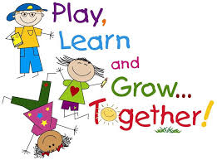
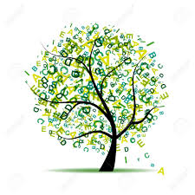
Sharing the Learning

Term:  4 | ClassP2: | Teacher:Mrs Jarrett  and Mrs Scott

Learning can take place through a number of contexts. These include ethos & whole school life (e.g. assemblies, fundraisers, Scottish book week, pupil council, buddies), wider achievement (e.g. pupils sharing a skill or knowledge, visitors, hobbies, pupil presentations, pupil council) CfE experiences & outcomes (curricular subjects) Interdisciplinary learning (where a few curricular areas link together e.g.STEM designing & making a pair of binoculars within a ‘space’ topic. (global citizenship, learning for sustainability, enterprise, financial education, outdoor education and developing the young workforce are delivered across all learning contexts).
Below are the main (not all) learning outcomes for this term.

;./

Learning contexts | Experiences & outcomes
Whole school life | P7 Leavers Assembly.  Sports Day.
Outdoor learning | RSPB Bronze Challenge.  Minibeasts topic.
Wider achievement | RSPB Bronze Challenge.  Leavers Assembly performance.
Interdisciplinary learning | Thinglink and Lumio- Digital Literacy.
Curriculum subject areas | Experiences & outcomes
Literacy  Reading  Writing  Listening & Talking | Reading  - I can read my reading books with confidence, fluency and expression.  - I can read books from the class library with a growing confidence.  - I can count syllables in words.  - I can read and generate lists of rhyming words.  Writing  - I can use end consonant blends such as sh/ th in my spelling.  - I can spell common words.  - I can write a set of instructions.  - I can write about the process of honey making.  - I can use punctuation including speech marks to create sentences.  Talking and Listening  - I can talk about written and digital texts.  - I can listen and answer/ask questions on a text.
Numeracy | Money  - I can identify all coins and notes to £5.  - I can name all coins and notes to £5.  - I can use coins and notes up to £5 to pay for items.  - I can work out change within £5.  - I can use £ and p notation when using money.
Health & well-being | Tennis  - I can copy the correct grip for a racket;  - I can balance a beanbag on a racket;  - I can hit a beanbag forwards towards a target.  Football  - I can keep control of a ball.  - I can dribble with various parts of my feet.  - I can pass to a team mate.  - I can shoot with accuracy.
Science | Our topic is: Minibeasts  - I can identify and name a range of minibeasts, and can talk about their characteristics.  - I can help to plant seeds/plants in our school grounds.  - I can make a minibeast environment using wood, leaves, mud and other den-making materials.
French | - I can say my name and age.  - I can say where I live.  - I can talk about pets.
Music | I can design a garden sound map.  I can enjoy performing at the P7 Leavers Assembly.

