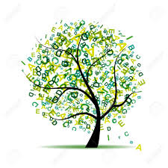
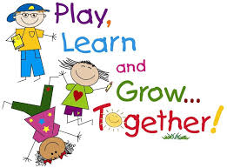
Sharing the Learning

Term:  4 | ClassP1: | Teacher:Mrs Jarrett  and Mrs Scott

Learning can take place through a number of contexts. These include ethos & whole school life (e.g. assemblies, fundraisers, Scottish book week, pupil council, buddies), wider achievement (e.g. pupils sharing a skill or knowledge, visitors, hobbies, pupil presentations, pupil council) CfE experiences & outcomes (curricular subjects) Interdisciplinary learning (where a few curricular areas link together e.g.STEM designing & making a pair of binoculars within a ‘space’ topic. (global citizenship, learning for sustainability, enterprise, financial education, outdoor education and developing the young workforce are delivered across all learning contexts).
Below are the main (not all) learning outcomes for this term.

Learning contexts | Experiences & outcomes
Whole school life | P7 Leavers Assembly.  Sports Day.
Outdoor learning | RSPB Bronze Challenge.  Minibeasts topic.
Wider achievement | RSPB Bronze Challenge.  Leavers Assembly performance.
Interdisciplinary learning | Thinglink and Lumio- Digital Literacy.
Curriculum subject areas | Experiences & outcomes
Literacy  Reading  Writing  Listening & Talking | Reading  - I can count syllables in words.  - I can read and generate lists of rhyming words.  Writing  - I can use consonant blends such as bl, cl, sl, pl tr, pr in my spelling.  - I can write a set of instructions.  - I can write about the process of honey making.  - I can use basic punctuation to create sentences.  Talking and Listening  - I can talk about written and digital texts.  - I can listen and answer/ask questions on a text.
Numeracy | Money  - I can find and name coins to at least 20p.  - I can put out amounts to 10p using 1p coins.  - I can make amounts to 5p using concreate materials or pictures.  - I can make amounts to 10p using concrete materials or pictures.  - Select 1p, 2p, 5p, 10p, 20p coins to buy things.  Numbers to 20  - I can read, write, count, order and lay out numbers to 20.
Health & well-being | Tennis  - I can copy the correct grip for a racket;  - I can balance a beanbag on a racket;  - I can hit a beanbag forwards towards a target.  Football  - I can keep control of a ball.  - I can dribble with various parts of my feet.  - I can pass to a team mate.  - I can shoot with accuracy.
Science | Our topic is: Minibeasts  - I can identify and name a range of minibeasts, and can talk about their characteristics.  - I can help to plant seeds/plants in our school grounds.  - I can make a minibeast environment using wood, leaves, mud and other den-making materials.
French | - I can say my name and age.  - I can say where I live.  - I can talk about pets.
Music | I can design a garden sound map.  I can enjoy performing at the P7 Leavers Assembly.

