
Ceres Primary School
St Andrews Road
Ceres
Fife
KY15 5NJ
Tel 01334 659454
ceresps.enquiries@fife.gov.uk

Site Traffic Management Plan

February 2020
(Next review date September 2020)

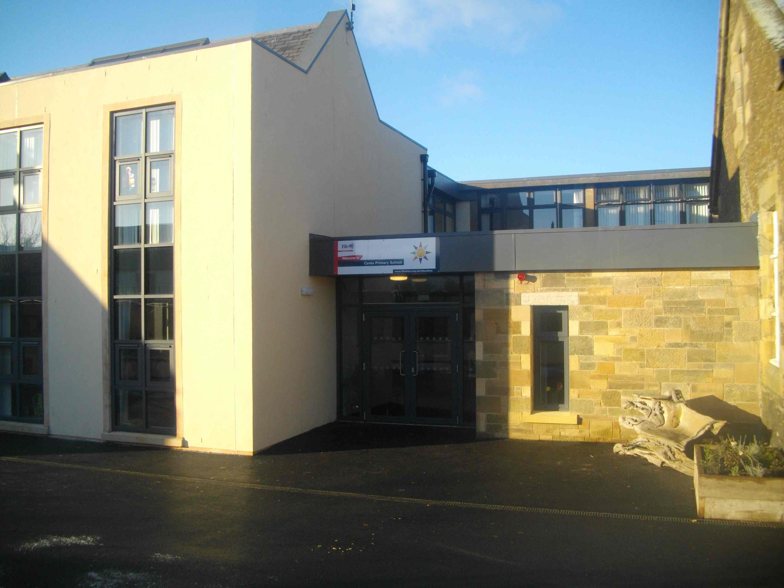

Contents

Section

- Introduction
- Layout / Access
- Pedestrians
- Pupils / Students
- Staff
- Visitors
- Servicing / Deliveries
- School Buses
- Contract Hire Services
- Disabled Access
- Out with the School Grounds
- Management Practices
Appendix A

1. Introduction

This document has been prepared to inform and instruct employees, pupils, parents and others who come onto the site, including visitors (both pedestrians and people in vehicles), about the site rules concerning pedestrian and vehicle separation.

Ceres Primary School takes the health and safety of all site users very seriously. It is therefore, imperative that individuals take care, exercise caution when in the school grounds or within the vicinity of the school grounds and follow instructions to avoid risk of injury. If there are any concerns about traffic safety, they should be reported to the school management team.

We urge all site users to read this document carefully and act in accordance with the instructions contained therein. The instructions constitute site rules. Pupils in breach of the site rules may be subject to disciplinary action.

Copies of this document have been shared with school staff, pupils, parents and carers. Copies are also available from reception. The document will be reviewed annually and awareness raised regularly through parental events, pupil sub-groups, assemblies and school meetings.

For further information, please contact:

Angela McCallion, Business Manager on 08451 55 55 55 + ext. 496708 or angela.mccallion@fife.gov.uk
Fiona Hynes, Headteacher on 08451 55 55 55 + ext 450951 or ceresps.headteacher@fife.gov.uk

2. School Layout / Access
School Crossing Patrol
Staff car park and disabled bay only
Bus Bay

Pedestrian access
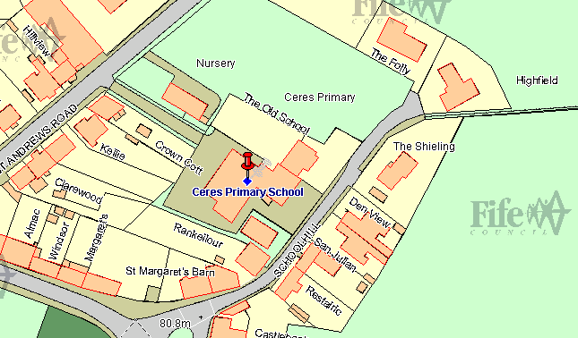

Main school entrance no access for vehicles
Residential Area – No Parking

3. Pedestrians

There is pedestrian access from St Andrews Road and at Schoolhill which is the main entrance.

Pupils must cross St Andrews Road using the manned crossing patrol when in operation. This should be used by both parents and pupils.

Designated Entry Points

Pedestrians should follow the footpath from St Andrews Road past the nursery taking care not to spill into the road and avoid staff vehicle parking. Pedestrians can also enter via Schoolhill. This has no access for vehicles. Entry into the school building is through a set of double doors at the front of the school.

4. Pupils

It is very important that pupils set a good example to others, particularly in the spirit of being a safe school. There are a number of site related areas pupils should be aware of:
- Pupils should be particularly aware that entry into the school ground via vehicular access points (school car park and the service area) is strictly forbidden. Whilst this may seem a quick way into the school, it is a breach of the site rules and compromises personal safety and the safety of others.
- Pupils found to be climbing over railings or walls, not following staff instructions in relation to the site, or not adhering to the contents of this plan will be in breach of the site rules and may be subject to disciplinary action.
- Parents and pupils are discouraged in the interest of Health & Safety from congregating around the main gate area. This is to ensure that children can leave the premises safely.
- Pupils must not walk on the roads around or near the school when leaving or entering the premises and take great care around the bus bay.
- Children arriving at school on bike or scooter transport are asked to stop at the main gate and enter the premises on foot at all times in the interest of all site users. They should then park their transport in the designated area at the side of the nursery accommodation.

Drop Off
There is no designated on site drop off for pupils. No vehicle should be accessing the car park for this purpose, without permission.

5. Staff

There is a main staff car park within the school grounds to the rear of the school which also has a disabled parking bay.

Staff are expected to act responsibly on the site when parking and accessing the school building. If you are aware of unauthorised use of parking bays, this should be reported via the school receptionist or to the school’s Headteacher who will inform/remind the offending driver of the correct use of the site. It would be helpful if staff could supply the school with their registration number so that you can be contacted if there is a need to do so. Staff should not park in the turning circle.

6. Visitors

There is no visitor parking in the school grounds at any time.

Alternative street parking is available in the surrounding area on St Andrews Road only, but if you are unfamiliar with the area, please make sure that you do not block residential driveways or park where this could cause an obstruction. There is a local car park within easy walking distance. We would strongly discourage any parking or dropping off/collecting on Schoolhill. This is a narrow residential road and you must be aware that children and parents will be exiting and entering here. The Education Department cannot take any responsibility for the safety of any vehicles in this residential area.

Access into the school is only permitted from the main entrance on Schoolhill. All visitors must report to reception and sign in before going anywhere in the school. On departure, visitors should sign out at reception and leave the building by the main entrance door.

If visitors need any advice on access or parking before their visit, please call the school reception on 01334 659454.

7. Servicing / Deliveries

Drivers of service vehicles (if they have not been on the site before or obtained instruction in advance) should report to the reception desk in the main building to advise the nature of their visit and get clarification on where they can park. Drivers may be issued with a copy of this plan for reference or simply be advised of the site rules in relation to the area they are parking in at the time.

Where the contractor is on site to carry out works by prior arrangement, please call the school reception on 01334 659454 in advance to agree the most suitable parking location.

Drivers should be aware that they are working in a school environment - exercise extreme caution and be vigilant when carrying out vehicle manoeuvres in any part of the school grounds.

8. School Buses

Buses that collect mainstream pupils should park on St Andrews Road in the allocated bus bay.

The bus should be at a complete stop before allowing pupils to get on or off - with the engine switched off. Only when pupils are clear of the vicinity or all on board, should drivers begin the journey.

Pupils are reminded about good conduct around the bus park in section 4 of this plan, however if there are any other concerns about how this is being managed, they should be raised with the Headteacher.

9. Contract Hire Services

Contracted vehicle drivers (including taxis and minibuses) will have specific instructions given to them through Transportation & Environmental Services as part of the terms of the contract. However there are some specific comments to make in relation to the site at Ceres.

Taxis for mainstream pupils

These vehicles should park on St Andrews Road as near to the pedestrian gate as possible.

- Contracted vehicles should limit the use of any reverse movements. These should only be carried out where there is ample space to do so, where there are no adults or pupils in the vicinity.

- Pupils who are transported by contracted vehicles should be dis/embarked on the pavement side only. No pupil should be on the concourse at any time. No driver should allow exit or entry from/into the vehicle if not within the drop off zone.

10. Disabled Access

Disabled access is primarily via the main front entrance. This can be accessed from St Andrews Road using the school pedestrian access and circle the school to the main entrance.

Parking
There is 1 disabled parking bay within the staff car park.

If visitors, staff or pupils require information on access or any other considerations, they should contact the school reception in the first instance on 01334 659454.

11. Outwith the School Grounds

The school accepts that parking near the school is not easy. St Andrews Road and Schoolhill are residential streets, used by Service buses as well as car traffic into and out of the surrounding area. It is important that the school is a good neighbour to local residents. Parents/Carers are encouraged not to park near the school and allow their children to walk the remaining distance if they drop them off further away.

Parking indiscriminately, such as mounting pavements, double parking, stopping on any yellow lines, obstructing access points to streets and driveways and parking near junctions causes danger to pupils and other road users. Accidents can arise if views are obstructed or pedestrians have to negotiate between parked vehicles. In addition, the roads can become congested which results in frustration and delays to services and ongoing journeys. Visitors should take care parking on St Andrews Road especially where the pedestrian path stops at the perimeter of Ceres.

Please act responsibly by parking if possible in the town car park which is only a short walk from the school. This will keep the pupils at Ceres Primary School, local residents and other road users safe.

12. Management Practices

Key to the ongoing monitoring of the plan is the role of Headteacher and other staff. All staff have a responsibility to make sure that they are acting in such a way as to not compromise the health and safety of themselves or others.

Supervision

The Headteacher will spot check access to the school. Janitorial staff will be providing limited monitoring of the access to the school. High visibility waistcoats will be worn when carrying out this duty.

Monitoring of compliance against this plan

The Headteacher will spot check access to the school. Where issues arise with vehicular access, taxi, minibus and bus drivers and staffing, these will be dealt with or escalated by the school Business Manager. The Headteacher will be responsible for addressing the conduct of all pupils where this is not consistent with the requirements of this plan.

Non-compliance

If there are concerns or incidents that constitute non-compliance these will be recorded on the form by those monitoring the site and appropriate action will be taken. This includes possible disciplinary action and reports going to Contractor or Service management which may result in investigative action. On days where there is no monitoring carried out and there is an instance of non compliance, these should be escalated immediately to the Headteacher who will make a record on the form and take appropriate action.
Appendix A

Traffic Management Plan
Weekly Site Monitoring Form

Completed by: Headteacher

Date | Area | Observations | Incidents | Signed by

