Castlehill Primary School

Anti-Bullying Policy



**August 2023**

**Policy Rationale**

At Castlehill Primary School we are committed to providing a caring, friendly and safe environment for all of our pupils so they can learn in a relaxed and secure atmosphere. Bullying of any kind is unacceptable at our school. If bullying does occur, all those involved should be able to tell and know that incidents will be dealt with promptly and effectively.

In Castlehill Primary School we have created our vision and values with the school community, staff, pupils and parents and this underpins our school ethos.

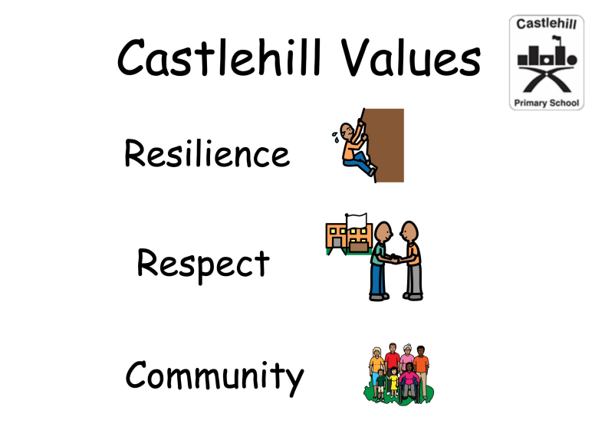

We adhere to guidance from the Scottish Government and Fife Council in relation to the development of positive relationships, behaviour and anti-bullying. Our policy details how incidences of bullying will be dealt with and should be implemented alongside our Relationships, Respect and Behaviours Policy.

At Castlehill Primary we believe that bullying in any form is unacceptable. We ensure that we have staff, trained by respectMe Scotland’s national anti-bullying agency, who pass their knowledge and skills on to other adults and pupils in our school.

**Aims of Policy**

* To create an ethos which values, respects and protects the right for each member to be within a friendly, safe environment.
* To develop, through example, practice and curricular activities, attitudes and skills which will prevent bullying and promote positive relationships, behaviour and self-regulation strategies.
* To encourage pupils and adults look after each other and know that all staff will listen and act on concerns.
* To foster active parental support.
* To follow the guidance laid down in our *Anti Bullying Policy and the Relationships, respect and Behaviour Policy.*

# What is bullying?

Bullying is the wilful, conscious desire to hurt, threaten or frighten someone. It can be physical or verbal in nature resulting in physical assault or verbal abuse, face to face or virtually. It can also include intimidation and extortion.

Bullying can be emotional, physical, verbal, carried out in person or via social media or through other forms of technology. Prejudice based bullying can include discriminatory behaviours that focus negatively on protected characteristics in the Equality Act 2010 as well as other characteristics including;

* Additional support needs
* Age
* Asylum seekers and refugees, racism
* Body image and physical appearance
* Disability
* Gender, Gender Identity, sexism, sexual orientation
* Gypsy/ Travellers,
* Looked after Children
* Religion and belief, sectarianism

**The Role of the School**

At Castlehill Primary we will ensure that awareness of bullying is raised through the curriculum. This will be addressed within our Health & Wellbeing curriculum, through assemblies and through our school values and ethos created by all in our school.

Within the curriculum pupils will be encouraged to develop strategies to deal with incidents of bullying through the Health and Welllbeing education and class/school discussions.

All pupils will be made aware of the support available to them if they are a victim of bullying.

Bullying incidents will be dealt with promptly and recorded on Seemis (the school management information system).

Castlehill Primary School’s Anti – Bullying Policy is available on our website.

**The Role of Parents & Guardians**

We ask that school is made aware of any incident of bullying reported by a child to their parent or guardian. Prompt notification to the school will enable immediate action to be taken to prevent the situation escalating.

**Identification of Incidents of Bullying**

A child may indicate by signs or behaviour that he or she is being bullied. It is important to be aware of these possible signs and take investigative action if your child:

* is frightened of walking to or from school
* changes their usual routine
* is unwilling to go to school (school phobic)
* begins to truant
* becomes withdrawn anxious, or lacking in confidence
* starts stammering
* cries themselves to sleep at night or has nightmares
* feels ill in the morning
* begins to do poorly in school work
* comes home with clothes torn or books damaged
* has possessions which are damaged or " go missing"
* asks for money or starts stealing money (to pay bully)
* has dinner or other monies continually "lost"
* has unexplained cuts or bruises
* becomes aggressive, disruptive or unreasonable
* is bullying other children or siblings
* stops eating
* is frightened to say what's wrong
* gives improbable excuses for any of the above
* is afraid to use the internet or mobile phone
* is nervous & jumpy when a cyber message is received

These signs and behaviours could indicate other problems, but bullying should be considered a possibility and should be investigated. Any concerns should be referred immediately to the school.

**Dealing with Referrals**

All referrals of bullying are noted on an incident form and logged in SEEMIS so that repetitive patterns, even if over an extended period of time, can be identified, tracked and tackled.

Upon referral, incidents of bullying may be dealt with on several levels depending on the nature of the incident in question.

The school adopts a restorative approach to promoting positive and respectful behaviours and actions.

A member of the Senior Leadership Team will meet with the pupil and their parents to discuss the bullying incident and to plan a way forward.



Appendix Fife Council Anti-Bullying Guidance

## Anti-bullying



We are committed to providing a safe and caring learning environment for all children and young people.  Bullying in any form is unacceptable and we have taken the following actions to ensure that all children feel safe and free from bullying or the threat of bullying.

* Working with respectMe, Scotland’s national anti-bullying agency, we have reviewed our Anti-bullying policy, building on work which has been ongoing in Fife and elsewhere for several years. As part of this policy we have a number of teachers who are trained anti-bullying trainers, who pass their knowledge and skills on to other teachers. Our schools are also required to log any instances of bullying and this information is reviewed regularly by Education Service Management.
* Every school in Fife is required to develop and maintain their own anti-bullying policy. This is developed in conjunction with children and parents, and is reviewed reqularly. Central to every policy is a commitment to encouraging children to be confident about approaching an adult if they feel they are being bullied, knowing that their concerns will be taken seriously. You can download your school’s anti-bullying policy from their website.
* On rare occasions when bullying does occur our key priorities are to make sure that the child who has been bullied feels safe and protected.  Our aim is to resolve the situation in a way that minimizes the chance of any recurrence. Schools apply restorative approaches in situations like this, by ensuring the child who has bullied realises the negative impact of their behaviour and understands that bullying is unacceptable and will not be tolerated.  We firmly believe that this approach helps children to change their behaviour and reduce the risk of them bullying in the future.
* Underpinning our commitment to anti-bullying is a range of measures and approaches to ensure that bullying is unlikely to occur in the first place. These are outlined in our Relationships and Behaviour Strategy, which is designed to support the development of positive behaviour and relationships in all schools. We know that when children feel safe and happy they enjoy school more and learn more effectively. The Relationships and Behaviour Strategy aims to achieve this, and to reduce the likelihood of any bullying occurring.