Castlehill Primary School
Approach to Respect and Positive Behaviour

August 2023

At Castlehill Primary School we are committed to providing a caring, friendly and safe environment for all so everyone can learn in a relaxed and secure atmosphere.

In Castlehill Primary School we have created our vision and values with the school community, staff, pupils and parents and this underpins our school ethos.

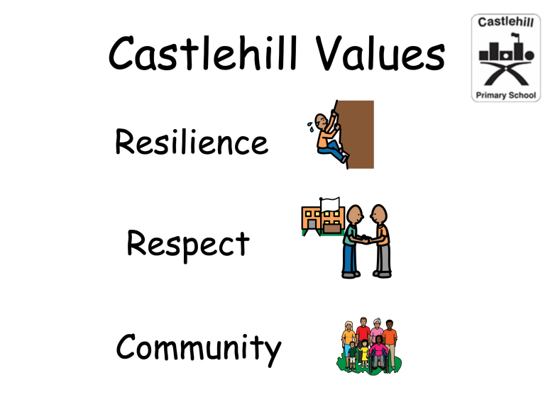
Our school ethos is one where everyone is included and, valued and respected.

We have 3 school rules;
- Be kind and caring
- Show respect
- Make safe choices

When you walk round our school you will see,
- Children and adults using a respectful tone of voice and encouraging each other to always try their best
- Children engaged in learning that is well planned to meet their needs so they feel challenged and supported to learn
- Adults and children valuing the learning that comes from making mistakes
- Positive language that praises effort and application
- Clear and purposeful learning
- Classes walking quietly in the corridor led by an adult
- Children moving round the school sensibly and quietly
- Children changing quietly in the changing rooms
- Children respecting property and looking after the school building and grounds
- Children walking into assembly, the dinner hall and other busy areas quietly and respectfully
- Everyone keeping the school tidy and clutter free
- All pupils respecting playground staff

Sometimes it is necessary to remind ourselves and each other about positive choices and to be kind and respectful. This is ok. Everyone makes mistakes.

Sometimes it is necessary for a member of the Leadership Team to remind a pupil about our school expectations.

If this happens often or behaviour is harmful or discriminatory parents or carers will be informed or invited to a meeting to discuss a way forward.

We celebrate successes and achievements everyday at Castlehill. Class and individual effort will be recognised and celebrated daily and via home and school communications.

