Bell Baxter High School Cluster

School: Castlehill PS

Teaching, Learning and Assessment Policy

Created: September 2022

Introduction and Rationale
This policy has been developed with all cluster schools in mind considering HGIOS 4 themes of Quality Indicator 2.3 - Teaching, Learning and Assessment. It aims to promote a common understanding of what constitutes effective practice and guide and support staff, ensuring that all staff offer the highest quality learning experience, tailored to the needs of their pupils.
Theme 1 - Learning and Engagement
In Engaging Learners (2012), Griffith and Burns refer to engagement as, “The class enjoying and being absorbed in the challenge of their learning and through that engagement making observable progress.” They further note that, “Without engagement nothing else is possible.” They believe that engagement is the starting point for all learning therefore, the way in which we engage pupils in learning is crucial in the teaching, learning and assessment cycle.

What Makes an Effective Learning Environment?
In the Bell Baxter cluster we use the CIRCLE framework as a toolkit for staff to ensure we provide learners with nurturing and inclusive learning environments. All learners are influenced by the physical environment, the people around them, how they feel about themselves and their interest in the tasks they have been asked to do. Circle (2015) https://education.gov.scot/media/szlogrpf/circle-primary-resource-int.pd
Learners experiences should be appropriately challenging and matched to their needs and interests. Learners should be able to exercise choice and take increasing responsibility for their learning. Staff should promote a growth mindset in all learners offering opportunities for learners to embrace challenge, demonstrate resilience and reach higher levels of achievement - see Appendix 1.
Classroom environments should both support and enrich the learning of all children. As well as being enabling and welcoming, the classroom environment should be a learning tool, a way of engaging children and building the class community. It should create a sense of ownership and be used to support and promote learning as well as celebrating children’s work/success. With thought and planning, an effective classroom environment is used as an interactive resource supporting teaching, learning and assessment. Our learning environments should be organised, resource rich, learning focused, inclusive (see CIRCLE document) and child centred in order to engage our children in the learning process from the outset.

Displays should be used to teach and inspire. Working walls show learning, differentiation, examples of pupil attainment, should be print rich and should clearly document the learning journey that a class is on. To engage they need to be visible so children can interact with them; at times children may take complete ownership of them. The ideal height for any working wall or teaching display is child eye level although we know this isn’t always achievable due to building layout and structure. Learning journeys will usually go in a particular order and therefore sometimes it may be important to make sure that your photos and annotations follow this order to ensure that the display makes sense.
Please also see Appendix 2 – Displays to Teach and Inspire, Working Walls for Learning Journeys

Theme 2 - Quality of Teaching
Level 5 illustration from HGIOS 4
‘Our teaching is underpinned by our shared school vision and values. We use a wide range of learning environments and creative teaching approaches. Learning is enriched and supported by our effective use of digital technologies. Our explanations and instructions are clear. We use skilled questioning and engagement to promote curiosity, independence and confidence and to regularly enable higher-order thinking skills in all learners. We observe learners closely to inform appropriate and well-timed interventions and future learning. We use feedback effectively to inform and support progress in learning.’
Teaching and Learning – 4 Part Lesson Model
In school we use the 4-part model to deliver all curricular lessons. The 4-part model is taken from “Visible Learning for Teachers” by John Hattie. It is designed to ensure consistency of teaching and learning across the school and implement a progressive 4-part model ethos for every child. The 4 Part Model allows children clear understanding about the skills they are practising and gives them a clear outline when discussing their learning.
Part 1 – Review, illicit, explain and share
Review previous learning with the children!
Explain and display learning intentions and involve the children in setting success criteria. Revisit and check these in part 4.
Part 2 – Direct teaching input
Direct teaching or shared learning activities referring to success criteria throughout.
Part 3 – Activities and Assessment
Activities using rotation where appropriate (with a balance across the week of Make-Say-Write-Do), assessment including AifL strategies (balance of teacher, self and peer assessment), some recording of assessment notes.
Part 4 – Review, assess, next steps
Review learning, check against learning intentions and success criteria. Decide on next steps in learning. Involve children in whole process. Update assessment notes if appropriate.

Differentiation and Meeting Learners’ Needs
All children learn in different ways and some pupils have barriers to their learning. We take measures to identify and support children with additional needs so they can maximise their potential, whilst also challenging and extending learners. We aim to meet the needs of all learners through careful planning and ongoing assessment.
Differentiated learning involves adapting learning, teaching and assessment to meet the learning needs of individual children and maximise progress. There is not one set way to differentiate; different methods of differentiation may suit different learning needs. For more information on the different ways we can differentiate and meet learners’ needs please see Appendix 3.
Pupils who have an additional support need should have a learner profile which will help staff to fully understand how to best support that pupil and will have strategies clearly identified.
The aforementioned Circle Framework provides ideas of good practice and strategies for improving the participation, acceptance and achievement of learners who have additional support needs and introduces the importance of considering inclusion in terms of 4 main areas:
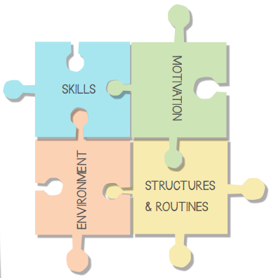
ICT to Support and Enhance Learning
ICT should exist at the core of our school providing a range of technologies and capabilities and the creativity for transformative, lifelong learning in the classroom, across the school and in the community. Digital skills for developing the young workforce and skills for everyday life in a modern world are essential. The revised Fife technologies curriculum is a great opportunity to pave the way for a new and exciting computing curriculum allowing better life chances and learning experiences for our young learners.
In order to best prepare our learners for success in tomorrow’s rapidly evolving and digital world, ICT should be routinely and effectively embedded in all aspects of learning and teaching and learners and staff should have personal access to ICT whenever and wherever it benefits learning and teaching.
We aim to:-
- Provide access to up-to-date, authentic information from a huge variety of sources
- Personalise and transform learning and teaching using a wide range of digital tools
- Extend learning, collaborate and publish beyond the classroom
- Develop the learning, thinking and digital literacy skills vital for success in today’s rapidly evolving, technology rich society
- Ensure our pupils develop safe and responsible attitudes relating to technology and understand the risks and responsibilities associated with using ICT and how to access help if things go wrong
- Ensure pupils who require access to 1:1 devices will have access to ICT whenever and wherever it is beneficial to support learning in school and at home
- Make effective use of online learning resources and tools and a wide range of ICT applications to demonstrate and improve learning across the whole curriculum
- Have all families agree to a code of conduct for the use of ICT within the school
- Raise the achievement of all pupils through the development of ICT and the effective deployment of a range of stimulating and creative technologies for learning across the whole curriculum and age range
- Continue to improve staff ICT capabilities through continued professional development
- Ensure parents can access information about the life and work of the school via the school website, Seesaw or equivalent
- Work in partnership with parents to support learning at home and school as well as upskilling parent’s ICT skills
Playful Pedagogy
“Play is the universal language of childhood, it is an activity which exists for its own sake but also has a fundamental role. Children’s play is crucial to Scotland’s wellbeing; socially, economically and environmentally. Our people are our greatest resource and the early years of life set the pattern for children’s future development.” (Scotland’s Play Strategy, 2013)
In Fife we promote a playful pedagogy approach and teachers should consider this when planning learning experiences for children of all ages. More information and guidance can be found in Appendix 4.
Outdoor Learning
Why?
Curriculum for Excellence offers opportunities for all children and young people to enjoy first-hand experience outdoors. Such experiences motivate our children and young people to become successful learners and to develop as healthy, confident, enterprising and responsible citizens.
Being outdoors and active is a vital part of growing up and living a healthy and fulfilled life. Outdoor learning benefits children, young people and adults alike. It engages our hearts through what we feel and the emotions we experience; our heads through what we think, see and say, and our hands through our physical experiences including how we move through the space the outdoors provides.
Well-constructed and well-planned outdoor learning helps develop the skills of enquiry, critical thinking and reflection. It provides opportunities for children to take risks and develop resilience and to build the skills necessary for our children and young people to meet the social, economic and environmental challenges of life in the 21st century.
The outdoor environment also encourages staff, pupils and parents/carers to see each other in a different light, building positive relationships and improving self-awareness and understanding of others.
Where?
Outdoor learning can happen anywhere – staff should plan for all children to engage in regular outdoor learning experiences, within our school grounds, local community and further afield. The learning potential of our playgrounds can be enhanced by the inclusion of ‘loose parts play’ resources, carefully assessed risk-taking and relevant training for all staff.
How?
Outdoor learning can introduce or embed taught skills and concepts in an engaging and motivating way. There should be a progression of skills and experiences across the school.
Fife’s outdoor learning progression ‘Natural Connections’ and the John Muir Award are examples of vehicles for meeting some of the skills and expectations of outdoor learning. Use of partners is an important aspect of outdoor learning e.g. the ranger service, RSPB, local businesses and services, museums, historic sights etc.
Partnerships with other educational settings and organisations enable schools to offer our older children enhanced outdoor education experiences e.g. Ardroy, Fife Outdoor learning team.
The following links may be helpful in planning for outdoor learning, but staff should look for opportunities within the day to day planning of lessons to take learning outdoors.
https://glowscotland.sharepoint.com/sites/LearningOutdoorsaroundFife/SitePages/Home.aspx#?wa=wsignin1.0
https://education.gov.scot/improvement/learning-resources/a-summary-of-outdoor-learning-resources/

Theme 3 - Effective Use of Assessment
Assessment helps provide a picture of a child’s or young person's progress and achievements and identify next steps in learning. Assessment approaches must promote learner engagement and ensure appropriate support so that all learners can achieve their aspirational goals and maximise their potential. Learners should be afforded an element of choice and personalisation in showing that they have achieved the intended outcomes.
Staff are expected to use their professional knowledge to use a range of summative and formative assessment, in order to gather holistic evidence of a learner’s current level of understanding across the curriculum. Assessment is also required as part of playful pedagogy. For more detailed information about key features of high-quality assessment please refer to Appendix 5.
Assessment Calendar
An assessment calendar supports planning that ensures that learners’ progress is planned for across each academic year. Staff should have a shared understanding of the assessment calendar so that they can ensure a balance of formative and summative assessment practices to enable learners to demonstrate their understanding across the curriculum and contexts for learning.
Example – to be edited by individual schools:
 | Aug | Sep | Oct | Nov | Dec | Jan | Feb | Mar | Apr | May | Jun | Jul
N |  | ELIPS | Planning & Tracking Meetings |  |  | ELIPS |  |  |  | ELIPS | ELIPS  Reporting
P1 |  | BASE |  |  |  | Planning & Tracking Meetings
P2
P3
P4 |  |  |  |  |  |  | SNSA
P5
P6
P7 |  |  |  |  |  |  |  |  |  | SNSA

Theme 4 - Planning, Tracking and Monitoring
At ************ Primary School, we use the following Forward Planning flow chart to exemplify and support our planning, teaching and assessment processes.
Forward Planning for Excellent Teaching, Learning and Assessment at ******** Primary School

Gathering Data
Where are my children? Accessing the suggested data below will help you to understand their current knowledge, skills and attitudes.
- Check TRAMS for attainment levels and predictions
- Access recent SNSA/BASE data
- Use in class assessment – see assessment toolkit for tools which can be used
- Observe the children when they are learning
- Refer to transition notes
Planning
Now begin to plan based on the data you have. Ensure you:-
- Identify the experiences and outcomes within the learning pathways each group will work on for the identified planning block.
- Consider how you are planning to assess the children’s learning. Try to achieve a balance of assessment types – Say, Write, Make, Do
- Use your pathways to inform your day to day planning.
- Share learning intentions and create success criteria with the children based on the planned learning.
Assessment – Say, Write, Make, Do
How have the children progressed in their learning?
How do you know? How do they know?

Summative Assessment
- End of topic assessment
- Final project linked to IDL
- Independent writing
- What do they know/can do?

Formative Assessment
- Self and peer assessment
- Teacher marking/jotter evidence
- Teacher observations
- What do they need to do next?
Achieved?

YES!
Mark on the Record of Understanding and move on to the next area of learning.
No………….
Plan further learning experiences, provide additional support. Chart progress on RfU.

Tracking and Monitoring
- Each class teacher is involved in termly tracking and monitoring meetings with the SLT. This involves staff in reviewing TRAMS CfE data for each child alongside additional contextual information such as that provided by, for example internal assessments, SNSAs, BASE and jotters.
- SLT will provide additional information from Power BI when appropriate to support tracking and monitoring meetings. This will include sharing information at a class or individual level such as LAC, FSM, SIMD, ASN, Parent in Armed Forces and Young Carer status in order to identify potential attainment gaps and then plan to address these.

Wider Achievement
Planning, Tracking and Monitoring Wider Achievement
- Pupil attendance at Sports or Physical activity is recorded on SEEMIS. This information is used to identify inactive pupils. Additional planning is then undertaken to remove barriers to attendance and encourage engagement.
- At …………….. pupil attendance at non-sporting clubs is also recorded and tracked. This allows us to identify children who are not attending any physical activity or external community club. We then identify barrier and undertake intentional promotions to involve children in a school-based club.
- Pupils are encouraged to bring in examples of wider achievement from outside school for us to share at assembly and on Twitter and Facebook. This earns the children House Points.

Having explored the 4 themes of quality indicator 2.3, please refer to Appendix 6, Expectations of an Excellent Lesson.

Appendix 1 – Growth Mindset
Through numerous studies it has been shown that beliefs surrounding the brain and intelligence highly affects motivation in life and learning. When learners believe they can get smarter, they understand that effort makes them stronger. Therefore, they embrace challenge, demonstrate resilience when learning is difficult and reach higher levels of achievement.
These research findings have implications for educationalists supporting learners in educational settings.
Staff should:
1. Establish high expectations. Challenge learners appropriately so they know that they have the ability to meet those expectations.
2. Create a risk-tolerant learning zone. Provide an environment that values challenge seeking, learning, and effort above perfection (see engaging learning environments above).
3. Give honest and explicit feedback that enables the learner to engage and improve.
4. As teachers, we are honest with our feedback and we identify specific areas of strength and the key next steps.
5. Avoid praising children for their intelligence and instead focus on effort and explaining the importance of their actions towards success.
6. Explicitly teach mindset and model growth mindset strategies. Don’t just teach growth mindset- our words and actions must follow.
Features of Highly Effective Practice
The learning culture is built on positive, nurturing and appropriately challenging relationships which lead to high-quality outcomes. High aspirations for achievement are shared by children, practitioners and parents. Learners are developing a positive attitude to learning.
Examples of Growth Mindset in practice include:-
- Learners are enabled to take risks. They know and accept that mistakes are part of learning.
- Teachers use mistakes as powerful teaching points to help the learner move forward.
- There is a shared language of learning across the whole school community.
- Grouping practices are fluid and responsive. Learners have opportunities to work in mixed ability groupings.
- Learners have opportunities to learn about brain plasticity. Learners know that abilities are malleable - the brain can grow and develop through learning, challenge, practice and feedback.
- Learners receive high-quality feedback and have an accurate understanding of their progress in learning and what they need to do to improve.
- Tasks, activities and resources are effectively differentiated and provide appropriate pace and challenge for all learners.
- Learners regularly engage in challenging dialogue with others about their learning and progress and use this to set themselves clear targets in learning
There is a wealth of current literature (Clarke, Boaler, Ricci) sharing case studies from schools who have successfully implemented a growth mindset culture.

Appendix 2 - Displays to Teach and Inspire
Working walls show learning, differentiation, examples of pupil attainment, should be print rich and should clearly document the learning journey that a class is on. To engage they need to be visible so children can interact with them; at times children may take complete ownership of them. The ideal height for any working wall or teaching display is child eye level although we know this isn’t always achievable due to building layout and structure. Learning journeys will usually go in a particular order and therefore sometimes it may be important to make sure that your photos and annotations follow this order to ensure that the display makes sense.
Effective working walls which enhance engagement, learning and self-esteem include:-
o Approaches to planning the learning
o Previous knowledge and skills
o Questions
o Labels
o Examples of activities for children to engage in
o Evaluative comments
o Images of the children at work
o Examples of completed work
o A variety of print
o Links to the curriculum/benchmarks for assessment
o Links to different texts
o Children’s achievements
Displays which are created to solely celebrate children’s achievements and build their self-esteem will also make children proud of their work and should make them want to achieve more. This type of display does not just show off children’s work but gives a clear indication that the staff in the year group have a clear and thorough understanding of the age-related expectation for their children and are keen to celebrate the achievements of their class and clearly understand what their next steps may be. So this kind of display could be a gallery of children’s work but it should be contextualised with statements that give the context for learning, examples of pupil voice and thoughts on their learning and some next steps. Some of these displays may be in the main corridors. It is important that School Values, referenced within the display, are clearly identified. Staff should be mindful that these displays do directly reflect their teaching to all visitors and therefore should be mindful of the standards of presentation and accuracy on display.
Things to remember about engaging learning environments:
- The classroom environment should support a developing love for reading at an age appropriate level (book areas, phonic displays, opportunities for children to share their views of books/reading, promotion of relevant stories/reading material). Books need to be respected and valued not just slung on a shelf and rotated regularly ensuring a variety of diverse books
- Print should be varied and include examples of the school’s chosen handwriting font e.g. cursive, joined etc
- All classrooms should be enabling environments. Children’s independence should be encouraged, resources clearly labelled in order for easy child access
- Visual progress measures that can be used within every lesson are apparent (e.g. red, green, amber references) 4 Part Model is displayed and referred to in lessons.
- A working wall for Literacy and Numeracy/Maths should document a clear learning journey. It should offer prompts (e.g. V.C.O.P.), ideas, challenges, targets and progress made towards them. Good examples (what a good one looks like/WAGOLL) that are generated during lessons which can be referred to and support future learning as well as the celebration of children’s work are beneficial
- Teacher’s personal work areas should set an excellent example to the children
- Resources should be well looked after e.g. pencils sharpened regularly with any old/unusable resources removed

Appendix 3 – Differentiation
Differentiation By Planning
- Topping and tailing; tail end will have more scaffolding and top end will have more challenge (if highest attaining children already have the skill being taught, plan a context for them to apply their learning/provide open ended tasks).
- Consider how children will be grouped:
- Most able , children who require more support, group by ability (ensuring fluid grouping), Pupil’s choice (e.g. chilli challenge).
- Effective questioning. Plan a range of higher order questions.
- Different timings; you may plan to give your learners varied amounts of time to work on the same activity. Pupils who have grasped the basics of the topic can be allocated more challenging extension tasks in order to develop a more rounded understanding.
- Learning Intentions; consider if the L.I. can be adapted for all learners within the same lesson.
e.g. all learners will know what is meant by (identify),
most learners will understand and also know how to use (use in a
structured task),
some learners will fully understand how and why (apply in own learning).

Differentiation by Resources
Resources can be used to support, extend and challenge learners. Here are some examples:
- Writing frames/templates e.g. with or without wordbank available
- Concrete materials e.g. numicon, dot arrays
- Add images /symbols
- Simple text/more advanced vocabulary
- Size of font/colour of paper
- Use of ICT (Clicker 8, Immersive Reader etc)
- Provide the grid/table/graph for those with poor motor skills, if creating them is
not the focus of the task

Differentiation By Task
Set different tasks/outcomes for pupils of different abilities. Ways to achieve this may include:
- Produce different sets of templates or activities depending on pupils’ abilities.
- Limit reading/writing for pupils with additional needs as this is often where difficulties lie.
- Limit or extend number of facts to find.
- Break big questions into smaller steps; bullet point, mini questions.
- Choice of task: give students options of how they demonstrate their learning e.g. different forms of writing, posters, art, film, drama.
Some learners only complete half the questions set/more complex questions

Appendix 4 - Promoting Playful Pedagogy
Playful Pedagogy
“Play is the universal language of childhood, it is an activity which exists for its own sake but also has a fundamental role. Children’s play is crucial to Scotland’s wellbeing; socially, economically and environmentally. Our people are our greatest resource and the early years of life set the pattern for children’s future development.” (Scotland’s Play Strategy, 2013)
What is Play?
The United Nations note that children’s play is any behaviour, activity or process initiated, controlled and structured by children themselves; it takes place whenever and wherever opportunities arise… play is undertaken for its own sake, rather than as a means to an end. (UN Committee on the Rights of the Child, 2013)
Why Play?
We believe firmly in ensuring that all children achieve their full potential, to be the best they can be. We are committed to ensuring that all young children are provided with a nurturing environment which promotes creativity and curiosity, encouraging children to lead their own learning. Children will be provided with opportunities to become co-constructors of the curriculum, enabling practitioners to adopt inquiry-based learning approaches, which are responsive to the children’s needs and interests.
The Value of Play
Play is the essence of childhood. It is a key part of children’s enjoyment and development. Through play, children create their own culture, develop their abilities, explore their creativity, challenge their limitations and assumptions and learn about the people and places around them.
We recognise the value of play in the following ways:
1. Play promotes children’s development, learning, imagination, creativity and independence.
2. Play contributes to keeping children healthy and active.
3. Play allows children to experience and encounter boundaries, and learn to assess and manage risk.
4. Play allows children to develop a sense of community by learning about different people, places and environments.
5. Play helps children learn about themselves; their abilities, interests and preferences and how that can contribute to a larger group.
6. Play is therapeutic and can help children deal with stress, difficulties and emotional concerns.
7. Play is an important way of initiating, building and maintaining important relationships.

Role of the Teacher
The role of the adults in the classroom can vary a great deal, depending on the age/developmental stage of the children, the nature of the activities or on the responses and initiatives of the children.
Stimulating interventions are open impulses that stimulate a range of actions in the children and make the difference between low and high involvement. Such as:
1. Engaging children’s curiosity and through skilled questioning
2. Helping children reflect and extend their thinking
3. Supporting children to solve their own problems
4. Suggesting activities to children that are not engaged
5. Offering materials that fit in an on-going activity
6. Inviting children to communicate
7. Confronting them with thought provoking questions

Observation, Recording and Reporting
1. Observations are made on the children’s learning developments whilst playing – observations form part of staff judgements on pupil progress towards achievement of curriculum levels.
2. Staff use play observations to support continued development of play experiences as well as to facilitate learning journeys for individuals, groups and the whole class.
3. Staff use a variety of strategies to record play e.g. floor books, observation schedules, pupil profiles, learning walls, ipad - photos and film e.g., See-Saw.
4. Examples of learning through play are regularly shared with parents – to promote parental understanding of the pedagogy of play and help parents to identify quality learning experiences.
Assessment
- Staff should always use a range of assessment techniques, both formative and summative to assess child progress.
- Staff observations of learning in a play context form an important part of the holistic assessment of child progress.
- Staff should use the Experiences and Outcomes along with the benchmarks from Curriculum for Excellence 3-18 when planning for learning and assessment.
- Children working at Early Level may take part in the Scottish National Standardised Assessments which provide another level of summative assessment to help to build a picture of learning and attainment.
https://education.gov.scot/improvement/learning-resources/early-level-play-pedagogy-toolkit/

Appendix 5 – Assessment
The Key Features of HQA:

Demonstrate breadth of learning: Require the learner to draw on a range of learning from a number of Es and Os across different organisers.
Demonstrate challenge: Promote higher order thinking skills – creating, evaluating, analysing
Demonstrate application of learning: In new and unfamiliar situations (4 contexts of learning)
High quality assessments are:
• Considered assessments, used periodically, throughout the year and across a level to form part of the evidence base for achievement of a level and continuous progress in learning
• Created when planning for learning and teaching
• Carefully constructed selecting Es and Os from planned learning to assess breadth of previously taught concepts and for planned new contexts for learning
• Carefully constructed to provide the appropriate level of challenge i.e. what skills are required from learners
• Carefully constructed to provide application of prior learning (knowledge and skills) to new and unfamiliar contexts
• Carefully planned to reduce bureaucracy by bundling Es and Os
High quality assessments are not:
• Unnecessary stacks of evidence
• An end of unit assessment
• The only assessment evidence to be considered as part of achievement of CfE levels:
How we use Assessment in Playful Pedagogy
- Staff should always use a range of assessment techniques, both formative and summative to assess child progress.
- Staff observations of learning in a play context form an important part of the holistic assessment of child progress.
- Staff should use the Experiences and Outcomes along with the benchmarks from Curriculum for Excellence 3-18 when planning for learning and assessment.
- Children working at Early Level may take part in the Scottish National Standardised Assessments which provide another level of summative assessment to help to build a picture of learning and attainment.

AifL
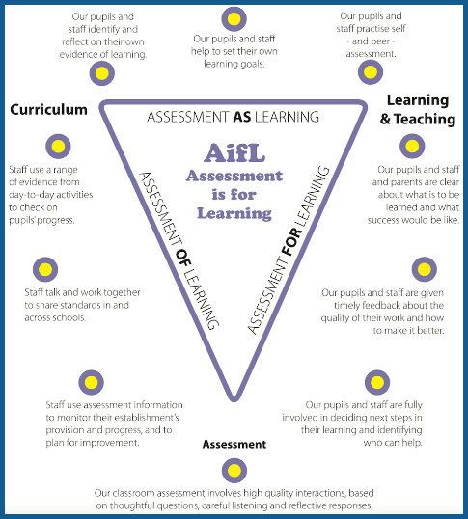
Assessment For Learning
· Discuss what is to be learned
· Recognise when learning has taken place
· Provide useful and timely feedback to inform next steps in learning
Assessment Of Learning
· Share learning across the school to determine levels of attainment
· Use plenary sessions to ensure the learning intention has been achieved for all children and identify next steps.
Assessment As Learning
· Gather information and interpret evidence to determine learning
· Plan learning activities and methodology
· Plan next steps in learning and the evidence to improve success
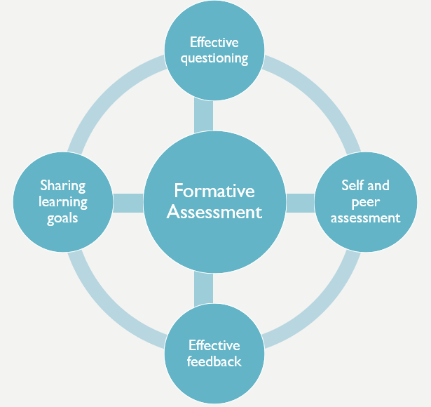
Sharing Learning Goals
· Clear Learning Intentions and purpose of activity should be shared with learners within each lesson
· Pupils should have a clear understanding of the Success Criteria within each lesson
· Both LI and SC should be shared at the optimum point in each lesson, not necessarily at the beginning
· Provides pupils with the opportunity to understand and explain their learning journey or pathway
Learning Intentions should be:
- Linked to learning
- Skills based
- Child friendly
- Displayed consistently
Success Criteria should be:
- Created with learners
- Differentiated
- Linked to feedback
- Used to identify next steps
- Used to self and peer assess
- Displayed consistently
Effective Questioning
· Should be planned and embedded across learning, teaching and assessment
· Determines what learners know or need to know
· Supports identification of additional support needs
· Can be created by learners
· Informs planning of next steps in learning

Effective Feedback
· Should always be linked to Learning Intentions and Success Criteria
· Recognises both areas of strength and development
· Should be shared with pupils within a familiar structure that maximise impact
· When written, pupils should have time to read and reflect on the comments
· When verbal, should be learner centred
Self & Peer Assessment
· Opportunities should always be linked to Learning Intentions and Success Criteria
· Develops a culture of reflection and goal setting
· Develops understanding of what success within a lesson looks like
· Benefit both the provider and recipient of the feedback
Moderation
Moderation helps to ensure that there is an appropriate focus on outcomes for learners, that learning is at the appropriate level and that learners develop the skills for learning, skills for life and skills for work, including higher order thinking skills, which will allow them to be successful in the future. It also helps professionals to establish consistent expectations in relation to achievement of a level. Moderation can take place face to face, or using online networking spaces such as teams to support professional dialogue around assessment processes.
The Moderation Process
Step 1: Choose a moderation focus
Step 2: Choose a group of practitioners
Step 3: Gather relevant evidence
Step 4: Evaluate evidence against national expectations.
The LTA/Moderation Cycle supports continuity and progression across the curriculum and help practitioners in making confident and accurate professional judgements.
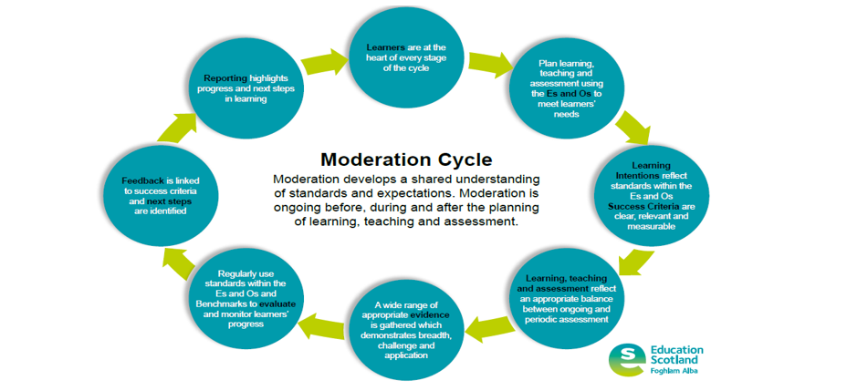
Appendix 6 – Expectations of an Excellent lesson
As mentioned in the flow chart above, lessons should follow the 4-part lesson model. During lessons we would also aim to show and demonstrate the following:
Learning and Engagement
- Children are engaged in teaching and learning.
- Children interact well during teaching and learning activities.
- Children’s experiences are appropriately challenging (linked to attainment data
- Tasks and activities meet the needs of all children.
- Children exercise choice including the use of digital technology (for learning)
- Children can discuss skills being developed.
- Children understand what they are learning and how to be successful.
Quality of Teaching
- Learning is enriched and supported by effective use of technologies.
- Explanations and instructions are clear – staff involved children in the co-creation of success criteria.
- Questioning is skilled, planned and enables higher-order questioning (questioning involves all children)
- Feedback is used effectively to support and inform progress in learning – verbally and written.
- Teaches make well-timed interventions – role of the teacher during learning activities.
Effective use of assessment
- A variety of assessment approaches – self and peer assessment are evident.
- Plenary is planned.
- Children’s progress and achievements are recorded at key points to provide reliable evidence, and this is evident in accessible planning documentation.
Personalised Support
- Barriers to learning are considered carefully and universal and targeted support are in place as appropriate.
- Support staff effectively support/challenge learning and learners.

