**Carnegie Primary School**

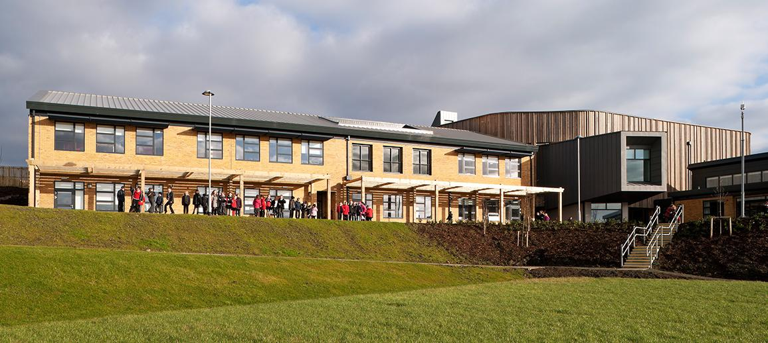

**Pupil Equity Fund Plan 2025-26**

**Session 2025-2026 Improvement Plan – PEF Plan**

|  |  |  |
| --- | --- | --- |
| **Pupil Equity Fund allocation for session 2025/26** | | **£** 110,250 (-16,640 underspend) |
| **School Context (copied from SIP)** | | |
| Carnegie Primary School is a non-denominational school serving part of the Eastern expansion of Dunfermline and the more established area of Halbeath. The children come from a range of social-economic backgrounds with 8.7% in SIMD 1 & 2 and 41.3% in SIMD 8 & 9. The school F.M.E. 13.5%. In June 2025, 88 children are supported by PEF. | | |
| **Cost of the School Day** (In what key ways do you plan to mitigate against Costs within the School Day) | | |
| **Click on the link below to access poster which is shared with parents via school website, groupcall and available at the office and in parent spaces in paper form.**  [**Cost of the school day poster**](https://blogs.glowscotland.org.uk/fi/public/carnegieps/uploads/sites/12471/2025/06/04193550/Cost-of-the-School-Day-poster.pdf) | | |
| **Stakeholder engagement**  (in what ways have you engaged with your stakeholders – children/parents/community etc.) | **Participatory Budgeting**  (Are you using any of your PEF allocation to support participatory budgeting. If yes, what is the focus?) | |
| We work closely with outside partners to ensure we are best meeting the needs of our most vulnerable learners. We work with NHS staff in Pediatrics, SALT, OT and the School Nursing Service. We have a close working relationship with our link EP as well partners from the Supporting Learners Service. All our children with an identified disability, health issue or social and emotional needs benefit from a range of target support at Carnegie. | The funding will focus on activities and interventions with improvement attainment in Literacy and Numeracy and planned outcomes in Health and Wellbeing. | |

|  |  |  |  |  |
| --- | --- | --- | --- | --- |
| **Rationale**   * Improvement in attainment across Literacy and Numeracy * Improvement in attainment and engagement in Writing * Improvement in children and young people’s health and wellbeing * Improvement in levels of attendance and punctuality | | **Amount of Fund allocated (if appropriate) £** | | |
| Intervention 1 – children have been identified across P2-P7 where the attainment gap is between 3 and 8 months off track and require intervention to close the attainment gap.  Intervention 2 – children across P2-P7 who are significantly off track, on average by 12-18 months in all areas, require intervention to reduce the attainment gap.  Intervention 3 - children across the school, where there is an identified difficulty and/or performing off track are accessing support from PSA for Literacy and/or Numeracy  Intervention 4 - A group of children have been identified where there is a need to improve social and emotional wellbeing  Intervention 5 - Targeted support for our families living in the Halbeath area, where there is a significantly higher level of deprivation compared to the overall catchment of the school | | | | |
| **Expected Impact**  (What is the expected impact on outcomes for children and young people)    If this links to a SIP priority, please reference | **Interventions Planned**  (What is the intervention? How will it be delivered? Who is responsible?) | | **Measure of Success**  (Triangulation of Evidence/QI Methodology) | **Impact on children**  **Ongoing evaluation Dec/June**  **(**What has been the actual impact/outcome, in particular for the targeted group of children)  (What data/evidence shows the impact of the project/intervention? Refer to outcome statement. Did you achieve what you set out?) |
| Intervention 1  By June 2026, the gap will close for identified children.  Intervention 2  By June 2026, the gap will be reduced by 3% for identified children.  Intervention 3  By June 2026, gaps within learning will be reduced or closed with almost all children meeting planned outcomes for PSA/CT sessions.  Intervention 4  By June 2026, all identified pupils for social and emotional intervention will have improved wellbeing, their barriers to learning will have been reduced  Intervention 5  Improvement in attendance for all by 2% | 1. Use BASE and NSA data analysis to identify gaps in learning and areas for improvement. Measurable over time therefore provides longer term planning 2. Baseline reading age taken from AR assessment 3. Increased time with class teacher in class with a focus on areas identified. 4. PSA will support children 3x weekly, planned by class teacher 5. Use of Clicker 8 to support writing. Children will undergo training from Support for Learning teacher to allow children to then use independently in class. Opportunity for Clicker 8 to be used at home 6. Review of appropriate universal and targeted support available. 7. Involvement of stakeholder partners/agencies to support particularly children with ASN, eg EP 8. Regular pace and progress meetings with DHT and SfL to review progress for identified children (termly).   School support team to continue to utilise the use of kitbag, lego therapy, cooking/baking sessions and other interventions to support our most vulnerable learners  Continue to use our Emotion works program and 5 ways to wellbeing approach to ensure a common language across the school, particularly for our most disadvantaged pupils.  Continue Seasons for Growth for both children and parents. Identified staff will work collaboratively to support children and their families effected by grief, loss or change. The Seasons for Growth context will encourage children and their parents to express emotions, building coping strategies and developing emotional literacy.  Cost of the school day review - subsidise school trips such as Ardroy for families where there is financial difficulties, clothing bank, faireshare, Christmas hamper etc. | | Improved attainment for our most deprived learners (3%) and engagement  Ongoing observations and assessment evidence as a result of staff working collaboratively  (DHT, CT, PSA)  Record of tracking and monitoring for most vulnerable pupils through Pace and Progress meetings.  Assessment evidence from BASE, NSA, end of level and benchmarks assessments  Positive feedback from children, staff and families.  Baseline questionnaire for Social and emotional intervention groups  Improved pupil engagement as a result of improved wellbeing  Improved health and wellbeing across children including improved attendance (2%) |  |