**Carnegie Primary School**

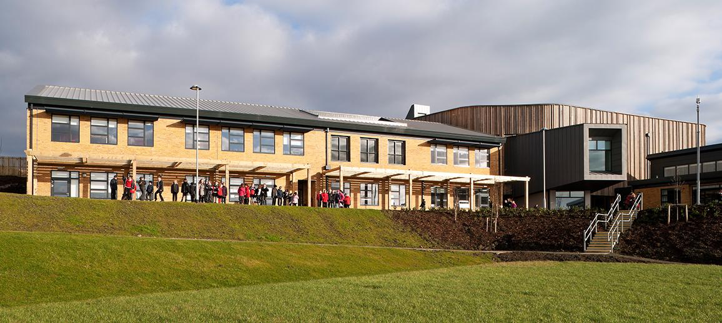

**School Improvement Plan 2025-26**

|  |  |  |  |  |  |
| --- | --- | --- | --- | --- | --- |
| **Education Directorate Improvement Plan:**  Equality & Equity/Achievement/Health & Wellbeing/Positive Destinations/Attendance & Engagement | | | | | |
| **Focused Priority: Culture**   * **Develop a culture of sustainability across our school and community.** * **Use our Digital Roadmap to develop a digital cultures programme understood and supported by our school community and partners** | | | | | |
| **HGIOS4 Quality Indicators** | | **Quality Framework** | | | |
| **Leadership of Learning (1.2)**  **Leadership of Change (1.3)** | | **N/A** | | | |
| **Expected Impact** | **Strategic Actions Planned** | | **Responsibilities** | **Measure of Success**  ***(Triangulation of Evidence/QI Methodology)*** | **Timescales** |
| A school and community committed to learning for sustainability  Learning for sustainability understood by all stakeholders  Learning for sustainability integral to learning across the curriculum  Carnegie’s approach to digital technology and digital learning clearly understood across the school and community | Learning opportunities to be provided via:   * Whole school focus days * Huddle focus * Homework tasks   Eco-Committee to roll out 3 year action plan focused on sustainability and Climate Action and to embed this within the School Improvement Framework.  Termly whole school tasks to raise awareness of the key climate issues linked to the Eco Schools Action Plan  Family learning sessions  Digi Leaders across the school (at all stages)  Partnership working  Engagement with Fife College and DLC | | **Lead**  DHT- Donna Parker  **Working Groups**  Community:  Led by Amy Cassley  Curriculum:  Led by Julie Munro  Campus:  Led by Vicky Gray  **Lead**  Douglas Webb  **Supported by**  DHT: Claire Thomson | Improved understanding of sustainability, global citizenship and climate action by pupils and staff.  Increased learner participation in Sustainability related activities.  LfS principles embedded across the curriculum through IDL and project-based approach.  Increased involvement from families and community stakeholders in sustainability actions. | August 25- Dec 25  August 25- Dec 25 |
| **Ongoing Evaluation:** | | | | | |

|  |  |  |  |  |  |
| --- | --- | --- | --- | --- | --- |
| **Education Directorate Improvement Plan:**  Equality & Equity/Achievement/Health & Wellbeing/Positive Destinations/Attendance & Engagement | | | | | |
| **Focused Priority: Relationships**   * **Use of Circle Framework to enhance inclusive practice across all school contexts** | | | | | |
| **HGIOS4 Quality Indicators** | | **Quality Framework** | | | |
| **Improving Wellbeing, Equity and Inclusion (3.1)**  **Leadership of Change (1.3)** | | N/A | | | |
| **Expected Impact** | **Strategic Actions Planned** | | **Responsibilities** | **Measure of Success**  ***(Triangulation of Evidence/QI Methodology)*** | **Timescales** |
| **A focus on inclusive practice will:****Build a deeper level of respect, kindness and empathy in all classrooms****Enhance emotional Intelligence, enabling** learners to recognise their own biases and emotions.**Improve peer relationships**Encourage teamwork and inclusive play.Help learners develop better communication and conflict-resolution skills.**Support increased learner engagement.**Develop more inclusive classrooms that foster creativity and critical thinking through diverse perspectives.Instill values of fairness, justice, and equality. | Professional dialogue and staff training to enable staff to better understand how to achieve a high-quality inclusive classroom.  Staff training led by Joanna Miller and SfL team to support use of Circle Framework  Review of De-escalation training and Trauma informed Practice  Engagement in whole school events celebrating and promoting diversity and inclusion across the school. | | **Lead**  DHT- Ashley Paterson  **Supported by**  SfL team-  Denise Watt  Sarah Nicholson  EP- Joanna Miller | Evidence of Circle training and profession learning relating to Inclusive Practice in all classes gathered through:  Class visits  Pupil feedback  Learning Partnership feedback  GWMP carried out with all learners (Feb 26). Feedback analysed and next steps actioned.  All children involved in a Diversity/Inclusive Practice celebration day.  Parents Evening used to share the work of the school with all families- family questionnaire to gather views and feedback. | Nov 25  March 26  Feb 26  March 26  March 26 |
| Ongoing Evaluation: | | | | | |

|  |  |  |  |  |  |
| --- | --- | --- | --- | --- | --- |
| **Education Directorate Improvement Plan:**  Equality & Equity/Achievement/Health & Wellbeing/Positive Destinations/Attendance & Engagement | | | | | |
| **Focused Priority: Learning**   * Develop learning for sustainability (pulling together RRSA/DYW/OL/Financial Education) * Plan a progressive curriculum across all 8 curriculum areas ensuring that all children receive their entitlement to a broad general education (BGE). * Use benchmarks for all curriculum areas to measure children’s progress and achievement of a level across the BGE using a range of assessment evidence * Develop the use of digital technology to ensure high-quality learning, teaching and assessment through intensive staff training and professional learning to create a more inclusive, engaging and personalised learning environment leading to improved outcomes for all children | | | | | |
| **HGIOS4 Quality Indicators** | | **Quality Framework** | | | |
| Learning, teaching and assessment (2.3)  Raising attainment and achievement (3.2)  Increasing creativity and employability (3.3) | | N/A | | | |
| **Expected Impact** | **Strategic Actions Planned** | | **Responsibilities** | **Measure of Success**  ***(Triangulation of Evidence/QI Methodology)*** | **Timescales** |
| Increased teacher confidence delivering quality experiences linked to Learning for sustainability  Increased opportunities for pupil led learning in learning for sustainability  Improved participation and engagement in learning for sustainability  All children will experience  planned, progressive learning  experiences across the broad  general education.  All staff will enhance their  assessment skills through  planned assessment and  moderation activity; this will  ensure all children are making  progress across all areas of the  curriculum  Tracking of children’s  progress across the broad  general education and use of  assessment evidence to support  professional judgements will  ensure children experience their  entitlement to a broad general education.  Through planned opportunities with families, knowledge of the broad general education will be developed, to ensure they can support children in their learning across the curriculum  All children will experience improved engagement and motivation in learning through creative approaches to delivering learning and teaching using a wide range of digital tools.  Through professional learning all staff will enhance their skills in using digital tools to deliver high-quality learning, teaching and assessment leading to improved outcomes for all children.  Children/young people in P6/7 will become more proficient in using digital tools to support them in their learning, preparing them with skills for learning, life and work.  All staff will increase their knowledge of how to personalise learning using a wide range of software, digital skills, and accessibility tools to meet the needs of all children/young people at universal, additional and intensive levels.  Through planned opportunities with parents/carers, knowledge of the use of digital technology will be developed to ensure they can support children in their learning across the curriculum. | Embed learning for Sustainability across learning pathways to identify cross-curriculum links and opportunities for interdisciplinary learning  Programme of staff training to develop knowledge and expertise using Education Scotland framework for learning.  **Professional Learning Activity**  Through collegiate sessions staff will engage in professional dialogue on assessment of all curriculum areas  All staff will use CfE benchmarks for all curriculum areas to engage in moderation activity.  **Forward Planning**  All staff will use the progression pathways for all curriculum areas to ensure planned learning experiences are progressive for all children.  **Attainment and Forward Planning** Professional dialogue will support assessment across all curriculum areas linked to assessment evidence which informs professional judgements.  **Tracking & Monitoring**  All staff in consultation with SLT will further develop their working knowledge of the Progress Framework to track progress in learning across the curriculum and record targeted interventions for individuals or cohorts of children  **Curriculum Rationale**  This will be further developed to ensure that it is reflective of the experiences of all children across the school in relation to the BGE.  Professional Learning Activity  5 collegiate sessions for staff to engage in professional learning on the use of iPads and associated apps to enhance the quality of learning, teaching and assessment.  Additional opportunities for staff to enhance their knowledge through self-led professional learning available on the Apple Education Community  Personalise staff learning by tailoring content on digital platforms to suit individual/class needs.  Enable all staff to use digital tools to make learning and teaching more engaging, accessible and inclusive  Staff training to ensure safe and responsible use of digital tools and platforms  Staff to implement their digital skills to   * plan appropriate learning based on Fife’s curriculum progression pathways * create and share explanations and to model learning processes * Plan for key learning to be shared via digital platforms to support P6/7 to access during and outside of lessons. * plan for differentiated learning by * involve children in the planning process, engaging them in decision making process * select learning activities and co construct success criteria * provide instant feedback to children. · * develop Digital Portfolios to showcase learning over time using Showbie   **Curriculum Rationale**  Our Curriculum Rationale will be further developed to ensure that it is reflective of the experiences all children are experiencing across the school in relation to the use of digital technology. | | **Lead**  DHT- Donna Parker  **Working Group**  Curriculum:  **Lead**  Claire Thomson  **Working Group**  SLT:  Ashley Paterson  Donna Parker  **Lead**  DHT Claire Thomson/Douglas Webb  **Working Group**  Luke Miller… | 90+% staff indicate increased confidence in delivering on learning for sustainability  90+% of children can articulate what learning for Sustainability is and what learning they have experienced over the school year  .  65% learners can talk confidently about why learning for sustainability is important.  Analysis of attainment data  Analysis of CFE and BASE/NSA/eLIPS  Analysis of data for identified cohorts SIMD, ASN, EAL, LAC  Feedback/professional dialogue with teacher through Pace and Progress meetings  Feedback from moderation activity  Parent/carer views relating to children’s experiences of BGE Parent’s nights)  Children’s views gathered through pupil focus groups, Learning Conversations and ‘Your Voice Matters’ on the learning experiences across the curriculum  Monitoring of forward planning  Jotter sampling across the curriculum  Classroom observations linked to identified areas of the curriculum (QA calendar)  Focus for LP  100% of teacher staff attend all training sessions and feedback positively re new learning  80+% staff will independently implement new learning in the classroom. (Staff identified as needing additional support to be paired with a mentor)  Increased use of digital learning in ALL classes.  Children’s views gathered through pupil focus groups, Learning Conversations and ‘Your Voice Matters’. All children feedback improved access to digital learning in their class.  Self Evaluation processes used to measure staff feedback re successes and next steps/ further training requirements.  Practitioner enquiries/Collegiate Enquiries developed across professional learning team to drill down on what is working well.  Monitoring of forward planning  Jotter sampling across the curriculum  Classroom observations linked to identified areas of the curriculum (QA calendar)  Focus for LP | August 2024- December 2025  September 25  January 26  March 26  May 26  Feb 26- Dec 27 |
| **Ongoing Evaluation** | | | | | |