Carnegie Primary School

School Travel Action Plan

Head Teacher: Mrs Julie Journeaux
School Address: Pittsburgh Road
Dunfermline
KY11 8SS
Telephone No: 01383 602460
Summary Page

The following travel plan is a collaborative plan involving parents, children, staff and stakeholders in researching and devising the content, agreeing the actions and aims to make the overall journeys to and from Carnegie Primary School safer, healthier and more enjoyable. Our aims are to:

- Make journeys to and from school safer for everyone;
- Reduce traffic in front of the school by reducing the total number of cars used for the
school journey;
- Increase awareness of active travel and educating all about road safety;
- Improving Active Travel facilities (bike and scooter storage, helmet storage, etc.);
- Promoting alternatives to car travel (cycling, walking and scooting), increasing the
percentages of active travel;

The key issues and perceptions relating to journeys to and from school were identified as: inconsiderate parking around the school gate and surrounding streets. This causes problems including: -

- Congestion
- Blocked vision for walkers and cyclists
- Blocked vision for other drivers
- Low proportion of children actively travelling to school, especially in bad
weather
- Concerns about road safety and speed of traffic

76 % of those pupils surveyed highlighted that they walk to school, with a further 24% who cycle or scoot. The survey also highlighted that 33% are driven to school most days.

Routes identified as safer routes to school are:

- The enclosed walkway up McBaith Way
- The residential areas leading from Braemar Drive
- Crossing further back from the open junction at Kellock Avenue
- The wide pathway leading up Dunlin Drive
- Crossing at the pedestrian crossings near the school

Proposed Behavioural Actions

- Promote active travel to school
- Promote safer routes to school
- Road safety education
- Reduce congestion around the school gates
- Deliver cycle training at school (Bikeability)

This plan is valid for 6 years and will be reviewed during year 3.

1.0 INTRODUCTION

1.1 School background

Carnegie Primary School was established in August 2009 and the school community moved into the new building in August 2011. It is a non-denominational school serving part of the eastern expansion of Dunfermline and the more established area of Halbeath. Our school caters for the mainstream education of Primary and Nursery children. The school was subsequently extended in 2017 to accommodate a continued increase in roll.
The combined school and nursery roll is 733. The school currently caters for 653 pupils across 23 classes. The Nursery accommodates 81 children aged 3-5.
Carnegie’s vision is ‘Growing Together, Soaring to Success’. All of our children are on a learning journey and we aim to promote this journey through our Values of Kindness, Respect and Ambition.

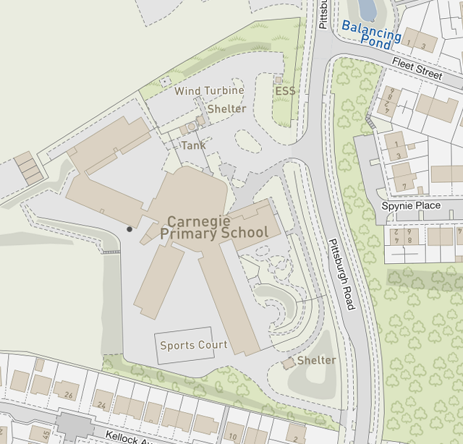
Highlighted are the main entrances into the school
2.0 POLICY AND OBJECTIVES

2.1 Formation of Junior Road Safety Officers

To address the issues raised with congestion around the school gate and to work on future initiatives, the school formed its Travel Action Group which consists of Junior Road Safety Officers and members of the School Parent Council.

Amaia Wilkinson-Quinn (Pupil)
Harris Ewing (Pupil)
Jamie Baxter (Pupil)
Cruz McKenzie (Pupil)
Josh Dalgleish (Pupil)
Aaron Knapman (Pupil)
Abby Fenning (Pupil)
Lynette Thomson (Parent Council)

3. CURRENT TRAVEL PATTERNS

3.1 Questionnaire Surveys

During the consultation period, 147 families and 30 staff members responded, and the following analysis is based on the data from those surveys.

3.1.1 Family Survey Data Analysis

Question 1. How do most of our pupils travel to school?
77% of parents stated their children walked to school
33% take the car to school
24% cycle or scooter to school
Question 2. What should our priorities be?
65% of parents felt a priority for our Travel Action Plan needs to be making the surrounding streets safer.
57% feel that we need to prioritise encouraging drivers to park in safer places.
33% feel we need to prioritise encouraging more children to walk to school.

Question 3. What are the current challenges?
Kellock Avenue – very congested with children crossing and cars trying to get parked. This was a common theme and mentioned by many. Cars parking with little awareness of children crossing and an accident waiting to happen.
Fife College car park – full of potholes / muddy etc. Difficult to walk over across, particularly in bad weather. In ‘terrible’ condition and in need of resurface. Lower car park has no safe walking route.
Finding a parking space in general can be challenging
Cars that park in Fleet Street are a hazard
Cars parking in residential streets on pavements
No traffic warden or lollipop person to man the area around Kellock Avenue
No zebra crossing near the school
No ‘drop and go’ zone for working parents
Cars parking and congesting McBaith Way

Question 4. Suggestions moving forward.
Show more understanding that some parents have no other option but to drive their children to school
Get the overflow car park at Fife College resurfaced
Employ a lollipop person down near Kellock Avenue
Have a zebra crossing near the school gates
Reward system for pupils walking to school
Tighter restrictions at Kellock Avenue – double yellow lines?
Widening of pavements along Pittsburgh Road to cope with volume of people
Having a safe drop off area
Zebra crossing at entrance to college car park
More bike/scooter sheds in the playground
Question 4. Suggestions moving forward continued.
Parking cones in Fleet Street to deter people from parking there
A direct pathway from Fife College to the school, utilising the empty space between the staff car park and overflow
Easier access to Fife College
No parking on Pittsburgh Road at school start and finish times

Pupil Audit – 16 Class Responses
How safe do you feel travelling to and from school – Average 4/5
What makes you feel unsafe?
Cars driving unsafely
Fear of cars not stopping at lights
Drivers not paying attention to you crossing
Drivers parking on pavements
Drivers parking in the streets where people live
Roads are so busy and people drive fast
Not enough crossings
Kellock Avenue is very dangerous with too many cars.

Suggestions Moving Forward:
Another lollipop person
A bigger bike shed to encourage more people to cycle to school
The JRSOs to teach more about Road Safety
Bikeability to start again
Speed control measures around the school

4.0 MAPPING WORK
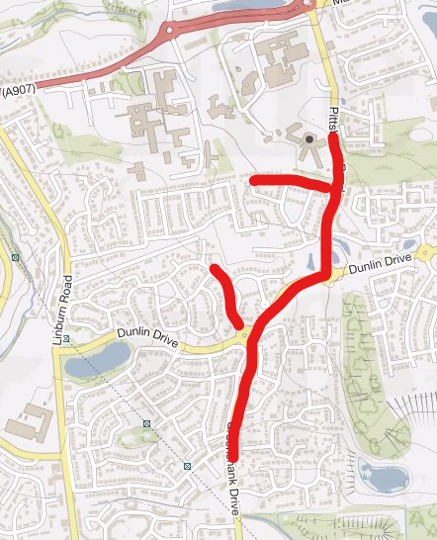

5.0 ROUTE AUDIT OF KEY ROUTES TO SCHOOL

A site visit of the above key routes was carried out on Thursday 17th March at 11:15am. The weather conditions were bright, sunny but cold.

The routes around the schools are well established multi-use paths that connect well and are managed by a number of crossing points.

For full audit report please refer to appendix 1.

5.0 STAFF DATA
How do staff currently travel to work?
93% of staff drive to work, with 87% using the staff car park.
Those who live close enough, tend to walk to school where possible. Others have no other option than to drive.
What are the challenges to the current situation?
Not enough spaces for all in the staff car park
Parents parking in unsafe areas
Overflow car park not being used as it should

Suggestions Moving Forward:
Better signage for use of Fife College as our overflow
60% feel we should make encouraging our children to walk to school more often, a priority
57% feel we need to encourage parents to park in safer areas
A ‘Walking Bus’
Resurface of the overflow car park

6.0 BEHAVIOURAL ACTION PLAN

Action | Solution | Action Owner | Target Date (Academic year)
Promote Active Travel | Take part in Active Travel Months  Take part in Bike Week  Take part in the SUSTRANS BIG PEDAL  Walk to school week | School/TAG  School/TAG  School/TAG  School/TAG | Term 2 & Term 4  Term 4  Term 3  Term 2
Promote Safer routes to school | Upload map to website  Put information board up at Parents Nights  Articles in school newsletters, social media and assemblies | School  School/TAG  School/TAG | Term 1  Term 2  Term 4  Ongoing
Road Safety Education | Run poster campaigns  Take part in Road Safety Week. | School/TAG | Ongoing  Term 2
Reduce congestion around school gate | Develop the following:  Parking Pledge  Park N Stride Site  Walking Bus | School/TAG | Ongoing
Bikeability | Offer cycle training to all P6 and P7 pupils | School | Ongoing

7.0 Physical Measures

Action | Action Owner | Target Date
No physical engineering works were identified at this time

8.0 MONITORING & EVALUATION
The JRSO’s will continue to meet periodically to monitor progress and will review the Travel Plan on an annual basis.
Specific progress will be monitored by participation in the “Hands Up Travel Tally” each year and a repeat of the full travel survey will take place 6 years after initial launch.
The school’s ongoing commitment to travel planning will be publicised on the school website, the school newsletters, the Parent’s notice board, the school Twitter page and through Huddles.

10. DISTRIBUTION OF SCHOOL TRAVEL PLAN

The following bodies will receive a copy of the School Travel Plan:

- Fife Council Assets, Transport and Environment via the Travel Plan Team
- Fife Council Education Service
- Fife Council School Estates Team
- Parent Partnership
- Active Schools
- Copies will also be made available to the parents from the School Office and
via the school website.

FIFE COUNCIL
ASSETS, TRANSPORTATION & ENVIRONMENT

CARNEGIE PRIMARY SCHOOL, DUNFERMLINE

ROUTE SAFETY AUDIT

INTRODUCTION

This report results from an Audit of key routes undertaken at Carnegie Primary School at the request of the school to facilitate their School Travel Plan.

The school is situated within a 20-mph zone on Pittsburgh Road, Dunfermline. All pupils enter the school site from the front of the building and there is an additional entrance for the staff car park. At the time of undertaking the route audit it was noted that parents taking pupils to the nursery walk along a dedicated path within the school car park.

A site visit of the key routes was carried out on the morning of 17th March, 2022. The weather conditions were bright, sunny and cold.

The audit team consisted of:

Marta Ramage – School Travel Plan Coordinator
Ashley Paterson – Principal Teacher

Amaia Wilkinson-Quinn
Harris Ewing
Josh Dalgleish
Cruz McKenzie Junior Road Safety Officers
Jamie Baxter
Abby Fenning
Aaron Knapman

The key routes audited were:

Pittsburgh Road
Kellock Ave
Dunlin Drive
Braemar Drive
Greenshank Drive

Findings and Recommendations

These streets were identified as the main routes taken by all pupils attending Carnegie. The streets were audited with no engineering requirements recorded. The streets are set within a 20-mph zone, visibility is good at junctions, all junctions have dropped kerbs. JRSO’s stated that at times they felt the traffic speed was excessive, but none stated that this made them feel unsafe.

JRSO’s also noted that at the junction of Pittsburgh Road and Kellock Drive parents were causing congestion due to gathering at the junction, while waiting to cross the road, waiting for pupils and just chatting, making visibility for pupils very difficult.

It was agreed to disperse parents by creating a map highlighting an alternative route along Kellock Ave and then joining Strathouse Crescent; thus then leading onto McBaith Way.

Pavements along McBaith Way narrowed at points and again causes congestion with pupils walking on the road. JRSO’s to highlight this during their Road Safety talks and remind pupils to cross at other sections of the path where visibility is clearer.

SUMMARY

Carnegie Primary School is situated on a main distributor road with a 20-mph speed limit. The school is well connected with paths and has various traffic management processes in place. During the route audit it was identified that no engineering works were needed and that the issues identified were of a behavioural change nature.

The school will work with the travel plan coordinator to develop an action plan that will be reviewed in year 3 of this report.

