Carnegie Primary School

Listening and Talking
Policy Statement

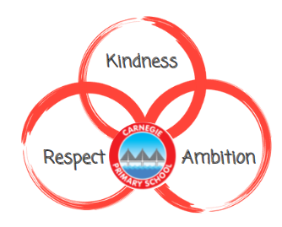

Review Date
August 2023

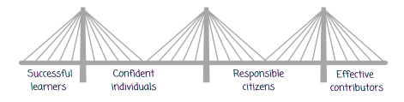

Rationale
‘Listening and talking are core skills for learning and are central to teaching and learning in all subject areas’ Education Scotland, 2015-16
At Carnegie, we want our learners to reach their full potential and become confident individuals, responsible citizens, successful learners and effective contributors. We know communication is key in all aspects of life. As a result, Listening and Talking is carefully planned for to ensure children have a range of experiences in Listening and Talking.
Aim
We will achieve this through:
- Literacy rich environments
- High quality assessment and tracking data
- All adults modelling effective listening and talking
- A wide range of high-quality texts to improve vocabulary
- A well-resourced school library with wordless picture books for all levels to promote discussion
- A wide variety of pupil voice groups
- Opportunities for active listening, group discussion and individual talks

Pedagogical Approach
All teachers and adults across all stages provide opportunities for active listening. Through our class novels and reading, children are given opportunity to engage in active listening. Children are also encouraged to take part in reading the class novel aloud, providing the opportunity for children to listen to their peers.
Our learners have daily opportunities to engage in talking and listening activities which range from group discussions as part of a lesson to debating topical issues. Our teachers ensure group work is well planned for in order to support the listening and talking of all members of the group.
Individual talks are encouraged at each stage. This provides a planned for speech to be delivered where our learners can practice the art of presenting effectively to a group of listeners.
Feedback is an important part of learning at Carnegie, we encourage this in all aspects of the curriculum. In addition to supporting active listening, it provides the opportunity for our learners to develop skills in supportive language and the importance of wording. Separate to discreet Listening and Talking lessons, our learners get experience with oral feedback during lessons such as Drama, Music and Physical Education.
Planning, Tracking and Assessing
The planning, tracking and assessment of our children is consistent across the primary school, with Nursery adhering to the play progression model of recording. All children are assessed proactively, with teachers ensuring a balance between summative and formative assessment is achieved. Teachers use a variety of assessment strategies within the class to allow for all learning to have appropriate challenge and pace.
Library
Our whole-school library is a welcoming space accessible to all with access to a wide range of texts. This includes sets of wordless Picture books, selected to promote discussion around stories within Listening and Talking lessons. For a list of texts, please see appendix 1.
Pupil Voice Groups
Pupil voice is at the heart of Carnegie with multiple opportunities for our learners to have an active and important role in the decision making of our school. The pupil voice group provides a platform for our learners to develop the skills in talking and listening which is modelled through our pupil voice groups impact on school life. These groups demonstrate the importance of your voice and allows for all our learners to develop these skills. The pupil voice groups are currently: Rights Respecting Schools Ambassadors, Pupil Council, Eco Committee, Junior Librarian, Sports Ambassadors, Playground Pals, Health and Wellbeing Committee, Diversity Ambassadors and Support for Learning Ambassadors.
Progression
At Carnegie, we are currently creating a progression to ensure all our learners have equal opportunities throughout primary school.

Appendix 1:
