Carnegie Primary School

Reading Policy Statement

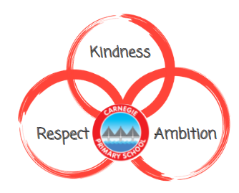

Review Date
August 2023

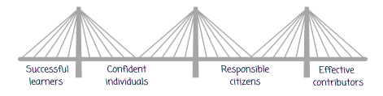

“Literacy is fundamental to all areas of learning, as it unlocks access to the wider curriculum. Being literate increases opportunities for the individual in all aspects of life, lays the foundations for lifelong learning and work, and contributes strongly to the development of all four capacities of Curriculum for Excellence.”
(Education Scotland, 2017)
Rationale
At Carnegie, we are passionate about creating a love of reading in our learners. There is a significant link between reading for enjoyment and academic achievement (OECD, 2002). In addition to raising attainment, studies have found literacy has a significant link with happiness and success in adulthood (Clark and Rumbold, 2006). As a result, reading is at the heart of what we do as educators.
Aim
We will achieve this through:
- Literacy rich environments
- Daily exposure to reading
- High quality assessment and tracking data
- Adults modelling reading
- A wide range of high-quality texts
- A well-resourced school library
- Pupil voice through the Junior Librarians
- Personalisation and Choice through Accelerated Reader
- Supportive reading schemes such as Bug Club
- Family Learning with reading as a focus
Pedagogical Approach
In Carnegie primary school, teachers provide stimulating contexts for learning and aim to achieve powerful literacy through a whole-class text. This allows for literacy to become a social process with cooperative learning, a shared emotional experience and an approach inclusive of all our pupils. This is achieved through the Workshop for Literacy approach which is used consistently across the school.
All reading, writing, spelling and phonics can be explored through the whole-class texts. Our classrooms provide literacy-rich environments and our learners have access to both a whole-school library and a classroom library.
We use high-quality whole-class texts and a variety of reading schemes to support the development of reading within Carnegie Primary School. Whole-class texts will mainly be used to support ‘reading to understand’ whilst reading schemes will support ‘learning to read’. All teachers provide daily exposure to reading. From Nursery to Primary 3, the children are read aloud to every day. From Primary 4 to Primary 7 there is a mixture of storytelling led by the teacher or children, independent reading and until successful in learning to read, supported group and individual reading.
Reading Schemes and Systems
From Primary 1 to Primary 3, the Bug Club reading scheme is used to target fluency, word-decoding skills, sight words and expression. The main focus is learning to read. There are several additional reading schemes which can be used to further support our learners including: Story World, Osborne First Readers, Oxford Reading Tree and Big Cat. Reading Schemes are used in the early stages of reading to target fluency, word-decoding skills, sight word recognition and fluency and expression.
From Primary 4, learners will use the Accelerated Reader system. To further support readers, the Rapid Reader scheme or Project X scheme can be used. Accelerated Reader is a system where books are ordered by reading ability. Children carry out a STAR assessment four times a year and engage in weekly Accelerated Reader quizzes as part of the system. This provides our school with valuable data to measure and track the progress of our readers across the school. The results of these termly tests and quizzes provide learners with a range from which they have the freedom to select texts. The system allows for a significant level of personalisation and choice. We are continually updating our reading materials and investing in more books to extend the choice for our learners. Until learners are successful in the skills of learning to read, teachers will continue to carry out supported group reading or individual reading on a regular basis.
Whole-class Texts
Our learner’s skills in reading to understand will be developed through the whole-class text. Each class will access the same text in order to achieve a shared experience. Learners will be enabled access to a shared text through a variety of ways; teacher-led (reading the story aloud), teacher-devised-text, child-led (children reading the story aloud) and through visual/auditory resources where suitable and available.
At Carnegie Primary School, every stage has several high-quality texts to explore and deliver Literacy Experiences and Outcomes through. From Primary 2/3 onwards, these are pre-selected whole-class sets. For a list of texts, see Appendix 1. In addition to the pre-selected texts, teachers have autonomy to explore other high-quality texts. We have class sets which explore a variety of themes focused on diversity. For a list of texts, see Appendix 2.
Planning, Tracking and Assessing
The planning, tracking and assessment of our children is consistent across the school, with Nursery adhering to the play progression model of recording. All children are assessed proactively, with teachers ensuring a balance between summative and formative assessment is achieved. Teachers use a variety of assessment strategies within the class to allow for all learning with appropriate challenge and pace.
Library
Our whole-school library is a welcoming space accessible to all with access to a wide range of texts. We use the Reading Cloud system to provide all learners and adults in the school with a school library card. Our library is run by a parent volunteer and our Junior Librarians. Our library is split into two parts, our Accelerated Reader section alongside the pre-selected class novels and our main library where books can be checked in and out using a library card. The Reading Cloud system also informs us about what books are being read most often to support how to expand our library for our learners. We use this to further promote reading for pleasure.
Junior Librarians
At Carnegie Primary School, we put the learners at the heart of everything we do and thus believe strongly in Pupil Voice. To achieve this within Reading, we have a group of leaders called Junior Librarians. The learners within this group are responsible for developing our library to ensure it meets the needs of the children within the school. Meeting regularly throughout the year, our Junior Librarians consult the school on issues and improvements to ensure our library is the best it can be. We are currently working towards becoming a Reading School through the Reading School Accreditation scheme courtesy of the Scottish Book Trust.
Family Learning
Our Nursery and Primary 1 families are welcomed into school to engage in Book Bug workshops which explore how the Scottish initiative can best be used at home to support our learners.
During our Literacy week (whole school) which marries up with World Book Day in March, our families our welcomed into our school to engage in a variety of reading activities including Secret Reader and Sharing Our Learning Events amongst many other.

Appendix 1: Class Novels for each stage
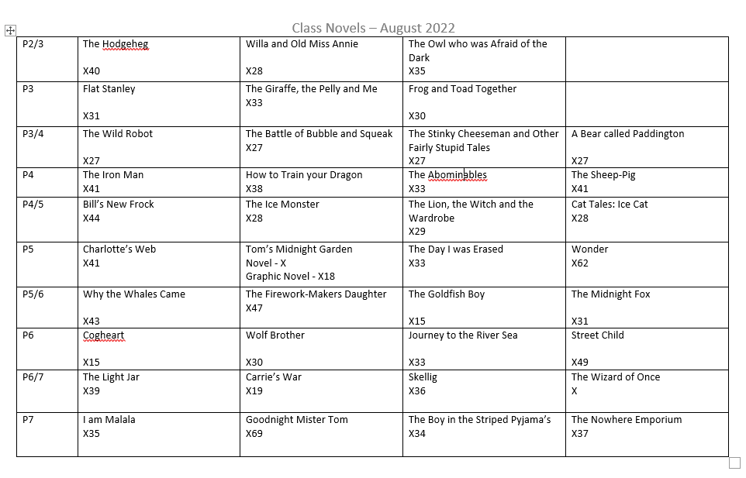

Appendix 2: Class Novels for Diverse Themes and Listening and Talking sets

