Carnegie Primary School

Modern Languages 1 + 2 Approach

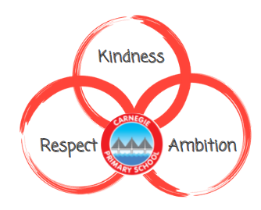

Reviewed August 2023

Rationale
At Carnegie we highly value the importance of modern language learning and teaching. Language learning is life enhancing and the advantages of early exposure to languages are well documented and contribute to young people's development as successful learners, confident individuals, effective contributors and responsible citizens.

Aim
At Carnegie we are dedicated to proving a meaningful, progressive and consistent approach to language learning across the school. Our L2 is French introduced in P1. Our L3 is German and is introduced from P5 onwards. We strive to inspire pupils to enjoy languages. It is a wonderful opportunity for active learning enhanced through games, songs, role play and so much more. In collaboration with our secondary colleagues, we aim to successfully prepare our pupils to flourish in their modern language learning journey in secondary and beyond. Ultimately, we aim to provide our pupils with the tools to fully engage with the increasingly global society and economy whilst appreciating Scotland as a multicultural and multilingual nation.

Pedagogical Approach
In collaboration with our cluster and modern language secondary colleagues we have developed a schedule of learning which details which topics should be covered and when. Here at Carnegie, we have expanded upon this and developed a P1 – P7 pathway. The planner includes topic areas, suggested learning experiences / resources and relevant E & O’s. The purpose of this planner is to provide consistency within stages and appropriate progression throughout the school. The Power Languages Platform is also available and provides a wealth of information, resources and materials. In order to share good practice, we have a Teams Tile on GLOW.
We will establish:
- Daily routines regularly undertaken in French / German
- Adults modelling a ‘give it a go’ approach
- A bank of French language books
- An ethos of sharing good practise and resources within stages
- French signage highlighting important places around the school
- Consistent and progressive language lessons

Further ReadingPlease find support documents and further information at:

Supporting documents - Language learning in Scotland: a 1 + 2 approach - gov.scot (www.gov.scot)

