Carnegie Primary School

Support for Learning Policy Statement

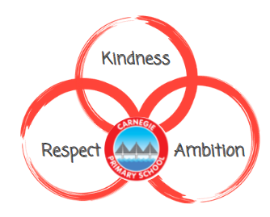

Reviewed January 24

‘Every child and young person is entitled to support to enable them to gain as much as possible from the opportunities which Curriculum for Excellence can provide’.
Building the Curriculum 3
Rationale

About a third of all children and young people in Scotland are recognised as having additional support needs. While all children receive support with their learning, some require an additional layer of targeted support and the need to remove barriers to learning to ensure all children’s needs are met.

As stated in the Education (Additional Support for Learning) (Scotland) Act 2004, a child has additional support needs for whatever reason, the child is, or is likely to be, unable without the provision of additional support to benefit from school education.
The Education Act (2004) provides the legal framework for the provision of additional support for learning. The legislation was amended by the Education (Additional Support for Learning) (Scotland) Act (2009). The key duties on education authorities are to identify, make provision for, and review provision for the additional support needs of the child.

A child has additional support needs if the child or young person is Care Experienced and looked after by a local authority. Everyone at Carnegie Primary School has an awareness and understanding of the care and support available for Care Experienced children.
In line with the principles of the Promise, at Carnegie we provide support to children who are care experienced by:
- minimising barriers to allow them to engagement with education
- building positive relationships
- valuing and recognising their individual needs
- ensuring robust tracking of attendance and attainment so there is early support intervention
- ensuring children will always have consistent and responsive access to a person of trust throughout their journey at Carnegie
- ensuring that care experienced children will have all they need to thrive at school
- supporting children’s transitions to high school to ensure continuity of a positive destination

Meeting the needs of all learners is not a new focus. Ensuring that the needs of all learners are assessed and successfully addressed is clearly at the heart of any teacher’s work and this is explicitly recognised throughout the Standard for Full Registration. Teachers are required to:
- plan coherent, progressive and engaging teaching programmes which address the needs of every learner
- identify the potential barriers to learning and plan differentiated and appropriately challenging learning experiences to ensure learning is accessible for every learner
- communicate appropriately with every learner, modelling and promoting competence and confidence in literacy, numeracy, health and wellbeing and digital literacy
- ensure teaching builds confidence and promotes the progress of ever learner
- employ appropriate teaching strategies and resources, including digital approaches, to meet the needs and abilities of every learner.

Additional to class teacher, to ensure all learning needs are met, Support for Learning staff will
- recognise when additional support is needed, providing a system for identification and consultation.
- work together with pupils, parents and partner agencies (where appropriate) to plan support, use strategies and resources to ensure equitable access to the curriculum.
- create an ethos where each child is valued, respected and is involved in the planning and review process.
- take a holistic view.

The Standard for Headship and The Standard for Middle Leadership place the strategic responsibility on Senior Leadership Team to ensure that inclusive cultures of learning are fostered, supported, and sustained. SLT will actively engage in and ensure multi and inter-agency working across the learning community and beyond, particularly by building capacity and capability with colleagues, in order to achieve positive outcomes for every learner.

Universal and Targeted Support and Removal of Barriers

The following universal strategies are used at Carnegie to support our learner’s cognitive development. These should be considered in the first instance, in line with the GIRFEC principle of being ‘minimally intrusive’, before exploring more individualised strategies.

1. Have clear, daily classroom routines (e.g. visual timetable, use of boardmaker).

2. Use a multi-sensory / multi-modal approach to teaching where concepts are presented in a variety of different ways (including use of practical activities and concrete materials).
3. Consider class layout and seating plans (e.g. quiet or reduced stimulus areas, seating near class teacher, seating to minimise distractions, seating to enable clear view of whiteboard).

4. Use visual information to support verbal information (e.g. symbols, word webs, pictures, models, mind maps).

5. Use familiar scripts and routines to reduce the need to process new information and to help develop self-regulation, including Emotion Works for emotional regulation.

6. Present information in manageable chunks (verbal and written information).

7. Give learners time to process questions / information before providing additional information and check for understanding by seeking pupil feedback.

8. Repeat key information if required (verbal repetition or also providing written/symbolised information).

9. Explicitly teach learners how to set learning goals, organise and effectively manage their learning independently (e.g. using planning formats, checklists, visual sequences, routines).

10. Encourage a growth mindset where learners believe they can improve through practise, hard work and determination, feedback is given in relation to success criteria and promote an ethos where mistakes are seen as part of the learning process.

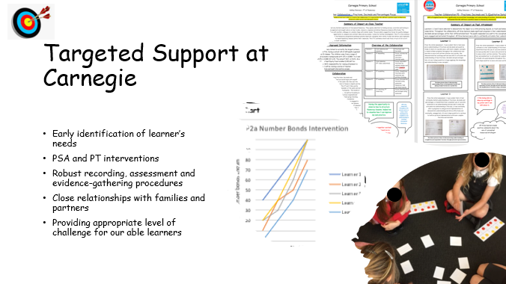

If there is a concern relating to a child’s learning then the class teacher will complete a Registering Concern Form and/or Request for Assistance Form and submit to the SfL team. The relevant SfL member of staff according to department/class will work with the class teacher to identify what the needs are and plan support interventions to address concern. The team will discuss the pupil profile and identify next steps and progress will be monitored. The child’s views will be shared and parents will be informed that there is a concern raised.

If closer assessment is deemed necessary, the SfL team will discuss this further with parents/carers and agree to complete a contextual assessment, trial an intervention or consult with outside agencies. There may be a need to create a child’s plan to assess against the Wellbeing indicators and to ensure the team around the child is clear on how to support the child best.

Parents are regularly consulted and updated regarding their child’s support needs.

Interventions and progress will be recorded on individual pupil chronologies. Supports will be regularly reviewed and updated in order to continue to meet the needs of the child. There are three opportunities across the year at SfL consultations with class teachers and Pace and Progress meeting with DHT to discuss and review any concern relating to Support for Learning.
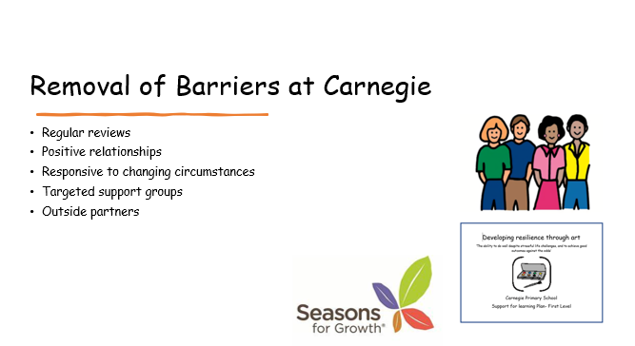

Partnerships with outside agencies
We work closely with outside partners to ensure we are best meeting the needs of our learners. Through a system of regular reviews, involving partners and parents, children’s barriers are identified and reduced. We work with NHS staff in paediatrics, SALT, OT and school nursing service. We have a close working relationship with our link EP as well partners from the supporting learners service.

Neurodevelopental Pathway

The Neurodevelopmental Pathway is a specialist service responsible for the assessment of neurodevelopmental conditions. Children may require assessment for a neurodevelopmental condition when they present with difficulties or additional support needs such as:
• Communication and social interaction difficulties
• Difficulties with emotional regulation
• Co-ordination and / or movement differences
• Developmental delay
• Intellectual difficulties or a need for adaptation to support learning
• Reduced independence in everyday environments, daily routines and activities
• Barriers to learner participation (e.g. aspects which prevent the child from fully engaging)

Our Support for Learning team will holistically assess the child gathering a range of evidence, including a child’s plan and/or assessment against the wellbeing indicators. Parents are fully involved in this process and include their own assessment evidence as part of the profile.
Neurodevelopmental disorders are diagnosed following assessment by a multi-disciplinary team, with appropriate training, skills and skill mix. Assessment findings and evidence from both report and observation. Assessments may result in overlapping diagnoses, including: Autism, ADHD, Intellectual Disability, Fetal Alcohol Spectrum Disorder, Developmental Language Disorder or Developmental Co-ordination Disorder

Carnegie Support for Learning Team

Donna Parker DHT – School Lead on SfL and ASN
Scott Mitchell - P1-2
Sarah Nicholson - P3-4
Ashley Robertson - P5-7

The Four Roles of the Support for Learning Teacher

- Support Learning and Teaching
- At Carnegie, the SfL Team will hold termly consultations with Class Teachers to discuss and identify where support is required.
- The SFL Team will support Class Teachers through shared planning and team-teaching (where applicable)

- Consultancy with All Stakeholders
- At Carnegie, the SfL Team will communicate regularly with parents and carers and where appropriate, will consult with Educational Psychology, Speech and Language, Occupational Therapy, Community Paediatricians, CAMHS, Family Support Service, the Sleep Clinic as well as other supportive charities.
- Where appropriate, the SFL Team will carry out contextualised assessments where a barrier to learning has been identified.
- Where appropriate, the SfL Team will carry out referrals to external pathways and support, to ensure the needs of all learners are met.

- Direct Tuition and Support
- At Carnegie, the SfL Team will lead targeted intervention work with identified pupils and support PSA staff to deliver interventions.

- Staff Curriculum / Development
- At Carnegie, the SfL Team will attend Professional Learning opportunities and cascade this learning to staff in order to meet the needs of the school.
- The SfL Team will deliver training to Teaching and PSA staff at staff meetings and INSET DAYS at various points throughout the year.

