Carnegie Primary School

Outdoor Learning

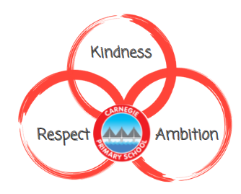

Reviewed January 2024

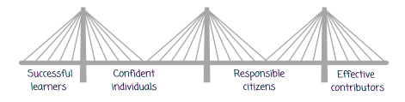

‘Being outdoors is a vital part of growing up and living a healthy and fulfilled life. Outdoor learning benefits children, young people and adults alike. It engages our heart through what we feel and the emotions we experience; our heads through what we think; see and say; and our hands through our physical experiences including how we move through the space the space provides. Outdoor learning can happen anywhere – from school grounds to local greenspace, from the high street, to national parks; from outside your front door to the rest of the world.’
Education Scotland, 2021

Rationale

Outdoor Learning can enhance and integrate a broad range of core experiences across the whole curriculum, not always visible in the classroom – a wide variety of activities which connect our learners with their environment, their community, their society and themselves. Learning outdoors can be enjoyable, creative, challenging and adventurous and helps children learn by experience and grow as confident and responsible citizens who value and appreciate the spectacular landscapes, natural heritage and culture of Scotland.

Definitions of Outdoor Learning
Learning Outdoors simply describes any type of learning that takes place in an outdoor environment. It will rarely require specialist training or equipment.
Outdoor Learning describes an approach to learning that can take place in a variety of outdoor settings. A school or a group of children with an ethos of outdoor learning, will engage in regular opportunities to take learning outdoors.

At Carnegie, we want children to
- participate in a range of progressive and creative outdoor learning experiences
- engage in regular, frequent, enjoyable and challenging opportunities while learning outdoors
- embed outdoor learning experiences across the curriculum so that learning in the outdoor environment becomes a reality

As Outdoor learning will become more regular and frequent, current practice will evolve as more use is made of our school grounds and local areas. Carnegie has vast school grounds to explore and will often be the first step in taking learning outdoors, this will progress to learning contexts further afield such as local woodlands or parks.

Learning Outdoors can motivate our children to become successful learners and to develop as healthy, confident, enterprising and responsible citizens. Outdoor learning can add significantly to children’s learning experience and their achievements and this can be closely linked to the four capacities:

Developing successful learners
- learners will develop their knowledge and skills in ways that add value to their everyday experiences in the classroom
- learning outdoors has the potential to raise attainment and improve attitudes towards the environment
- outdoor learning fosters the development of specific academic skills, as well as improved engagement, achievement and stronger motivation to learn

Developing confident individuals
- outdoor learning can impact positively on children’s attitudes, beliefs, and self-perceptions, for example, independence, confidence and self-esteem
- outdoor learning has benefits of positive behaviour and improved physical wellbeing and fitness.

Developing responsible citizens
- sense of nurture in community with greater sense of place, of belonging and responsibility
- benefits of outdoor learning on social development and greater community involvement
- children develop more positive relationships with each other, with their teachers and with the wider community
- outdoor learning increases knowledge and understanding of the natural world and environmental systems and processes, developing responsible attitudes to the environment.

Developing effective contributors
- positive effects in the short term and continued gains in the long term.
- outdoor learning can impact positively on children’s interpersonal and social skills such as communication skills, group and teamwork

Health and wellbeing
At Carnegie, 5 Ways to Wellbeing is our school approach to promote social and emotional health. In particular ‘TAKE NOTICE’ suggests using the environment and links to nature to support good physical health and emotional wellbeing. Nature can make positive contributions to our health, wellbeing which could be enhanced through learning outdoors. Another 5 Ways to Wellbeing which is relevant is ACTIVE. Learning outdoors inevitably involves physical activity, if not through the learning itself then in travel to the activity (journeying). Outdoor learning opens doors to opportunities to lead physically active lives supporting our physical wellbeing.

Partnership working
At Carnegie, we would welcome any opportunities to work with local businesses or partners within our community. There are many creative and stimulating ways to experience practical activities which may best be achieved by working with partners, working in the school grounds or the local area. We recognised that partnership working will progress and increase outdoor learning experiences for our children. Partners, who may be professionals or volunteers with expertise, can offer us invaluable technical knowledge and guidance and will also help to provide and support Professional Learning opportunities for Carnegie staff. High quality PL for all will be central to the development of successful outdoor learning experiences.

Residential Experiences
In Primary 6 and Primary 7, children have the opportunity to got to Ardroy as their Residential Experience.
Residential experiences refer to educational visits where outdoor learning is the main focus of the experience and which include several overnight stays. This experience offers a completely different range of learning outcomes, particularly those which cannot easily be achieved in the classroom, school grounds or our local community. Spending time away from the home environment gives children opportunities to develop:
- confidence, by living more independently and making their own decisions
- resilience, by having individual and group ownership for learning and community living
- a sense of adventure, by exploring new places and new environments
- an appreciation of the benefits of a healthy lifestyle through physical activity
- a chance to reflect on experiences and learning.

Learning outdoors with Natural Connections
Natural Connections is based on the belief that the best outdoor learning combines adventure skills, personal and social development and learning about the environment. Other important aspects of learning outdoors are the benefits to health, gaining a better understanding of our rights and responsibilities and learning to understand and deal with risk. The Natural Connections programme is designed to offer this balance. Natural Connections uses enjoyable and challenging outdoor experiences to progressively develop skills and understanding.
Natural Connections balances six different outdoor experiences. The different elements of Natural Connections are all connected
- finding your way provides skills that will make journeying successful
- discovering nature helps understanding of the natural world by making connections when developing adventure skills
- working together makes it easier when helping the environment
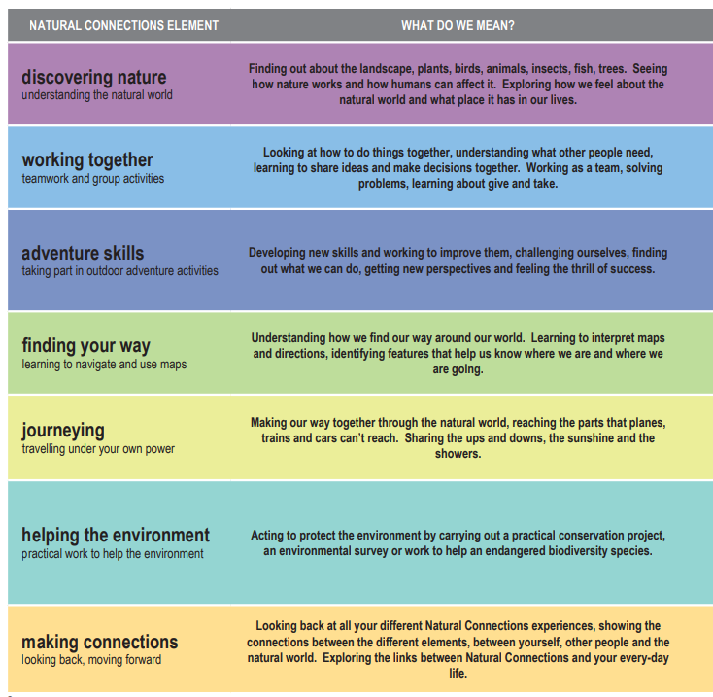

Natural Connections levels of award
Foundations
The Natural Connections Foundations programme is aimed at Primary 1-3 and builds on the Forest Kindergarten experiences encouraging regular opportunities to learn outdoors.
- Participate in 4 elements for at least 5 hours per element
- Time commitment at least 20 hours plus time to produce a record of experiences
- A journey of 2-3 hours is required depending on the age
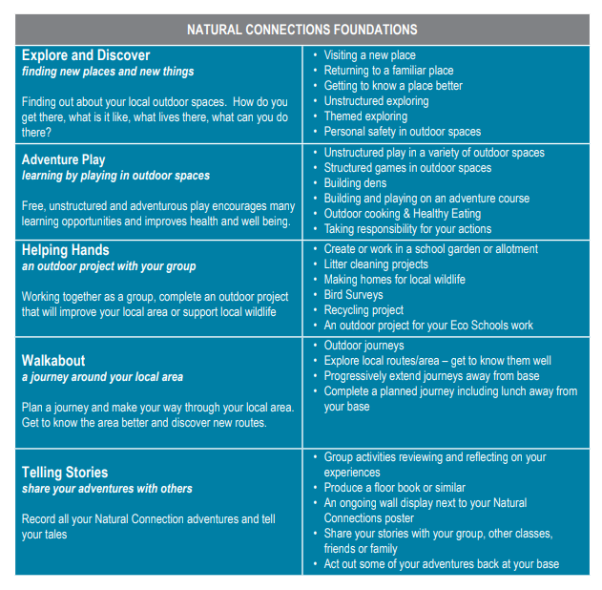
Level 1
Level 1 Is best suited to children in Primary 4-7.
- Participate in activities for the six elements for at least 3.5 hours per element
- Total time commitment at least 30 hours plus time to produce a permanent record of all your experiences
- The Journey element must be completed in one session; it cannot be combined with other elements.
Level 2
Level 2 Is best suited to P6 - S2, transition/secondary education
- Participate in activities for the six elements for at least 7 hours per element
- Total time commitment at least 60 hours plus time to produce a permanent record of all your experiences
- Extra time for planning activities for helping the environment and journeying
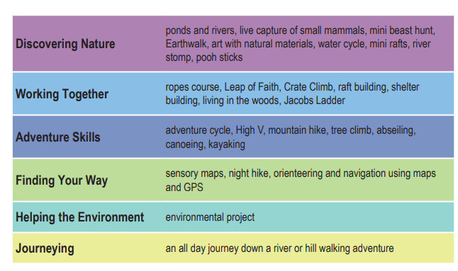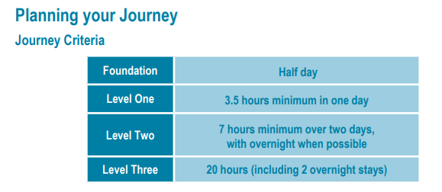

Curriculum
Opportunities for learning outdoors exist within and across all curriculum areas, including the themes for development across learning such as Enterprise Education, Sustainable Development Education and Global Citizenship. In addition to these themes great value is placed on learning outdoors to achieve positive outcomes in Health and Wellbeing and Personal and Social Development. Supporting experiences and outcomes in Health and Wellbeing, Literacy and Numeracy across learning are also the responsibility of all staff at Carnegie. Therefore, outdoor learning offers many opportunities for learners to deepen and contextualise their understanding within curriculum areas, and for linking learning across the curriculum in different contexts and at all levels.
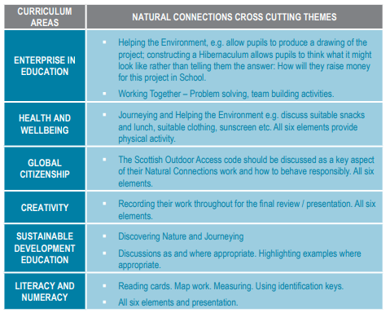

At Carnegie, from Primary 5, classes will engage with the John Muir award
The John Muir Award was set up to
- Promote educational, social and personal development through engagement with wild places and involvement in conservation.
- Encourage an active environmental approach within organisations.
- Ensure that people’s circumstances don’t exclude them from opportunities to experience wild places.
Four Challenges are at the heart of the John Muir Award. They are designed to promote a holistic approach – including awareness, understanding, and action - and reflect John Muir’s wilderness experiences. To achieve a John Muir Award each child engages in a range of activities that meet the following four Challenges
Discover a wild place
Explore its wildness
Conserve it
Share your experiences

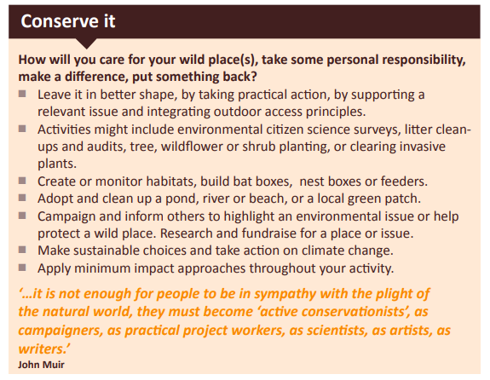
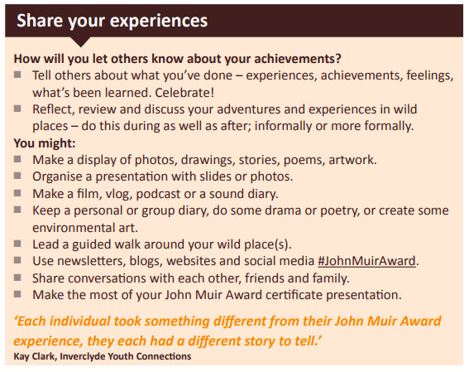
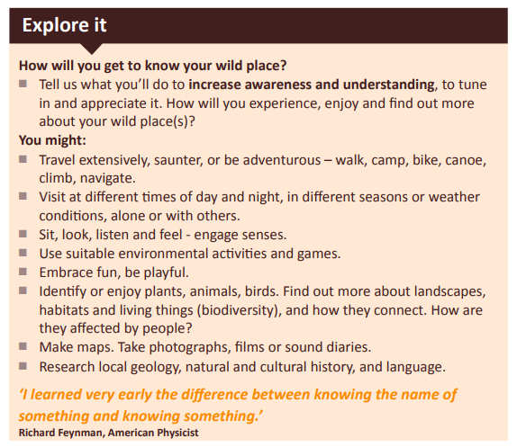
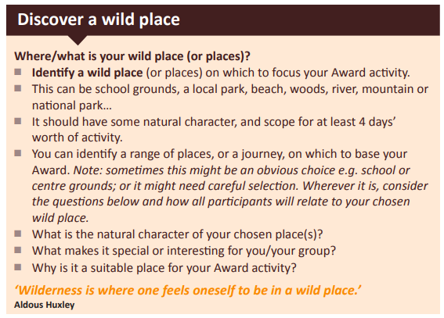

Benefits of John Muir award
- Challenge and adventure from being in wild places.
- Environmental awareness from exploring such areas.
- Knowledge and skills gained from experience in the outdoors and involvement in conservation activities.
- Shared experiences with friends, colleagues and role models.
- Opportunities to take responsibility for change at a local and national level.
- Strengthens character values of cooperation, achievement, challenge, self-esteem…
- Opportunities for active learning.
- Strengthens values relating to care, respect, nature connection, belonging, sense of place, curiosity, responsibility…
- Teamwork skills, from planning, decision-making and completing expeditions, conservation projects etc.
- Confidence and communication skills from sharing experiences and knowledge with a wider audience. n Material to include in CVs, learner profiles and portfolios of work.
- A nationally-recognised certificate for each John Muir Award level attained.
- Helps promote healthy living, physical activity and relaxation

Planning
The Natural Connections Whole School Overview (see appendix), provides a progression through the levels; Foundation, Level 1 and Level 2, incorporates the NC elements and offers suggested teaching and learning experiences.

Working Party
A working party with Carnegie teaching staff with representation across primary stages, will develop a more streamline progression through the primary stages and Natural Connections levels, focussing in particular on accessing a range of Curricular areas while learning outdoors. The working party will promote positive attitudes towards Outdoor Learning across staff and children and finally, ensure we are equipped with what we need to facilitate high quality learning experiences for our learners.

