**Carnegie Primary School**

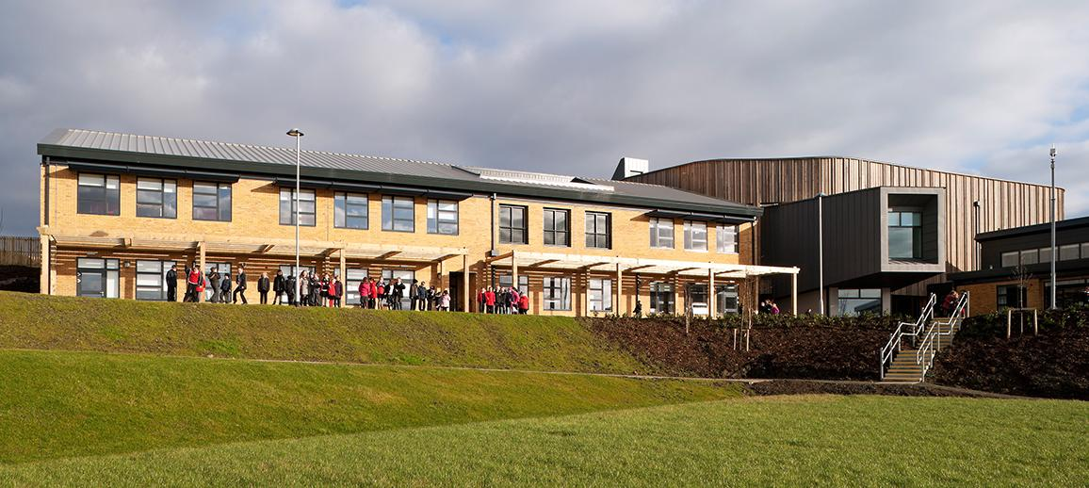

**School Improvement Plan 2023-2024**

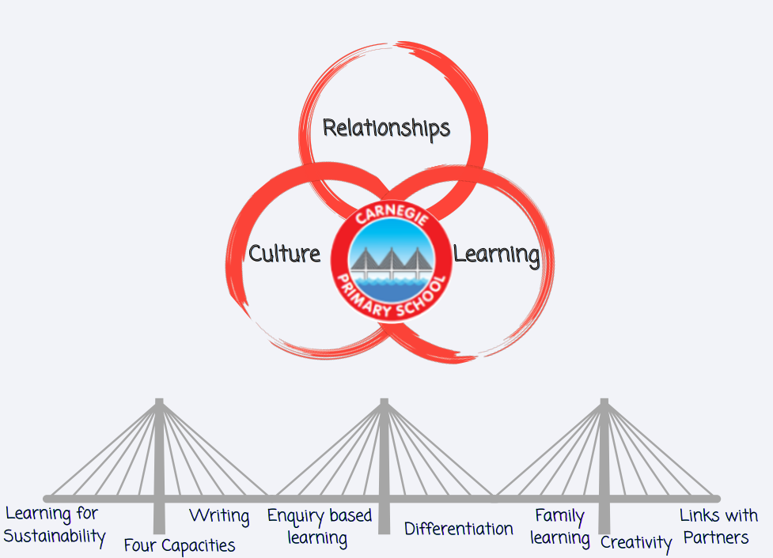

|  |  |  |  |  |  |
| --- | --- | --- | --- | --- | --- |
| * **National Improvement Framework Priority:**   **Placing the human rights and needs of every child and young person at the centre of education.** | | | | | |
| **Focused Priority: Culture: Promoting a strong culture of achievement across the school community built on the four capacities and our school values**  **Create a school and community culture committed to learning for sustainability** | | | | | |
| **HGIOS4 Quality Indicators** | | | **HGIOELC Quality Indicators** | | |
| **Leadership of Learning (1.2)**  **Leadership of Change (1.3)** | | | N/A | | |
| **Expected Impact** | **Strategic Actions Planned** | **Responsibilities** | | **Measure of Success**  ***(Triangulation of Evidence/QI Methodology)*** | **Timescales** |
| A shared commitment to promoting and recognising achievement.  A shared pride in our school’s capacity for improvement and achievements.  4 Capacities embedded as a school community framework for celebrating achievement and used by learners to talk about their own learning pathways  Strong professional collaboration and professional knowledge developed leading to improved outcomes for all learners.  A school and community committed to learning for sustainability  Learners who are responsible citizens and effective contributors with a deeper understanding of global issues and their role in improving outcomes for the future | Embed 4 capacities across our school community to recognise and promote achievement through   * Departmental display boards * House Activities * Huddle focus * Homework tasks * Postcards home   Plan and implement opportunities for individual & whole school achievements.  Inc. John Muir Award, Natural Connections, Bikeability, RRS Gold Award, Green Flag and Kitbag Award  Develop an action plan for achieving the Digital Schools Award  All class teachers to used 4 capacities within 4 Part Model.  Learning Conversations to focus on the language of core skills and 4 capacities  Effective processes in place for learners to profile their own learner journeys.  All teachers to build on previous knowledge and understanding of PI to critically reflect on pedagogy and practice through collaborative enquiry.  Professional dialogue and staff training to enable staff to better understand how to achieve high quality learning for sustainability  Learning opportunities to be provided via:   * Whole school focus days * Huddle focus * Homework tasks * Embedded across the curriculum   Eco-Committee to develop a 3 year action plan focussed on sustainability and Climate Action and to embed this within the School Improvement Framework.  Termly whole school tasks to raise awareness of the key climate issues linked to the Eco Schools Action Plan | DHT- Laura Inglis  Pupil led Achievement Committee  Pupil Council  Parent Council  Shared across staff with leadership roles.  DHT- Laura Inglis  CT-Douglas Webb  IT Working Group  Pupil led Achievement Committee  Pupil Council  Parent Council  All staff  All Staff led by HT  Led by:  Pupil Voice Group  DHT- Laura Inglis  CT-Vicky Gray and Working Group  Supported by:  PT-Sarah Nicolson/ Scott Mitchell (RRS)  Shannon Philp (Pupil Council)  Silvia Kremeyer (ECO) and ECO Committee  Silvia Kremeyer (ECO) and ECO Committee | | Consistent use of language in relation to achievement across the school community.  All staff confident in use of language relating to the 4 capacities and the skills being developed.  All children aware of the 4 capacities and how they develop them  Individual and whole school accreditations achieved  Positive Feedback from all stakeholders  Implementation plan in place to achieve Digital Schools Award  Effective collegiate working with parent group leading to well attended Parent Workshops.  60% parents feedback indicating an understanding of 4 capacities  All learners to have a individual learning profile which captures their learning journey.  80% of learners can articulate their learning journey and relate progress to core skills and the 4 capacities.  All teachers engage in collaborative teaching opportunities.  All teachers to undertake a Collaborative Enquiry  All class teachers can report on impact of CI including quantative and qualitative data relating to a collaborative enquiry.  Feedback from pupils indicates that +80% can articulate our commitment to ensuring learning for sustainability  All parent voice activities contain reference to and promote learning for Sustainability  All parents receive information relating to our commitment to learning for sustainability and 50% parents know what our aims are.  All staff undertake training and can demonstrate an understanding of the school’s commitment to learning for sustainability  Eco-Committee Action Plan updated to show record of progress towards, and achievement of, the Eco Schools Green Flag award  Inclusion of sustainability within curricular and wider school planning. | **August 2023-June 2024**  **Dec 2023 - May 2024**  **November 2023-December 2024** |

|  |  |  |  |  |  |
| --- | --- | --- | --- | --- | --- |
| **National Improvement Framework Priority:**  **Improvement in attainment, particularly in literacy and numeracy**  **Closing the attainment gap between the most and least disadvantaged children** | | | | | |
| **Focused Priority: Relationships: Create a framework for meaningful family learning across the curriculum**  **Develop links with partners and businesses to support and enhance learning and teaching, with a focus on STEM/DYW** | | | | | |
| **HGIOS4 Quality Indicators** | | | **HGIOELC Quality Indicators** | | |
| **Family Learning (2.5)**  **Increasing creativity and Employability (3.3)**  **Leadership of Learning (1.2)** | | | N/A | | |
| **Expected Impact** | **Strategic Actions Planned** | **Responsibilities** | | **Measure of Success**  ***(Triangulation of Evidence/QI Methodology)*** | **Timescales** |
| **Strong partnership with parents and families that enhance learners’ experiences both in and out of school**  **An active and engaged school community**  **Strong links with education partners leading to enhanced experiences for all learners.**  **Ambitious learners who can articulate the choices they have and what they need to do to achieve them.**  **Learners understand and can explain the links between skill for learning and skills for life and work.** | Develop a menu of family learning sessions to be offered and delivered throughout the year   * Family cookery sessions * Family gardening-development of a mini allotment * Family Outdoor Learning * Literacy (1+ 2 French classes) * Family numeracy workshops * HWB and PE family sessions   Offer a variety of format and timings for family learning opportunities  Review home learning model to enhance home/ family learning opportunities  Transition activities planned and implemented for all P5, P6 and P7 pupils to support cluster transition to DLC  Links with business partner Redstart to support Financial Education programme  Re-establish links with Fife college to support STEM learning  Develop links with local business to support STEM learning  Establish partnerships with Skills Development Scotland, Scottish Enterprise and Woodmill High School’s STEM Ambassadors  School Careers Fair organised for September 2023 to bring together the partnership development and learning priorities  Create a menu of opportunities to ensure sustainability and a skills progression to ensure teachers build on prior learning.  Work in partnership with Ardroy to embed outdoor education and John Muir Award across curriculum learning pathways | Avril Foster/Donna Parker  Working Group:  CT- Scott Mitchell  CT- Claire Thomson  CT- Leigh McCrea  PSAs and EYOS to lead key initiatives  Nicola Atherton  Pam Cassley  DHT (Laura Inglis) and HT  PT (Ashley Paterson) to lead working group  DHT (Laura Inglis to lead working group  CT Isla Ferguson | | Active engagement with families happening across the school  40% of families engaging on onsite opportunities across the year.  70% of families engaging remotely through home learning opportunities.  Positive feedback from 98% of families who participate in family learning experiences  Increased engagement (a further 8 families in 2023-24) for family learning that supports our most deprived families in particular (see SAC plan)    Improved attainment for our most deprived learners (a further 2% in 2023-24)  Improved attendance for our identified families (a further 3% in 2023-24)  Positive feedback from learners, teachers and partners.  Active engagement with partners across the school  Enhanced learner experiences in STEM subjects  A progression framework in placed for skills based learning that is used by all teachers.  Evidence of contextual play in classes  Raised attainment in the top 5% of learners (3%)  Improved attainment and engagement  Positive feedback from learners, teachers and families. | August 2023- June 2024  August 2022- August 2024  (To be reviewed/ evaluated termly)  August 2022- August 2024 |

|  |  |  |  |  |  |
| --- | --- | --- | --- | --- | --- |
| **National Improvement Framework Priority:**   **Improvement in attainment, particularly in literacy and numeracy**  **Closing the attainment gap between the most and least disadvantaged children.** | | | | | |
| **Focused Priority: Learning-** ImproveDifferentiation to drive forward pace and challenge in learning  Develop creativity in Learning- Visible learning/critical thinking/collaborative learning/enquiry based/play/project based learning  Raise attainment in Writing  Learning for Sustainability- Embed learning through RRSA, DYW, Outdoor Learning and Financial Education within learning pathways | | | | | |
| **HGIOS4 Quality Indicators** | | | **HGIOELC Quality Indicators** | | |
| Learning, teaching and assessment (2.3)  Raising attainment and achievement (3.2)  Increasing creativity and employability (3.3) | | | N/A | | |
| **Expected Impact** | **Strategic Actions Planned** | **Responsibilities** | | **Measure of Success**  ***(Triangulation of Evidence/QI Methodology)*** | **Timescales** |
| Differentiation in planning and pedagogy which is matched to learners’ needs  Increased focus on the pace and challenge of learning leading to increased attainment for the most able learners.  Improved attainment in writing  Professional knowledge and expertise of staff enhanced by staff training, leading to improved learner experiences in writing.  Effective moderation and assessment of writing to ensure robust data that is aligned to learners’ progress.  An enquiry-based framework for learning across all stages that promotes creative, play based approaches to learning increasing pupil participation and engagement in learning.  Staff development and training leads to consistently high-quality learning experiences in writing  that build on prior learning.  .  Increased teacher confidence delivering quality experiences linked to Learning for sustainability  Improved participation and engagement in learning for sustainability  Learners who are Effective Contributors and Responsible Citizens | Staff training and professional dialogue.   * Referencing Sue Crawley- The Ultimate Guide to Differentiation * Dylan Williams/Shirley Clarke * Input from Fife QAMSO * Moderation focus * Peer class visits   Staff training and professional dialogue   * Use of SEIC resource to support pedagogical approaches * Increased focus on symbolic play and emergent writing in the early years. * Staff training using the ‘Writing Bundle’   Promote writing across the community:  Writing festival/Author visits  Writing given increased profile  Entry to Writing competitions, including the Rotary Young Writers Award  Develop a Carnegie Anthology 2024.  Staff training and professional dialogue.   * John Hattie-Visible Learning * Andy Griffiths/Mark Burns- Teaching Backwards * Moderation focus * Peer class visits * Collegiate working with Dalgety Bay PS * Collaborative Enquiry by CTs   Embed learning for Sustainability across learning pathways to identify cross-curriculum links and opportunities for interdisciplinary learning | DHT- Avril Foster  PT- Sarah Nicholson  Professional Learning Working Groups  CT- Vicky Gray  Working Group | | Differentiation evident in all classes  Planning evidences differentiation of learning and challenges the most able learners.  Increased challenge evidenced by improved attainment of most able learners (additional 3 months progress for 10% of those ahead of expected level)  Positive learner and parent feedback  Attainment of Writing at all stages increased by 3%  Quality and diversity of writing approaches evident through, Pace and Progress meetings, class observations and jotter monitoring  Positive feedback from pupils  Improved self-esteem for learners in relation to their writing  Feedback from Learners indicates a more ‘can do’ attitude. Improvement of 15%  Classroom observations evidence enquiry-based learning as a meaningful and challenging part of the learning process.  90% of children reporting they feel challenged in their learning  90% of children can articulate the core skills they are developing, how they relate to the 4 capacities and how they contribute to learning, life and work.  Improved attainment for the top 5% of our learners  Increased motivation and participation for those currently off-track and a 3% reduction in the attainment gap.  80% staff reporting increased confidence in the teaching of an enquiry-based approach.  90+% staff indicate increased confidence in delivering on learning for sustainability  90+% of children can articulate what learning for Sustainability is and what learning they have experienced over the school year.  65% learners can talk confidently about why learning for sustainability is important. | August 2023-  January 2024  August 2023-December 2023  January 2024-December 2024 |