Carnegie Primary School

Family Engagement Statement

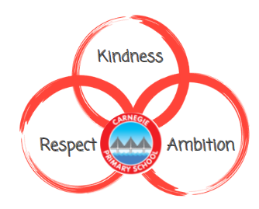

September 2022
Reviewed August 2023

‘Parents, carers and families are by far the most important influences in a child's life. Their support can play a vital role at all stages of their child’s education. Attention should also be given to the parent’s own learning journey. This will support parents to be able to meaningfully engage in their child’s learning and life at school, whilst enhancing their own educational skills and employment opportunities.’
(Education Scotland, 2017)

‘Family learning is a powerful method of engagement and learning which can foster positive attitudes towards life-long learning, promote socio-economic resilience and challenge educational disadvantage.’

(Scottish Family Learning Network, 2016)

Rationale

It is recognised that the first and foremost educators of any child are there parents and the most effective way to support our children and young people is for schools and families to work together in close partnership.
Research suggests that if a family member engages with a child’s education at an early stage, they are more likely to be actively involved throughout their child’s school career, leading to increased engagement and attainment for the child. This can also have a positive impact on the whole family (Family Learning Framework, 2018). Family Learning will allow children to develop skills such as self-reflection, communication and cooperation as well as enhancing confidence and providing opportunities to celebrate learning and achievements.

In Carnegie Primary School we strive to ensure our family learning opportunities meet the needs of all our families. Through regular opportunities to participate in events within the school we provide families with an insight to their child’s school experience. These opportunities are designed to be fun and hands on with adults and children learning and sharing experiences together.

This statement aims to set out how we can effectively involve our parents and families in the life of our school and engage them in a meaningful way in their child’s learning and education.
Our overall aims are in line with the objectives of the Scottish Government in that we aim to empower parents and families to be:
- involved with their children’s education and learning
- welcomed as an active participant
- encouraged to express their views on all matters relating to education

Key Aims of Family Learning at Carnegie Primary School

- Children will have opportunities to share and celebrate the work they do at school and their wider achievements
- Children will talk more openly about their learning and their education with their families
- Families will gain an insight to what and how their children learn at school in each area of the curriculum
- Families will feel increasingly empowered to help support their child’s learning at home
- A strong link will be formed between a child’s home and school
- Families will feel comfortable with our open doors policy and experience no barriers to their child’s education
- Children and adults will be motivated and engaged in their learning throughout the curriculum
- Children will feel comfortable working with a range of adults and peers in the school environment
- Children and adults will enjoy the family learning experiences they share together

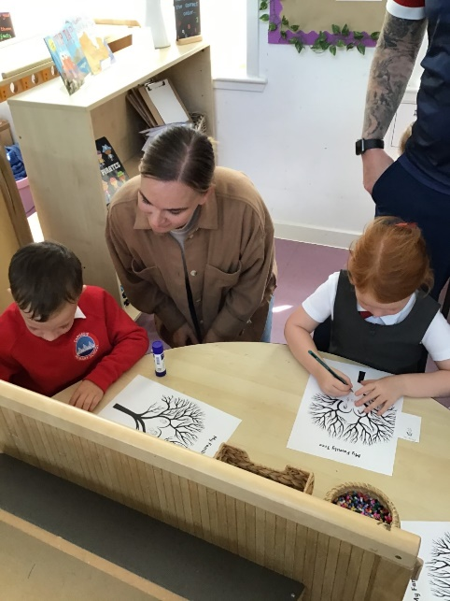
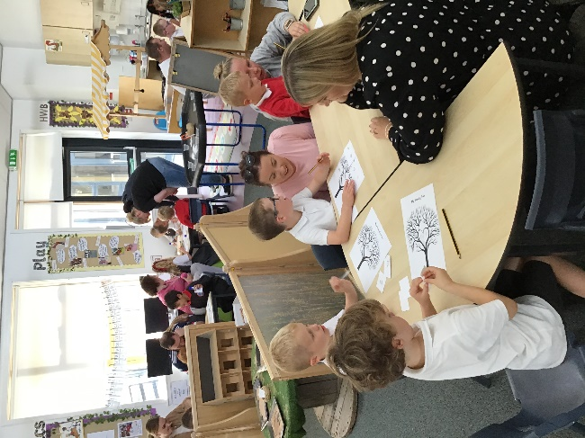

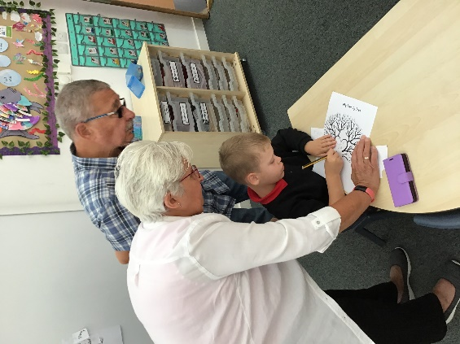

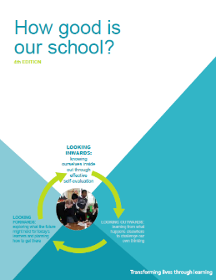
Implementation of Family Learning

HGIOS 4 – ‘How Good is our School states’ that:

Families should receive high-quality universal and targeted support that enables them to access learning activities which meet their needs. Universal support should be open to all families.

Families should have regular opportunities to discuss their learning with staff and set appropriate targets for the next stages. Families should be well supported to plan opportunities for personal achievement.

Parents and carers must be supported to actively and meaningfully engage in their children’s learning and life at school. Staff should work with parents and carers to reduce potential barriers to engagement and are responsive to the family circumstances.

Family Learning at Carnegie Primary School

We ensure:
- Regular ‘shared finish’ opportunities will be offered on a variety of days to allow families to share children’s learning in their classes.
- A range of nursery parent groups will be run on a weekly basis.
- Family workshops are offered to provide information about school development themes and inform parents about current learning across the curriculum.
- Topic based ‘open days’ and ‘exhibitions’ are held to allow children to share their learning with their families.
- P1 transition programme will allow a smooth transition from nursery groups and will extend to support families throughout their child’s first year in school. This will include formal, informative workshops on a range of subjects as well as informal, fortnightly opportunities to share in learning within the classroom environment.
- Our early year Family Learning Programme offers a variety of family learning opportunities including outdoor education opportunities.
- Staff will strive to think of creative and innovative ways to make family learning a fun, worthwhile and meaningful experience for all. Staff will always value feedback from families and use this to inform their ideas.

Impact:

‘Parental engagement is recognised in the National Improvement Framework as one of seven key drivers in achieving excellence and equity in Scottish education. The engagement of parents and families can help raise attainment for all and help to ensure every child has an equal chance of success.’
(Education Scotland, 2018)

- Increased opportunities for families to be involved with children’s learning
- Positive relationships built between home and school
- Families empowered to support children’s learning at home
- Families have an increased understanding of each curriculum area
- Children have regular experience of family members being in their school environment
- Increased dialogue about children’s learning at home
- Children’s learning achievements are shared and celebrated
- Children and families motivated and engaged in all learning experiences
- Positive, supportive relationships built between families in the community

What can families do?
At Carnegie we support and encourage our families to be actively involved in all aspects of their child’s education.

- Give us your thoughts
Support family learning by working in partnership with the school, providing feedback on existing family learning and sharing suggestions for future ideas. We want to hear from you!
- Show an active interest
Encourage children by showing an active interest in their school career.
- Spend time talking
Talk regularly with your children about school and their thoughts and feelings about learning.
- Attend school events whenever you can
Don’t feel guilty if this isn’t always possible! Remember that Grannies’, Grandads, Aunts, Uncles and older siblings can always be sent as representatives too!
- Model learning at every opportunity
Families are by far the biggest influence in a child’s life. Chances are if they see you enjoy learning they will too!
- Come and speak to us
Remember we have an open door policy and no problem is too big or small to share.

