Carnegie Primary School

Digital Technologies Statement

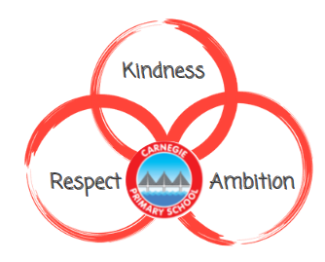

August 2022
Reviewed August 2023

“Digital Literacy should be placed at the heart of all learning, not only the technologies area of the curriculum. Digital literacy outcomes could be met in any/all curriculum areas and so all practitioners can contribute to and reinforce them”
(Education Scotland, 2017)

Rationale

Digital technologies have transformed almost every aspect of our lives and we recognise that we have a responsibility to ensure all of our learners are developing strong digital skills for life.
This statement aims to set out how we can effectively integrate technology into classrooms to have the most powerful impact on our learning and teaching and to make sure we are applying technologies selectively and flexibly to complement our current teaching strategies.
Our aims are in line with the objectives of the Scottish Government in that we aim to develop skills and confidence in both educators and children to ensure digital technologies can support learning in the most effective ways. We want to improve access to digital technologies for all learners and ensure that it is a key consideration in all areas of the curriculum.

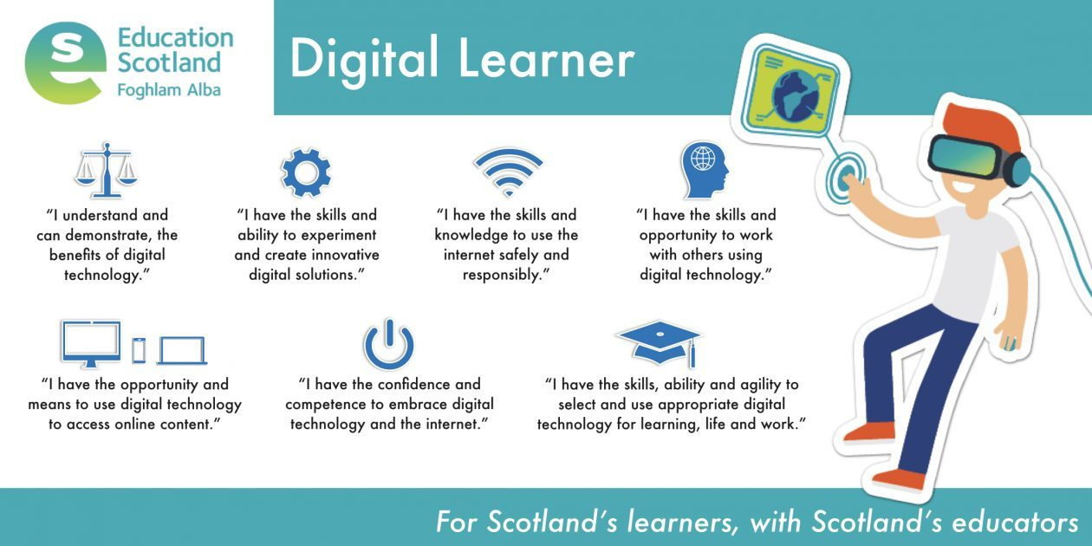

Digital Skills:
Our aim at Carnegie is for children to leave with “Digital Intelligence”. This is the set of social, emotional and cognitive abilities that will enable them to face the challenges and adapt to the demands of digital life. As you can see from the diagram on the right, Digital Intelligence can be broken down into eight interconnected areas:
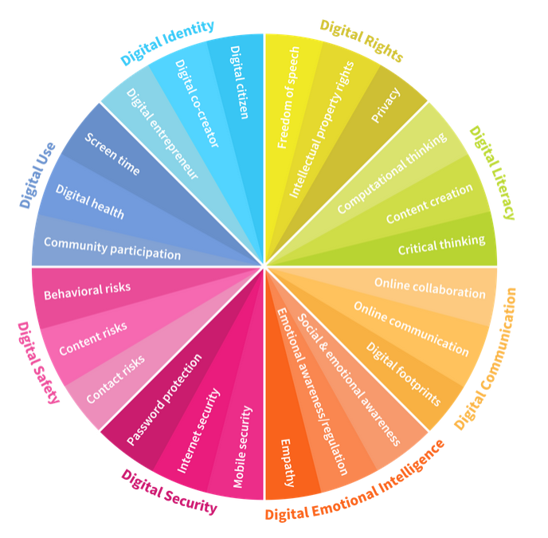
IDENTITY: The ability to create and manage an online identity and reputation. This includes an awareness of your online ‘persona’ and understanding of the short-term and long-term impact of decisions made online
USE: The ability to use digital devices and media, including having an awareness of the healthy balance between life online and offline
SAFETY: The ability to manage risks online (e.g. cyberbullying, grooming) as well as problematic content (e.g. violence and obscenity), and how to avoid and limit these risks
SECURITY: The ability to detect cyber threats (e.g. hacking, scams, malware), to understand best practices and to use suitable security tools for data protection
EMOTIONAL INTELLIGENCE: The ability to be empathetic and build good relationships with others online
COMMUNICATION: The ability to communicate and collaborate with others using digital technology
LITERACY: The ability to find, evaluate, utilise, share and create content as well as competency in computational thinking
RIGHTS: The ability to understand and uphold personal and legal rights, including the rights to privacy, intellectual property, freedom of speech and protection from hate speech.

Planning Considerations

Although there are areas of the Technologies curriculum that can be delivered separately (e.g. Coding/Computing Science), ‘Digital Technologies’ should NOT be considered as a standalone subject. Instead, digital skills should be taught regularly and embedded through other areas of the curriculum in order to give them meaning and purpose. Some examples of how lessons can be adapted have been given below.

Previous Lesson: We are learning to create a presentation using PowerPoint.
Adapted: Creating a poster about a research topic where you can introduce different aspects of PowerPoint as they are needed, rather than all at once.

Previous Lesson: We are learning to touch type.
Adapted: Spelling activity where children use Pages/Word to type out their spelling words where guidance can be given about hand position as part of it.

SAMR Model:

During planning sessions, both termly and weekly, a key question that should be asked is: ‘Could we use technology to enhance these lessons?’. At Carnegie we encourage the use of the SAMR Model to determine whether the technology application is enhancing or transforming the learning.

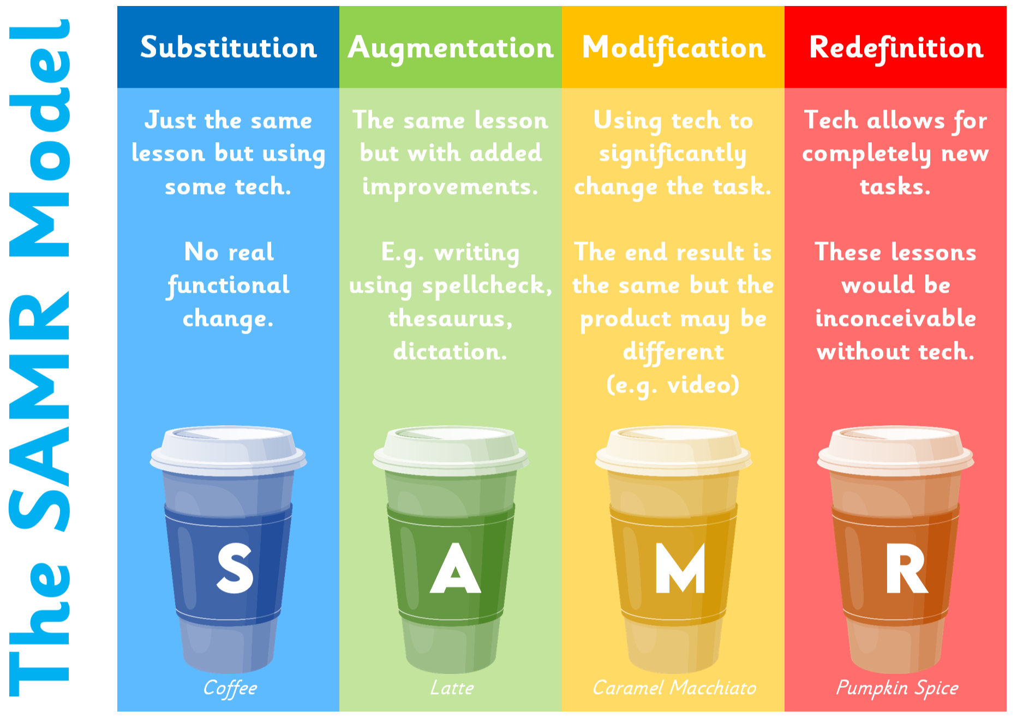

Learning Pathways
At Carnegie we understand that, unlike some other curricular areas, learning pathways are not fixed or linear when it comes to digital technologies. Using the benchmarks, we recognise that there should be a continuing focus on digital skills and ensure that learners are demonstrating these effectively ACROSS the curriculum.
Microsoft 365 Accounts:

Children are given access to individual Microsoft 365 accounts. These accounts are accessible from school and home and provide children with access to the Microsoft Office suite of apps including Word, PowerPoint and Excel.
Using Microsoft 365 gives children the opportunity to save, share and collaborate on work with peers and their teachers as well as develop skills in new apps such as OneNote, Sway and Forms. They will also begin to use emails using the Outlook app.

Digi - Leaders
The ‘Digi- Leaders’ are a pupil group consisting of pupils from P4 upwards.
The group meet regularly with a member of the Digital Working Group and they take a lead role in developing the use of technology at Carnegie.
Some of our older pupils are also trained as ‘technicians’ which allows them to help out with the regular maintenance of our devices and also solve numerous problems (e.g. wi-fi issues). They can then use this knowledge to provide support to others in the school – staff as well as children!

Continuing CLPL
There are links to a variety of suggested websites and resources, many of which will be found within Microsoft 365 within GLOW in the teams Fife CPD and e-Learning Team site so it is advised that staff who do not already use GLOW, should consider this an area of development for moving forward.
Within the Fife Council Microsoft “Teams” site there are areas where teachers can chat, collaborate and share examples of good practice and pitfalls. These resources will continue to increase as the use of the GLOW site grows and develops.

Useful links and websites:

Fife Council GLOW – Fife Digital Learning
https://glowscotland.sharepoint.com/sites/FifeCouncil/FifeDLT/SitePages/Home.aspx#?wa=wsignin1.0

- What Digital Learning Might Look Like (Education Scotland, 2020)
https://education.gov.scot/media/uh2jebbs/nih158-what-digital-learning-might-look-like.pdf

- Features of Highly Effective Digital Learning, Teaching and Assessment in Schools (Education Scotland, 2022)
https://education.gov.scot/media/cxwnqrma/nih312-features-of-highly-effective-digital-learning-and-teaching-01-22.pdf

- Enhancing learning and teaching through the use of digital technology (Scottish Executive, 2016)
https://www.gov.scot/binaries/content/documents/govscot/publications/strategy-plan/2016/09/enhancing-learning-teaching-through-use-digital-technology/documents/00505855-pdf/00505855-pdf/govscot%3Adocument/00505855.pdf?forceDownload=true

- Digital Strategy (Education Scotland, 2019)
https://education.gov.scot/Documents/ESDigitalStrategyJune2019.pdf

