Carnegie Primary School

Child Protection Policy

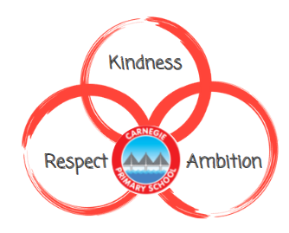

March 2022
Reviewed August 2023

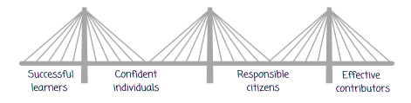

What is Child Protection?

At Carnegie Primary School, the needs of the children are at the centre of what we do – to safeguard them from harm or at risk of being harmed.
We aim to:
- keep them safe
- minimise their risk of harm
- improve their wellbeing
- build a positive, trusting relationship with the children, our families and community.

We believe that our values and aims are achieved when:
- We create a calm, safe and happy learning environment.
- We create a consistent approach where clear boundaries and expectations are established, understood and accepted throughout the school by all members of the learning community
- All children and staff show and demonstrate a care and respect for each other.
- Ensure children are listened to, loved and cared for in a way that makes them feel respected and nurtured.
- There is a good understanding of needs and being responsive to them.
- Each child is seen as an individual and encouraged to reach their full potential.
- Parents and school are in partnership to help children and families who need support.
- School and outside agencies, eg social work, are in partnership to help our most vulnerable families.

Staff, parents and visitors all have a responsibility with Child Protection. Safeguarding is everyone’s responsibility.

At Carnegie Primary School it is the responsibility of all adults to be aware of different forms of child abuse and neglect. Staff at Carnegie Primary School are aware of and understand the following:

Child abuse and child neglect

Abuse and neglect are forms of maltreatment. Abuse and/or neglect can happen anywhere and by anyone. It may involve inflicting harm, failing to act to prevent harm or failing to provide care and support.

Types of abuse and neglect

- Physical abuse
- Emotional abuse
- Sexual abuse
- Criminal exploitation
- Child trafficking
- Neglect
- Female genital mutilation
- Forced marriage

Physical abuse
Physical abuse is the causing of physical harm to a child or young person. For example, hitting, shaking, drowning, poisoning, scalding etc. Physical harm may also be caused when a parent or carer feigns the symptoms of, or deliberately causes, ill health to a child. Cultural sensitivity must not deflect practitioners from a focus on a child’s essential needs for care and protection from harm.

Emotional abuse
Emotional abuse is the persistent emotional ill treatment that has severe and persistent adverse effects on a child’s emotional development. Emotional abuse is present to some extent in all types of ill treatment of a child, but it can also occur independently of other forms of abuse.

Neglect
Neglect is the persistent failure to meet a child’s basic physical and/or psychological needs. These can be:
- Physical
- Educational
- Emotional
- Medical

When there is a CP concern, this should be shared with Child Protection Coordinators and/or a member of the SLT following Carnegie PS procedures.

Care Experienced Children
Everyone at Carnegie Primary School has an awareness and understanding of the care and support available for Care Experienced children. Children who are care experienced will be supported in one or more of the following ways:
- At home: cared for by a relevant person or primary carers.
- Kinship Care: where the child is placed with someone whom the child is related to.
- Foster: cared for by a person approved by the local authority as suitable.
- Residential: to ensure the needs of the children are met when they cannot live with their own family and when foster placement is not an option. Typically run by local authorities to ensure children are in their own communities.

The Promise: Scotland
In October 2016, the First Minister made a commitment that Scotland would “come together and love its most vulnerable children to give them the childhood they deserve.”

It is vital that this is everyone’s responsibility.

The following 5 foundations must be at the heart of how Scotland thinks, plans and priorities for children and their families.
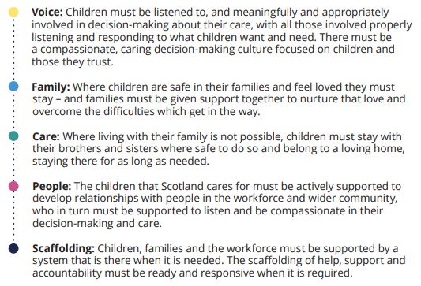

Ready and Responsive Support
At Carnegie, we feel it is important that children and their families will be listened to, respected, involved and heard in decisions that affects them.
Carnegie staff will be supported to provide the support children and their families need to flourish.

At Carnegie we aim to support children who are care experienced by:
- minimise barriers to allow them to engagement with education
- build positive relationships
- value and recognise their individual needs
- ensure robust tracking of attendance and attainment so there is early support intervention
- children will always have consistent and responsive access to a person of trust throughout their journey at Carnegie
- committed to ensuring that care experienced children will have all they need to thrive at school
- support children’s transitions to high school to ensure continuity of a positive destination

Social Media and Internet Safety
For the purposes of this policy we have adopted Fife Council’s definition of social media as follows:
Online communication including social media and social networking sites has become an extremely well-used and important communications channel. Social media is the term commonly given to web-based tools which allow users to interact with each other by sharing information, opinions, knowledge and interests online.

Agreed expectations from pupils and staff based on Curriculum and school values to ensure safety online:
Pupils
- Engage in annual focus week on Internet Safety
- Responsive teaching of Internet Safety during ICT and within other areas of the curriculum.
- Engage in Community Police visits to reinforce Internet Safety
- If a mobile phone is deemed necessary, parents must be aware that it is the parent and child’s responsibility and children must follow school procedures

Staff
- Staff should avoid accessing social media from any workplace computer
- Ensure the highest privacy settings are enabled across all of your social media and review these regularly.
- should be mindful that they have a professional duty to uphold when working for Fife Council and Carnegie Primary School. When using social media, be mindful of what they choose to post.
- Do not accept friend requests from pupils, current and ex, or parents to the school
- Maintain your professional conduct on social media at all times
- Be mindful that extended periods of screen time, may have a detrimental effect on your own mental wellbeing. Prioritise your work-life balance.

This policy will be reviewed August 2023.

