Carnegie Primary School

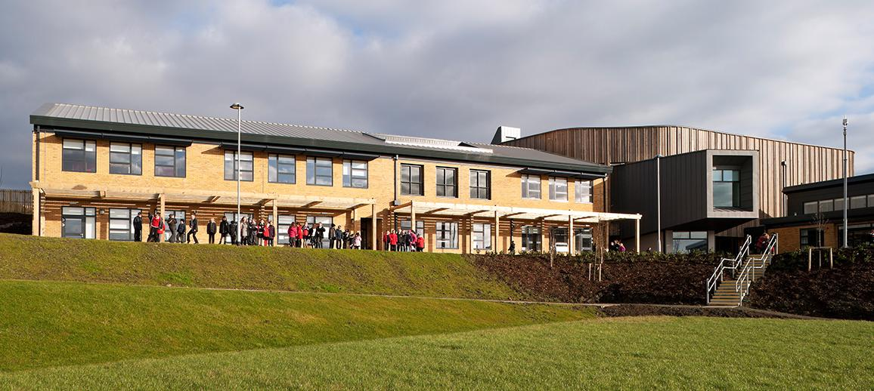

School Improvement Plan 2022-2023

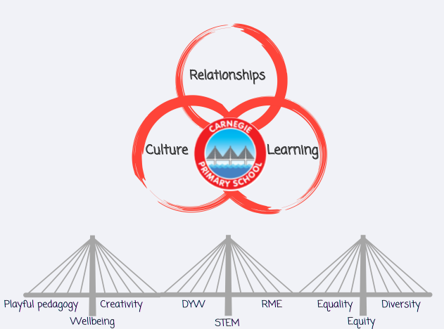

National Improvement Framework Priority: Improvement in children and young people’s health and wellbeing

Focused Priority: Culture: Promoting a strong culture of wellbeing across the school community
Building a culture of collaborative teaching and learning
Develop our learners’ autonomy to improve motivation and sense of wellbeing
HGIOS4 Quality Indicators |  |  | HGIOELC Quality Indicators
Improving Wellbeing, equality and inclusion (3.1)  Leadership of Learning (1.2)  Leadership of Change (1.3) |  |  | N/A
Expected Impact | Strategic Actions Planned | Responsibilities |  | Measure of Success  (Triangulation of Evidence/QI Methodology) | Timescales
A shared commitment to improving our mental health and wellbeing.  5 Ways of Wellbeing recognised as a school community approach to wellbeing by staff, families and pupils.  Improved wellbeing across the school community leading to improved engagement and attendance  Strong professional collaboration and professional knowledge developed leading to improved outcomes for all learners.  Children can articulate an understanding of what autonomy is and how they can use theirs effectively  Pupils to be more autonomous in their interactions and experiences while at school.  A school and community commitment to equality and diversity.  All members of our community feel valued and included  Learners begin to develop an understanding of climate issues within the school and wider community.  Eco Committee to lead work towards developing an Action Plan focussed on Climate Action and 2 other topics | Implement 5 Ways of Wellbeing across our school community to support pupil wellbeing  - Whole school focus days  - Huddle focus  - Homework tasks  - Embedded in HWB Curriculum  Work collegiately with parent groups to promote a school community approach to health and wellbeing  Programme of Health and Wellbeing activities to meet staff needs and promote positive wellbeing.  All teachers to build on previous knowledge and understanding of PI to critically reflect on their own pedagogy and practice through a critical friend buddy system.  Professional dialogue and staff training to enable staff to better understand how we will collegiately achieve more autonomous learners.  Learning opportunities to be provided via:  - Whole school focus days  - Huddle focus  - Homework tasks  - Embedded in HWB Curriculum  Form a Pupil Voice Group to identify what is important to our learners and promote equality and diversity  Ensure that Equality and Diversity is a theme threaded through all parent voice activities  Eco-Committee to develop an action plan focussed on Climate Action and to embed this within the School Improvement Framework. Termly whole school tasks to raise awareness of the key climate issues linked to the Eco Schools Action Plan | DHT- Donna Parker  HWB Staff Group (school & nursery)  Pupil led HWB Committee  DHT (Donna Parker) led Parent Group  Pupil Reps from HWB Committee  HWB Staff Group (school & nursery)  All staff  All Staff led by DHT  (Donna Parker)  Led by:  Pupil Voice- Laura Inglis  E and D- Donna Parker  Supported by:  Sarah Nicolson (RRS)  Shannon Philp (Pupil Council)  Vicky Gray (ECO)  Vicky Gray and  ECO Committee |  | Consistent use of language in relation to health and wellbeing across the school community.  All staff confident in use of language  All children aware of the 5 Ways and how they use them  Effective collegiate working with parent group leading to well attended Parent Workshops.  50% parents feedback indicating an understanding of 5 Ways to Wellbeing  Improved health and wellbeing across our staff team including improved attendance (2%)  All teachers engage in a collaborative teaching opportunity with their teaching buddy  75% staff providing positive feedback on buddy system  Class teachers can report on impact of PI including quantitive and qualitative data relating to a practitioner enquiry.  Revisit questions from Glasgow Motivation and Wellbeing Profile.  +80% of learners to identify this as a strength  Feedback from children indicates that +80% can articulate what autonomy is and how they can use theirs effectively  Feedback from pupils indicates that +80% can articulate our commitment to ensuring equality and diversity  All parent voice activities contain reference to and promote equality and diversity  All parent receive information relating to our commitment to equality and diversity  All staff undertake training and can demonstrate an understanding of the school’s commitment to Equality and Diversity  Eco-Committee Action Plan updated to show record of progress towards, or achievement of, the Eco Schools Green Flag award  Raised awareness of sustainability and climate issues within the school and community.  Promotion of sustainability within curricular and wider school planning. | February 2023  March 2023  Reviewed termly  Reviewed termly  Reporting May 2023  August 2022-June 2023  June 2023  December 23  (feedback May 23)  Reviewed termly  School feedback task May/June 2023  May/June 2023

National Improvement Framework Priority: Improvement in attainment, particularly in literacy and numeracy
Closing the attainment gap between the most and least disadvantaged children

Focused Priority: Relationships: build strong links with partners and businesses to support and extend learning and teaching, particularly linked to STEM
Re-establish family learning onsite with a focus on our hardest to reach families (see SAC plan)

HGIOS4 Quality Indicators |  |  | HGIOELC Quality Indicators
Family Learning (2.5)  Increasing creativity and Employability (3.3)  Leadership of Learning (1.2) |  |  | N/A
Expected Impact | Strategic Actions Planned | Responsibilities |  | Measure of Success  (Triangulation of Evidence/QI Methodology) | Timescales
Strong links with education partners leading to enhanced experiences for all learners.  Ambitious learners who can articulate the choices they have and what they need to do to achieve them.  Learners understand and can explain the links between skill for learning and skills for life and work.  Increased parental involvement in learning experiences.  A skills progression framework in place and used by class teachers to ensure progression in learning.  Strong links with parents and families that enhance learners’ experiences both in and out of school  An active and engaged school community | Transition activities planned and implemented for all P5, P6 and P7 pupils to support cluster transition to DLC  Links with business partner Redstart to support Financial Education programme  Re-establish links with Fife college to support STEM learning  Develop links with local business to support STEM learning  Establish partnerships with Skills Development Scotland, Scottish Enterprise and Woodmill High School’s STEM Ambassadors  School Careers Fair organised for September 2023 to bring together the partnership development and learning priorities  Create a menu of opportunities to ensure sustainability and a skills progression to ensure teachers build on prior learning.  Re-establish universal family learning opportunities previously in place (eg. Bookbugs, PEEPs, bedtime stories, curriculum workshops)  Audit families to identify what families want and what we can offer.  Develop a sustainable menu of family learning sessions to be offered and delivered throughout the year with a focus on skills for learning, life and work. (eg. cookery sessions, gardening, literacy and numeracy learning) | DHT (Laura Inglis) and HT  PT (Ashley Paterson) to lead working group  DHT (Laura Inglis to lead working group  DHT (Laura Inglis) to Lead working group  DHT (Laura Inglis) to Lead working group  DHT (Laura Inglis) to Lead working group  DHT (Laura Inglis) to lead working group  PSAs, EYOS and DHTs(Donna Parker and Avril Foster) to lead working party |  | Feedback from learners, teachers and partners.  Active engagement with partners across the school  Enhanced learner experiences in STEM subjects  A progression framework in placed for skills based learning that is used by all teachers.  Evidence of contextual play in classes  Raised attainment in the top 5% of learners (3%)  Improved attainment and engagement  Positive feedback from learners, teachers and families.  Families identify what family learning should look like  Active engagement with families happening across the school  Enhanced learner experiences in core skills  A framework in placed for family learning that that supports our most deprived families in particular (see SAC plan)  Improved attainment for our most deprived learners (3%) and engagement  Improved attendance for our identified families (5%) | August 2022- August 2024  (To be reviewed/ evaluated termly)  August 2023  August 2022- October 2022  September 2022  August 2022- May 2023

National Improvement Framework Priority: Improvement in children and young people’s health and wellbeing
Closing the attainment gap between the most and least disadvantaged children

Focused Priority: Learning- staff training and professional learning to develop creativity and core skills at all stages
Complete and implement progression pathways developed last session (listening and talking, 1+2, Expressive Arts)
Introduce and implement progression pathways for RME and STEM subjects with a focus on skills development
Collaborative learning approaches introduced across the school.

HGIOS4 Quality Indicators |  |  | HGIOELC Quality Indicators
Curriculum (2.2)  Learning, teaching and assessment (2.3)  Raising attainment and achievement (3.2)  Increasing creativity and employability (3.3) |  |  | N/A
Expected Impact | Strategic Actions Planned | Responsibilities |  | Measure of Success  (Triangulation of Evidence/QI Methodology) | Timescales
Increased pupil participation and engagement in learning.  Consistently high-quality learning experiences in expressive arts, 1+2 and listening and talking  that build on prior learning.  Teachers who are more creative in their pedagogy  Learners accessing more creative approaches to learning and supported to develop core skills through application in STEM subjects and high-quality play.  Children challenged to develop and deepen their learning through high quality contextual learning  Increased teacher confidence delivering quality science that builds on prior learning  Improved participation and engagement in RME as a result of a consistent progression pathway and teacher knowledge. | Working Group to complete progression pathways for all staff  Staff to pilot effectiveness of progression pathway, review in November towards full implementation in Term 3  Audit staff knowledge and confidence re delivering creativity and a play-based approach to learning. Undertake professional learning and professional dialogue.  Introduce and implement Playful pedagogy approaches across all classes  Link play pedagogy to skill development and create a framework to be used across the school.  Promote the develop of creativity in the classroom to extend learners experience and challenge able learners.  Collaborative learning approaches used in class to enhance pupil engagement  Engagement in Redstart to develop Financial education across the upper school  Review and develop our progression pathway for Science  Staff training to build confidence in teaching Science and Technology  Review and develop our progression pathway for RME  Staff training to build confidence in teaching RME | Working Groups led by:  Ruth Robertson, Isla Ferguson (Ex Arts)  Sarah Hutcheson (1+2)  Sarah Nicholson  (Listening and Talking)  DHTs (Laura Inglis/Avril O’Donnell)  Supported by working group:  Kayleigh Braid  Shannon Philp  Lindsay Gallagher  Andy Callaghan  Julie Munro  Working Group to be established  Working Group:  Ruth Robertson  Zoe McWilliam  Sarah Hutcheson |  | Consistent learning and teaching in all classes.  All staff using progression pathways that build on prior learning.  Increased challenge evidenced by improved attainment and achievement.  Positive learner and parent to feedback  Classroom observations evidence play as a meaningful and challenging part of the learning process.  90% of children reporting they feel challenged in their learning  90% of children can articulate the core skills they are developing and how they contribute to learning, life and work.  Improved attainment for the top 5% of our learners  Increased motivation and participation for those currently off-track and a 3% reduction in the attainment gap.  80% Staff reporting increased confidence in the teaching of core skill though play pedagogy and STEM subjects.  Positive feedback from and about Redstart programme.  100% of staff using a science progression pathway that builds on prior learning  80% staff reporting increased confidence in the teaching of science.  Parent and pupil feedback evidence more and better opportunities to learn through science. (+60%)  100% of staff using an RME progression pathway that builds on prior learning  80% staff reporting increased confidence in the teaching of RME.  Parent and pupil feedback evidence more and better opportunities to learn through RME. (+60%) | August 21-November 2022  December 2022-  December 2023  January 2023-August 2023  January 2023-August 2023

