Carnegie Primary School

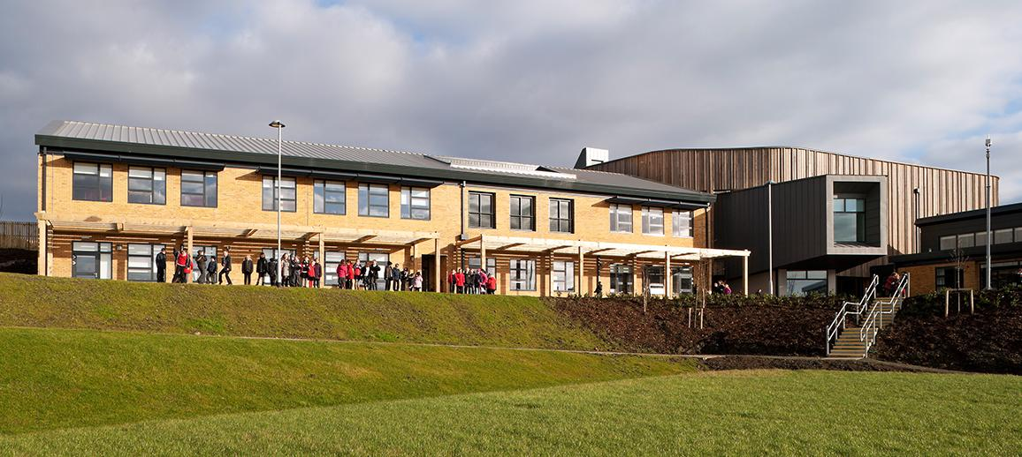

Scottish Attainment Challenge Plan 2022-2023

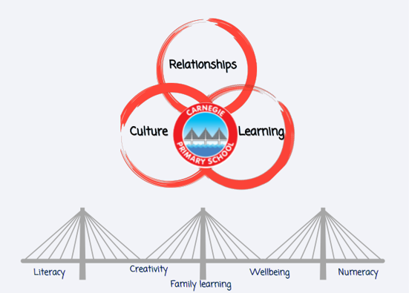

Learning - Attainment Fund Rationale  - Improvement in attainment across Literacy and Numeracy |  | Amount of Fund  £52,048 (PT and PSA time across 3 interventions)
Rationale

Intervention 1 – 5 children have been identified across P2 and P3 where the attainment gap is increasing in Numeracy

Intervention 2 – 7 children across P4 and P5 where they are currently on average 6 months off track in Reading and Writing

Intervention 3 - 4 children across P6 and P7 where they are currently 12-24 months off track in Reading, Writing and Numeracy

Expected Impact | Interventions Planned |  | Measure of Success  (Triangulation of Evidence) | Impact on learners  Ongoing evaluation
Intervention 1  By June 2023, the gap will be reduced for 5 identified learners by 3%.  Intervention 2  By June 2023, the gap will be closed for 7 children and will move from First level to Second level as expected for age and stage in Reading and Writing  Intervention 3  By June 2023, the gap will be reduced for the 7 children by 3% in Reading and Writing and 5% in Numeracy. | - Use BASE data analysis and completion of STAR Maths assessments to identify gaps in learning and areas for improvement.  - Use SNSA data to identify gaps in learning and areas for improvement.  - Baseline reading age taken from AR assessment  - Increased time with class teacher in class with a focus on areas identified.  - PSA will support children 3x weekly, planned by class teacher  - Use of Clicker 8 to support writing. Children will undergo training from Support for Learning teacher to allow children to then use independently in class. Opportunity for Clicker 8 to be used at home.  - Review of appropriate universal and targeted support available.  - Regular pace and progress meetings with PT, DHT and SfL to review progress for identified children (termly). |  | Ongoing observations and assessment evidence as a result of staff working collaboratively (PT, CT, PSA)  Assessment evidence from STAR, end of level and benchmarks assessments  Positive feedback from children, staff and families.

Culture - Attainment Fund Rationale  - Improvement in children and young people’s health and wellbeing |  | Amount of Fund  £8,000
Rationale

A group of children have been identified where there is a need to improve social and emotional wellbeing

Expected Impact | Interventions Planned |  | Measure of Success  (Triangulation of Evidence) | Impact on learners  Ongoing evaluation
Intervention 4  By June 2023, all identified pupils for social and emotional intervention will have improved wellbeing, their barriers to learning will have been reduced  Improvement in attendance for all by 2%  5 Ways of Wellbeing recognised as a school community approach to wellbeing by staff pupils and particularly supporting our most vulnerable families  Children to articulate an understanding of what autonomy is and how they can use theirs effectively | School support team to develop the use of kitbag, lego therapy and other interventions to support our most vulnerable learners Continue to develop our Emotion works programme to ensure a common language across the school.  Implement 5 Ways of Wellbeing across our school and community to support and extent our Emotion Works Programme.  Establish a programme of Seasons for Growth. Identified staff will work collaboratively to support children effected by grief, loss or change. The Seasons for Growth context will encourage children to express emotions, building coping strategies and developing emotional literacy. |  | Glasgow Motivation wellbeing survey, particularly relating to autonomy  Improved health and wellbeing across children including improved attendance (2%)  Improved pupil engagement as a result of improved wellbeing  Positive feedback from children, staff and families

Relationships - Attainment Fund Rationale  - Improvement in attainment across Literacy and Numeracy  - Closing the attainment gap between the most and least disadvantaged children and young people |  | Amount of Fund  £25,644
Rationale

Targeted support for our families living in the Halbeath area, where there is a significantly higher level of deprivation compared to the overall catchment of the school

Expected Impact | Interventions Planned |  | Measure of Success  (Triangulation of Evidence) | Impact on learners  Ongoing evaluation
Intervention 5  Identified families taking part in family engagement opportunities will achieve the following:  - positive and secure relationships between parents and children  - enjoy opportunities sharing learning experience  - engagement with their child’s learning in a meaningful way  - families building confidence, taking the skills they learn and using them at home.  - shared positivity relating to learning  - parents feeling valued as educators of their child  Strong links with education partners leading to enhanced experiences for our most vulnerable learners. | Develop a sustainable menu of family learning sessions to be offered and delivered throughout the year with a focus on skills for learning, life and work.  - Identify families who would benefit  - Audit the families to establish their needs and wants  - Use the information from the audit to make a clear plan  - Implement the key interventions with families across a 6 week block each term supported by PSA and EYO staff |  | Improved attainment for our most deprived learners (3%) and engagement  Improved attendance for our identified families (5%)  A framework in place for family learning that supports our most deprived families  Positive feedback from children, staff and families.

