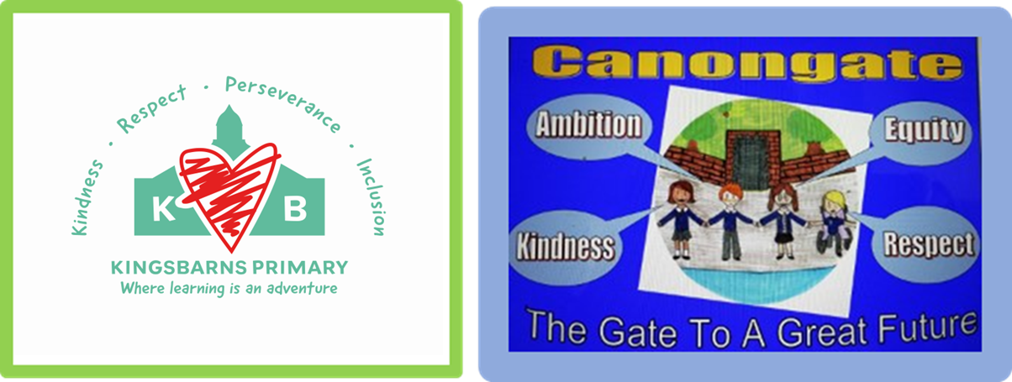
Canongate and Kingsbarns Primary Schools
Behaviour and Relationship Procedures
March 2024
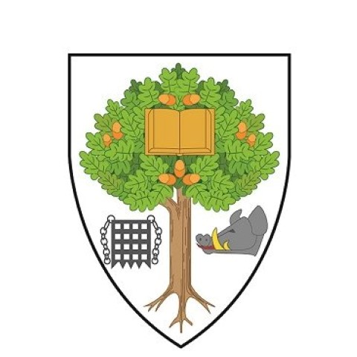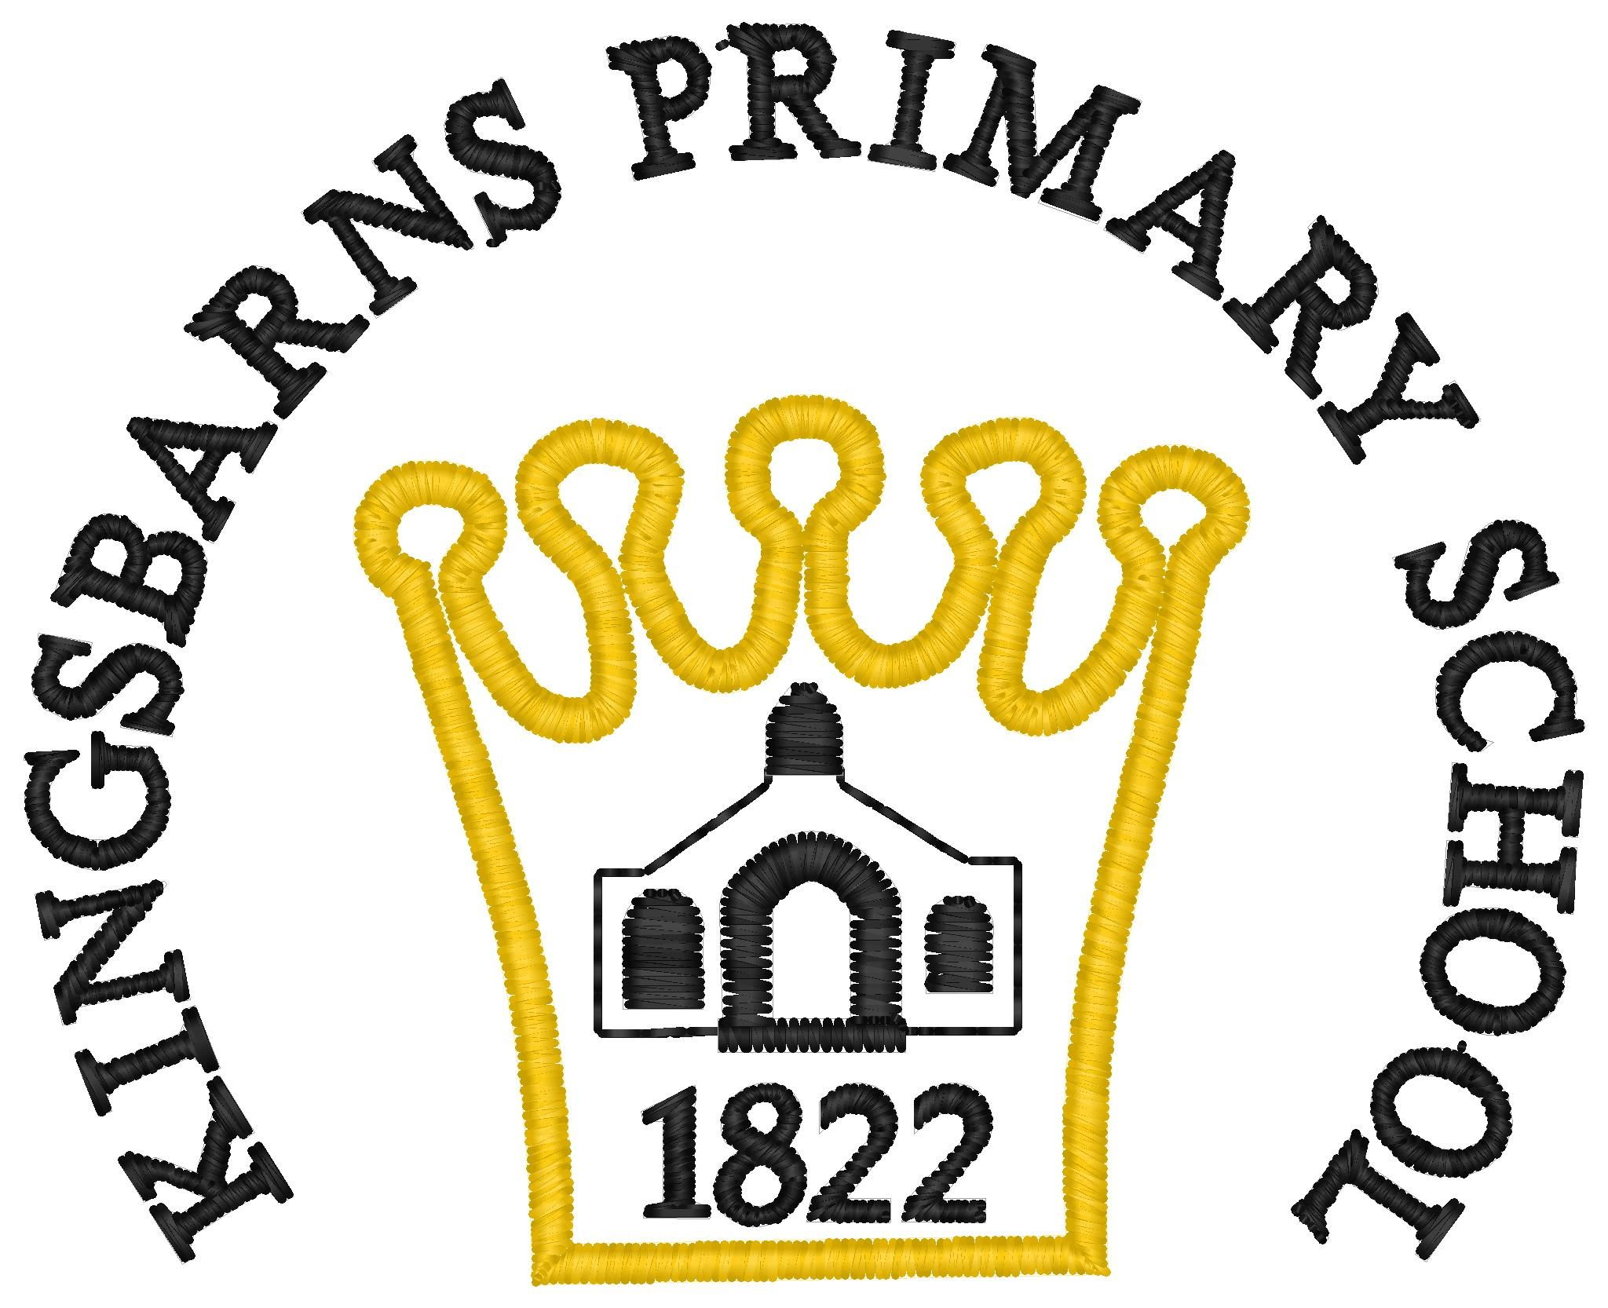
Statement of Belief
We believe that promoting positive behaviour and relationships is the responsibility of all who are involved in the school. This includes the pupils, staff, external professionals, parents and the wider community. We promote positive relationships and behaviour in a meaningful, supportive context by employing a range of effective, appropriate strategies. These will enable each pupil to access the curriculum and develop positive relationships within the school community and beyond.
Rights Respecting Guidelines & School Values
We are committed to the ethos and guidelines of the Rights Respecting Schools as well as our core school values of ‘Kindness, Ambition, Respect and Equity’ (Canongate) and ‘Kindness, Respect, Perseverance and Inclusion’ (Kingsbarns). This encourages everyone in school to show respect for all. All children are made aware of the UNCRC and the importance of their own rights. It also reminds us to respect the basic rights of others which include being safe, being cared for and the right to an education.
Positive behaviour and relationships are promoted through
- Our curriculum
- Daily life of the school which includes nurturing approaches.
- A variety of subjects including health and wellbeing
- Cool in School
- Anti bullying work and campaigns
- Our Building Resilience assembly programme (including the five ways to wellbeing)
- Focused work where necessary and thinking about protected characteristics.
- Peer mediation work.
- Focusing on the fact that all of us our leaders.
Most importantly we remember that children learn from those around them and the relationships they observe in school should be respectful.
Our core school values are encouraged and discussed regularly throughout the school week to model expectations. Children who have not managed to maintain class and school rules will have time to reflect at lunchtimes with a member of staff to help them consider their choices and how to move forward in a positive way. This may escalate to involving SLT if required.
Staff will continue to celebrate success both at class level and through assemblies. Our special award includes
Managing Incidents
It is always the aim when managing incidents to consider how best to get children back on track and to ensure that all sides of the story have been listened to fairly. This is what we call a 'restorative approach' where the emphasis is getting pupils to think about the impact of their behaviour on others and what they can do to make things better. We talk about making good choices so that pupils realise they are responsible for their own behaviour.
1. Teacher Reminder: In the classroom teachers can utilise an appropriate moment to take children aside to remind them of classroom expectations and the right of all to learn.
2. ‘Time Out’: support where a pupil can be based with an agreed supporter e.g. a Class Teacher, a PSA, SFL teacher or Senior Leadership Team for a short spell. This allows the pupil some space and time to consider their actions and how they can return to their learning in a positive way. At either school if SLT are not available, a call will be made to inform if necessary.
3. Extended Support: The pupil may benefit from moving away from a situation for more serious behavioural incidents. In this case, the HT or DHT or in their absence- the designated supporter -should be contacted as discreetly and calmly as possible. SLT or the supporter will..
- Attempt to calm the child.
- Ascertain all the relevant facts.
- Encourage reconciliation.
- Contact parents, if necessary at an appropriate time.
- Feedback to teacher/SLT.
- Monitor situation and liaise with CT and PSA staff to consider effective strategies.
4. Reflection Time: If a child has instigated inappropriate behaviour as per ‘Behaviour Pathway’, they will be given reflection time during lunch. During this time an adult will be able to go through the event with them and think about next suitable steps – main goal is to get back on track.
5. Playground Incidents: Depending on the severity of an incident, PSA staff will refer incident to Class Teacher/SLT but these may also need to be recorded/
6. Exclusion: It is the school's policy to include rather than exclude. However, if the need for exclusion should arise, the HT/DHT will deal with this in line with Fife Council Policy. Exclusion may occur when a child has intentionally either physically or verbally hurt or injured another child, staff member or damaged property or where it is considered that for the child to remain in class/school, would not allow us to maintain a safe environment. However it may also be appropriate for a child to spend some time out of class as part of cooling down time / any restorative or empathy work.
7. Recording - Class Teachers will record any incidents that are referred for reflection if these come from the classroom situation. Teachers will maintain their own records for persistent offending etc. It may be necessary to complete a HS1 online form which will include a discussion with SLT to discuss possible actions and prevention of a repeat.
As a proactive measure, staff may contact parents to discuss persistent low-level behaviour. As per our anti bullying policy , where there is a clear case of bullying (and not simply dispute) we will use the bullying app within the Seemis application.
Equalities Statement
We are an inclusive school and constantly consider the diverse needs of the children in our care; we are committed to meeting the needs of every child and actively promoting our school value of equity/ inclusive. As each child is an individual; staff strive to support children on a case by case basis depending on their needs to enable them to access every opportunity, learning experience and achieve their full potential. This may mean a different approach in some situations, depending on the understanding of the child. We also access support and advice with other professionals in a variety of individual cases.
Parental Support
We believe that a joint approach to promoting positive behaviour and relationships is the most effective. We therefore hope parents will;
- Discuss incidents calmly with their children.
- Encourage pupils to realise the impact of their behaviour.
- Support the school in promoting positive behaviour and relationships by reinforcing our values and the Rights Respecting ethos and working with staff to help pupils.
- Contact the school early if worried about anything relating to their child.
Continuing to promote positive behaviour and relationships in our school
We hope to continue to improve our behaviour and relationships in the school through the following;
- Staff have received de-escalation training (trying to de-escalate distressed behaviours.)
- Staff have received ‘5 Point Scale’ training (to identify children’s emotional wellbeing at different times throughout the day.)
- Continue to promote anti - bullying agenda. Ensure policy is shared by all.
- Continue to promote language and ethos of school values and Rights Respecting Schools and ensure parents are aware of UNCRC
- Continue with our Building Resilience Programme.

Date March 2024

