Canongate Primary School and Nursery

Standards and Quality Report
Achieving Excellence and Equity

Our Vision
Canongate – The Gate to a Great Future
Our Values
Respect, Ambition, Kindness, and Equity
Our Aims
- Celebrate diversity and respect the rights of all.
- Always promote positive relationships with our families, partners, and community.
- Nurture every child, keep them safe and promote healthy lifestyles.
- Open windows for life through a broad range of learning opportunities and achievements.
- Nurture enquiring minds and a joy of learning.
- Grow and develop a sense of place in St Andrews, Scotland and the wider world and a responsibility for sustainability.
- Appropriately challenge pupils and promote resilience and determination.
- Teach and model positive relationships and behaviours.
- Educate and prepare children effectively for transitions, the world of work and life skills.
Context
Setting/School Roll (including ELC/ASC) | - In 22-23 Canongate Primary started with 7 mainstream classes but after Census and addition of another child the school moved up to 8 classes.  - Our Nursery caters for 3- and 4-year-old children during term time from 9am until 3pm.  - Canongate Primary School hosts two additional support classes within the school, almost all children attending are from out with Canongate Primary Catchment. Children come to us from across Northeast Fife, included the East Neuk, Leuchars, St Andrews, and Tay Bridgehead Areas.  - Number of children who access additional support classes is total in Oak Class is 9 children and total for Sycamore is 10 children (Total is 19)  - Percentage of EAL (English as an Additional Language) learners is significant – currently 11% across the school. This includes children who have moved with a parent attending St Andrews University, children from Ukraine and other families that have moved to work in the area. Near our entrance we have a list of countries we have connected to through our learners and these now amount to 33 different nationalities.  - Our Early Learning Centre roll is 35  - We have 189 children with 13 of those children added to ASC but also attend local primary. 19 children in ASC
FME | Total as a percentage is 21 %
SIMD Profile for establishment | In 20-21 averaged described as 4.1  Care should be taken in this as St Andrews generally shows a high SIMD, yet many families live in rented accommodation or social housing that is still shown in a higher SIMD.
Attendance (%) 91.44 % | Authorised | 7.13 % | Unauthorised | 1.53%
Exclusion (%) | 0
Attainment Scotland Fund Allocation (PEF (Pupil Equity Fund) and SAC (Scottish Attainment Challenge)) | £52,675

Improvement Priority Session 2022 – 2023
(Duplicate section to reflect number of priorities from 2022- 2023 improvement plan)
Priority 1 – Numeracy

NIF Priority Improvement in attainment – particularly in numeracy and literacy

NIF Driver Assessment of children’s progress.
School improvement
Performance information

Has this priority been:  (Please highlight) | Fully  Achieved |  |  | Partially  Achieved  x |  | Continued into next session
Progress:

At the beginning of the session all learners (not ASC) were assessed using MALT assessments to give supplemental / additional evidence for teaching staff. These were used to identify the key areas where there were largest gaps in knowledge throughout school in key concepts.

Purchase of SEAL (Stages in Early Arithmetic Learning) resources. Diagnostic assessments used. (Short bursts)

Training was given in use of Seal Maths Resources to PSAs from Lead teacher (this was delayed due to staffing PSAS required in ASC). Strong focus in P2 led by teacher with additional time given.

All PSAs completed conceptual understanding training using self-study support.
In January to April school were able to use a focus from PEF funding to additionally train PSAs in the use of Seal approach

Series of six Maths inputs were delivered by curriculum leader in areas identified as repeatedly showing up as poor conceptual understanding in MALTS.
Creation of Canongate times tables teaching approaches and progression.

Improvement work led to reinstatement of use of records of understanding for assessment and planning.

Impact:

All staff reported improved confidence when delivering numeracy through using high quality resources.
Almost all learners across the school experience high quality numeracy learning. Learning partnership identified every class were using conceptual approach and this improvement priority was very evident across the school. The work of this group will have future impact also as SWAYs available for all new teachers.

Use of assessment has improved to move learners forward and recording of assessment has also improved through use of Records of Understanding. Improved methodology to identify gaps in learning. One PSA has become specifically skilled at using SEAL diagnostic assessment.

MALT assessment data shows improvement in target areas for almost all learners across the school. Whilst this may not translate to improvement in attainment figures it does evidence improvements.

Shared Classroom experiences and pupil feedback from groups has shown that most children across the school are motivated and engaged in numeracy learning.

Feedback from P2 pupils – Seeing an improvement in BNWS
‘Good.’
‘Lets me know more…My totals when adding’
‘Fun’
· Feedback from P3 pupils –
‘I like the work,’ I like trying to find the answers,’ ‘I like learning stuff’

Pupil voice data gathered, using ‘wee HGIOS,’ highlights some positive impact of the improvement work this session on children’s attitude to maths. Following pupil voice gathering in term 4, the majority of learners across the school enjoy their mathematics and numeracy learning. In P1-3 this statement can change to most learners. There remains an issue around enjoyment of numeracy as overall in years 4-7 only the majority of children said they enjoyed their maths learning
Next Steps

Assessment information from MALT/ Records of understanding/ SNSA / BASE and teacher assessment used in transition information to target areas of need for cohorts and individuals. SEAL assessment data will support P3 and P4 cohorts and targeted learners in P5-7. PSA who is confident is using SEAL diagnostic to support others in learning and be used across the school.

Seal Specific
- Purchase of resources and continued assessment to direct support.

Teaching staff should continue to engage with pedagogy SWAYS provided. Session 23-24 to begin use of new whole school agreement on approaches to times tables teaching.

Continue to ensure Records of Understandings are used consistently.

Most children in the school can state that they receive feedback from their teachers and feel they understand what to do next in their learning. However, this statement does not match with feedback from external scrutiny from the learning partnership. Not all children were able to articulate their understanding of their next steps in numeracy learning. Feedback is an area taken forward in next school improvement plan.

Above are natural next steps expected and do not necessarily mean this needs to be continued on Plan.
Priority 2 Writing

NIF Priority – to improve attainment for all particularly in literacy and numeracy.

NIF Driver
Assessment of children’s progress
Teacher professionalism
School Improvement

Has this priority been:  (Please highlight) |  | Fully achieved |  | Partially achieved | x | Continue into next session
Progress
Whole school rollout of QI methodology involving cohorts of learning in P1-P3 and almost all learners in P4-P7.
All teaching staff trained in QI methodology culminating in presentation of findings in collaborative sharing sessions.
Some qualitative feedback collected during session and pupil voice used to gather feedback from children.

Impact
Almost all cohorts of children targeted were able to achieve aims and stretch aims set. Almost all staff have stated improved confidence in declaring a level using the data generated. Teachers have highlighted progression towards having ‘tighter’ learning experiences linked to very explicit success criteria.
There is more discussion that has evolved around writing with staff and pupils and parental feedback has been positive.
Most children stated they enjoyed writing in pupil voice session and in particular QI sessions but clear difference with those that need identified additional support.

Examples of evidence gained First Level

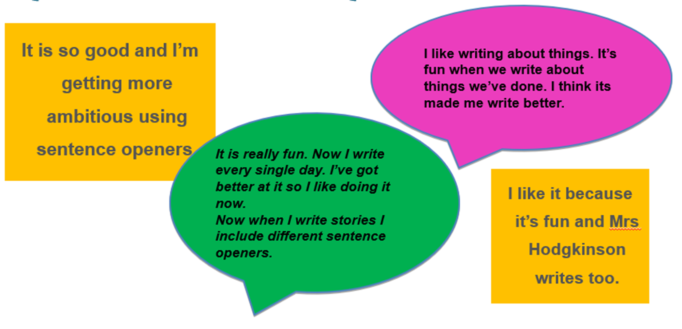

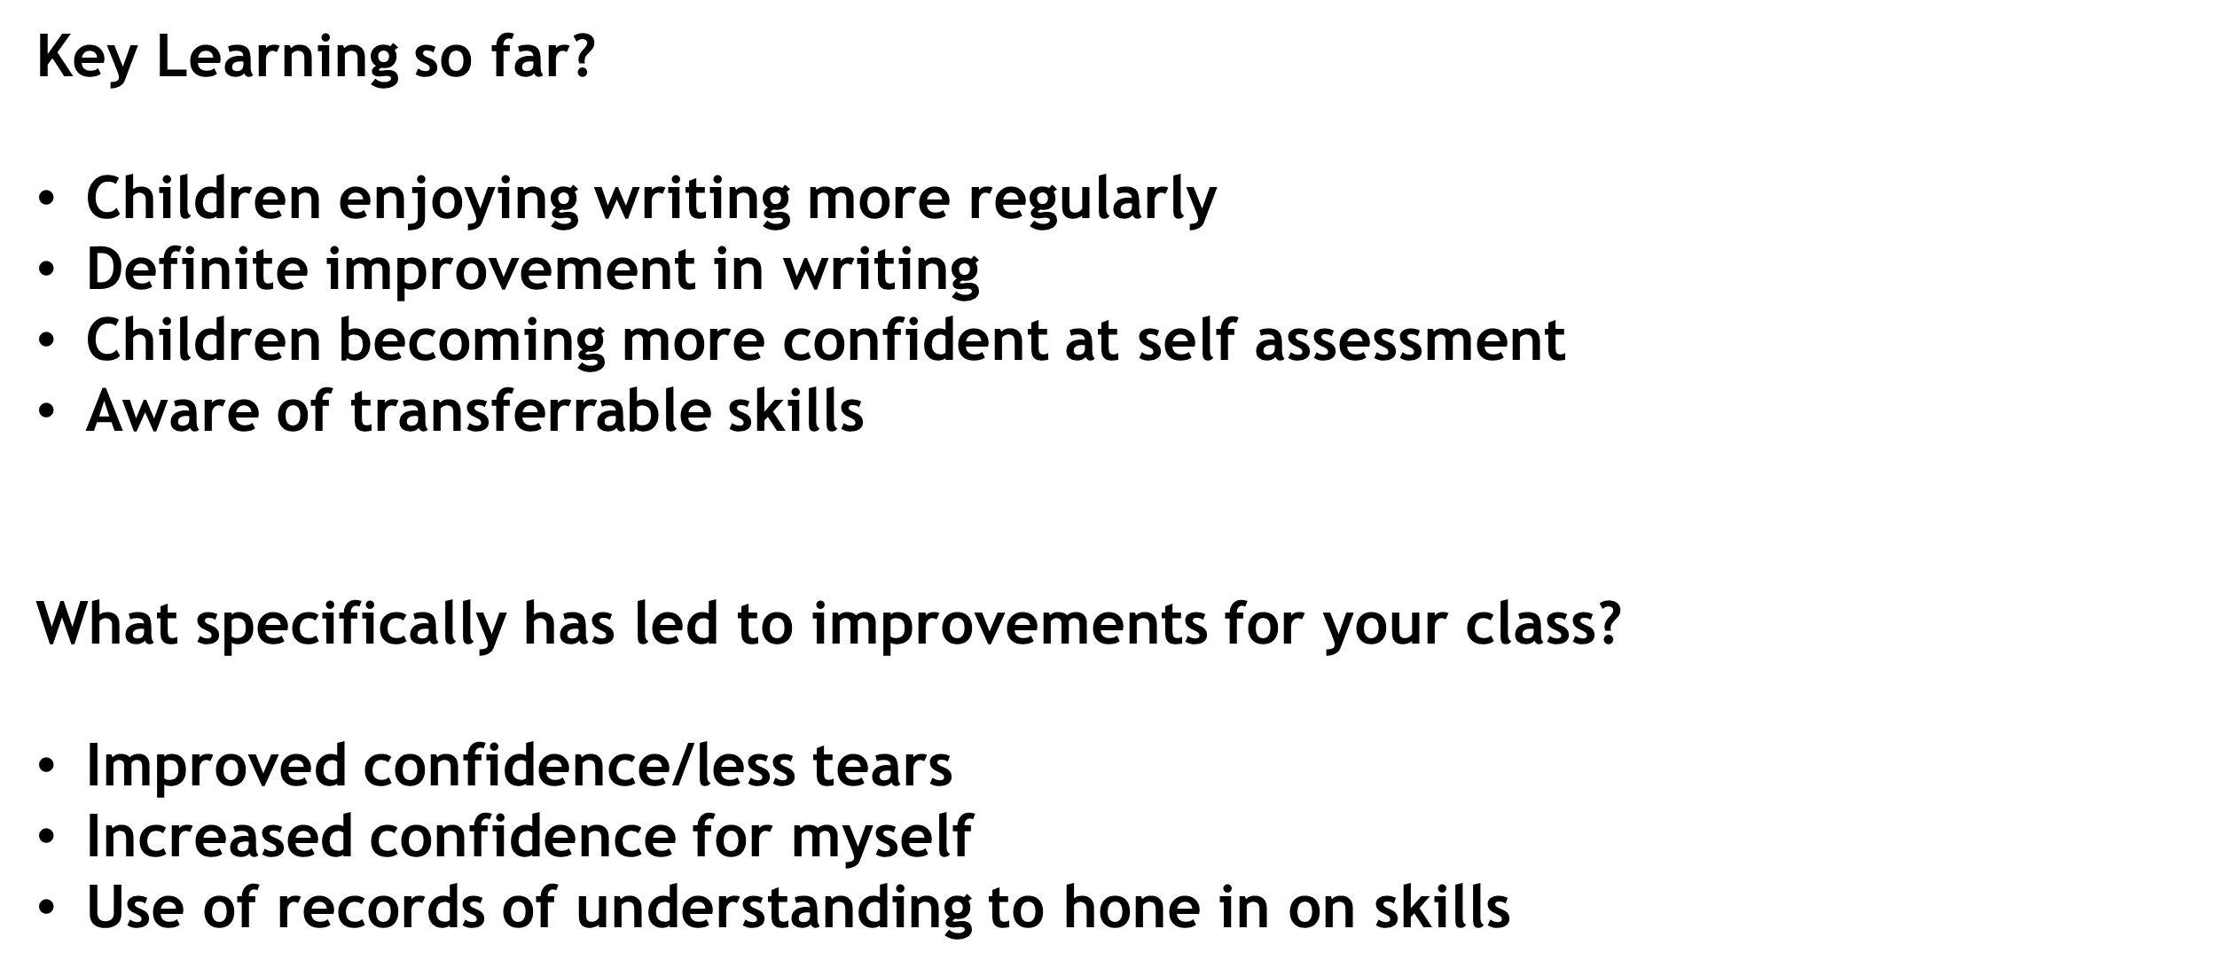
Second Level - P7
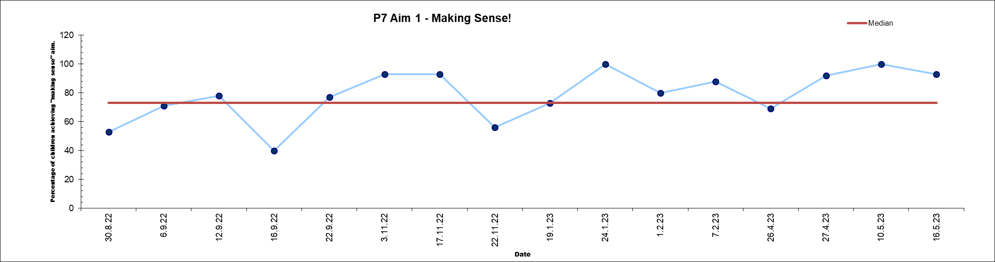

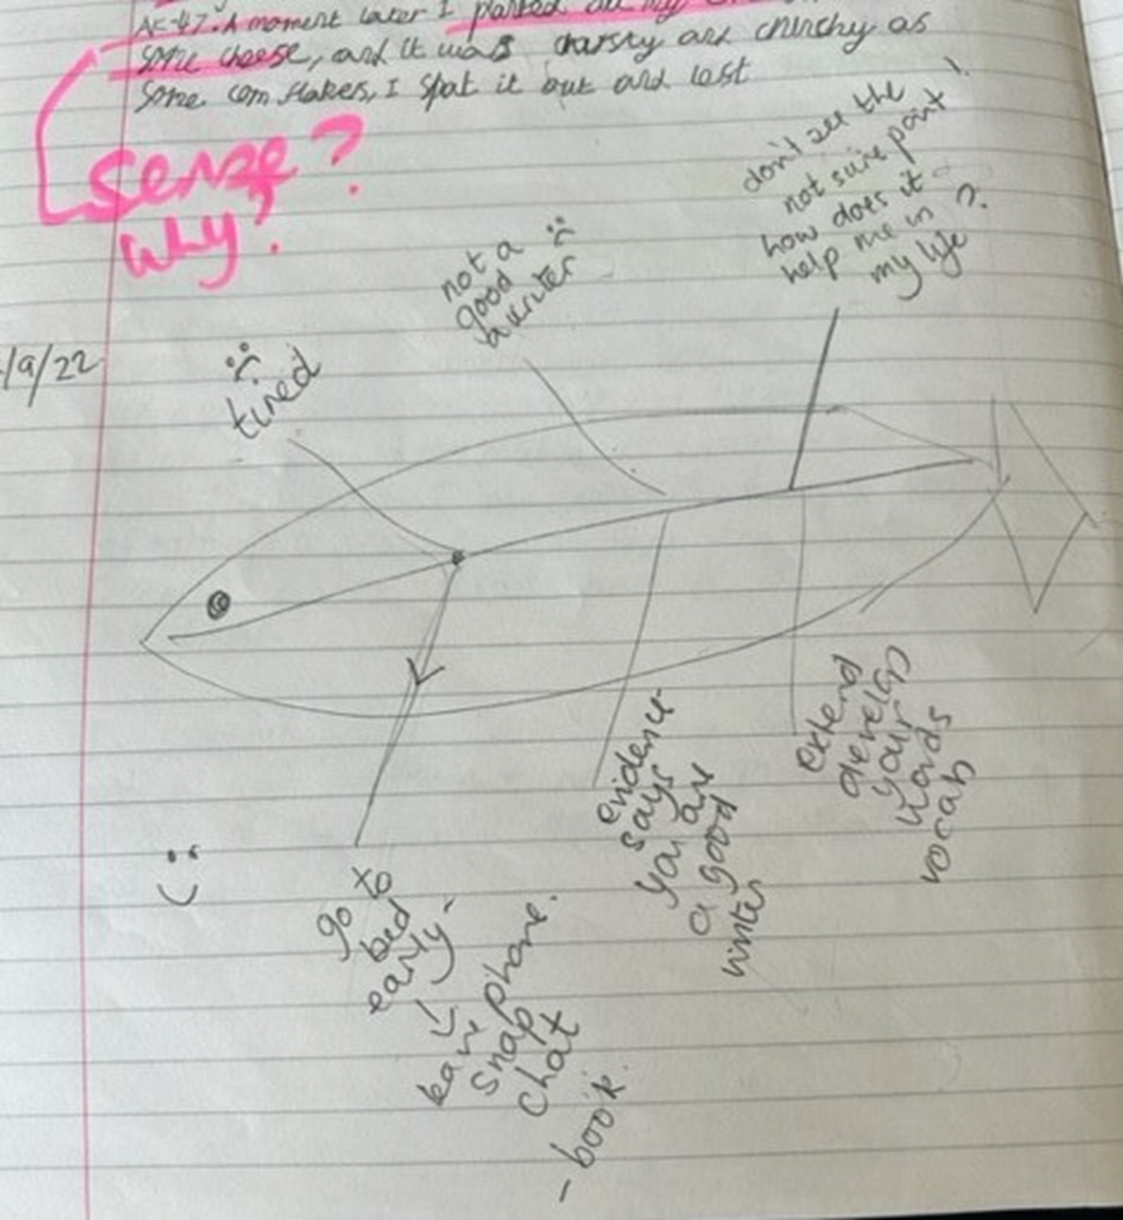

P7 Conclusions

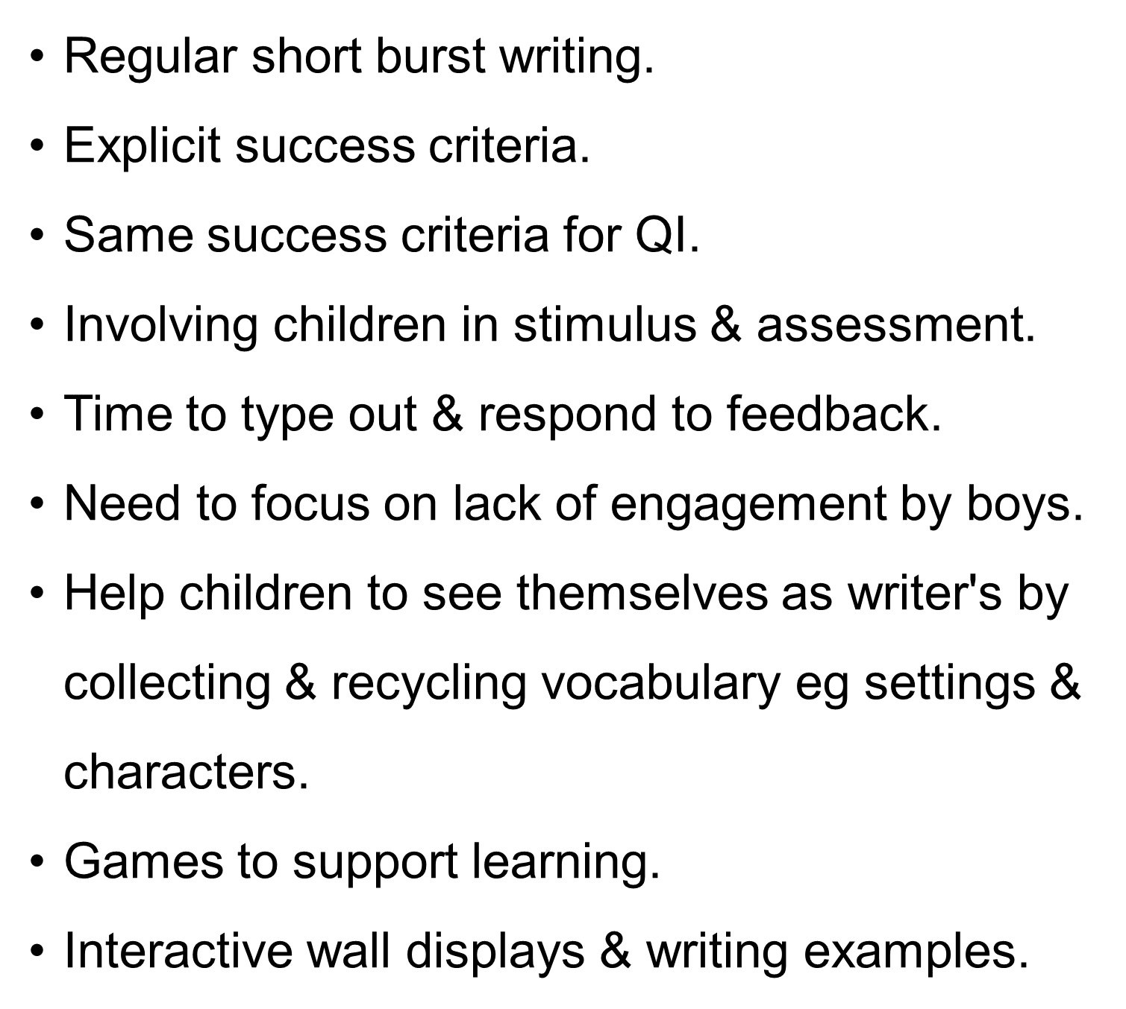

Key Learning Points

.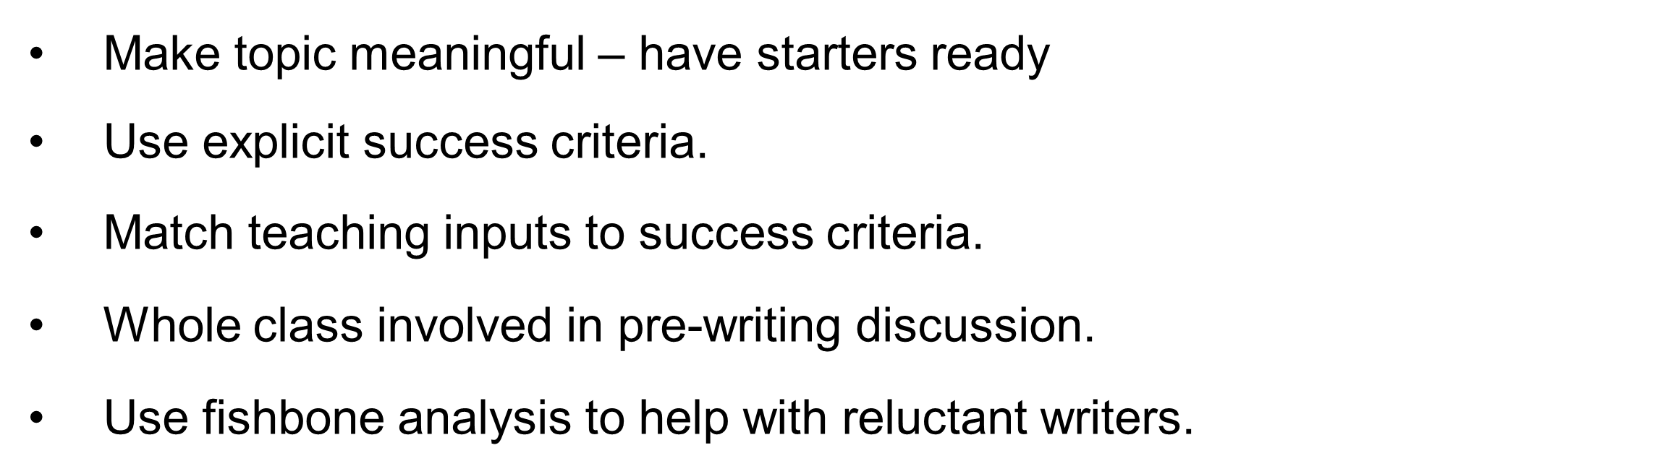
Next Steps example from a teacher
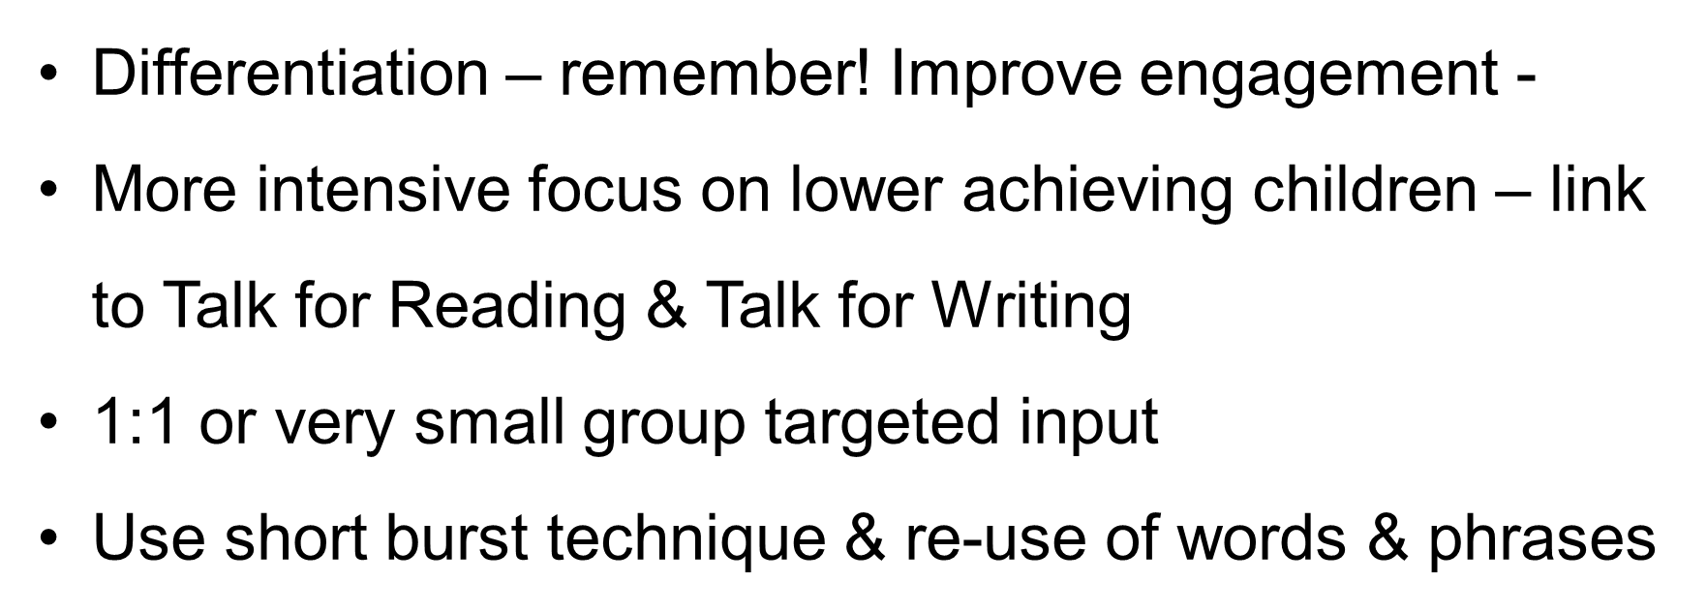
Every teacher has provided a full poster for evidence and measurement.
Next Steps
QI Methodology to continue after analysis using pareto charts – class use based on need and stage.
The top priority is to see the ‘tools for writing’ embedded in main writing.
PSA staff to have training regarding implementation pack and supporting correction of errors when working with learners.
Improve consistency of use of differentiated pyramids, technology to support writing in general and use of check lists.
Teacher CPD (Continuing Professional Development) on Pie Corbett strategies such as short burst writing.
School needs to consider the universal supports and strategies to ensure these learners have the necessary tools, including digital supports.

Priority 3 – 1+2
NIF Priority Improvement in attainment, particularly in literacy and numeracy

NIF Driver
School improvement
Our priorities
Teacher professionalism

Has this priority been (Please Highlight) |  | Fully achieved |  | Partially achieved | x | Continue into next session | x
Progress
- Agreements made at beginning of term regarding French time/ teaching.
- New planning considered and adopted.
- Attendance of all at Cluster in Service to received key messages – especially for P7 teachers.
- Qualitative data sought from staff throughout session
- Pupil voice questions on 1 plus 2.
- Audit carried out in term 1
- New school link established with French school in Cretail but no work carried out yet.

Impact
- Class displays across school show that French is being taught progressively. These were commented on during learning partnership.
- All children questioned during pupil voice sessions said they had weekly French lessons and incidental French for routines etc.
- Primary 7 level have covered the key concepts and more – are competent at second level main areas and should not need to repeat learning when moving to Madras. Impact will be that S1 at secondary should be progressive.
- Most children in Primary 7 writing simple sentences in Friench.
- Improved confidence in speaking French or participation for almost all children during observations and discussions.
- Qualitative data from staff stated increased confidence in teaching French.
- French Fife Languages skills progressions pathway now fully in place.

Next Steps
- Ensure Spanish is taught for whole block in P5-7 (not started this year)
- Ensure link is being used with Cretail school. Teams Meetings etc.
- New staff to have access to training as identified.
- Continue to make displays progressive and French should be visual.
- Assemblies to have French element.

Canongate ELC (Early Learning and Childcare) Improvement Priorities
Focused Priority: Embedding technology across the core provision, and involving children and families in self-evaluations
NIF Priority: Closing the Attainment Gap and Improving the Health and Wellbeing of our children

NIF Driver

Has this priority been:  (Please highlight) | Fully achieved |  | Partially achieved |  | Continue into next session  x
Progress:

- An audit of current technology resources in the setting highlighted the need for renewed technology resources. Additional devices and new SMART board have been added to the setting.
- Staff have been creating opportunities to learn how to login and access programs on the devices.
- Children have been using the devices to share their learning with families at home. They have been using the cameras and the devices to take pictures and share them in their PLJs and using the SeeSaw app.
- The setting has also integrated food technology into the setting and are using this to allow children to take part in the preparation of snack in the setting. The children are learning how technology can be used as tools to support the preparation of food.
- Children can and do share their learning in ICT with peers and parents.
- Staff have been making more links with technology experiences and outcomes in their PLJs and Daily Responsive Planning.
- Staff have been developing learners' independence using digital technology in the setting. The majority of learners can login to the iPad and computers without adult support but use concrete supports made from natural materials.

Impact

- Children are more confident accessing digital resources and using them to support their play and learning. This is not just exclusively linked to computers and tablet but also digital scales, torches, walkie talkies and robots such as Beebot.
- Staff capacity and confidence using the resources has increased. This has been highlighted through professional learning activities.
- There are a variety of technology opportunities for learners to access in the setting. Computer, tablets, SMARTtv and food and robotics technology also. This is an enhancement in our capacity for offering technological learner experiences.
Next Steps:
- Extend our understanding of how we can use digital resources and technology in the setting. Specific resources like Lumio and Clicker have Early Years application. Digital technology will be part of a whole school improvement priority and nursery staff will be involved with the specific training that includes resources like these. EY staff will then have the capacity to offer specific opportunities to support learning in literacy through clicker.
- Continue to develop our understanding of digital learning away from a screen. We have made progress but there are more experiences we could develop for our learners through robotics, simple coding, and computational thinking experiences.
- Continue to develop our understanding of the curriculum for excellence technology experiences and outcomes. The Fife Digital Learning Pathways document and Education Scotland’s “What Digital Learning Might Look Like.” document will support this development.

Focused Priority: Self-Evaluation in relation to family and wider community engagement

NIF Priority: Closing the Attainment Gap and Improving the Health and Wellbeing of our children

NIF Driver

Has this priority been:  (Please highlight) | Fully achieved |  | Partially achieved  x |  | Continue into next session  x
Progress:

- PEEP, Play on Pedals, Bookbug and Stay and Play sessions being offered across the setting throughout the session. At times during the session, we were able to offer activities with a family engagement focus weekly. This represents a significant improvement post pandemic. At all events parents are encouraged to share feedback through paper exit cards and QR codes with links to MS Forms.
- Pupil voice has formed a core part of PLJs. Children are actively encouraged to engage with their PLJs.
- Our improvement planning work has highlighted areas where we can seek to gain more community engagement including: PLJs, Daily Responsive Planning, learning walls and Forest Kindergarten. Having a close connection with our families has helped us provide learning experiences that relate to the children’s experiences at home too. This has been shared both in person and through our electronic communication with our families.
- Our nursery has been involved with several whole school activities that has brought the school community closer to the nursery. Being part of assemblies, family engagement days and through enhancing our transition to P1. This was highlighted by several parents as a positive start to school and an excellent way for the families to become integrated with school.

Impact
- Through ongoing self-evaluation and moderation activities, EY staff are identifying collective strengths and areas for development. Enhancing our strategies for family engagement has led to an increase of home learning
- Staff engaging in regular moderation activities with peers has led to increased amounts of sharing good practice.
- Two members of EY team are now trained to deliver parental engagement activities. Emma Stothers can deliver PEEP sessions and Shona Wilson can deliver Play on Pedals and Bookbug. This is an increase on previous sessions.
- Care Inspectorate visit highlighted self-evaluation and leadership as a clear strength in the setting.
Next Steps:
- Increase staff capacity of parental engagement activities by training more members of the EY team next session. We would look to increase our ability to host this session through a variety of staff. Currently, only 2 members of staff have formal training in Bookbug, Play on Pedals or PEEP. We would look to enhance this next session.
- Continue to develop PL (Professional Learning) opportunities next session that can support and enhance our family engagement. Learning walls training and sharing learning training will support this.
- Integrate EY team with school team during professional learning opportunities for EY team to benefit from wider professional dialogue and sharing of good practice.

Attainment of Children and Young People (Primary and Secondary)
Attainment evidence/Achievement within a level information from ELC/school from this session
Successes and gaps identified throughout session (this should link to improvement plan for session 2023- 2024)

Attainment which excludes number of children in ASC
Stage | Reading | Writing | Listening and Talking | Numeracy
P1 | 90% | 90% | 90% | 90%
P4 | 73% | 73% | 82% | 77%
P7 | 86% | 82% | 91% | 91%

Attainment which includes ASC Children
Stage | Reading | Writing | Listening and Talking | Numeracy
P1 | 87% | 87% | 87% | 87%
P4 | 70% | 70% | 78% | 74%
P7 | 77% | 73% | 82% | 82%

Overall Attainment for 2023 – 2024 (excluding ASC)
 | Literacy | Numeracy
P1 | 90 | 90
P4 | 73 | 77
P7 | 82 | 91

Overall Attainment for 2023 – 2024 (including ASC)
 | Literacy | Numeracy
P1 | 87 | 87
P4 | 70 | 74
P7 | 73 | 82

Literacy |  | Numeracy
Stretch Target | Actual | Stretch Target | Actual
78.3 | 82%  (77%) | 82.6 | 86%  (81%)

Evaluative statement of attainment over time.

Data over time in Canongate is somewhat misleading with changes in children due children coming from university and leaving. Also new children arriving at any stage at any time being either on track or not. The number of children from other countries is significant.
In Numeracy
Our attainment in Numeracy has maintained and improved from our projections for the key stages in P1, 4 and P7. For those learners who have not met the identified level for their age and stage we can still show progress using our assessment data. We have offered the results both with ASC included and without as feel this is significant. There are plans in place for learners who are not on track. Some of the learners not on track have specific learning difficulties that we are supporting. In P1 almost all learnings (excluding ASC) have achieved early level using the benchmarks, but our Base Data has shown a drop in some numeracy areas that we need to explore further.

At P4 level learners are achieving (excluding ASC) but with continued support and intervention we hope the percentage will increase. Some learners in this cohort have very specific needs that will mean it is unlikely to move to ‘almost all learners. It is also a small class group. SNSA data confirmed teacher judgement in the main.

Our attainment in P7 in numeracy has improved over time for the cohort with an increase from the beginning of the year. With a high level of intervention, the attainment for this cohort has increased to almost all learners (excluding ASC) achieving second level. SNSA data confirmed teacher judgements in the main.

In Literacy and English overall attainment is described as good.

In Primary 1 writing, almost all children are achieving early level.
In Primary 4 reading and writing equates to only the majority children achieving first level (excluding ASC) and whilst this would indicate a drop over time, it is not as this may relate to new statistics. It is very close to being most but would not be projected to be almost all due to the specific difficulties for every learner.

In primary 7 our targets have maintained to be most children in reading and writing achieving. This has been with significant intervention after a drop in Primary 6. However, for some of these learners who have not previously been with the school, after moderation and looking at evidence it was clear that children were not working on track as described on tracking on entry.

Whilst almost all learners in P1 and P7 have achieved appropriate levels in listening and talking there is a need to ensure assessment in this area is robust and some moderation work to ensure this is in line with cluster/ wider agreement. Most children in P4 are described as having achieved first level.

Evidence of significant wider achievements
Successful Learners

Assembly programmes – P7 Remembrance, P5 Middle Ages, P3 Potatoes/ harvest, P5- anti bullying, P4
Middle Ages and our leavers Service.
Primary 1 and 2 organised a very successful French afternoon for parents with singing and food.
Shared learning afternoons have been well received – parents enjoy being back in school.
Range of trips have supported learners to learn about the local world.
ASC have participated in Swimming and horse-riding lessons.
Bikability has been offered at level one and Level 2 with all children who wanted to participate in P6 and P7 included, and bikes provided.
Numerous workshops from RNLI, dogs trust, SSPCA, young carers, library,
Classes have all visited Botanics for a range of workshops about our environment and nature.
Classes have visited the castle/ cathedral in St Andrews and our local heritage museum.
Most classes also visited the St Andrews Aquarium to trial new workshops about the sea.
Nursery have been given the opportunity to participate in Play on Pedals and attend the Bookbug sessions organised by EYOs
Younger children have enjoyed trips to the fire station in St Andrews and visits from the Fire Service. They have also experienced storytelling and a range of visitors to the school.
Our ASC pupils were given a special award for four pupils doing their rendition of their Burns Poem for the Burns Society. This was an award for overcoming difficulties and was very well deserved as involved reading out in front of an extremely large audience.
See evidence in SWAYS shared with parents termly and on weekly feedback on Seesaw.

Confident Individuals
As a school we have embraced the opportunity for as many children as possible to participate in sports. We are currently in line to achieve our Gold Sports Award once submission is complete.
Football tournaments - St Leonards Festival Winners Sept 22. Runners up in Leuchars area tournament (out of 19 schools). Our school organised girls football tournament for cluster and our school were winners.
Cross Country Festival – over 30 children participated – all abilities. Some children ending up in top 20 for around 200 winners. Excellent effort by all.
Lacross Festival – St Leonards – children embraced the challenge of this new sport to them.
Swimming Festival – super effort by the team.
Athletics Festival – Team of 40 children taken to St Leonards and were praised for their behaviours and ambition.
Targeted Rugby sessions in P5 and a breakfast rugby club has been offered.
Football club runs for boys and girls.
Tennis after School Club on a Friday.
Buddies in P6 for new entrants and P7 for Primary One have been excellent role models and their care for younger children has been noted by the new parents.
Primary 7 residential trip to Loch Insch – full week. Despite nerves this was well attended – all that wanted to go were able to attend regardless of whether families felt they could afford this.
Whole School Christmas Production of ‘Cinders’ Pantomime. Very high-quality show which was highly praised by whole school community (see letters).
Our Scottish Afternoons for P1-3 and P4-7 demonstrated confidence in learning and performance of poems. It is particularly notable to see how many of our international students embrace learning about Scottish Culture and performed beautifully. They were mentioned specifically by the Burns society/.

Effective Contributors
DCA film festival – Primary 4 won a bus to participate in the DCA discovery film festival and to vote on films.
Our Glee club is now at 47 members – practising every week and performing regularly. Everyone is welcomed from P4-7 with nobody turned away. Includes members of ASC community.
Due to our commitment to music and expressive arts, Primary 5-7 attended ‘Once upon a Tune’ at the Caird Hall in Dundee. The children relished the opportunity to participate and contribute to the discussions and were given art from a famous artist/ author in recognition for their efforts.
Nursery attended the Big Ears Little Ears concert at the Byre theatre.
This year we participated in the Fife Festival of music and Frisson Glee competition. We were given positive feedback.
Our school was also represented at the Fife Dance Festival – performing to a high standard.
Primary 7 attended Leuchars Camp station activity day and showed they had learned lots. Some even performed on the day.
Four children from P6 represented the school in the St Leonards Technology festival.

Responsible Citizens.
Our Junior Sports Leaders have led assemblies/ organised and delivered lunch time sports clubs for younger children and organised sports day. They also helped by organising a special transition sports event and Wake up Shake up for Sports week and for our new P1 entrants.
Primary 5 have shown amazing skill and kindness by delivering Sensology sessions to our ASC Sycamore class. They have shown excellent leadership and nurturing capacities. For many children in ASC this has been the highlight of the week. The link and bond is now so strong that both classes are going on the same summer trip.
Our P5 JRSO team created a manifesto which was delivered to local counsellors and members of parent body. This is to be taken forward as part of our travel action plan next session.
Our house captains have created their mascots, kept tabs of weekly house points, and been used in a wide variety of capacities to support school and for pupil voice. These have been supported by our P7 prefects.
Our P6 peer mediators have started supporting younger children in the playground with conflict resolution. This will be built on next session.

Feedback from External Scrutiny
Learning Partnership at Canongate – 14th February 1023
Strengths Identified

- School has a clear overview of assessment processes in place linked to the Working Time Agreement, looking at triangulated evidence, with three tracking meetings for updating and planning build into the school year.

- Jotter work sampled suggests improvements in children’s writing. Children in focus group which reflected upon this were able to talk about techniques they can use to help to improve the quality of their writing.

- Classroom observations evidenced that school improvement priorities within Conceptual Numeracy are leading to change in classroom practices. In all classes where Conceptual Numeracy teaching and learning was observed practice showed differentiation in practice, good use of range of resources and associated language of learning and range of strategies demonstrated by children.

- From practice and interactions observed relationships are respectful, positive, and nurturing,

- Play environment is established (as Pods) at Primary One and Two, children are well engaged and feedback and interventions from adults was effective System for assessment and teaching is woven into the model.

- ASC staff know children’s needs and protected characteristics very well and respond very well to those individual needs in terms of their interactions. Attention Autism is used effectively for intensive interactions and turn taking.

- There are good examples of blended partnerships and practice between children in the mainstream and ASC classes. For example, Sensology practice within the school is helping children to reflect upon and understand different people’s needs. Primary Five children involved in leading this can articulate this well. And Sports Leaders from P6 (and soon P7) support PE learning with ASC children.

- Evidence of displays around school evidenced a full range of experiences across the curriculum and opportunities for leadership. Lots of opportunities available.
- School reintroducing records of understanding for literacy and numeracy.

Areas for Improvement

- Continue to build focus in tracking by supporting consistently effective use of Record of Understanding for Maths across whole team.

- Consider opportunities to continue to extend children’s experience of resource-based, more independent learning, weaving in extension/enriching/play/ challenge/choice activities into children’s programmes across the day.

- Consider how feedback is used across the school and how children’s experience of feedback develops as they move through the school. Ensure children understand and can articulate their learning and know their next steps

- Takes steps to embed digital technology in learning and teaching.

- As a school (to include children’s voice) consider display policy – how does that progress as children move through the school? What do children want/get from displays?)

- Equity within Curriculum: Reflect upon next steps in connection to curricular learning around protected characteristics

- Outdoor Connections practice is in place within the school. Consider how that relates to bringing broader learning from across the curriculum into Outdoor Learning – start with numeracy.

- Consider how to make more use of the environment to stimulate learner’s engagement and the quality of learners’ experiences in Nursery

- Consider scope to now build in further challenge within play environments at early stages.

- Continue to reflect upon ways to safely develop ASC environment and use of visual cues and timetable use within ASC (e.g., starting with keyrings)

- Children involved in Sensology practice to be supported to consider next steps.

- Continue to build Parental Engagement and partnership post-Covid to include a) continued gathering of evidence of feedback from wider Parent Group to inform school evaluation and improvement work and b) partnership with parents in Sports and Physical Activity.

- Consider opportunities to re-introduce Canongate ‘Six for Success’ and recipe for a good lesson so that these are visual and known.

Education Scotland - Strengths and Areas for Improvement
NA

Care Inspectorate - Strengths and Areas for Improvement
Following Care Inspectorate Inspection in February 2023 the following strengths and areas for improvement were highlighted:

Strengths
- Children experienced a nurturing and caring environment. Staff showed the importance of securing strong relationships with children and families.
- Children enjoyed a relaxed and unhurried mealtime experience.
- Staff team are skilled and were able to develop quality play experiences which allowed the children to lead their play and learning.
- Staff team had completed extensive work with technology, and this showed in a play environment that used digital technology well to support play and learning.
- Children’s achievements were celebrated and documented by the staff and children.
- Staff reflected on the play and learning using a measured approach which used evidence to form next steps and develop practice.
- Regularly reviewed risk assessments were in play and evidence a regular self-evaluation.
- The environment was well maintained, clean and well ventilated. The staff took care and attention to ensure the safety of learners throughout the setting.
- There is a shared inspirational vision amongst all staff which value children and supported each child to reach their full potential.
- There was a clear improvement plan with achievable targets for the setting.
- The leadership team knew their setting and children well and led by a shared approach.
- Very good quality assurance procedures are in place which evaluated many aspects of practice.
- Regular review meetings took place with staff, the team feel empowered to take forward developments and lead the improvements in the setting.
- Staff felt fully supported by the management team and felt their views were listened to and made to feel important.
- There was a wide range of training opportunities available. Staff had received training in the setting which they of passionately and confidently This training had led to improvements for the children.
- Staff were supportive to colleagues and were able to support new staff through a robust induction process that helped integrate them into the team and the setting.

Areas For Improvement
- Improving the quality of interactions through questioning and development of learning opportunities.
- Develop the learning environment to include more homely touches and focus on attention to detail. Additionally, ensure all areas of the environment takes into consideration the interests of the children to ensure all children can engage in their play and learning.
- Continue to develop ways learners can be independent during mealtimes.
- Continue to reflect on the deployment of staff in the setting throughout the day to ensure continuity of experience for the learners.
- Develop opportunities for peer moderation of PLJs and DRP.
- Continue to develop opportunities for parents and children to be part of the self-evaluation process in the nursery.

PEF Evaluation/Impact
Targeted Interventions
- Nurture interventions – targeted pupils
- Numeracy interventions – targeted pupils
- Attendance interventions – targeted pupils. (23 learners with attendance less than 85 percent)
Progress:
- Clear challenges affected progress in all areas which included some additional traumas for some children regarding attendance/ family circumstances. This may have necessitated a more target of resources to fewer children in greater need.
- Need to include some additional children on return from session 22-23 due to new arrivals or circumstances or their particular needs in a mainstream class.
- Significant challenges around staffing recruitment and retention in our additional support class. It was important to ensure our most vulnerable learners were adequately supervised and supported. Whilst they were not on the PEF plan for this session, there had to be a change of plan for a considerable amount of the year.
- Some unavoidable prolonged absence of PEF funded staff has affected progress.

What was done?
- Seal Boxes were purchased (but delayed arrival)
- Some looking out to see how other local school used this resource to assess
- Staff development happened for PSAs – delivered by teacher.
- Some additional teacher time paid for to support initial roll out of SEAL Maths interventions.
- SEAL target maths was evaluated (not started properly until Feb 23)
- PSA time used to support in nurture practices – continued kitbag, Lego club,

Impact:
- Children affected by significant traumas in session were fully supported and their attainment either maintained or improved. For these children, the trauma did not lead to increase of distressed behaviours in school because they were fully supported. Pupil voice used throughout. Led to more inclusion in whole school event when previously this was not possible.
- Pupil voice showed that nurture-based PSA made children feel more confident and willing to share in school. Working with small numbers from P1. P4, P5, P6 and P7.
- PSAs were able to work with parents in some circumstances and build bonds that were important to the child. In the majority of the children identified their attendance increased. However particular situations for others led to decreases. In all cases good relationships with PSAs were identified in pupil voice.
- SEAL maths intervention work by PSAs has led to almost all children showing progression in MALT (Maths Assessments for Learning and Teaching) assessment and improved understanding of diagnostic testing. Increase of use of concrete materials in evidence in all classrooms. However only the majority (11/20) targeted children were then on track.
- Qualitative evidence from children/ teachers/ parental feedback is showing that kitbag sessions and Lego therapy sessions are definitely having positive impact on chosen pupils.
‘...a place to show your feelings and how your feel. It is peaceful and quiet. My favourite …...you can say how you feel about someone and what they mean to you...
‘a place to reflect. Colour card is my favourite as you get to express how you feel.’
‘Fun and gives me space to help me think about things. Like the animal cards as they describe people.’
‘Makes me express my emotions in a different way. My favourite thing is the Wonder Journey as it makes me feel calm.’
‘it’s relaxing.’

Feedback from teacher included in main plan for SEAL intervention.

C
School/Setting Name - Canongate Primary School
NIF Quality Indicators (HGIOS 4) School Self- Evaluation
Quality Indicator | 2020 -2021 | 2021- 2022 | 2022-2023 | Inspection Evaluation  (Since August 2022)
1.3 Leadership of change | Good | Good | Satisfactory
2.3 Learning, teaching, and assessment | Good | Good | Good
3.1 Ensuring wellbeing, equity, and inclusion | Good | Good | Good
3.2 Raising attainment and achievement | Satisfactory | Satisfactory | Satisfactory

NIF Quality Indicators (HGIOS ELC (Early Learning and Childcare)) Early Years Self- Evaluation (Nursery)
Quality Indicator | 2020 -2021 | 2021- 2022 | 2022-2023 | Inspection Evaluation  (Since August 2022)
1.3 Leadership of change | Very Good | Good | Very Good
2.3 Learning, teaching, and assessment | Good | Good | Good
3.1 Ensuring wellbeing, equity, and inclusion | Good | Good | Good
3.2 Securing children’s progress | Good | Good | Good

Care Inspectorate (within last 3 years) | Grade (if applicable)
 | 2020 -2021 | 2021- 2022 | 2022-2023
Quality of care and support |  |  | Good
Quality of environment |  |  | Good
Quality of staffing |  |  | Good
Quality of leadership and management |  |  | Very Good

Headteacher Patricia Shafren (who completed SQR)

