
Child Protection
in Fife Education Establishments
Category: Care and Welfare
Risk Management and Legal Implications

Failure to manage risk may impact on the delivery of Service objectives and the outcomes achieved by Service users. The Education Service aims to mitigate the implications by ongoing management and review of risk in all elements of work activity.

The production of this document is one way in which we aim to reduce our exposure to risk. By providing staff with information on good practice, making reference to other guidance that is available across the Council and providing clarity on how we should do things, we can ensure that the management of risk is intrinsic to what we do

Document Owner | Version | Date of publication | Date of next review
G Waterston/CP SOG | 2 | October 2023 | October 2026

Officer/Committee: Gavin Waterston/Child Protection Strategic Oversight Group
This page is intentionally left blank

Concerns about possible harm to a child from abuse, neglect or exploitation should always be shared with police or social work, without delay.

If you believe that a child or children is/are in immediate danger, do not
delay, call Police Scotland on 999

Confidentiality is not an option.

If you have a concern and the child is not in immediate danger you should contact the Social Work Contact Centre on 03451 55 15 03 or, for Emergency Out of Hours (5pm onwards) call 03451 55 00 99.

The Fife Child Concern Notification Form (NoCC) for use by all partners in Fife has been developed to allow the recording and sharing of child protection concerns. The form should be completed by education staff and submitted to the Social Work Contact Centre at the email address SW.Contactctr@fife.gov.uk This can be followed up with a telephone call to the Contact Centre. It is essential that all staff know the procedures for dealing with child protection concerns.

Staff should complete as much of the form as they can, but must not delay in sending the form, even if there are sections that cannot be completed or there is information that is not available. Most of the boxes on the NoCC form are self-explanatory; however, staff should contact their line manager or child protection lead if they would like clarification about how to complete this form.
See NoCC Guidance and flowchart for further guidance.
See Fife Child Notification Form with prompts for exemplification of NoCCs.

It is more important that concerns are acted upon quickly, with some gaps in
information, than failing to act due to concerns being shared too late.

Feedback from Social Work will be provided as appropriate, to the person that submitted the notification form. The person submitting the concern is also encouraged to seek feedback regarding the issues raised. If they are not satisfied with the information provided they should use the Escalation process.
Ideally information recorded as Care and Welfare in SEEMiS should be shared with parents/carers as appropriate, through discussion, unless to do so may put the child at risk. Where a child has disclosed that the parent(s)/carer(s) may have abused them, this must not be disclosed to parents/carers by staff.
Headteachers are reminded that new staff and supply staff must be given details of the Child Protection procedures and telephone number of the Social Work Contact Centre as part of the induction process on the first day of employment.
Safeguarding Induction Pack must be completed by all new employees. CPC to retain evidence of completion and understanding.
Contents

Context 1
Information sharing – flowchart 3
Staff roles & responsibilities 5
Reports of concerning behaviour by adults 7
Recognising and responding to concerns 8
Child Protection specific circumstances 11
MARAC 11
Child Protection Planning Meetings 12
Child Protection Register 13
Children’s Hearings 13
VPDs (Vulnerable Person Database) 14
IRD (Interagency Referral Discussion) 15
Escalation Process 16
Transfer of Care and Welfare/Child Protection Records 17
Sector Specific Care and Welfare Process: Early Years 19
Sector Specific Care and Welfare Process: Primary/Secondary 20
Sector Specific Care and Welfare Process: Active Schools 21
Sector Specific Care and Welfare Process: Gypsy & Traveller Education Service 22
Sector Specific Care and Welfare Process: Music Service 23
Sector Specific Care and Welfare Process: Out of School Service 24
Appendix 1: Child friendly materials/approaches 26
Appendix 2: Parent/carer leaflets 28
Appendix 3: Volunteers 30
Appendix 4: Child Protection Advice Cards 32
Appendix 5: Care and Welfare form 33
Appendix 6: Child Protection Planning Meeting standard report 34
Appendix 7: Child Protection Register Process 36
Appendix 8: Glossary of terms 37
Appendix 9: Key acronyms 39
Appendix 10: Template Establishment Policy 40
Appendix 11: Self-evaluation/Self-assessment 46

Context

The Scottish Government is responsible for child protection in Scotland. It sets out policy, legislation, and statutory guidance on how the child protection system should work. The key guidance for anyone working with children in Scotland is the National Guidance for Child Protection in Scotland 2021 - updated 2023
Child Protection Committees (CPCs) are responsible for multi-agency child protection policy, procedure, guidance and practice and they operate in each local authority. Fife Child Protection Committee work with local agencies, such as children’s social work, health services and the police, to protect our children. All staff working in education should be aware of the Fife Inter Agency Child Protection Guidance 2016
The national approach to improving outcomes for children and young people in Scotland is GIRFEC - Getting It Right For Every Child (Scottish Government, 2021). This provides a framework for those working with children and their families to provide the right support at the right time.
In Scotland, the definition of a child varies in different legal contexts, but statutory guidance which supports the Children and Young People (Scotland) Act 2014, includes all children and young people up to the age of 18.
Where a young person between the age of 16 and 18 requires support and protection, services will need to consider which legal framework best fits each person’s needs and circumstances. The National Guidance for Child Protection in Scotland gives more detail about this and explains how professionals should act to protect young people from harm in different circumstances.
Aims
Promote a culture where children and young people are listened to and respected and feel safe from harm. Ensuring a climate of trust which encourages both pupils and staff to safely express their concerns.
Ensuring children, young people and their families know about the organisation's safeguarding and child protection policies and what to do if they have a concern.
Building a safeguarding culture where staff, volunteers and children know how they are expected to behave and feel comfortable about sharing concerns.
Ensure detailed and safeguarding policies and procedures are in place that are regularly reviewed and quality assured.
Making sure all staff and volunteers understand and follow the safeguarding and child protection procedures.
Initial and regularly update of training cycles which respond to staff training needs.
Ensure that a system of identified Child Protection Coordinators and Depute Coordinators is maintained.
Ensure liaison with other services and agencies when required.
Procedures are in place when recruiting and selecting staff to ensure effective pre-employment checks on the suitability of adults to work with children are carried out and where appropriate staff are registered with their relevant professional body and hold a PVG (Protection of Vulnerable Groups) Scotland scheme record.
When recruiting volunteers to work in schools, nurseries, or childcare settings the Recruitment and Selection Policy (RS01) and guidance is followed.
Have in place procedures to deal with children who are missing from education.

Further information around specific scenarios (e.g. 1 to 1 situations; inline teaching; transporting pupils; home visits; managing infatuations… can be found in the Safer Working Practices Guidance)
Engagement with Children in Child Protection
Child abuse is, by its very nature, a secret activity, and few children are likely to disclose or wish to be identified as being abused. Children may, however, display challenging or disturbing behaviour.

Staff within education are well placed to observe physical and psychological changes in a child which could otherwise pass unnoticed. Children often see teachers / childcare workers and support staff as a trusted source of help and support and as such, they may be the first to be aware that a child may be being abused, is at significant harm or their family is experiencing difficulties.

It is essential that all staff are trauma informed and vigilant in noticing changes which give cause for concern. Crucially, schools should be promoting a positive ethos where all children can thrive; where they feel safe from harm and where there is a climate of trust which encourages both pupils and staff to safely express their concerns (see Appendix 1 for an example of child friendly explanation of what to do if they worried about themselves or another.

Fife Council continues to work in partnership with NSPCC and to engage in the primary Speak out Stay safe virtual programme as part of our safeguarding approach. The programme reinforces key messages about abuse and neglect and aims to empower children by giving them the understanding and confidence to speak up. All primary aged children should receive this input every 3 years.

Voices of children and young people shaped the Children’s Charter in 2004. Those voices are echoed and strengthened by the voices of those who, 15 years later, contributed to consultation on the National Practice Model for Advocacy in the Children’s Hearing System. Expectations of children and young people are represented in the wheel diagram (Appendix 1).

Disclosure refers to a child talking about something that may have happened to them. If a child wants to speak to a member of staff about something which is clearly both sensitive and difficult, it is important that staff are able to make it possible for them to do so, particularly as this may be the first time they have attempted to talk about their experiences.

If a child discloses to you, please:
DO | DON’T
- Stay calm.  - Establish child’s level of understanding.  - Listen carefully and attentively. Allow the child to lead the conversation.  - Take all you are told seriously.  - Ask open question; who, what, where, when?  - Try to avoid the need for the child to repeat details which are potentially embarrassing.  - Tell the child what you will do next.  - Inform the Child Protection Co-ordinator of your concerns immediately.  - Record what was said as soon as possible. Write down the child’s words where possible - don’t change the wording.  - Reassure the child you will continue to support them.  - Seek support for yourself. | - Promise the child confidentiality but give assurance that information will be shared only with people who need to know and can help.  - Ask any leading questions; interrogate the child; put ideas into the child’s head or jump to conclusions.  - Dismiss what the child is telling you or show disbelief no matter what the child discloses.  - Stop or interrupt a child who is recalling significant events.  - Express an opinion about the alleged perpetrator of the abuse.  - Tell the child everything will be ‘OK’.  - Delay passing details of disclosure on.
In the event of a disclosure remember that the child or young person trusted you enough to disclose to you.

Information sharing – flowchart
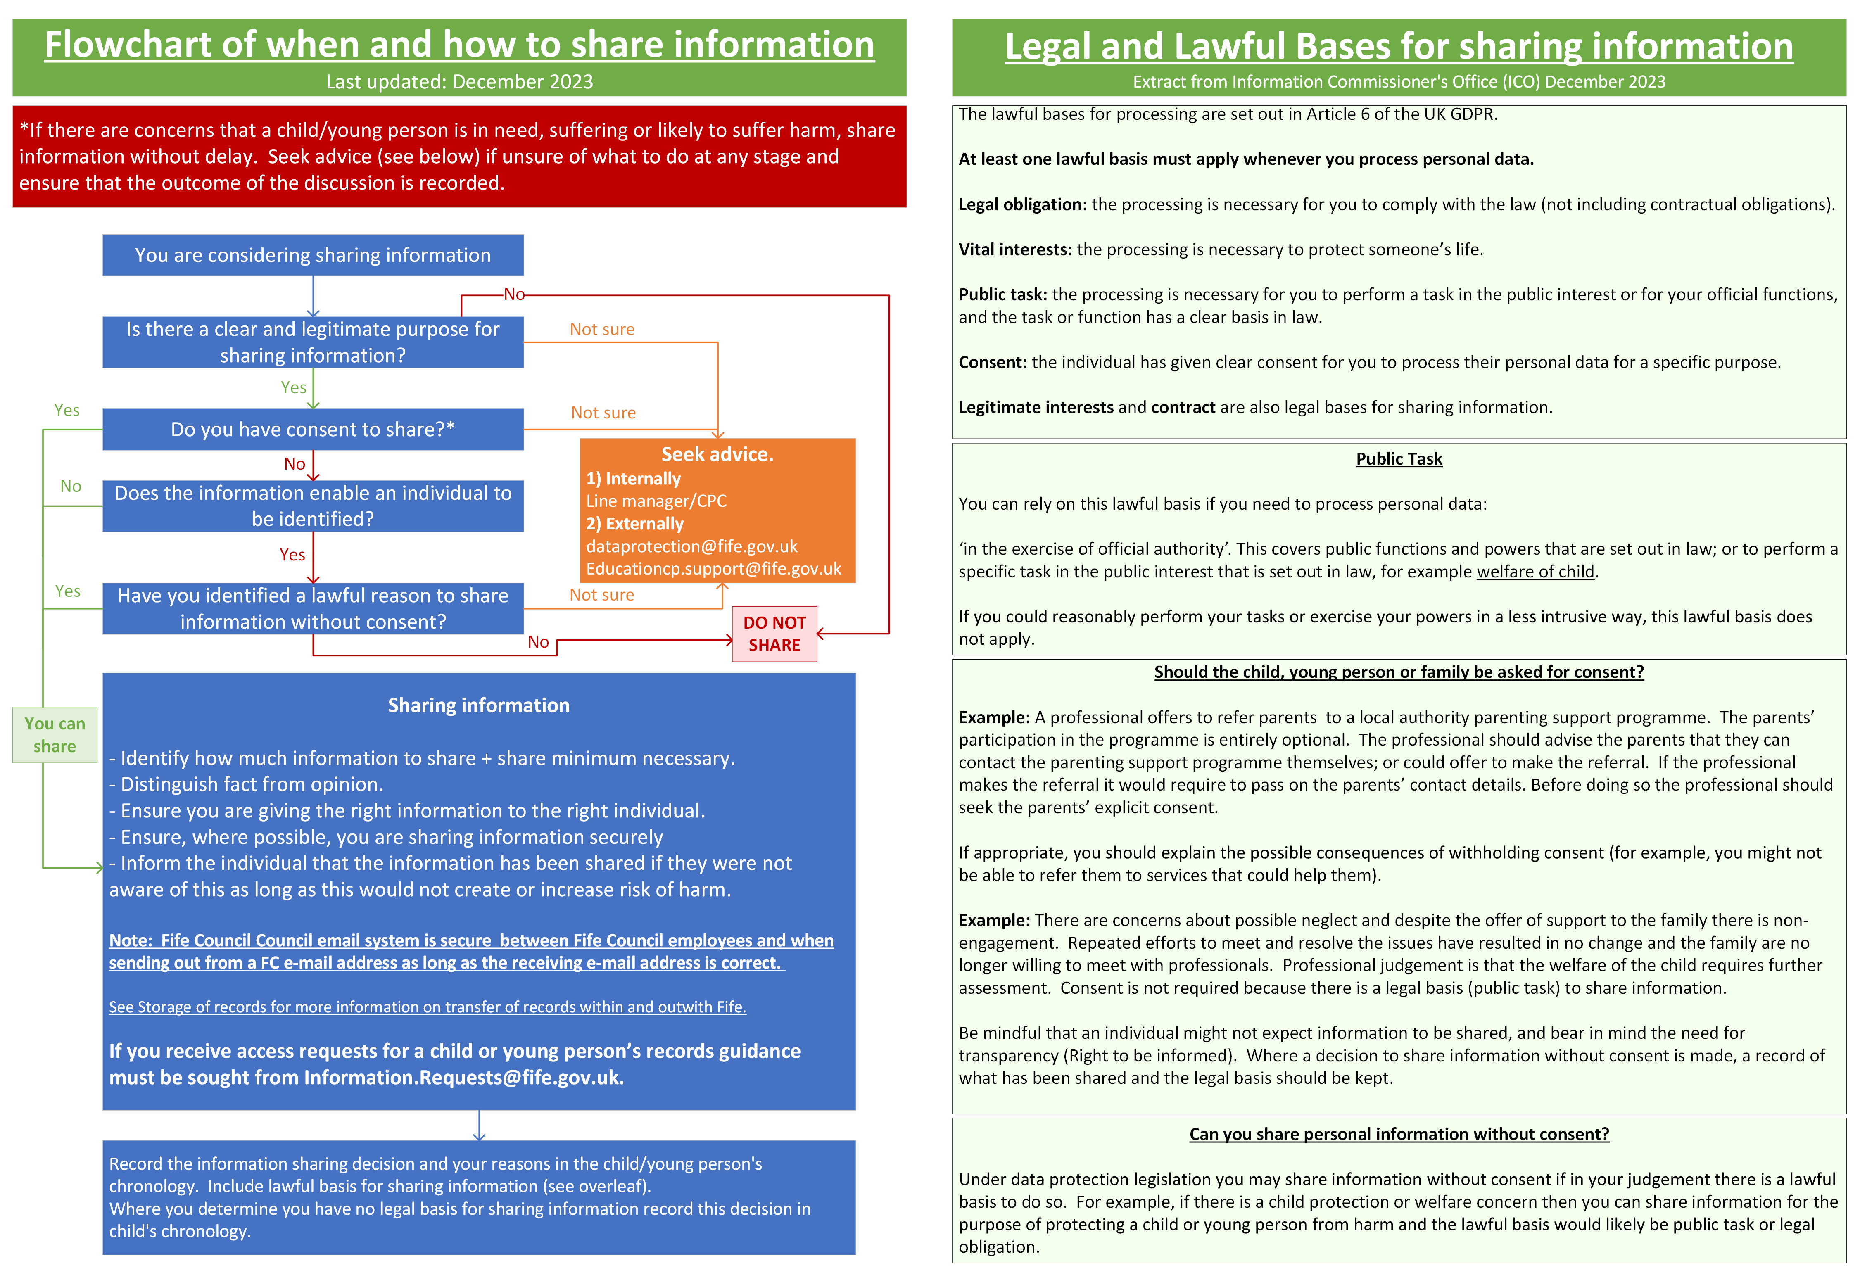

Staff roles & responsibilities

Child Protection Coordinators

All Fife schools/nurseries must have a Child Protection Coordinator (CPC) and a recognised Depute (DCPC). In smaller settings, consideration could be made for a ‘buddy’ to be identified from within the cluster who would be able to provide support and cover as a recognised depute when required. CPCs are charged with a number of key responsibilities and must be suitably experienced and trained prior to undertaking the role and have a duty to keep up to date with policies and legislation changes when in the role.

The Child Protection Coordinator must be the Head Teacher or Depute Head Teacher.

Child Protection Coordinators and Depute Child Protection Coordinators must
- Report to the Headteacher on a regular basis and provide an update on all wellbeing and child protection matters.
- Ensure all staff, including new staff, are briefed and aware of the school/nursery’s Child Protection, Safeguarding and Wellbeing Policy, Fife’s Interagency Child Protection Procedures and any amendments to them.
- Facilitate the development of sound safeguarding and child protection practice throughout the school/nursery and include it in school/nursery improvement plans.
- Be approachable. It is essential that staff feel confident to approach the CPC to discuss their concerns and clarify thinking when they are not sure. It is essential that a culture of listening to young people and taking concerns seriously is maintained.
- Attend mandatory Child Protection Safeguarding and Protecting your School Community Training and Multi-Agency Child Protection Risk Assessment and Processes training (and subsequent refreshers) to keep up-to-date with developments in the field.
- Provide Safeguarding and Child Protection updates (to include raising awareness of Prevent) on an annual basis at the start of each academic year and at regular points during the academic session.
- Be familiar with all local and national safeguarding and child protection policies and procedures and be confident in following them.
- Monitor the management of information held in wellbeing and child protection folders, ensuring records, including chronologies are up to date and kept securely.
- Share information without delay to enable information gathering and discussion to take place at an early stage and before time scales become critical, e.g. before the end of the school/nursery day. (Children will often disclose or exhibit signals that cause concern as the time approaches for them to leave the safety of the education establishment. It is important that these circumstances are not compounded by lack of action).
- Maintain an overview of any referrals made and action taken.
- Ensure that information is shared with the receiving CPC when a child transfers to another school/nursery.
- Co-ordinate ‘in-house’ arrangements for Children Missing from Education (CME) and liaise with CME Co-ordinator: CME@fife.gov.uk
- Oversee the planning of any curricular initiatives designed to give children the knowledge and skills to keep themselves safe from all forms of abuse.
- Keep children and young people updated with their legal rights, procedures to keep them safe and make key numbers/contacts readily available (e.g. how to contact guidance, how to make a complaint, Childline, Police).

All staff
Extracted from National Guidance for Child Protection in Scotland 2021.
All staff working in education establishments, including early learning and childcare (ELC) settings, have a key role in the support and protection of children and young people.  Day-to-day professional experience of, and relationship with children is a fundamental protective factor. All staff must be aware of, and must follow, child protection procedures. | Education services are an essential part of inter-agency planning and support with children and their parents, whether this is within child protection processes or as part of the co-ordinated planning within a GIRFEC approach. Community learning and development and youth work may provide significant support in planning around each child’s needs.
Every school and ELC service should have a child protection co-ordinator taking lead responsibility for child protection in the school, in liaison with the head of establishment,  to whom he/she will report. The child protection lead should also engage with appropriate training and development in order to be able to respond effectively to child protection  concerns, to support staff and to share learning. | Some protective work is preventative and developmental. For example, ‘Personal and Social Education’ aims to provide children with the knowledge, skills and values  associated with healthy choices and relationships, and preparation for adult life.
While all staff in ELC services and schools have responsibilities in relation to child protection, the named person within the GIRFEC approach has a focal role in the recognition of concerns and the co-ordination of help and response from the service, as appropriate. Education services will share information & contribute to investigation and assessment, according to inter-agency child protection protocols, and as far as may be proportionate, relevant and lawful. A child may be referred to the Principal Reporter if there is cause to believe they may be in need of a Compulsory Supervision Order. | The Health & Wellbeing Across Learning: Responsibilities of All Experiences and Outcomes within Curriculum for Excellence, alongside the GIRFEC wellbeing indicators, summarises how practitioners, pupils, parents and communities must work together in protecting and promoting children’s rights, wellbeing and safety. This includes helping children develop in their ability to keep themselves and others safe; and helping them learn how to get help and support if they need it.
When concerns about risk of harm arise, education services are well placed to notice and respond to:  • additional needs or factors that may impact on a child’s ability to voice concern.  • physical and emotional changes in a child that could indicate abuse or neglect.  • family, school, cultural and community context of concerns about a child or children.  • escalating support needs of a child and their family.  • risks and stresses for some children in transitional stages as they move into a new school or on to adult life and services. | Specific forms of concern require appropriate levels of awareness, knowledge and skills within an establishment. These include recognition of neglect, mental health problems, parental alcohol and drug use, under-age sexual activity, child sexual abuse and exploitation, honour-based abuse, forced marriage, female genital mutilation and bullying.  Education establishments and early learning and childcare settings have a responsibility, in co-operation with Child Protection Committees, to ensure that there are appropriate and regularly reviewed procedures and guidance in place.
As with any service that works directly with children and their families, ELC providers are well placed to identify concerns, offer support, and participate in plans to reduce risk as appropriate. They are also expected to have effective child protection procedures in place to ensure staff have a clear understanding of their responsibilities, and to respond appropriately. | Where a child goes missing from education, services within local authorities will conduct investigations in line with their local policy.
Children often see education staff as a trusted source of help and support in confidence. However, when there are concerns about harm to a child emerging from their presentation, or from what they have said or done, then the nominated child protection officer will be consulted without delay. All steps and actions will be recorded.

Reports of concerning behaviour by adults

The following protocol must be followed when dealing with a concern about the conduct of an employee of Fife Council, or adult working with young people (eg volunteer).

Link: HOW TO DEAL WITH REPORTS OF ALLEGATIONS REGARDING ANY ADULT WORKING IN SCHOOLS OR ESTABLISHMENTS – PROCESSES FOR HEADTEACHERS/HEADS OF ESTABLISHMENTS AND SENIOR LEADERS IN EDUCATION.

Whistleblowing Policy for employees

All allegations must be treated seriously, and the response must be prompt.

Do not inform the member of staff of the allegation/concern/charge until advised to do so by an Education Manager/Head of Service.

All staff and volunteers should understand what to do if they receive an allegation against them or an allegation is made to them concerning the behaviour of another member of staff, volunteer, or visitor.

All allegations against staff, volunteers or visitors must be dealt with transparently, but with considerable sensitivity to the management of information.

Duty of care to the employee

It is important to emphasise to the staff member that this will be a stressful time for them and you want to advise them to speak to someone outwith work or family.

Make it clear that the Council can provide counselling to support you at this time. This is accessed through a management referral or a self-referral.

For further information: https://fifecloud.sharepoint.com/sites/HSWMental/SitePages/Counselling.aspx

Checklist for Headteachers/Head of Establishment
Task | Y/N
Contact line manager (Education Manager) immediately.
If unavailable, contact any EM/Head of Service.
Provide full details of incident/allegation/charge.
Provide details of member(s) of staff involved.
(Name, telephone number and job title.)
Inform any other service if relevant i.e. if you do not line manage the person.
Inform HR of the issue.
Complete a NOCC form for each child involved or vulnerable adult if required depending on seriousness of allegation.
If precautionary suspension required then HT must arrange for letter to be handed over to employee with disciplinary process included.
HT must arrange a check a person for the member of staff re their health and wellbeing.

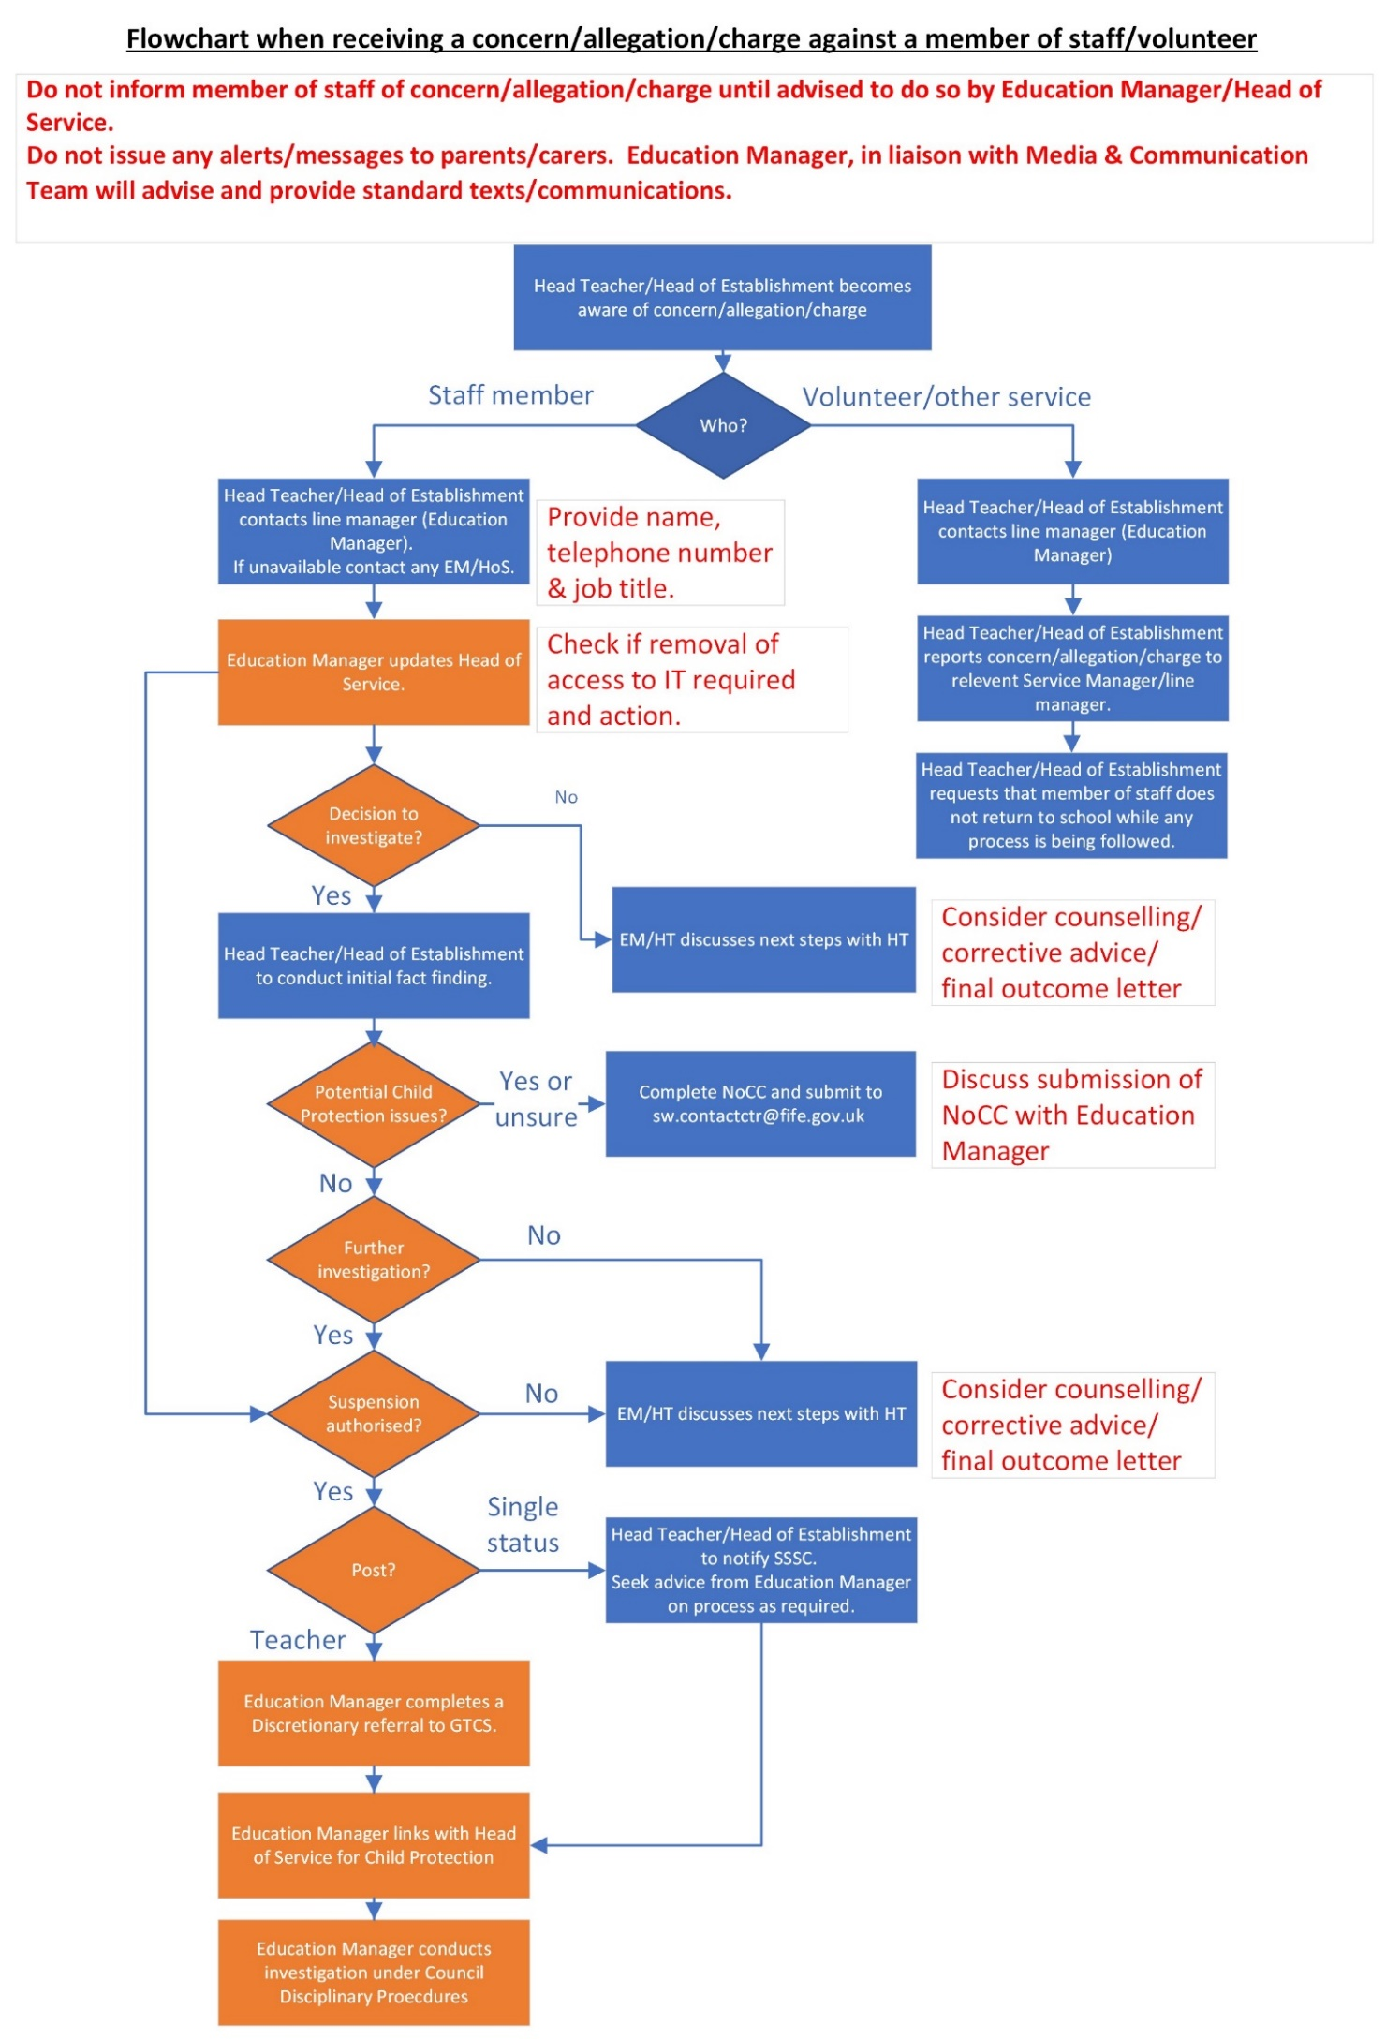
Recognising and responding to concerns

Child protection refers to the processes involved in consideration, assessment and planning of required action, together with the actions themselves, where there are concerns that a child may be at risk of harm. Child protection procedures are initiated when police, social work or health professionals determine that a child may have been abused or may be at risk of significant harm.
Harm in this context refers to the ill treatment or the impairment of the health or development of the child, including, for example, impairment suffered as a result of seeing or hearing the ill treatment of another.
For some actions and legal measures the test is ‘significant harm’ or risk of significant harm. There is no legal definition of significant harm or the distinction between harm and significant harm. The extent to which harm is significant will relate to the severity or anticipated severity of impact upon a child’s health and development.
The National Guidance for Child Protection in Scotland 2021 - updated 2023 provides further insight into recognising and responding to concerns across a multitude of areas including:
Physical abuse | Emotional abuse | Sexual abuse
Criminal exploitation | Child trafficking | Neglect
Female genital mutilation | Forced marriage | Terrorism

All staff working in education establishments, including early learning and childcare (ELC) settings, have a key role in the support and protection of children and young people. Day-today professional experience of, and relationship with children is a fundamental protective factor. All staff must be aware of, and must follow, child protection procedures.
Across Education, staff are supported in understanding their role within child protection through various inputs including annual updates in August Inset and more comprehensive training in accordance with their remit on a three-yearly cycle.
Children often see education staff as a trusted source of help and support in confidence. However, when there are concerns about harm to a child emerging from their presentation or what they have said or done, the Child Protection Co-ordinator (CPC) or Depute Co-ordinator (DCPC) will be consulted without delay. This is also the case if concerns are brought to attention through a third party or anonymously.
All staff are issued with a Child Protection Advice Card which details signs of abuse and the action to take should they have a concern. If you require new cards, please contact EducationCP.Support@fife.gov.uk (see appendix 9 for example).
All staff use our Care and Welfare system to alert the CPC / DCPC to any concerns they may have that a child is at risk. Each establishment has an electronic template of the Care and Welfare form (appendix 5) as well as blank paper copies for staff who do not have access to IT systems. Once completed, the form is shared with the CPC / DCPC without delay and feedback is provided to the referrer when appropriate action has been taken.
Should there be concern that a child is at significant risk, a NoCC form should be completed and submitted to SW.Contactctr@fife.gov.uk as detailed on page 2.

Specific to Early Years and Childcare Services – NoCC

Care Inspectorate have advised ‘when a registered service shares a concern or information about a child protection matter with a lead protection agency (social work or police), that this must be notified through the ‘Allegation of Abuse’ notification eform.’
Care Inspectorate have indicated that they use this information to ensure procedures have been followed and appropriate supports have been put in place to support children when there have been allegations of abuse.
Therefore, whenever a NoCC is submitted or a telephone conversation is had with the Social Work Contact Centre then Care Inspectorate should also be notified. Please remember that, in line with the reporting of accidents and incidents, you should not identify individuals when reporting any allegations of abuse – the information required on the eforms system is the child’s initials and date of birth.
For those children who are known to Social Work already and there has been a concern discussed with the child’s Social Worker, you should link with your Care Inspector to ascertain whether you should submit a notification through the eform process.

Prevent

If there are concerns about a child or young person in danger of becoming radicalised, or involved in groups with extremist views, staff should alert their CPC / DCPC who can progress a referral to Prevent using this form. The overall aim of Prevent is to safeguard and support those most at risk of radicalisation by identifying them early and offering support – to prevent them from moving from extremist activity to terrorist related activity.

Child Protection specific circumstances

Families affected by Imprisonment

Families Outside acknowledges the impact felt by a child when a family member or loved one goes to prison. The most recent Scottish Prisoner Survey showed that 61% of people in prison have a child. This correlates to more children experience the imprisonment of a parent each year than a parents’ divorce.

Research indicates (Families Outside) that children and young people can experience the following issues when a parent/carer becomes imprisoned:

Many children who witness criminal behaviour and/or the arrest of a parent suffer significant trauma.

They are often isolated and judged for an offence they did not commit.

They often feel so ashamed of their situation that they do not tell others about their family member’s imprisonment to avoid the risk of being bullied.

Not having contact with an imprisoned parent can have a detrimental effect on children and young people’s emotional wellbeing.

In an attempt to protect children, adults may choose to lie to them, saying that their family member is ‘working away’ or similar, which can lead to confusion, uncertainty, and anxiety.

MARAC

MARAC (Multi Agency Risk Assessment Conferencing) is a public protection process relating to high-risk domestic abuse. MARAC takes places every fortnight and is attended by a multi-agency group of professionals.
The four aims of a MARAC are to:

Appropriately share information across agencies and public protection arrangements.

Safeguard victims, children and any vulnerable persons identified.

Protect agency staff.

Address the behaviour of the perpetrator.

Where school staff have concerns pertaining to domestic abuse, Care and Welfare / Child Protection procedures should be followed.
Where there are significant concerns, the school can make a referral to MARAC themselves using the MARAC Referral Form or can contact the MARAC Co-ordinator at marac@fife.gov.uk
MARAC may request that schools carry out safety planning with children and young people. Advice can be found within the MARAC Resources section - Fife Child Protection and Named Person Support Pack

Child Protection Planning Meetings

A Child Protection Planning Meeting (CPPM) is a formal multi-disciplinary meeting which must include representation from the core agencies (social work, health and police) as well as any other agencies currently working with the child and their family.
The purpose of the CPPM is to ensure that relevant and proportionate information is shared, to carry out a collective assessment of risk, and to agree a plan to minimise risk of harm to the child.
A school representative may be invited to attend a CPPM and will be required to provide a report, for which there is a standard template (see appendix 12).
The recommendation section of the report must always be completed with the writer’s opinion of whether the child should be placed on the Fife Child Protection Register.
The report may contain both fact and professional opinion, but these should be clearly differentiated and supported by evidence drawn from care and welfare information and a chronology of concerns. The content of these reports should be shared with the child and their views obtained wherever possible and appropriate. Parents should be invited to attend a meeting at the school to discuss the contents, but where this invitation is declined, a copy of the report should be sent to them with a covering letter before the CPPM takes place.
Where an Initial CPPM takes place during the school holiday period, the CPC / DCPC will be made aware and an education representative will attend on their behalf if required. Review CPPMs should be held within 6 months of the CPPM. If a review CPPM is known to take place during a holiday period, a report should be sent to the Social Work Reviewing Officer, parents and to the following inbox: Education.Notification@fife.gov.uk
A child attending school during or after a Child Protection investigation may have to deal with a range of physical, psychological and emotional experiences which may have an impact on their learning and behaviour in school. They may have contact with a range of partners to provide the opportunity to work through some of the issues which have arisen. A child will find it easier to deal with school life if staff are positive and welcoming and appropriately informed of any issues which may affect their work or attendance in school.

Following the CPPM

If, as part of the CPPM, the child is placed on the Child Protection Register, the education representative will be invited to be a part of the Core Group. This group has responsibility for implementing, monitoring and reviewing the Child Protection Plan, in partnership with children and parents.
When a child’s name has been added to Fife’s Child Protection Register, a Child’s Plan will be drawn up outlining the support which is to be put in place. A Lead Professional will be nominated, usually the social worker, to coordinate, progress and review the plan. The named person will be integral to this plan and will be required to attend regular Core Group meetings to review the plan.

Child Protection Register

All local authorities are responsible for maintaining a central child protection register for all children who are the subject of an inter-agency Child Protection Plan. The register has no legal status. The Child Protection Register is an administrative system for alerting practitioners that there is sufficient professional concern about a child to warrant an inter-agency Child Protection Plan.
Local authority social work services are responsible for maintaining a register of all children in their area who are subject to a Child Protection Plan.
The decision to place a child’s name on the register should be taken following multiagency assessment and a Child Protection Planning Meeting.
A child may be placed on the register if there are reasonable grounds to believe or suspect that a child has suffered or will suffer significant harm from abuse or neglect, and that a Child Protection Plan is needed to protect and support the child.
See appendix 12 for further information on making enquiries to the Child Protection Register. All establishments should ensure the accuracy or the Child Protection Register at all times as well as ensuring robust planning for those recently deregistered (within last 6 months) against known risks identified with partners.

Children’s Hearings

GIRFEC seeks to ensure that professionals work together to meet identified wellbeing needs at the earliest possible stage and that support is then appropriate, proportionate and timely.
Where voluntary engagement has not sufficiently addressed a child’s needs, or is thought unlikely to be able to do so, a referral to the Reporter should be considered for the purposes of compulsory intervention.
The statutory criteria for referral to the Reporter are:
(a) the child is in need of protection, guidance, treatment or control; and

(b) it might be necessary for a Compulsory Supervision Order to be made in relation to the child. The Local Authority and the Police must refer a child when the criteria apply. Any other person may do so.

Before making a referral to the Reporter, the referrer must have considered the referral criteria and believe that they apply. This should involve consideration of whether voluntary engagement will be likely to meet the child’s needs and, if not, whether a Compulsory Supervision Order might be a proportionate response. In many situations the provision of voluntary support will have been tried before a referral is made, but in some circumstances this may not be necessary.
If a decision is taken at Team around the Child (TAC) Meeting to refer the child to the Reporter the child’s allocated Social Worker will take responsibility for submitting the referral to SCRA by way of full Social Work report, irrespective of the nature of the referral. Where a child is unallocated to social work, the TAC Meeting should allocate responsibility for the referral.
If the decision of the TAC Meeting is that the child is not to be referred to the Reporter, but one agency still considers that it might be necessary for a compulsory supervision order to be made in relation to the child, this should be discussed with immediate line management for consideration of a single agency referral to the Reporter.(for further information see embedded Children’s Hearing Protocol.)

VPDs (Vulnerable Person Database)

Police Scotland use a database known as the Vulnerable Person Database (VPD) to record details of concerns relating to children and adults. The Concern Report is used by officers to provide details of any concern that should be recorded in the VPD system.

The Police Officer attending an incident completes the Concern Report and sends this by email to Police Scotland DHQ in Glenrothes. Staff based at ‘P’ Division Headquarters carry out checks on each child referred to in the Concern Report to determine whether the issues raised require referral to the Reporter to the Children’s Panel, action by Fife Council Social Work Children & Families or partner agencies, such as Health and Education.
Please note the incident described in the Concern Report does not relate to an offence by the child.

Please see VPD processing guidance for more information.

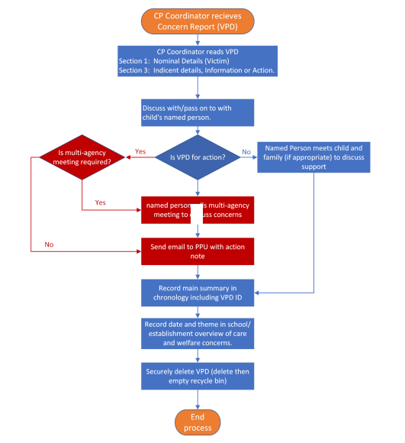

IRD (Interagency Referral Discussion)

As part of child protection, an Interagency Referral Discussion (IRD) is the first stage in the process of information sharing, assessment and decision making between Police, Social Work, Health and Education, about children and young people who may be at risk of harm or significant harm. The IRD process seeks to coordinate a multi-agency response to the concerns about a child.
An IRD
Can be generated by Police, Social Work or Health.
Is undertaken if a child is suspected of being a victim of a crime of physical or sexual abuse or of sexual exploitation or serious neglect.
May be undertaken if a child has been witness to a significant event such as a death.
May be undertaken if there is suspected peer-on-peer abuse.
Will always be undertaken in the cases of Sudden Unexpected Death in Infancy/Children.
Will be undertaken for any child aged two years or younger, who is open to social work, who has a fracture.

Please see IRD Processing Guidance 2022 for further information.

IRD Process

Stage 1: Initial checks
1. Business Support staff in Rothesay House (on behalf of the Public Protection Unit) will request basic information from schools on the morning of the IRD meeting.
2. Responses to these questions should be returned by email within two hours. Senior management are asked to support the person who knows the child best to complete these questions as a matter of urgency.

Stage 2: IRD Meeting
Meetings are held via Teams each morning. Police, Social Work, Health and Education will feed relevant information into the meeting for discussion.

Outcomes of the discussion can be one or more of the following:
Single agency response.
Joint agency response.
Joint Investigative Interview (JII) - Conducted by trained police officers and social workers
Specialist or Joint Paediatric Forensic Medical Examination (JPFME).
Should a decision be made for the child to be jointly interviewed by Police and Social Work, a request may be made for this to be carried out in school.

If the interview is being held in school the Child Protection Co-ordinator should:

Ensure the Headteacher is aware the interview is taking place.
Ensure a quiet room is available.
Ensure there are no interruptions during the interview of the child.
Have chronologies available should they be requested.
Arrange for someone to support the child if this has been requested.
Be aware that parental consent is not required for a child to be interviewed.

Stage 3: Processing
Schools (Named Person Mailbox) will receive an abridged copy of the completed IRD form following the meeting.

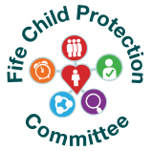
Escalation Process
FIFE CHILD PROTECTION ESCALATION PROCESS
Notification of Child Concern (NoCC) forms should be used to raise concerns about the immediate protection of/significant harm to a child that will inform a decision around the need for an IRD (same day) in office hours.
NoCCs relating to immediate protection concerns outside of office hours will be responded to by the Police and out of hours social work sevice. See page 2 for contact telephone numbers.
This time standard applies, even when there has been an accumulation of concerns, which has resulted in a NoCC raising concerns regarding immediate protection/significant harm.
If having raised a NoCC, you do not feel the necessary action/decision has been made and the child remains in need of immediate protection/ significant harm, you need to escalate your concerns. Follow the flowchart below.

IF A LIFE-OR-DEATH SITUATION PHONE POLICE ON 999 -DO NOT DELAY
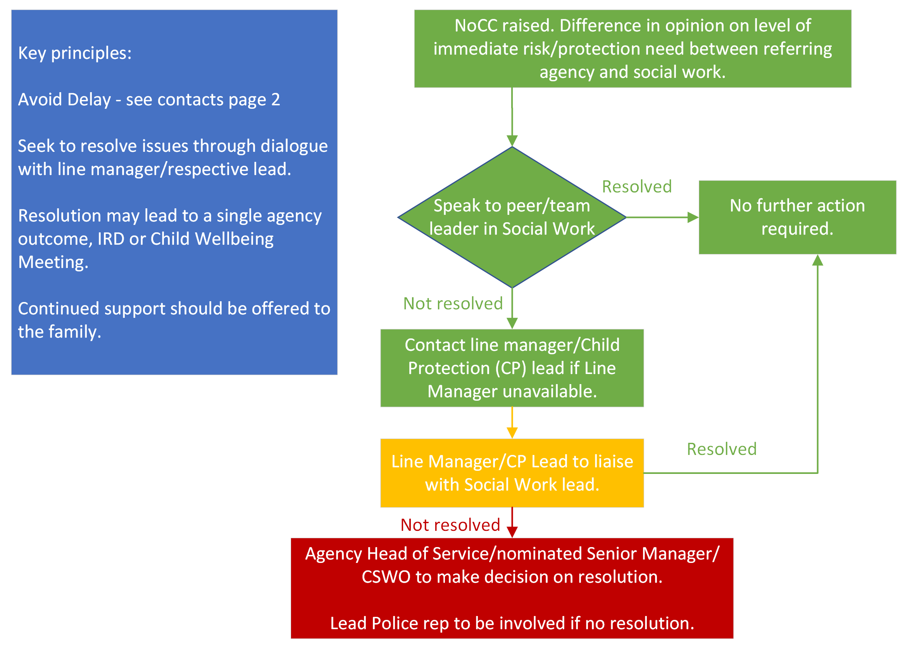

There will always be difference in professional opinions around risk/harm and interventions. This process ensures that in the event of difference in opinion around immediate protection /significant harm, professional concerns can be escalated.

Transfer of Care and Welfare/Child Protection Records

Please see Storage and sharing of records for more information.

Where a child is on the child protection register and in cases where concerns exist about child protection, relevant data must be shared with the new setting as soon as it is known that a child will be transferring to a new school or setting.

Care and welfare information and child protection concerns must always be transferred to the child’s new school or educational establishment when a pupil moves from one school or establishment to another. File follows child.

Pupil records stored in SEEMiS can also be electronically transferred to schools’ and other local authorities, when a pupil moves to a school in another Scottish local authority area that uses the Wellbeing Application. This is a protective factor in child protection instances as it allows the receiving authority to instantly see the child’s history.

Transfer of information within Fife is accomplished by transfer of the electronic record.

Within Fife

Chronology: Electronic and paper chronology where in existence should also be transferred.

Transfer of files including:
- Childminder or Funded Provider to Local Authority ELC.
- Childminder or Funded Provider to Primary School.
- Local Authority ELC to Funded Provider or Childminder.
- Local Authority ELC to Primary School.
- Primary to Secondary.

Paper care and welfare files should be collected by the Child Protection Coordinator of receiving school or passed directly from Child Protection Coordinator to Child Protection Coordinator. A signed record of transfer of paper files should be retained by both establishments.

Staff must be alert to the risks of leaving a child’s records in their vehicles/in plain sight in their vehicles. Theft of a vehicle could result in a data breach. Staff must not leave a child’s records unattended in their vehicles.

Primary/Secondary to PSS

PSS must ensure they have full knowledge of chronology and any health care needs/plans at point of entry to PSS and over time. PSS holds responsibility for ensuring the information held for learners accessing PSS is accurate and live.

Outwith Fife - Sending records out of Fife

The Care and Welfare Forms, Child Protection documents and correspondence and the Chronology of events for the child must be downloaded and sent in a separate envelope, marked confidential, with the PPR. The Records must be sent by secure mailing service of Royal Mail. A receipt for these documents should be requested and retained by the sending school. Information about current/live child protection activity or concerns should be passed quickly to the receiving school. This should be done via a conversation between CPC of sending school and CPC of receiving school sharing main concerns.

Where appropriate, the electronic records should be transferred to the new school, and any paper records (PPR, Care and Welfare and Child Protection) are packaged securely and posted to the new school, using the secure mailing service of Royal Mail. Proof of posting must be retained. In addition, the package used to contain the paper records must be robust enough to withstand handling by the mailing service (double enveloped in case of accidental Post Office tear or robust padded envelope).

Schools must not place a child’s records in polythene wallets or plastic packaging which would allow the contents to be read by those handling the mail.

Outwith Fife - Receiving records from out of Fife
​
Report a data breach if at point of receipt a care and welfare file being received is damaged to the point of being readable by mail handlers by contacting dataprotection@fife.gov.uk.

Outwith Scotland

When a pupil moves outwith Scotland the receiving school should be alerted to any concerns as soon as possible.

Sector Specific Care and Welfare Process: Early Years

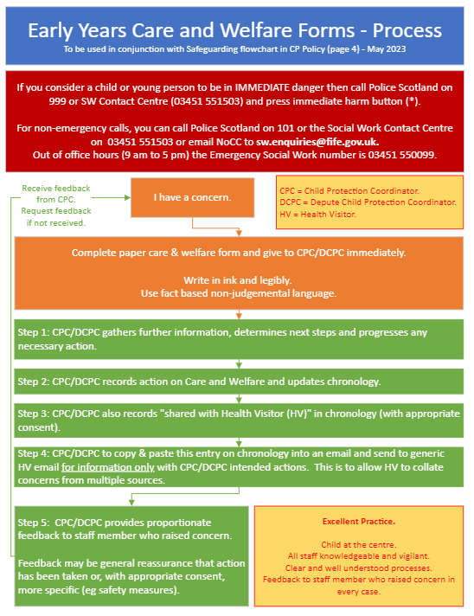

Sector Specific Care and Welfare Process: Primary/Secondary
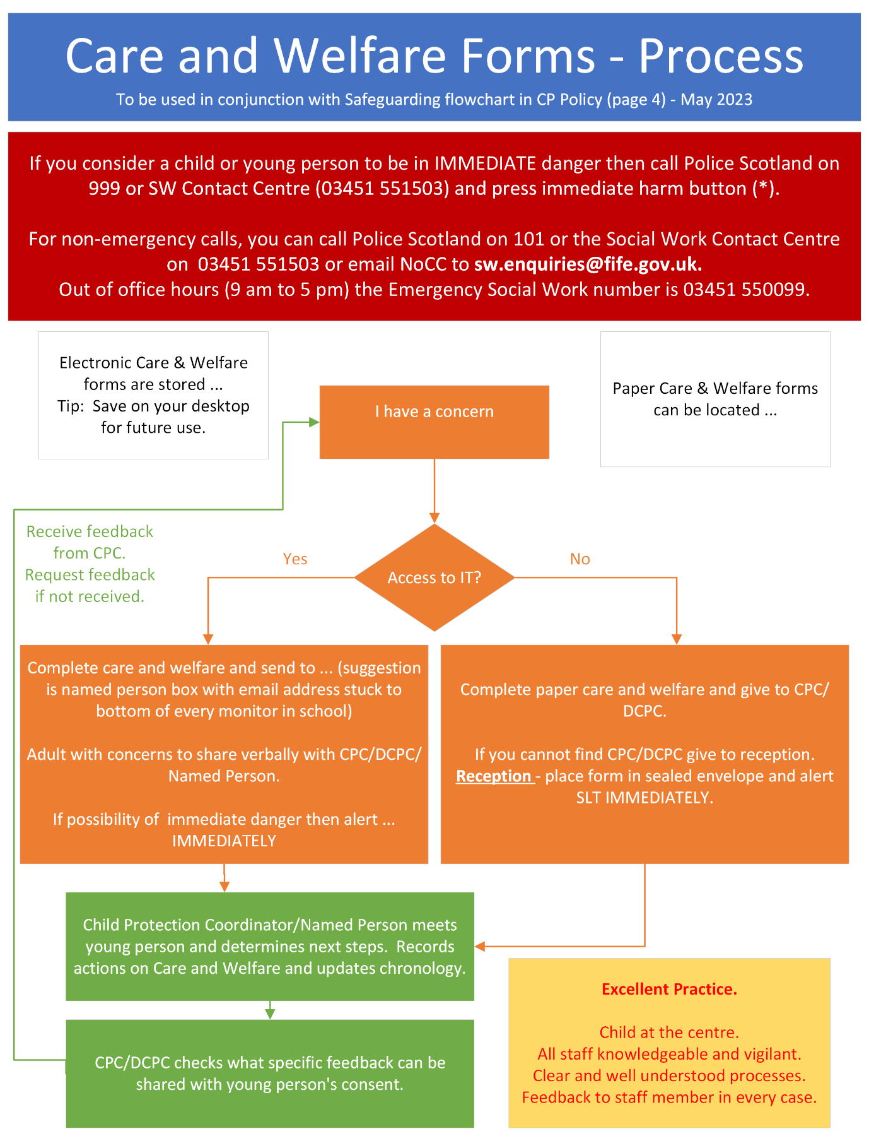

Sector Specific Care and Welfare Process: Active Schools

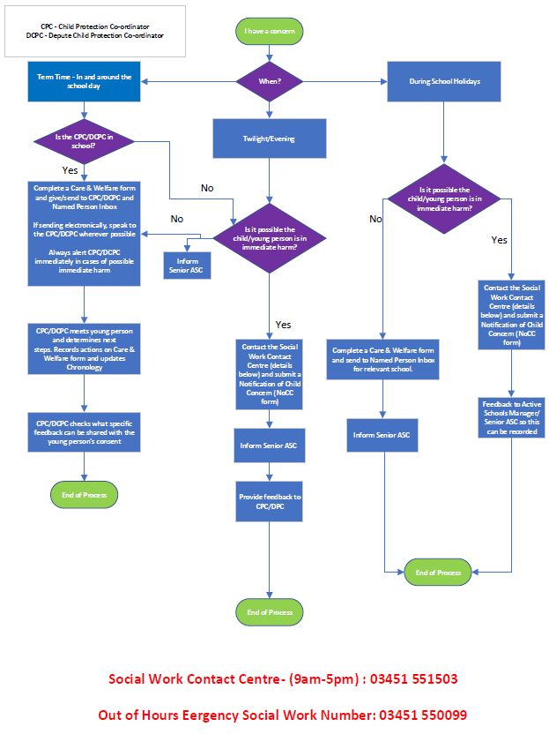

Sector Specific Care and Welfare Process: Gypsy & Traveller Education Service
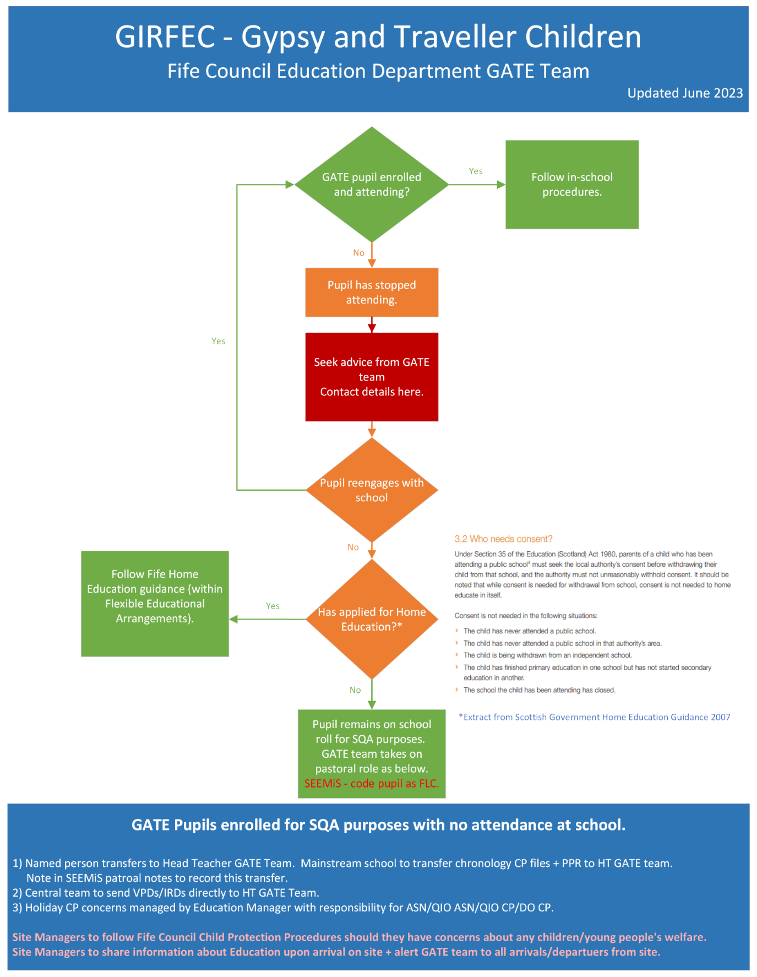

Sector Specific Care and Welfare Process: Music Service
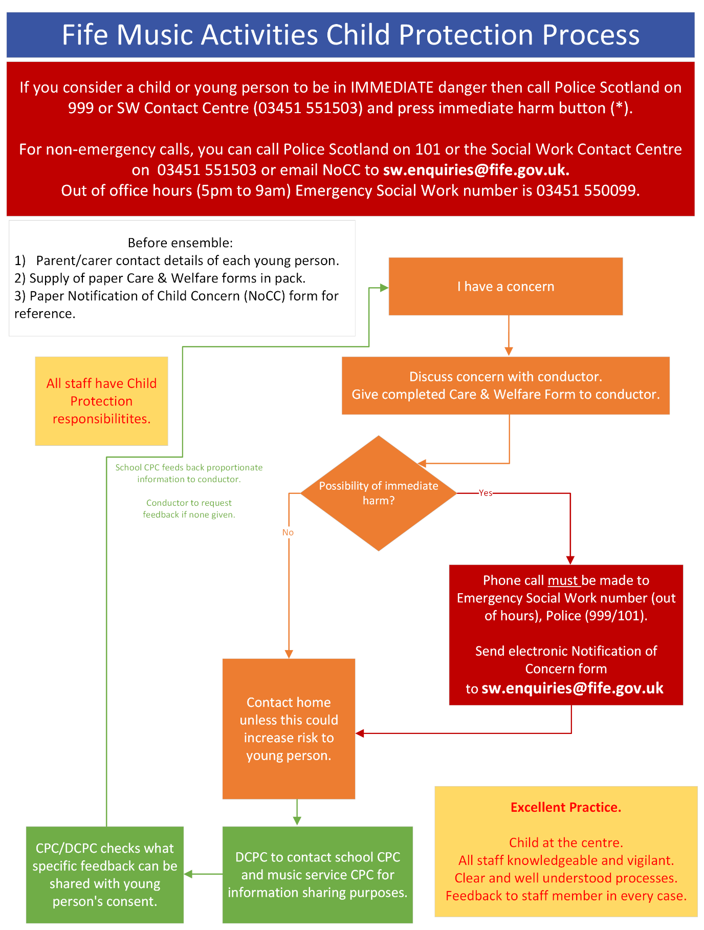

Sector Specific Care and Welfare Process: Out of School Service
Out of School Service - Child Protection, Wellbeing and Safeguarding Flowchart
If you consider a child or young person is in IMMEDIATE danger, then call Police Scotland on 999 or Social Work Contact Centre (03451 551503) and press immediate harm button (*)

For non-emergency calls, you can call Police Scotland on 101 or the Social Work Contact Centre on 03451 551503 or email Notification of Child Concern form to sw.enquiries@fife.gov.uk

Out of office hours (5pm to 9am) Emergency Social Work number is 03451 550099
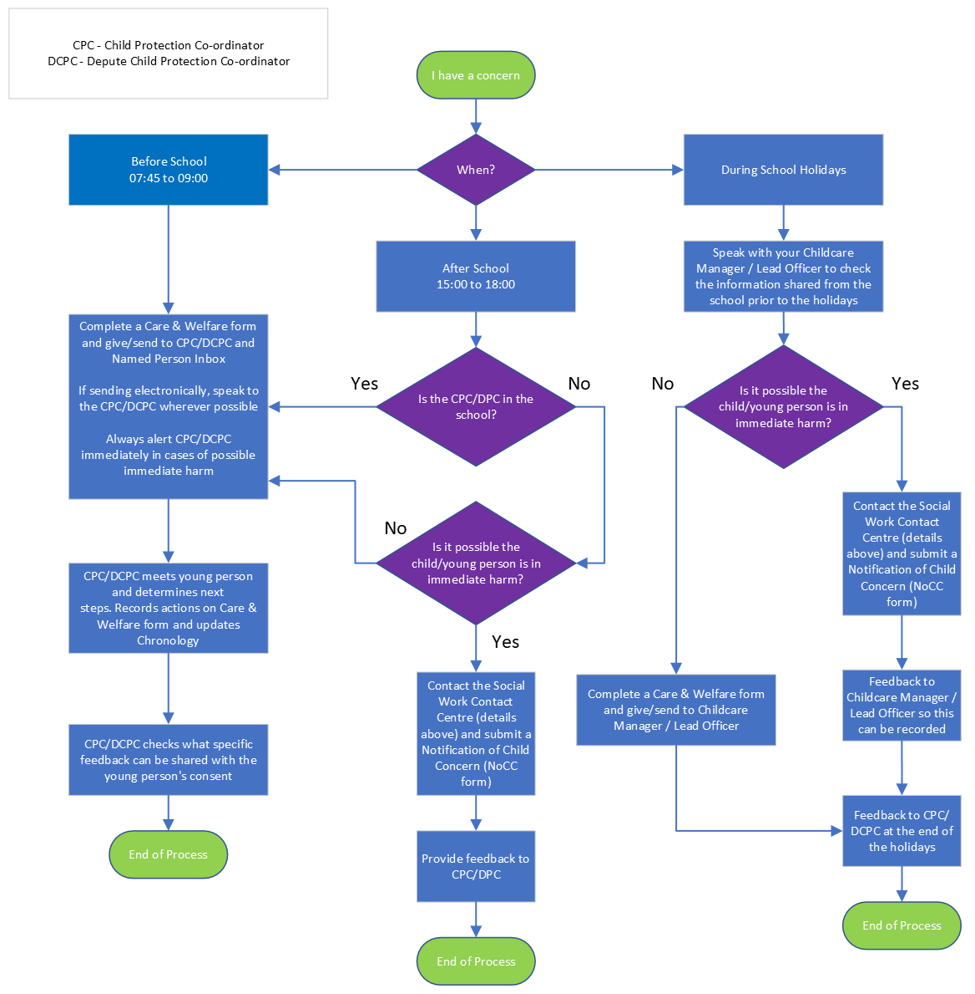

Out of School Service - Child Protection, Safeguarding and Wellbeing
Information Sharing Guidance
During the main school holiday periods (Easter / Summer / October) Fife Council’s Childcare Services Team continues to operate Out of School Clubs.
To support the service in making quality judgements around child protection, safeguarding and wellbeing, the Childcare Manager and their Lead Officer must have access to appropriate information about each child who will be attending.
The form below is provided to aid the sharing of information.
The Childcare Manager will provide the form with the names of each of the children who are booked to attend over the holiday period. The school should then complete the remainder of the form which will include:
- If there are any current concerns about the child/family
- If there is social work involvement, who the social worker is, including contact details.
- If there any other agencies involved with the child/family, what is their involvement, including their contact details.
- If the child is looked after/on child protection register
- Any other relevant information
  - Are there any special instructions for example, social work should be informed if child is absent?
  - Is there a pro-active management plan in place - if so, a copy should be available to the Childcare Manager.
  - What are the risk factors? i.e., risk is heightened when child is in mum's care.
  - Attendance - is this being monitored and what is the plan in place if the child does not attend?
When form is completed a teams / phone call or face to face meeting should be arranged with the Childcare Manager to discuss this form in detail.
All completed forms must be saved to the Children’s Information document library on SharePoint as this can only be accessed by the relevant people within the service.
Child Protection, Safeguarding and Wellbeing
Child’s Name | Date of Birth | Are there  current concerns? | Is the child  on the Child Protection  Register? | Social Worker (if applicable) | Other Agencies (if applicable) | Summary of Concerns | Additional Information

Appendix 1: Child friendly materials/approaches

Child friendly leaflet.docx (sharepoint.com)
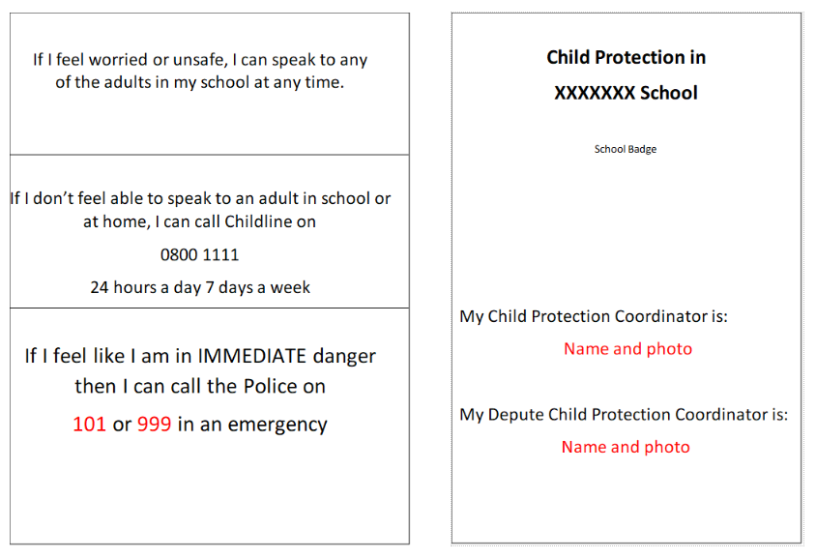
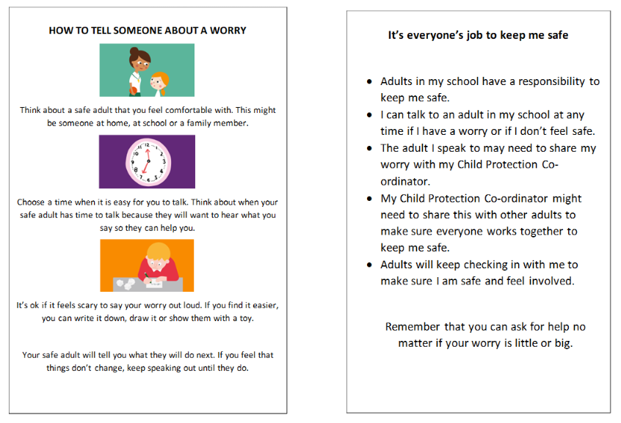

Expectations of children and young people involved in child protection processes from National Guidance for Child Protection in Scotland 2021 - updated 2023

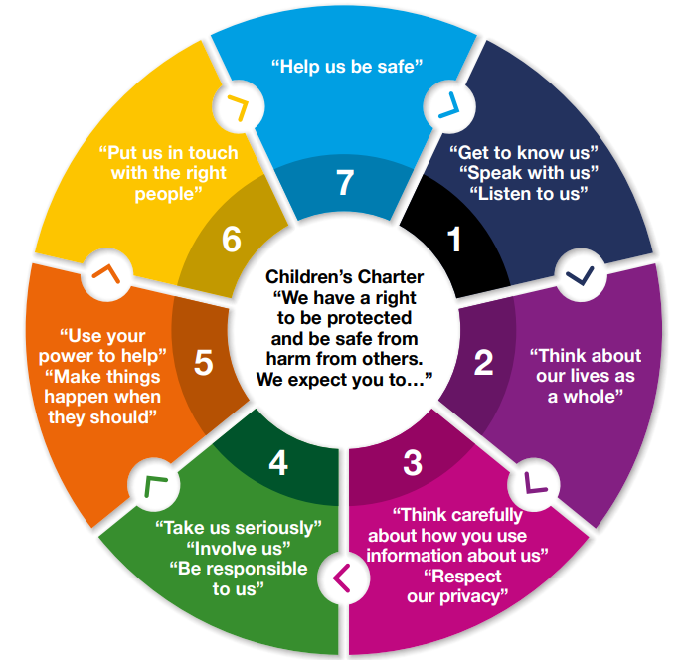

Appendix 2: Parent/carer leaflets
Child Protection & Safeguarding
Information for Parents/Carers

XXXXX School

Child Protection Coordinator: Name and Role
Depute Child Protection Coordinator: Name and Role

“Child Protection is everyone’s job and everyone’s responsibility”
Worried about a child?
If you see behaviour that is of concern, or if a child tells you something worrying, you need to do something about it and speak to someone.

You can speak to a teacher, health visitor, social worker or police officer.

However, if you think a child has been harmed, telephone the Social Work Contact Centre on 03451 55 15 03, from Monday to Friday, 9am to 5pm.
Out-with these hours, please call them on 03451 55 00 99.
You can call the police on telephone number 101, 24/7.

If you consider a child(ren) to be in immediate danger, do not wait, call the Police on 999

What to say
Explain exactly what you have seen, heard or been told and what it was that concerned you.
If you can, keep a note of dates, injuries and the exact words used. These will help you give as much information as you can about the child and their family/carer.
Let the person know if there are other things they should be aware of, for example, immediate risks for the child or any other child.

Will you need to give your name?
You can ask to remain anonymous but any information about you will be treated with care. Any details, including your name, will not be revealed unless the child's safety requires it. Even if you do not give your name, enquiries can still be made into the child's care and welfare. Withholding your name may make it more difficult for those looking into these concerns.

What will happen to the child or young person and their family?
When you contact a professional about your concern, unless the child is in immediate danger, they will make some initial enquiries before taking action. They will check whether the child is known to them and what information is held. All information will be treated seriously and acted upon as appropriate. This may lead to immediate action or a more planned response.

Should you mind your own business?
Many people do not tell because they fear that:
- the child will be at further risk of harm
- that nothing will be done
- the child would be taken away
- the family may find out who reported them
- telling may ruin family relationships.

In reality, it is best for everyone that action is taken early to identify any abuse before it gets worse. Long-term abuse is much more likely to cause problems for a child as they get older. Even if you think an incident is just a one off, other professional agencies may already have concerns about the child.

In Scotland it is everyone’s job to make sure children are OK.
At all times we keep the child’s best interests at the centre of any required actions or planning, and in almost all cases liaise closely with family.

Staff know to alert the Child Protection Coordinator in the school immediately should they have a Child Protection Concern.

When the Child Protection Coordinators are made aware of a concern we do the following in most instances.

- Talk to the child. This is usually our first step. The discussion is conducted sensitively to the child, making it clear that any information they share is confidential unless they or someone they know may be in danger.

We take the child’s views into consideration in planning next steps and include them in any subsequent planning to keep them safe.

If we have to share information with other agencies we will discuss this with the young person wherever possible.

The child is offered a quiet, safe environment if they are upset for as long as needed.

- Contact the child’s family. In almost all situations we include the child’s family early in order to support the child so long as they are not part of the concern. In most instances a family member comes to school to support the child if they are distressed.

- Consider action & update appropriate agencies (Health Team etc). We look at appropriate supports for the young person and their family. This is done in conjunction with the young person and family.

Any safety planning will include the young person’s opinions and is monitored closely.

- Record the concern. We record the concern securely including the action we take and any monitoring required. The record is kept securely with access limited to the Child Protection Coordinator(s), Head Teacher and the young person’s named person if different.

- Plan and monitor over time. The Child Protection Coordinator will keep in close contact with the child and manage any supports they require over time.

The Child Protection Coordinator will in almost all instances stay in close contact with the child’s family and plan jointly with them to identify supports.

- In the event of a young person being in immediate danger, we contact the Public Protection Unit to liaise with Police and Social Work.

Parents/carers are always contacted unless doing so may put the young person at greater risk.
Extract from National Guidance for Child Protection 2021
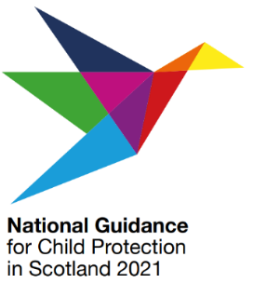
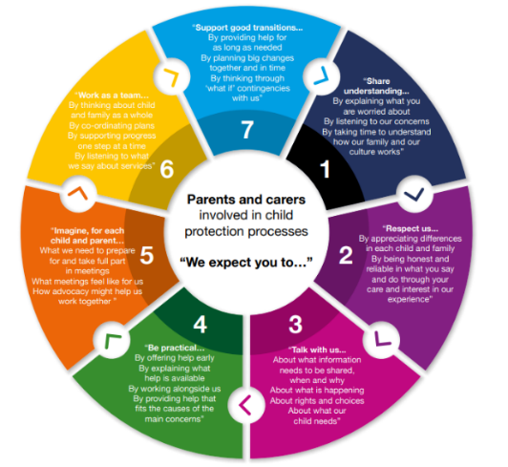
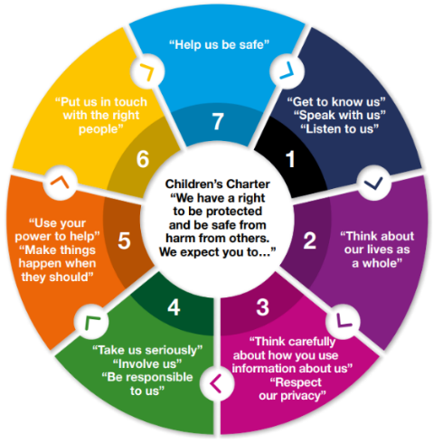

Appendix 3: Volunteers
Key Contacts

Social Work Contact Centre

03451 55 15 03
Out of Hours Social Work (after hours, weekend and public holidays)

03451 55 00 99

Emergency Services
101 or 999 in an emergency

XXXXXXXXXX School
Child Protection Procedures

School Badge

The Child Protection Coordinator is:
Name and photo

The Depute Child Protection Coordinator is:
Name and photo
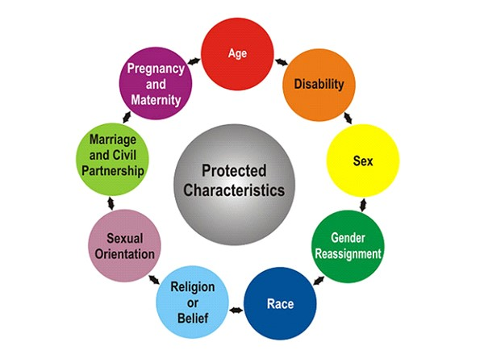
Please report any discrimination you witness immediately by recording on a
Care and Welfare form
(found at reception, guidance and staff room)

Guidelines for Responding
The role of school staff is to recognise, respond, report and record:
- Recognise when the child’s behaviour and demeanour is a cause for concern and respond.
- Report concerns immediately to the Child Protection Coordinator.
- Record what you have seen and heard, and when, using the young person’s own words where possible.

Procedures for dealing with a disclosure
- Listen with care and take the allegation seriously.
- Do not give a guarantee of confidentiality.
- Use open ended questions to establish the basic facts - Who, What, Where and When, then STOP.
- Reassure the young person that you know it is not their fault
- Tell the young person that the Child Protection Coordinator will have to be informed
- Report immediately to the Child Protection Coordinator/Deputy Child Protection Coordinator
- Record on a Care and Welfare form (found at reception, guidance, staff room).
If you are on your own, don’t delay, phone Social Work, Police or Health yourself (Contact Numbers overleaf).
Remember: Keep a record of all calls.

Child Protection Procedures for all Staff and Volunteers

We fully adhere to the processes and procedures contained within the National Guidance for Child Protection in Scotland 2014.

Responding to Concerns

Wellbeing / Child Protection concerns may arise in the following circumstances:
- through observation of the child’s behaviour or appearance, or comments the child has made;
- by a child telling a member of staff they have been abused or feel unsafe;
- through a third party, this could be another pupil, a parent or carer or member of the public;
- by letter or phone call, which may be anonymous.

Protected characteristics:
The Equality Act became law in 2010. The Equality Act protects people from discrimination, harassment and victimisation under the protected characteristics.

Appendix 4: Child Protection Advice Cards
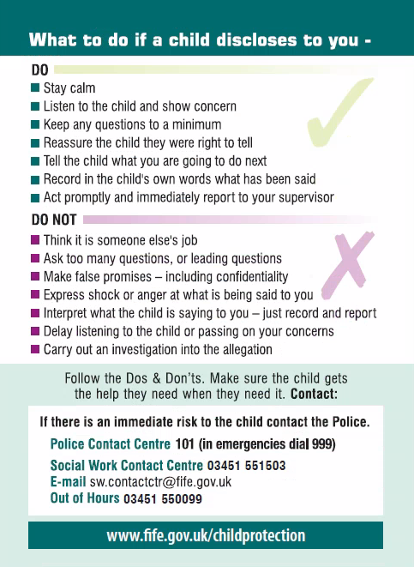
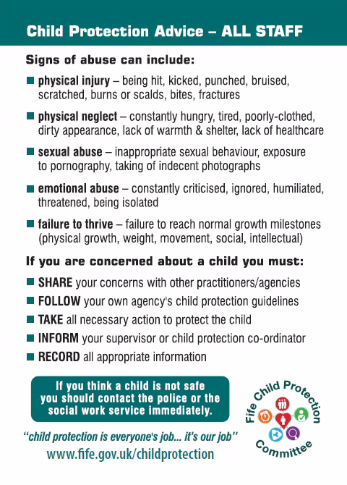

Appendix 5: Care and Welfare form

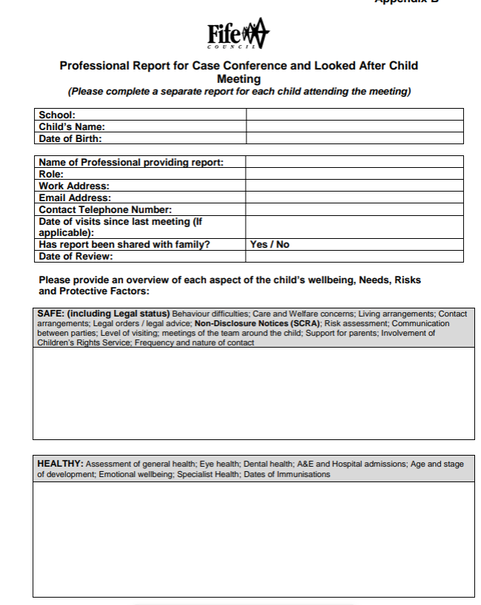
Appendix 6: Child Protection Planning Meeting standard report

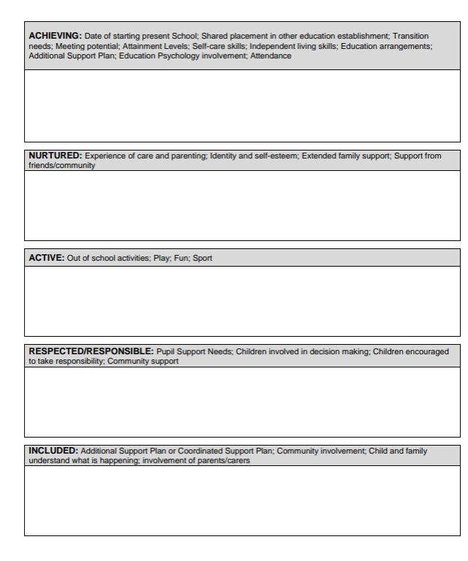
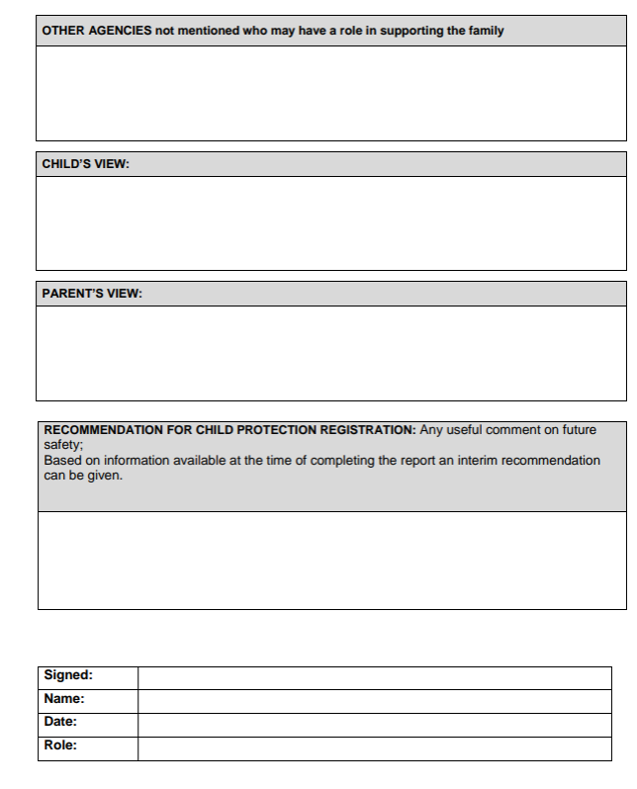

Appendix 7: Child Protection Register Process

Appendix 8: Glossary of terms

Extracted from National Guidance for Child Protection in Scotland 2021

Advocacy: A term used within different contexts in this Guidance. Listening to a child, or an adult who cares for the child and working out with them how to represent their views, experiences and needs within assessment, planning and decision-making processes. The terms of some forms of advocacy are provided for in statute. | Disabled children: A term used in this Guidance and in Scottish Government policy documents to reflect a social model of disability in which the barriers created by society are recognised as a cause of disadvantage and exclusion, rather than the impairment itself. (p7. A Fairer Scotland for Disabled People.) It is the right of individuals, families and groups to use terms which feel acceptable to them, such as ‘children with disabilities’.
Care and Risk Management (CARM): Processes which are applied when a child between the ages of 12 and 17 has been involved in behaviours which could cause serious harm to others. This includes sexual or violent behaviour which may cause serious harm. CARM processes are also applicable when an escalation of behaviours suggests that an incident of a seriously harmful nature may be imminent. | Joint Investigative Interviews (JII): These are formal interviews of children conducted by trained police officers and social workers where there is a concern that a child is a victim of, or witness to, criminal conduct, and where there is information to suggest that the child has been or is being abused or neglected, or may be at risk of significant harm.
Chief Officers Group: The collective expression for the Local Police Commander and Chief Executives of the local authority and NHS Board in each local area. Chief Officers are individually and collectively responsible for the leadership, direction and scrutiny of their respective child protection services and their Child Protection Committees. | Lead professional: The social worker who leads and co-ordinates the multi-disciplinary child protection assessment, and oversees implementation of actions to protect the child.
Child: Child protection processes within this Guidance relate to unborn babies and children and young people under the age of 18 years. (Part 1 seeks to summarise some of the relevant legal definitions of ‘child’ in Scotland, and the applicability of legislation relating to the protection of young adults). | My World Triangle: Within the GIRFEC National Practice Model, the My World Triangle is a starting point for considering what risks might be present in a child’s life. The Triangle focuses attention on the three dimensions of a child’s world: the child, their family, and their wider environment.
Child abuse and child neglect: Abuse and neglect are forms of maltreatment of a child. Somebody may abuse a child by inflicting, or by failing to prevent, harm to a child:  • emotional abuse is persistent emotional neglect or ill treatment of a child causing severe and lasting adverse effects on the child’s emotional development. ‘Persistent’ means there is a continuous or intermittent pattern which has caused, or is likely to cause, significant harm  • neglect consists in persistent failure to meet a child’s basic physical and/or psychological needs, which is likely to result in the serious impairment of the child’s health or development. There can also be single instances of neglectful behaviour that cause significant harm. Neglect can arise in the context of systemic stresses such as poverty, and is an indicator of support needs  • physical abuse is the causing of physical harm to a child or young person  • child sexual abuse is an act that involves a child under 16 in any activity for the sexual gratification of another, whether or not it is claimed that the child either consented or assented. For those who may be victims of sexual offences aged 16-17, child protection procedures should be considered; and must be applied when there is concern child about sexual exploitation or trafficking. | Named person: A core component of the GIRFEC approach, this is a professional point of contact within universal services, if a child, young person or their parents need information, advice or help. Local arrangements and the term used to describe this role or function may vary from area to area.
Child’s plan/Child Protection Plan: Where those working with the child and family have evidence to indicate that support across services may be required to meet the child’s wellbeing needs, a child’s plan is drawn up to co‑ordinate a single plan of action. This should be managed and reviewed through a single planning process, including a single meeting structure, even if the child is involved in several processes. The child’s plan will incorporate a Child Protection Plan if the criteria for registration are met, namely risk of significant harm requiring a multi-agency plan. The Child Protection Plan must focus on actions to reduce risk. | Notification of Concern: Where concerns about possible harm to a child arise, these should always be shared with the appropriate agency (normally police or social work) so that staff responsible for investigating the circumstances can determine whether that harm is significant. Where a practitioner has a concern about a child’s wellbeing, this can be shared with a named person (or equivalent) where this has been discussed with the family.
Child protection: The processes involved in consideration, assessment and planning of required action, together with the actions themselves, where there are concerns that a child may be at risk of harm from abuse, neglect or exploitation:  • child protection guidance provides overall direction for agencies and professional disciplines where there are concerns that a child may be at risk of harm.  • child protection procedures are initiated when police, social work or health professionals determine that a child may have been abused or may be at risk of significant harm, and when an inter-agency referral discussion (see below) takes place. | Parents and carers: A ‘parent’ is someone who is the legal mother or father of the child, whether genetic or not. This is subject to the Human Fertilisation and Embryology Act 2008, which sets out which persons are to be treated as the parents of a child conceived through assisted reproduction. A ‘carer’ is someone other than a parent who is looking after a child.
Child Protection Planning Meeting: A multi-disciplinary meeting, formerly termed a Child Protection Case Conference. Involvement of child and relevant family members should be supported. The purpose of the meeting is to consider and agree an assessment of risk and form a plan of required action to protect a child or young person. Participants are those persons essential to the Child Protection Plan. | Resilience: This refers to positive adaptation despite serious adversities and threats to a child’s development. Within the GIRFEC National Practice Model, the resilience matrix is a tool which promotes consideration of the dynamic interaction of stresses and protective factors in the child’s world.
Child Protection Committee: The locally-based, inter-agency strategic partnership responsible for child protection policy and practice across the public, private and Third Sectors. Working on behalf of Chief Officers, its role is to provide individual and collective leadership and direction for the management of child protection services in its area. | Team around the child: Those practitioners who support the child and family, and are likely to be participants at a child’s plan meeting.
Child protection register: All local authorities are responsible for maintaining a central register, known as the child protection register as described in Part 1 of this Guidance. This is a list of all children, including unborn babies, who are subject to a Child Protection Plan. | Wellbeing Indicators: A holistic and rights informed framework, within the GIRFEC National Practice Model, which outlines a child’s wellbeing needs under eight headings: safe, healthy, achieving, nurtured, active, respected, responsible and included.
Core Group: A group of identified practitioners, and child/family including the lead professional, who liaise regularly between Child Protection Planning Meetings to ensure that actions are being progressed and to monitor risk. This may be a smaller group than the team around the Child, involving those practitioners with direct and regular engagement.

Appendix 9: Key acronyms
Extracted from National Guidance for Child Protection in Scotland 2021 Appendix B: acronyms
ACR: Age of criminal responsibility | ECHR: European Convention on Human Rights | MARAC: Multi-Agency Risk Assessment Conferences
CAMHS: Child & Adolescent Mental Health Service | EHRC: Equality and Human Rights Commission | MATAC: Multi-Agency Tasking and Co-ordination
CARM: Care and Risk Management | FASD: Foetal Alcohol Spectrum Disorder | RMA: Risk Management Authority
CCE: Child criminal exploitation | FGC/FGDM: Family Group Conferencing/Family Group Decision Making | RSHO: Risk of Sexual Harm Orders
CELCIS: Centre for Excellence for Children’s Care and Protection | FGM: Female genital mutilation | SID: Sudden Infant Death
CHS: Children’s Hearings Scotland | FII: Fabricated or induced Illness | SCRA: Scottish Children’s Reporter Administration
CICA: Criminal Injuries Compensation Authority | FNP: Family Nurse Partnership | SCLD: Scottish Commission for Learning Disability
CPO: Child protection order | GIRFEC: Getting it right for every child | SHANARRI: GIRFEC wellbeing indicators – safe, healthy, active, nurtured, achieving, respected, responsible, included.
COG: Chief Officers Group | HBA: Honour-based abuse | SOS: Signs of Safety
CSA: Child sexual abuse | HIS: Healthcare Improvement Scotland | SPS: Scottish Prison Service
CPC: Child Protection Committee or Child Protection Coordinator dependant on context. | HMICS: Her Majesty’s Inspectorate of Constabulary in Scotland | SUDI: Sudden unexpected death in infancy
CPCC: Child Protection Committee Chairs | ICR: Independent Care Review | TEPOs: Trafficking and Exploitation Prevention Orders
COPFS: Crown Office and Procurator Fiscal Service | IRD: Inter-agency referral discussion | TEROs: Trafficking and Exploitation Risk Orders
COSLA: Convention of Scottish Local Authorities | JII: Joint Investigative Interview | UASC: Unaccompanied asylum-seeking child
CSO: Compulsory Supervision Order | JPFE: Joint Paediatric Forensic Examination | UNCRC: United Nations Convention on the Rights of the Child
CYCJ: Centre for Youth and Criminal Justice | PRR: Parental responsibilities and rights | VAWG: Violence against women and girls
CPPM: Child Protection Planning Meeting | LAAC: Looked after and accommodated child | VISOR: Violent and Sex Offender Register
CSE: Child sexual exploitation | NHS: NHS Education Scotland
CSWO: Chief Social Work Officer | MAPPA: Multi-Agency Public Protection Arrangements

Appendix 10: Template Establishment Policy

Child Protection, Safeguarding and Wellbeing Policy

This policy applies to all staff and volunteers.

Within our school/nursery we aim to create an environment in which all pupils are safe and feel safe in school/nursery. There is a strong, robust and proactive response from adults that reduces the risk of harm to children. Adults working with them know and understand the indicators that may suggest that a child/young person is suffering or is at risk of suffering harm. (Ref: How good is our school 4th Edition)

We are committed to practice in a way that protects all children and young people and fully adhere to the processes and procedures contained within Fife’s Inter-Agency Child Protection Guidance 2016 https://www.fife.gov.uk/__data/assets/pdf_file/0030/194970/CPC-Inter-Agency-Guidance-Final-Master-27.09.16.pdf.

This document states that:

- All education staff have important roles in protecting children from abuse and neglect and in identifying children who may be at risk of abuse.
- The protection and wellbeing of the child must remain at the heart of all considerations and decisions

The purpose of this policy is;

- to protect children and young people attending ________________ School/Nursery.
- to provide staff and volunteers with the overarching principles that guide our approach to safeguarding and child protection;

Staff at _____________ School/Nursery believe that a child or young person should never experience abuse of any kind. We have a responsibility to promote the welfare and wellbeing of all children and young people and to keep them safe.
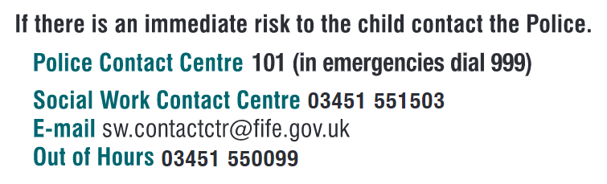


Fife Key Child Protection Principles

Fife Child Protection Committee’s ‘Six for Safety’ promotes best practice when working with children and families. Developed from analysis and learning from Significant Case Reviews, these are day-to-day ways of working to support and protect children and young people and support improved decision making.
- Child at the Centre – The needs of children and young people are at the centre of all practice.

- Relationships – Ensuring that all relationships with children, parents/carers are effective, constructive and are central to improving wellbeing and minimising risk of harm.

- Quality Assessment and Planning – All assessments and plans are accurate and effective by achieving outcomes in meeting needs and minimising risk of harm. All available resources and tools are used to best effect.

- Information Exchange and Communication – Relevant information is shared appropriately, clear lines of responsibility for action are understood across partners and communication is effective in minimising potential risks.

- Early Intervention – Early and effective intervention is achieved where possible, minimising risk of harm to children and young people.

- Professional Support and Oversight – A culture of effective management support and/or supervision is embedded which embodies the values and principles of Fife Child Protection Committee.

We recognise that:
- The welfare of the child is paramount, as enshrined in The Children (Scotland) Act 1995.
- All children, regardless of age, disability, gender, racial heritage, religious belief, sexual orientation or identity, have a right to equal protection from all types of harm and abuse.
- Some children are additionally vulnerable because of the impact of previous experiences, their level of dependency, communication needs or other issues.
- Working in partnership with children, young people, their parents, carers and other agencies is essential in promoting young people’s welfare and wellbeing.
We will seek to keep children and young people safe by:
- Valuing them, listening to and respecting them.
- Appointing a Child Protection Co-ordinator for Child Protection for the school and also a Depute Child Protection Coordinator.
- Adopting the processes and procedures contained within Fife’s Inter-Agency Child Protection Guidance.
- Developing and implementing an effective e-safety policy and related procedures.
- Providing effective management for staff and volunteers through training, support and quality assurance measures.
- Recruiting staff and volunteers safely, ensuring all necessary checks are made.
- Recording and storing information professionally and securely.
- Using our procedures to share concerns and relevant information with agency’s who need to know, and involving children, young people, parents, families and carers appropriately.
- Using our procedures to manage any allegations against staff and volunteers appropriately.
- Creating and maintaining an anti-bullying environment and ensuring that we have a policy and procedure to help us deal effectively with any bullying that does arise.
- Ensuring that we have effective complaints and whistle blowing measures in place
- Ensuring that we provide a safe physical environment for our children, young people, staff and volunteers, by applying health and safety measures in accordance with the law and regulatory guidance.
- Sharing information about safeguarding and good practice with children, their families, staff and volunteers via leaflets, posters, one to one discussions.

Safeguarding Procedures Poster
You suspect there is something wrong at home/school.
You see physical symptoms/signs.
You have concerns about behaviour changes.
A learner comes to talk to you/messages you.

Fill in a Care and Welfare Form as fully as possible ensuring you note all facts clearly.
Give/send Care and Welfare form to Child Protection Coordinator.
Make it as easy as possible to talk/message.
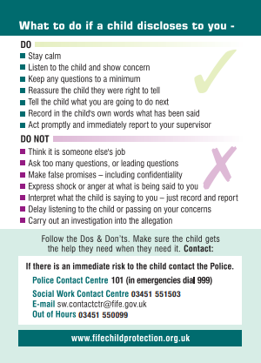
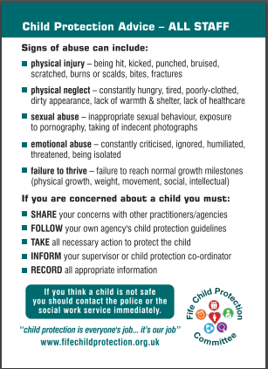
Contact details
Child Protection Coordinators names. (add thumbnail photos if possible)
Expect and ask for feedback.

Discuss with Child Protection Coordinator.
Take the learner seriously and reassure them. Remain neutral and try not to express shock or anger at what is being disclosed to you – just record and report.

Be honest about what you are required to do to ensure the learner gets the help they need.
Be explicit about being required to pass on information to the right people.
Fill in a Care and Welfare form as soon as practically possible and give/send to Child Protection Coordinator.
Record facts as fully as possible and use learner’s own words where possible.

Do not attempt to gather evidence/proof.
If comfortable ask “wh” questions but do not ask leading questions. (Who, What, Where)
Take time/space to listen.

Child Protection Coordinator
Name
VOIP
Email

Depute Child Protection Coordinator
Name
VOIP
Email

Add additional names if more than one DCPC

We are committed to reviewing our policy and good practice annually.

This policy was last reviewed by on (Date)

Position:

Signed: _____________________

Legal Framework
This policy has been drawn up based on overarching legislation and guidance that seeks to protect children, namely but not exclusively:
- National Guidance for Child Protection in Scotland, Scottish Government, 2021
Child Protection Guidance 2021 (theapsgroup.scot)
- Inter-agency Child Protection Procedures – Fife (2016)
https://www.fife.gov.uk/__data/assets/pdf_file/0030/194970/CPC-Inter-Agency-Guidance-Final-Master-27.09.16.pdf
- Getting it Right for Every Child Policy
https://www.gov.scot/policies/girfec/latest/
- General Data Protection Regulation/Data Protection Act 2018
https://ico.org.uk/for-organisations/guide-to-data-protection/guide-to-the-general-data-protection-regulation-gdpr/
- Children’s Hearing (Scotland) Act 2011
https://www.legislation.gov.uk/asp/2011/1/contents
- Children and Young People (Scotland) Act 2014
http://www.legislation.gov.uk/asp/2014/8/contents/enacted
- Children (Scotland) Act 1995
https://www.gov.scot/publications/scotlands-children-children-scotland-act-1995-regulations-guidance-volume-1-support-protection-children-families/documents/
- Children Scotland Act (2020)
https://www.legislation.gov.uk/asp/2020/16/body/enacted
- Education (Additional Support for Learning) (Scotland) Act 2004
https://education.gov.scot/improvement/research/education-additional-support-for-learning-scotland-act-2004/
- National Framework for Child Protection Learning and Development in Scotland (2012)
http://www.gov.scot/Topics/People/Young-People/protecting/child-protection/national-framework-cp-learning-2012
- The Protection of Vulnerable Groups (Scotland) Act 2007
http://www.gov.scot/Publications/2011/08/04111811/1
- United Nations Convention on the Rights of the Child
http://www.unicef.org.uk/UNICEFs-Work/Our-mission/UN-Convention/

Appendix 11: Self-evaluation/Self-assessment
Setting name: | Date: | Completed by:

On visit to a school Education Manager/QIO/DO for CP will check the following:
- Foyer sign showing CPC/DCPC is visible, especially to visitors.
- CP Policy in place and on website.
- CPC / DCPC details on back of visitor badges. Snapshot of awareness of CPC/DCPC (Ask 3 random young people)
- CPC awareness – ask a few young people about knowledge of who Child Protection Coordinator is as well as ways school keeps young people safe/what happens in the event of a child protection alert.
- CPC / DCPC knowledge of individual children. Overview of needs being maintained and used to identify support / interventions.
- Copies of Fife Council’s Inter-Agency CP Procedures 2016 and National Guidance for CP (Scotland) 2021 accessible to staff. Electronic and paper.
- Training log is complete and up to date.
- Induction Handbook and Staff handouts being utilised.
- All live CP folders and ones currently being investigated and at least 2-4 other CP folders.
- Electronic single agency chronologies.
- At least 3-5 PPRs, CP folders and LA children/young people- see guidance on this
- Log for administration of medication and speak to the person who administers this, this may include looking at a few Healthcare plans.
- Log for First Aid and speak to the First Aider.
- CPC / DCPC knowledge of attendance information, interventions and support.
- Bullying & Equalities log and analysis/action plan - check process and equalities module.
- Compliments/Complaints log and themes.

Area |  | Yes | No |  | Yes | No |  | Yes | No
Foyer sign showing CPC/DCPC visible | Available at front of school. |  |  | Available in other places around the school. |  |  | General awareness of who the CPC/DCPC is.
CP policy in place | Has review date. |  |  | On the website. |  |  | Part of staff induction.
CPC awareness | CPC/DCPC details on visitor badges. |  |  | Young people awareness of who CPC/DCPC are. |  |  | Young people aware of C&W process and follow-up.
Care & Welfare | Paper copies of form at main office. |  |  | ELC specific. E-form being used where appropriate (e.g. for all NoCCs). |  |  | C&W overview spreadsheet or similar being used.
Individual needs | Knowledge of CP registered children / young people. |  |  | CP registered pupils have a plan in place.
 | Knowledge of care experienced young people. |  |  | Has a CSP for all LAC been considered + consideration noted? |  |  | CSPs are high quality and up-to-date.
Procedures/Guidance | Copies in HT/ CPC Office. |  |  | Copies accessible elsewhere.
CP Training log | Complete and up to date. |  |  | Has other training included. |  |  | Annual Updates (inc Prevent).
Induction handbook and Staff Handouts | Induction Booklet used for new starts + log kept. |  |  | All staff have prompt sheets for dealing with a disclosure (on CP Advice cards)
CP Folders | Locked cabinet with restricted access. |  |  | Organised correctly. |  |  | Chronology at front of folder.
Chronologies + overview. | In secure part of server. |  |  | Organised correctly. |  |  | Advice given.
PPRs | Stored separately from CP folders (markers used if other folder exists). |  |  | Organised correctly i.e., in date order. |  |  | Does not contain confidential info.
Administration of medicine | Log available in central point where administered. |  |  | Permission slip signed by parents corresponds to medication held by school. |  |  | Medication is in date.
 | Forms used are from current Fife Guidance. |  |  | HCPs are in date and signed by school, parent and healthcare professional. |  |  | Medical cabinet locked. Emergency medication easily accessed i.e. access to Epipen.
 | Staff appropriately trained
First Aid | Log available. |  |  | Consistent information recorded. |  |  | Carers informed appropriately.
Attendance | Knowledge of attendance rates / non-attenders. |  |  | Power Bi / tracking system used to scrutinise attendance data. |  |  | Appropriate support given to children / young people.
Bullying log - equalities module | Bullying log seen. |  |  | All aspects completed. |  |  | School is acting on trends/patterns.
Compliments log | Compliments log/tab seen. |  |  | All aspects completed. |  |  | School promoting good practice.
Complaints log | Complaints log/tab seen. |  |  | All aspects completed. |  |  | School acting on issues.
Outstanding actions for setting regarding area from above audit
Area | Comments | By whom | By when

Good practice to share with others

Setting name
(E)Signed by
Position - (Headteacher or CPC)

Return to QIO Child Protection Gavin.waterston@fife.gov.uk for central logging.

