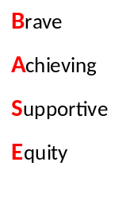
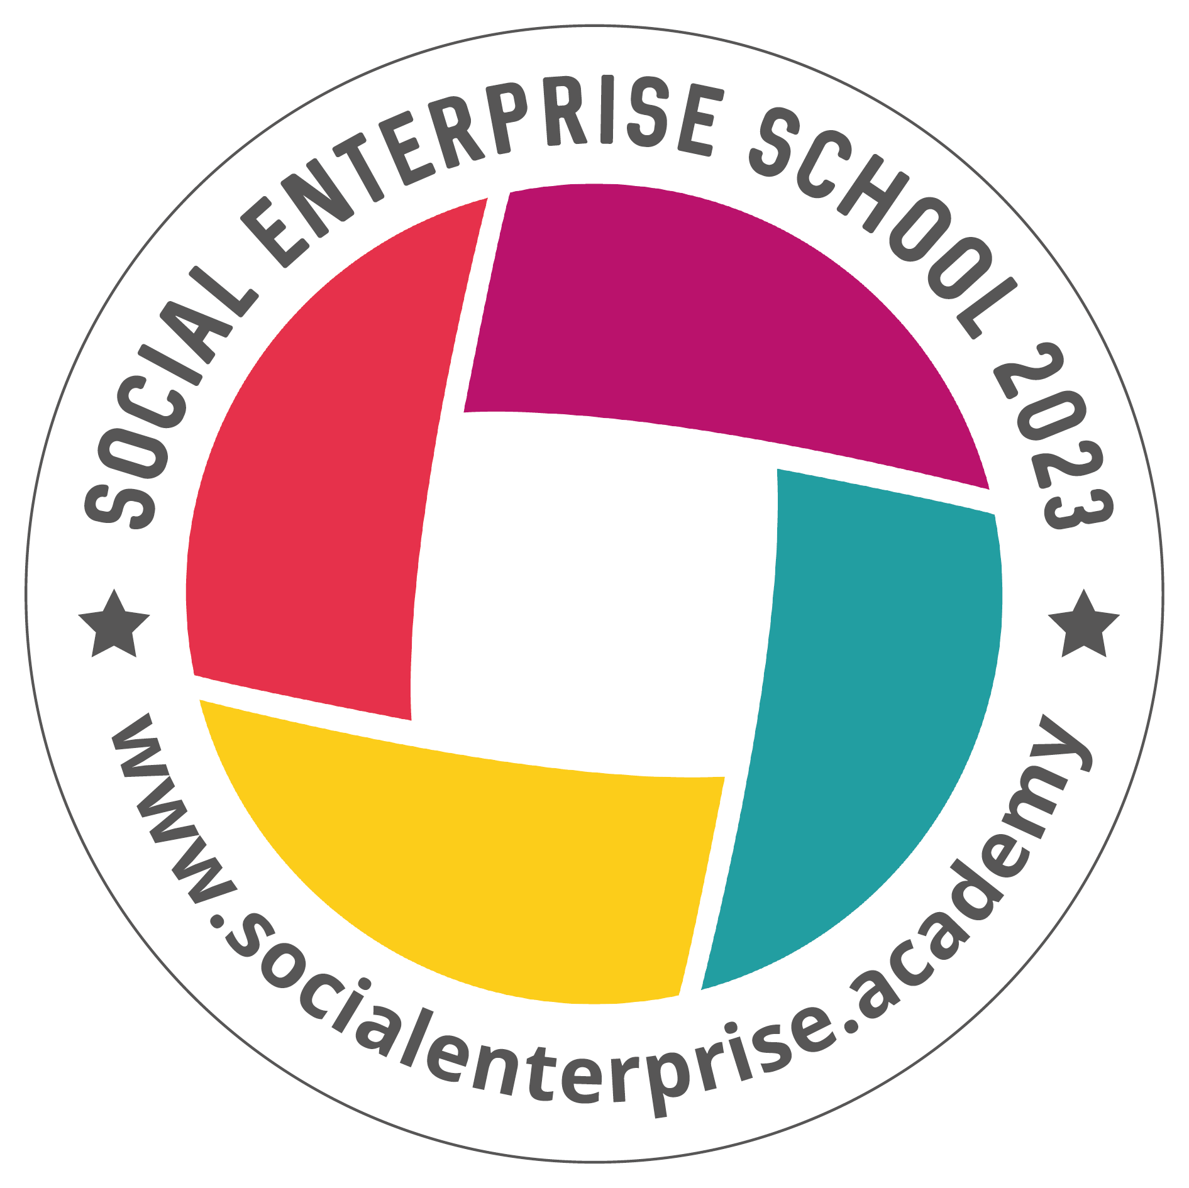
Blairhall Primary School
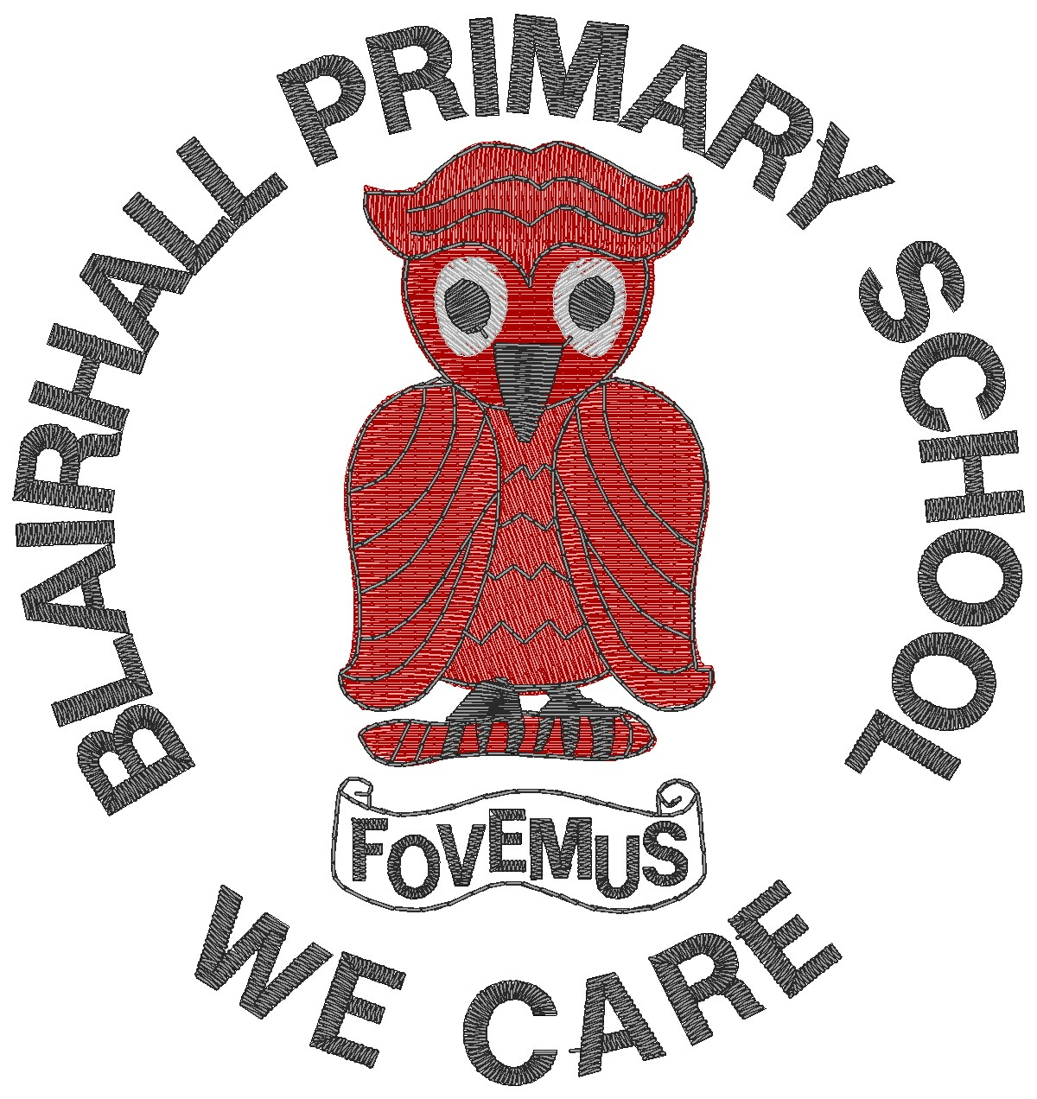

Primary Seven Family Learning Grid – Term 1
The tasks on each home learning grid are designed to cover a variety of curricular areas and important life skills as well as making connections with the United Nations Convention on the Rights of the Child. The UNCRC promotes children’s rights including the right to education, family guidance and rest, play, culture and arts. Completing at least one task a week
This allows children the opportunity to make links between these rights at school and at home.
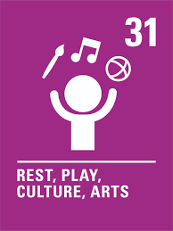
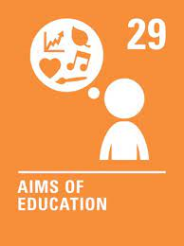
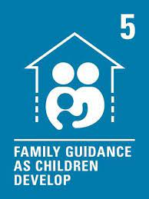

I can independently share and teach the skills I have been learning from a club or class. | I can produce something to teach younger children about how to use the green cross code and highway code. | . I can reduce my use of waste materials. I can think of ways to be more sustainable and discuss these in class. | I can research and make or draw the work of a chosen artist.
I can set a personal target/action to help tackle climate change. | I can create an algorithm and ask someone else to follow it, for example, a recipe. | I can take part in the couch to 5k programme. I can try to improve my personal best when running. | I can use my knowledge of time in everyday/cooking contexts.
I can try out a new club or activity in my local area and share my experiences. | I can take part in a team activity. I can discuss my role in the team and identify my next steps. | I can independently tie my own tie. | I can help or support at a local event. I can discuss the skills I had to use.
I can make a replica/prototype of a famous landmark. I can make a model that will withstand a force. | I can explain how having positive friendships is important for my emotional wellbeing. | I can create a family tree for myself or a famous person | I can create a poster about rights and responsibilities as a digital citizen with examples of appropriate online behaviour.

You will have a chance to share your completed tasks in class every Friday
You can also choose to upload any photos or written pieces of work to Teams.

