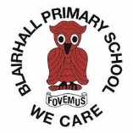
Primary P4/5/6/7 Important Information
PE   | Fridays
Outdoor Learning  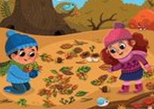 | Wednesdays
Reading   | In line with our new guided reading approach, children will keep reading folders and records in class, however they will have a choice of reading books to take home every week and enjoy with family.

