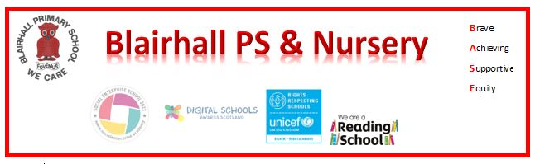
Assembly News!!!
Date: Wednesday 10th June

Reporter: Jack Leitch

Leaders: Miss Porterfield and miss bow


Here is a summary of what we did and learned in assembly today: In assembly today, we started of with our Blairhall school song after that we started to do work about our school improvement plan then digital leaders came up and talked what have they been doing in their committee this term. Then we scanned this QR code and putting in what you think of the digital leaders then we had to ask how iPads are helping us with our learning. Then we did awards and then did another song.

News Round -Up
