

Fresh Air Frankie’s
School Travel Plan
25/26
24

School: Blairhall Primary School

Headteacher: Nicola Bow

School address: Rintoul Avenue, Blairhall, KY12 9HG

Telephone No: 01383 602444

Social Media/Website: Website

Contents Page

3: 1.0 WHY HAVE A SCHOOL TRAVEL PLAN

3.: 2.0 BENEFITS OF HAVING A SCHOOL TRAVEL PLAN

5: 3.0 Current Travel Habits

3.1 Family Questionnaire Data
3.2 Staff Questionnaire Data

7: 4.0 ROUTE AUDIT OF KEY ROUTES TO SCHOOL

4.1 Access Arrangements

9: 5.0 3 YEAR REVIEW

5.1 Summary of Parent feedback

13: 6.0 ACTION PLAN

14: 7.0 MONITORING AND EVALUATION

15: 8.0 DISTRIBUTION OF SCHOOL TRAVEL PLAN

1.0 Why have a school travel plan

School-related traffic congestion and the risks congestion poses to the safety of the pupils, teachers, parents, residents, and motorists in and around school locations is a significant problem in communities around Fife.

The most obvious cause of traffic congestion around our schools is vehicles, and the biggest source of those vehicles is parents’ dropping off and picking up their children from school.

Statistics highlight that 1 in 4 cars during the hours of 8:30 to 9:15 and 2:30 to 3:15 is primary school traffic.

Encouraging active travel—such as walking, cycling, or scooting to school—offers children a healthier, more energising start to their day. It helps improve physical fitness, boosts mood and concentration, and reduces traffic congestion and pollution around school gates, making the environment safer for everyone.

Fife Council’s Road and Transportation Service are working with schools in Fife to develop School Travel Plans; a practical framework to promote sustainable travel and address barriers families may face by supporting Frankies Active Campaigners Team (FACT) to lead activities, raise awareness, and celebrate progress. These initiatives empower children to take pride in their choices and inspire others to get moving – making active travel a positive part of everyday school life.

2.0 BENEFITS OF HAVING A SCHOOL TRAVEL PLAN?

The benefits of encouraging active travel are clear and a school travel plan can ensure that your school has a long–term vision with aid to support your FACT group with delivering campaigns that will;-
- Improve health and well-being by reducing harmful emissions and increasing activity levels.
- Improve safety through engineering measures and increasing road safety education.
- Improve access and opportunity by developing pupils’ skills for safe and independent travel.
- Improve the environment by reducing pollution and CO2 emissions.
- Gain school accreditations such as Fresh Air Frankie STP Awards, Active School Award and Eco Schools.
All work associated with School Travel Planning has been designed to fit into the Curriculum for Excellence.

3.0 CURRENT TRAVEL HABITS

Each year all Fife schools undertake the hands up survey which gives a true reflection of how pupils are travelling to school, and the 2024/25 results show that 46% of pupils are actively travelling to school. However, with 54% still being driven to school the school must remind parents of their responsibilities around the school gate.

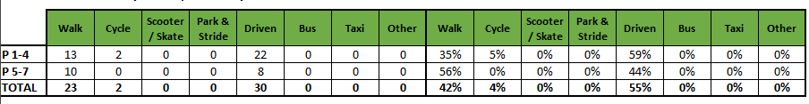

3.1 Family Questionnaire 2023

11 families highlighted that active travel was their main mode of travel to school followed by 7 families citing that they drive to school.

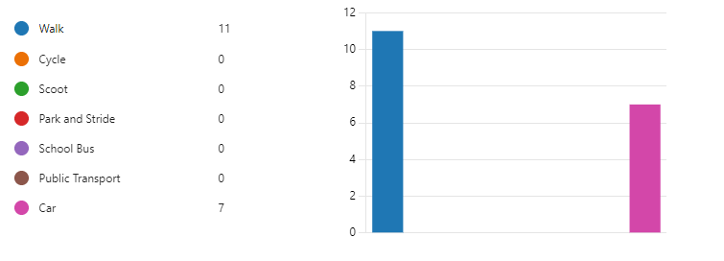
Those who indicated that they drove to school were asked “Where do you park, please give the name of the street or car park” no one answered this, but the survey did highlight that some parents parked in the school bus stop which caused issues for those utilising the bus.

Families were then asked what the main reasons is for choosing their travel mode, families answered the following.

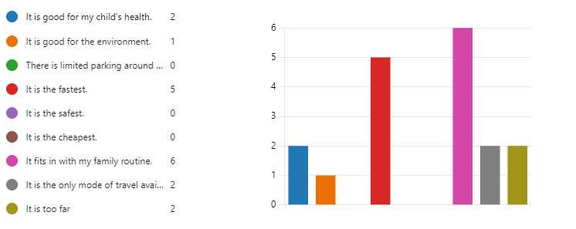

When asked “How far do you live from School?” only 7 families answered this question.

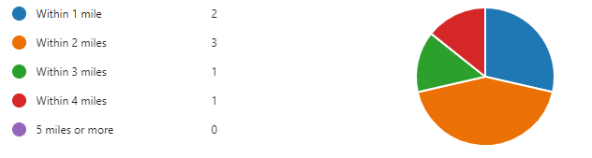
When asked how long does your journey to school take all families responded with the majority stating that it took them less than 10 mins.

According to the survey 61% of families are satisfied with the way their child/children travel to school with only 12% stating that they were neither satisfied nor dissatisfied and no one stated that they are very dissatisfied.

When asked “What factors might affect your decision whether to let your child/ren travel actively to school, or to the bus stop, families indicated that more safe crossing facilities on busy roads was needed and knowing that they were actively travelling with other pupils or parents.

Only 1 family indicated that they were aware of any active travel initiatives taking place at school to encourage pupils to be more sustainable.

Finally, families were asked if there was anything else they would like to tell us about their journey to school. The following is a list of the most common comments.

Safe place to cross over Rintoul Ave
Speed of traffic on Rintoul Ave
Parent parking on paths/grassed area as well as parking in no parking areas.
Majority of parents noted that most children should be encouraged to actively travel to school due to the area being a small village and the most of the pupils live within the village.

4.0 MAPPING WORK AND ROUTE AUDIT 2023

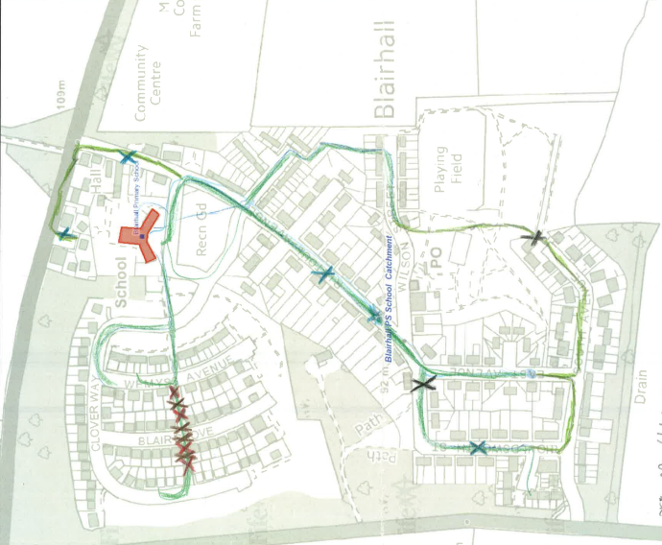
A mapping exercise was carried out within the school to identify the routes pupils travelled. These were then analysed and the 4 main active travel routes to school were identified.

4.1 Access Arrangements and Route Audit 2023

There is 1 pedestrian access points to the school on Rintoul Avenue.

The streets audited were:-
- School Lane
- Rintoul Avenue
- All village streets connecting onto the above streets.
The school as one main pupil/visitor entrance as well as a car park entrance from School Lane.
The residential areas adjacent to the school are covered by a full time mandatory 20mph speed limit and has associated traffic calming features and repeater signs.
At the time of undertaking the key route audit all school keep clear signage and other relevant markings were clear and readable.

School Lane
Issue
During the mapping exercise pupils from the upper school were asked about any barriers to them actively travel to school and although none were noted teachers stated that parents continue to park in the school bus stop on School Lane due to congestion in the area and this caused concern for those who travel by public transport.
Recommendation
Investigate options for improving parking and reducing congestion around the school gate.
Action
School Travel Plan team to work with the JRSO’s to develop a parking campaign to highlight the danger parents are creating by parking in the dedicated bus stop and the effects this is having on those pupils who actively travel to school.
School to contact the local police for support in moving parents out of the bus lane.

Rintoul Avenue
Issue
There is a perception from parents that the speed of traffic on this main distributer road exceeds the 20mph restrictions thus causing concern for those actively travelling to school as they feel there is not a safe crossing point.
Recommendation
Investigate the possibility of installing a safe place to cross and request analyse on the speed of traffic through the village.
Action
School to work with the local community police to undertake a speed survey and then publicise this on any local community notice boards as well as the school website and app.
School Travel Plan team to investigate the possibility of requesting an additional zebra crossing on Rintoul Avenue but after undertaking this audit the recommendation would be for the JRSO and the school travel plan team to identify safe crossing points and publicise these to parent and pupils by creating a safer route to school map.

Additional Streets within the Village
Issue
Like most small villages in Fife the streets within these when built were narrower and accommodated less cars on the road. There are considerable residential parking issues within the old part of the village which restricts visibility for pupils travelling to school. However, there are a lot of off-road connecting paths from the bottom of the village that allows pupils to commute mainly on off road paths.
Recommendation
Continue with Road Safety Training for pupils and connect more with the local community about the work the school carries out to make the journey to school more enjoyable for all.
Action
Work with the school travel plan team to undertake the actions agreed within the school travel plan.

5.0 3 Year Review

Only 5 families took part in the review process with the findings listed below.

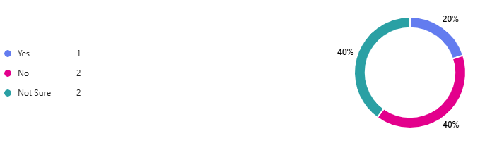
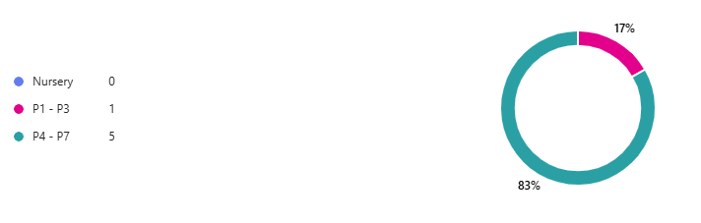
What school year is your child/ren in?
Are you aware that the school has a Travel Plan aimed at reducing congestion and promoting active travel?

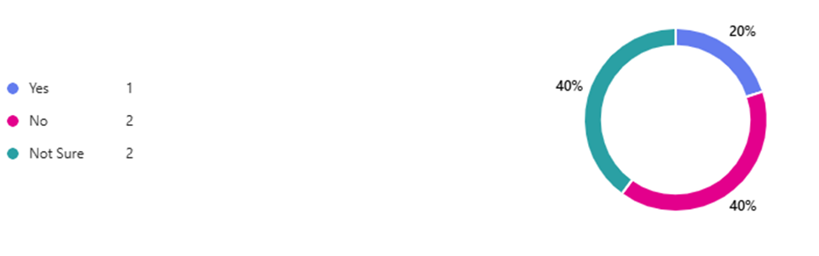

Have you noticed any changes in traffic levels around the school over the past three years?

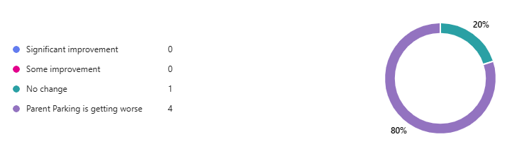

Which of the following initiatives are you aware of that the school has implemented?

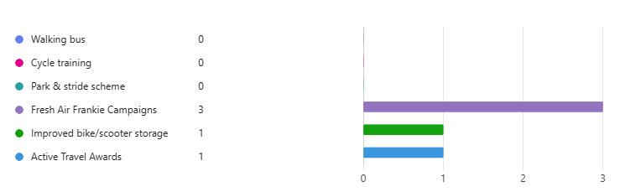

Do you feel these initiatives have helped reduce congestion around the school?

- Haven't noticed any chance nor was aware of any improvement plans, infact it seems to be getting worse regarding parking for dropping kids off
- School road continues to be congested with parents parking up on the pavement and on the zigzag li es at pedestrian crossing
- Parking is worse and there are more cars than ever before, parents now parking in staff car park and cars going in and out of the gate is causing a hazard for children crossing there to go home.
- I am not sure, it doesn't seem less crowded in the morning/afternoon
- I done really feel these are promoted and know little about the initiatives

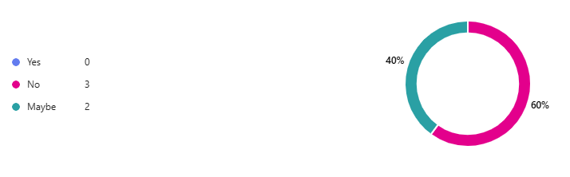
Are you familiar with Fresh Air Frankie and the messages he promotes about clean air and active travel?
Do you feel the school communicates effectively about its efforts to reduce congestion and promote active travel?

- No
- Yes, parents aren't listening
- Not really. The presence of a traffic warden was a deterrent for a short time but things have returned to how they were.
- I haven't heard of it and my child started nursery at Blairhall and is in P5 now
- I don’t think they promote it

ls there anything else you would like to tell us about your journey to school.

- Perhaps parking should be reserved for those who stay outside the village.
- A handful of children live out with Blairhall where it would be difficult to walk but many of those that live in the village can easily walk to school except for those with mobility issues etc.
- My daughter walk when we can but I go straight to work most mornings so I normally drop her at school, but she walks home with her friend.

  - Summary of Parent Feedback – Three-Year School Travel Plan Review

Parent feedback gathered during the three-year review highlights clear concerns about the school’s support for safe and active travel. A recurring theme across responses is that families feel there has been little visible improvement to travel conditions, and some believe the situation has deteriorated.

Several parents reported no noticeable changes or communication regarding any improvement plans, with one commenting that they “haven't noticed any change nor was aware of any improvement plans, in fact it seems to be getting worse regarding parking for dropping kids off.”

This reflects a wider perception that the school has not actively promoted its travel initiatives or provided regular updates to the school community.

Congestion remains a significant challenge. Parents repeatedly described the school road as highly congested, with frequent instances of unsafe parking behaviour. Feedback noted cars parking on pavements and on the zig-zag lines at the pedestrian crossing, creating hazards for children and reducing visibility at key crossing points. One parent observed that “the school road continues to be congested with parents parking up on the pavement and on the zigzag lines at the pedestrian crossing.”

Several respondents felt that overall car use has increased, worsening safety concerns. Reports included cars entering and using the staff car park at peak times, causing additional conflict where children are crossing to go home. Parents highlighted this as a hazard, noting that “parking is worse and there are more cars than ever before… cars going in and out of the gate is causing a hazard for children crossing there to go home.”

In terms of active travel promotion, parents expressed that current initiatives are not well communicated or sufficiently visible. One parent stated, “I don't really feel these are promoted and know little about the initiatives,” indicating that families may not be aware of the options or support available to encourage safer walking, cycling, or scooting.

Overall, the feedback suggests that parents perceive limited progress in creating a safer, more supportive environment for active travel. Many feel that congestion has increased, unsafe parking behaviours remain unaddressed, and active travel initiatives lack visibility. Strengthening communication, increasing enforcement or monitoring around key safety concerns, and re-establishing active travel promotion could help rebuild confidence and support more sustainable travel behaviours going forward.

6.0 ACTION PLAN

Action | Solution | Action Owner
Promote School Travel Plan | - Upload plan to website and social media pages.  - Create a FACT notice board.  - Upload generic social media posts throughout each term.  - Keep the school travel plan team updated on all work carried out by completing your FACT floor book. | School
Fresh Air Frankie Awards Campaigns | Term 1  Hands up Survey Active Travel  FACT Assembly about Active Travel Month  Send out generic Social Media Posts  Active Travel Month (distribute and collect Fresh Air Frankie  Travel Passports)  Term 2  Launch #dontparkhere Campaign  FACT Assembly  Send out generic Social Media Posts  Road Safety Week  Term 3  Frankie’s Step into Spring Campaign  FACT Assembly  Big Walk and Wheel  Term 4  FACT Assembly about Active Travel Month  Send out generic Social Media Posts  Active Travel Month (distribute and collect Fresh Air Frankie  Travel Passports) | School – full details held within your FACT folder
Reduce congestion | Consider developing the following:- Parking Pledge  Walking Bus  Campaigns to increase active travel to school. | School – full details held within your FACT folder
Bikeability | Deliver Level 2 Bikeability and apply for Cycle Friendly School Award | School/Bikeability
Annual Active Travel Award | Top 3 schools that can showcase the largest increase in Active Travel to School will be crowned champions. Data will be collated from the HUSS and our own travel tracker. | School/Travel Plan Team

7.0 MONITORING & EVALUATION
The FACT will continue to meet periodically to monitor progress and amend strategies to comply with the actions set out in this plan. Specific progress will be monitored by participation in the “Hands Up Survey” each year and a review of the travel survey will take place in 2029/30.

The school’s ongoing commitment to travel planning will be publicised in the school handbook, the school newsletters, the Parent’s notice board and through assemblies.

8.0 DISTRIBUTION OF SCHOOL TRAVEL PLAN
The following bodies will receive a copy of the School Travel Plan:
• Fife Council Sustainable Transport and Travel via the Travel Plan Team
• Fife Council Education Service
• Parent Partnership
• Copies will also be made available to the parents from the School Office and via
the school information sites.

