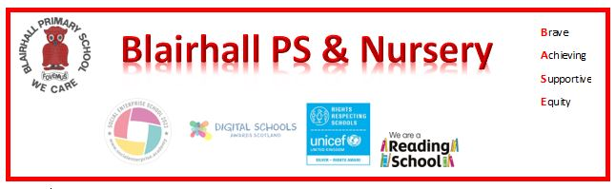
Assembly News
Date: Wednesday 6th May 2026

Reporter: Marley Mackay

Leaders: Mrs Bow

News Round -Up

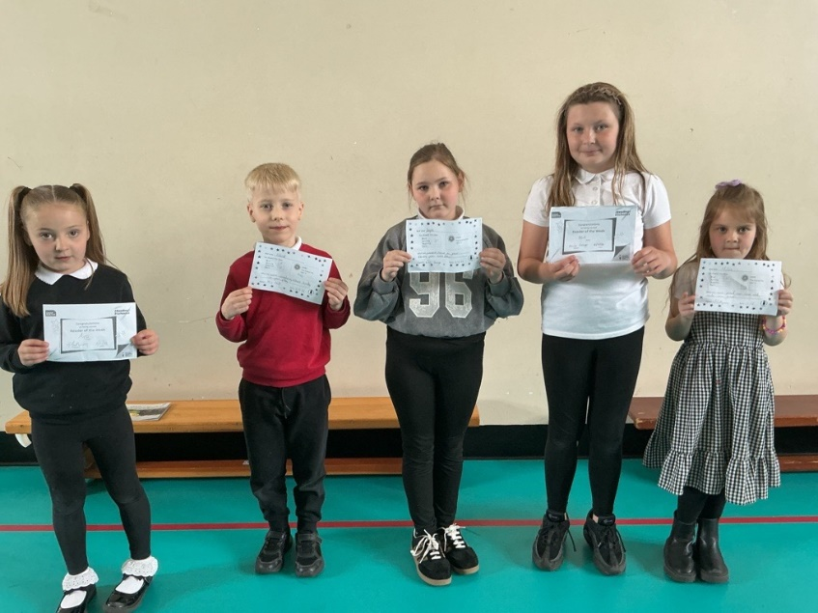
Photo Gallery
Here is a summary of what we did and learned in assembly today:
Today, the book committee brought out a variety of books to read for all ages! Most of the people in assembly decided to check out some of their books and gave it a little read. Blairhall Books are glad to help and entertain with books! We hope you loved them. Next, the committees all have done questionnaires about what they like about committee’s and what they can do to change it. They all took turns on school iPads for the form so everybody gets a try.

