If I feel worried or unsafe, I can speak to any

of the adults in my school at any time.
If I don’t feel able to speak to an adult in school or at home, I can call Childline on
0800 1111
24 hours a day 7 days a week
If I feel like I am in IMMEDIATE danger then I can call the Police on
101 or 999 in an emergency

Child Protection in
Blairhall Primary School
My Child Protection Coordinator is:
Mrs Bow
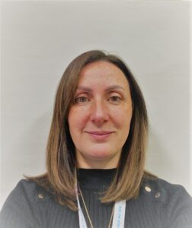
My Depute Child Protection Coordinator is:
Miss Porterfield


It’s everyone’s job to keep me safe

- Adults in my school have a responsibility to keep me safe.
- I can talk to an adult in my school at any time if I have a worry or if I don’t feel safe.
- The adult I speak to may need to share my worry with my Child Protection Co-ordinator.
- My Child Protection Co-ordinator might need to share this with other adults to make sure everyone works together to keep me safe.
- Adults will keep checking in with me to make sure I am safe and feel involved.

Remember that you can ask for help no matter if your worry is little or big.

HOW TO TELL SOMEONE ABOUT A WORRY

Think about a safe adult that you feel comfortable with. This might be someone at home, at school or a family member.

Choose a time when it is easy for you to talk. Think about when your safe adult has time to talk because they will want to hear what you say so they can help you.
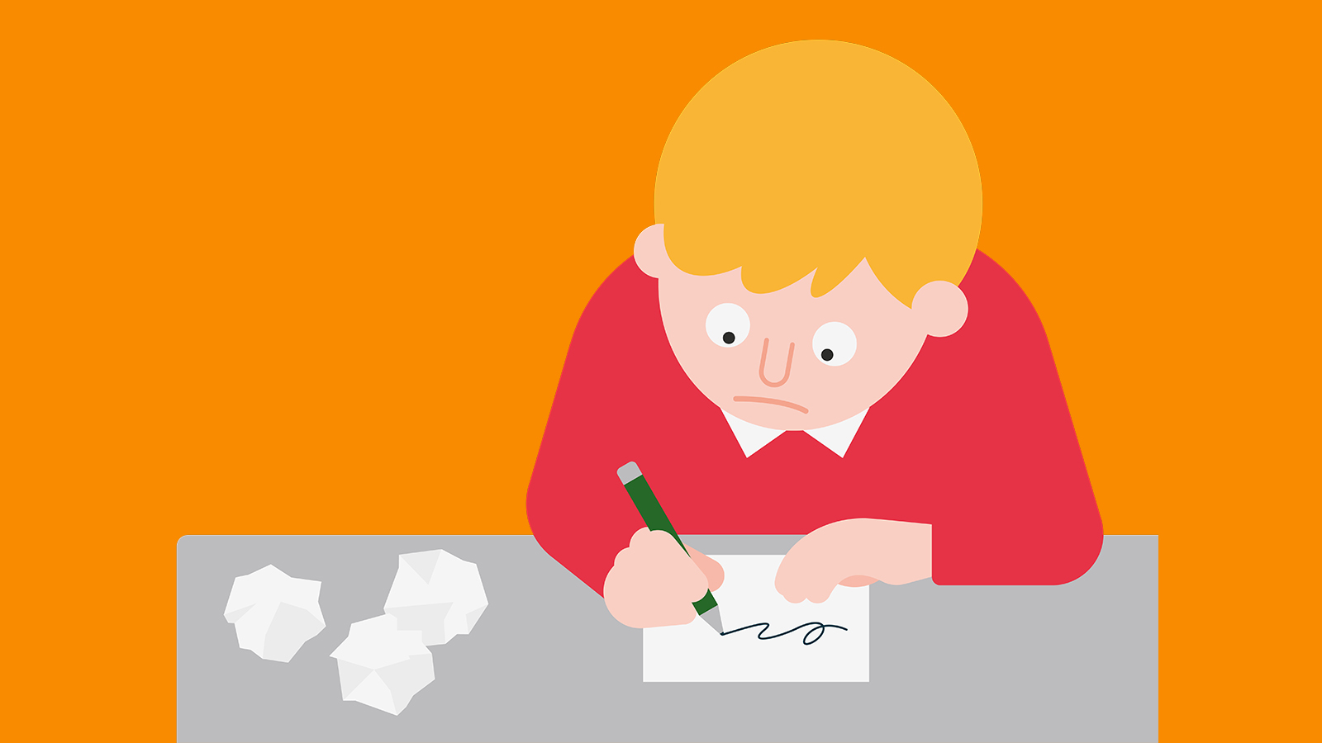
It’s ok if it feels scary to say your worry out loud. If you find it easier, you can write it down, draw it or show them with a toy.

Your safe adult will tell you what they will do next. If you feel that things don’t change, keep speaking out until they do.

