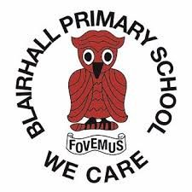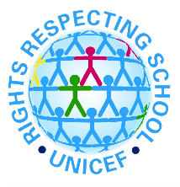

Blairhall Primary School: Whole School Charter

2024-25

These rights are of particular help to us in school…

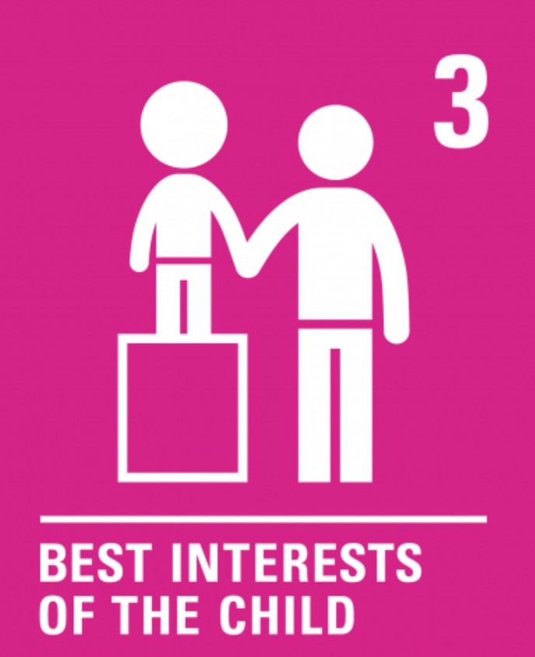 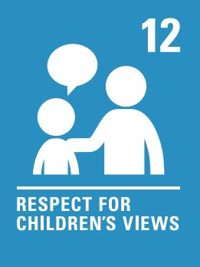 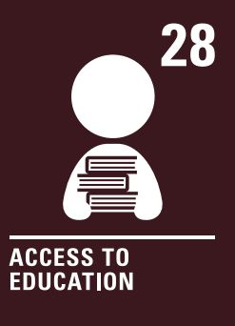

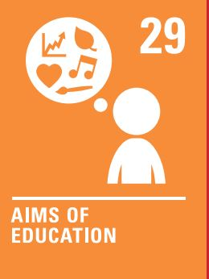 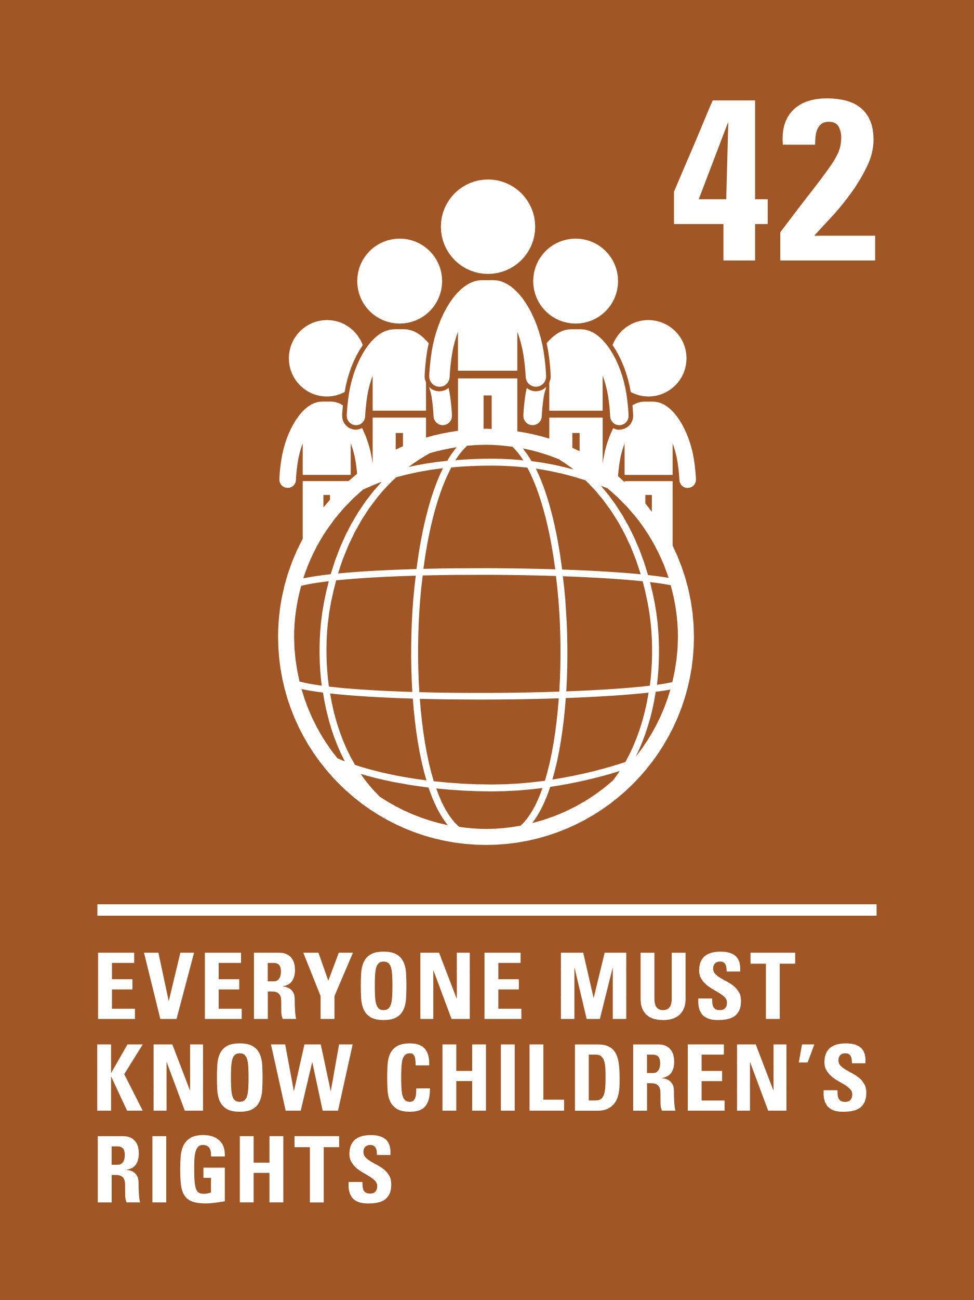

* Respected
* Protected
* Safe, clean environment
* Challenging and engaging learning
* Chance to develop our talents, skills and abilities
* Learning about diversity and rights

DUTY BEARERS

Duty Bearers will respect these rights by:

* Listening to all children and considering their views and opinions
* Helping children to solve problems
* Modelling right choices
* Valuing diversity and recognising everyone is unique
* Treating everyone with respect and dignity
* Making sure we provide a range of exciting learning opportunities
* Looking after our school and the resources in it
* Showing our BASE values

RIGHTS HOLDERS

Children will respect the rights all children have by:

* Using kind words and actions
* Trying our best in all that we do
* Respecting differences and treating ourselves and others with respect and dignity
* Having a positive attitude
* Listening to other people, even if we don’t agree, and sharing our ideas
* Looking after each other
* Looking after our school and the resources in it
* Showing our BASE values