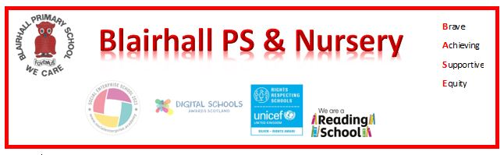
Assembly News
Date:
07/05/25
Reporter:
Jorgie
Leaders:
Life Guards
News Round -Up
Photo Gallery
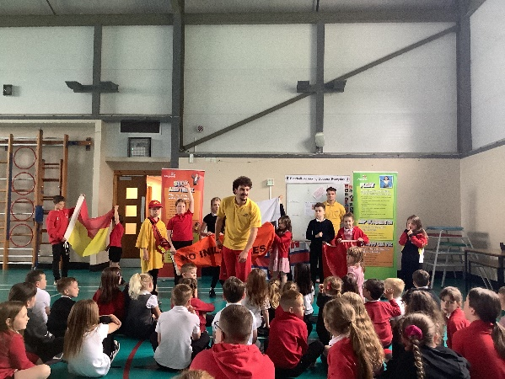
Here is a summary of what we did and learned in assembly today:
Today two life guards were in and they were telling use how to stay safe on a beach RNLI it means Royal National Lifeboat Institute if you get stung by a Jellyfish you get salt water to help the sting here is different beaches
- Burtisland
- Seat and sands
- Aberdour
- Culross
We have been learning about the safe places on a beech to swim between the red and yellow flags, to go on the water on surf boards and paddle board go between the black and white flags. No inflatables when bad winds and the flag shows and red flags means don’t go in the water

