Blairhall Primary School

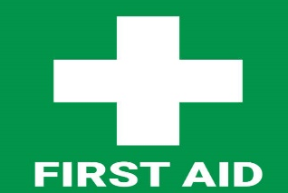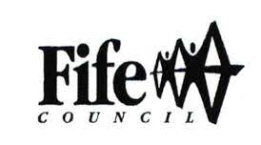

Information for Parents

In any school it is inevitable that children, from time to time, will require treatment for a minor injury or treatment for a sudden illness.

What is First Aid?

“First Aid is the initial assistance for the treatment for any sudden illness or injury.”

What is the role of the Education Service?

The Education Service will ensure that First Aid facilities and the selection and training of First Aid staff are provided in accordance with the requirements of current First Aid Regulations.

What is the role of the school?

The school will ensure that

- First aid provision is available throughout the day

- Once first aid has been administered, a decision will be taken on further appropriate action. This may include:

- A child returning to normal school activities
- Observation in school
- Informing/Summoning parents/carers
- Immediate medical attention

- Parent/Carers are kept informed as to the procedure within the school

What is the role of the home?

Parents/Carers should ensure that

- The school in informed of any changes to emergency contact numbers and the name of the child’s GP

- The school is alerted to any potential risk e.g. injuries a child has when he/she comes to school, medication which the child is on, recovering from an illness, allergies, etc

At Blairhall

Procedures are in place to give appropriate first aid provision to all children.

- There is a names person responsible for first aid.
- First Aid provision is provided in the school First Aid Room and any child requiring assistance will be taken/directed there by an adult in the school.
- Children should first, if possible, report injuries or illness to the nearest adult. This adult may, if necessary summon the First Aider to the scene in order to prevent a child having to move.
- Where concern still remains over an injury we will automatically contact parents/carers or an emergency contact, especially when a bump to the head is involved.
- If there has been a bump to the head, a note is sent home so parents/carers are aware of it.
- We may ask parents/carers to collect children as a result of injury or illness,
- Should we be unable to contact parents/carers/emergency contacts, we may take the decision to pursue further medical attention if appropriate,
- We ask that if children are ill, they should be kept at home and not sent to school.

In the interest of safety, we will never send a child home unaccompanied. At the time of contact, parents/carers may however decide to ask the school to send the child home on their own.

