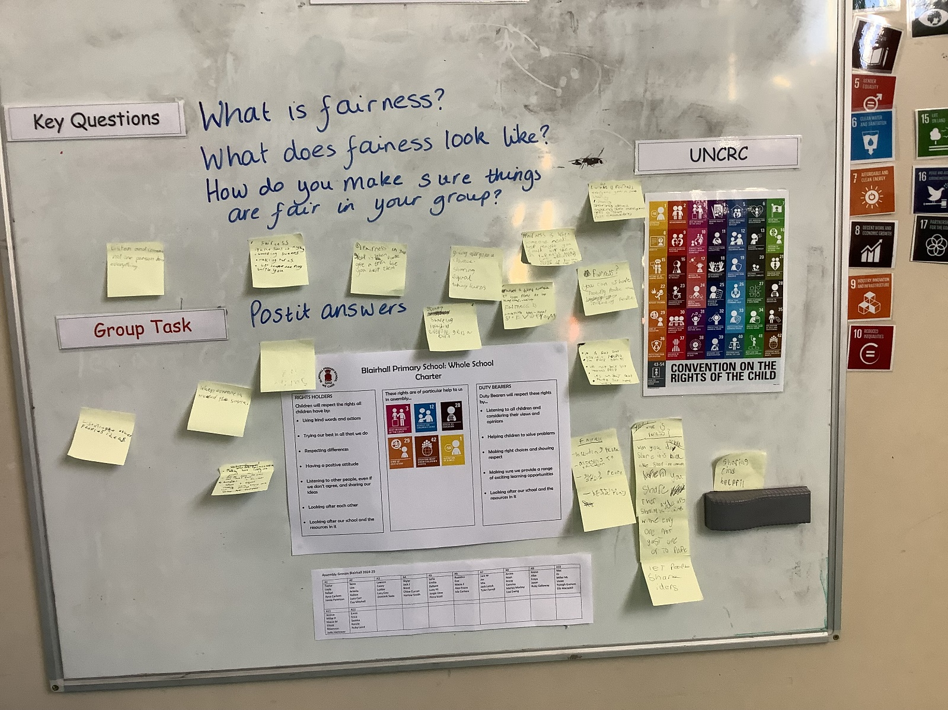**Assembly News**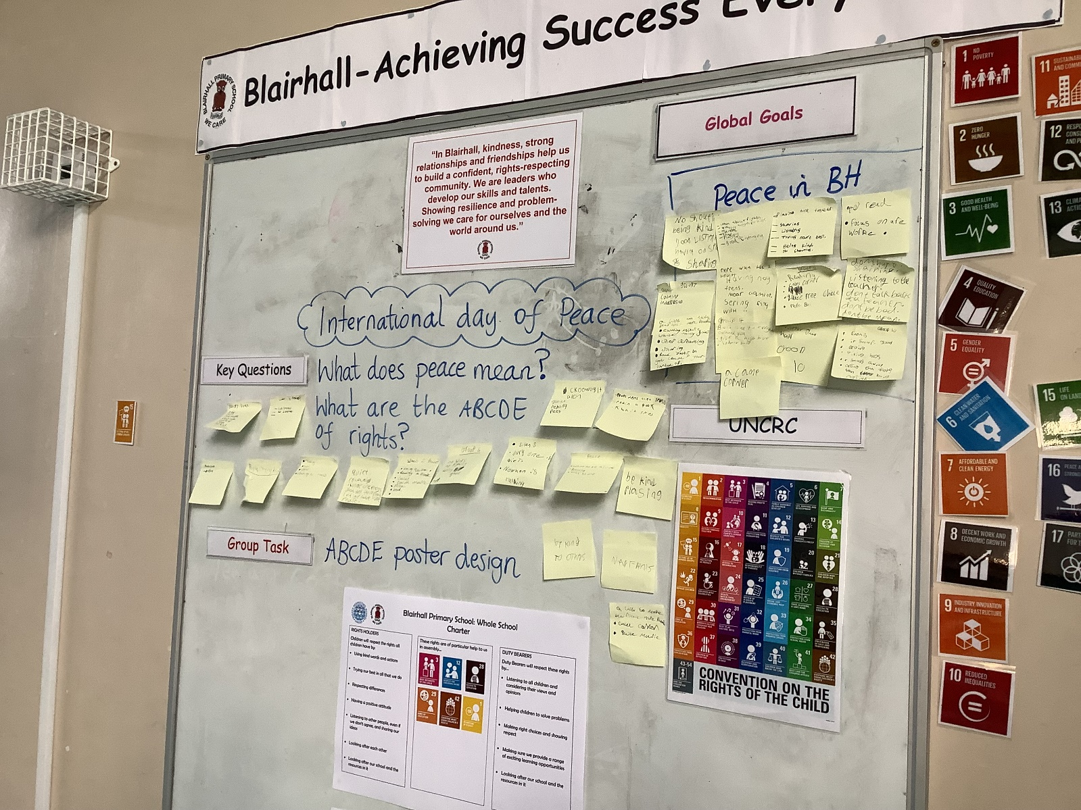

In todays assembly we were talking about, “what is peace?”.

-No war

-being kind

-peace and harmony

-being friends

We watched a short story about peace, peace is saying sorry, peace is planting a tree, it keeping the street clean, it planting a garden, or being free, or giving a hug to friend.

Then in our groups we talked about, “How to make Blairhall primary peaceful?”

-new friends

-sharing

-no fighting

We also talked about the ABCDE of rights: ALL, BIRTH, CANNOT, DO NOT, EQUALLY.

We then made fun posters about the ABCDE of rights.

**Here is a summary of what we did and learned in assembly today: In todays assembly we talked about, “what is fairness?” and discussed it with our groups.**

**What is fairness?**

* **Everyone gets a shot**
* **Sharing**
* **Listening to everyone**
* **Sharing ideas**
* **Make sure no one is left out**

**What does fairness look like**

* **Communication**
* **Helpful**

**We also watched a short video about diversity, and what it is.**

**We also watched a short video about diversity and what it is.**

Date: 26/9/24

Reporter: Flora, Eva

**News Round -Up**

Leaders: Tyler, Ruby G

Photo Gallery