Dear Parent/ Carer,

These home learning tasks have been designed to help and support your child’s learning. There are a wide range of tasks which cover Literacy, Numeracy, Health and Wellbeing and other Curricular areas. You do not have to complete all of the activities; you and your child can pick a range of activities from the grid to complete each day. Please post completed tasks onto your team page.

First Level (P2-P4) Tuesday 26th September 2023

Literacy | Reading  Read a story/book, try to use different voices for each character to make it really come alive. | Writing  Create a detailed description of an imaginative castle, can you use similes and metaphors in your description? | Handwriting  In your best handwriting write your full name- can you join any of the letters? | Spelling  Pick 6 words from a book and write them out in bubble writing.
Maths | Numeracy  Roll a dice to create addition sums. What strategies can you use to solve them? | Beyond Number  Complete the shape patterns in this game.  https://www.topmarks.co.uk/ordering-and-sequencing/shape-patterns | Problem Solving  Use trial and error to figure out how many outfits Bobbie Bear can wear. https://www.nctm.org/Classroom-Resources/Illuminations/Interactives/Bobbie-Bear/ | Real Life Application  Go for a pattern or texture walk in your local community. What shape, colour or number patterns can you spot?
HWB | HWB- PE  Join Joe Wicks for a ‘Spin the wheel’ workout:  https://www.youtube.com/watch?v=Qjcw2Vov_5k&t=258s  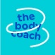 | HWB- Food  Prepare and eat a healthy snack. | HWB- Mindfulness  Have some relaxation time listening to your favourite song. | HWB- Connect  Draw a picture or write a card to give to your friend.
Other | STEM  Design and build a bridge that will hold two books. Can you draw a picture of your bridge and label it. | STEM  STEM  Beebot online-  https://beebot.terrapinlogo.com/  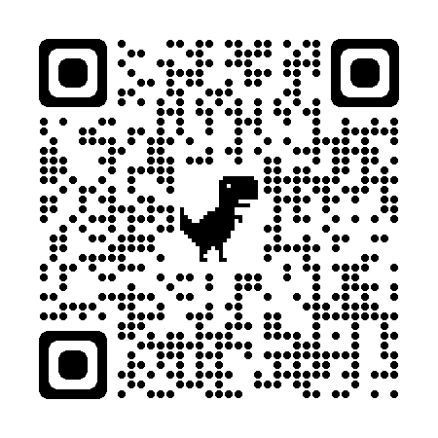 | Music  Listen to a song- use different body parts to keep to the rhythm of the music? | French  Can you count to 20 in French with the clip?  https://www.youtube.com/watch?v=UsEz58BblMY
First Level (P2-P4) Wednesday 27th September 2023

Literacy | Reading  When reading a text pick out three words that you find interesting, can you find out what they mean and use them in a conversation today? | Writing  Create a character profile for who might live in your castle, can you use some adjectives to describe in detail what they look like. | Spelling  Pick 6 words out of a book and write them forwards and backwards. | Grammar  Help an adult write a shopping list, can you use bullet points to write the list?
Maths | Numeracy  Revise addition strategies using Hit the Button.  https://www.topmarks.co.uk/maths-games/hit-the-button | Beyond Number  Go to a shop and look at the price of different items. What coins would you need to pay? Do you need change? | Problem Solving  Use a dice or write out the numbers 1-10. How many different ways can you make 10 by adding two numbers together. Can you make 20 by adding 3 numbers together? | Real Life Application  Using your knowledge of weight, use scales to make a tasty treat for you and your family
HWB | HWB- PE  Do some yoga with Jaime:  https://cosmickids.com    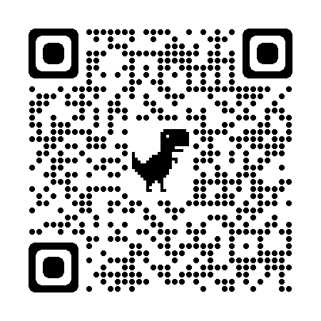 | HWB- Food  Help prepare and eat a healthy balanced meal. | HWB- Mindfulness  Calm Breathing- Put a teddy on your tummy and slowly breathe in and out 10 times- don’t let the teddy fall off your tummy! | HWB- Connect  Play a board game with someone.
Other | STEM  Senses walk  Go for a walk and think about the things that you can see, hear, smell and touch. | STEM  Design a model which is high as a table- think about what you can use to make it high and sturdy. | RME  Make a list of what is important to you? What do you value? | Art  Use natural resources to create an Autumnal piece of art. You could use leaves, stones, sticks.

First Level (P2-P4) Thursday 28th September 2023

Literacy | Reading  Before you read a text, can you predict what is going to happen? Write it down then check if you were right. | Writing  Create a story map of the plot of your imaginative story in the castle using your writing from Tuesday and Wednesday. Can you write an imaginative text? | Listening and Talking  Tell the story you have created to someone and ask for feedback. | Spelling  Pick 6 words from a book that you find tricky to spell and write them out three times.
Maths | Numeracy  Revise your number formation by creating your own number line or a 100 square. Make sure you write the numbers the correct way and in the correct order. | Beyond Number  Revise symmetry by playing this game.  https://www.topmarks.co.uk/symmetry/symmetry-sorting | Problem Solving  Use your number skills to collect the treasure.  https://www.abcya.com/games/mystic_numbers | Real Life Application  Take a mini beast survey outside. Use tally marks to track how many insects you find.
HWB | PE  Join Joe Wicks for a spin the wheel workout:  https://www.youtube.com/watch?v=Qjcw2Vov_5k&t=258s | HWB- Food  Draw a picture of your favourite balanced meal using the Eatwell Plate https://www.nhs.uk/live-well/eat-well/food-guidelines-and-food-labels/the-eatwell-guide/ | HWB- Mindfulness  Flower and Candle – Relaxation Breathing  Pretend you have a nice smelling flower in one hand and a slow burning candle in the other.  - Breathe in slowly through your nose as you smell the flower.  - Breathe out slowly through your mouth as you blow out the candle.  Repeat a few times. | HWB- Connect  Eat a snack or meal with someone in your home- ask them how they are feeling today?
Other | STEM  Floating and Sinking  In a basin or tub of water pick some waterproof objects around your home and find out what floats and sinks. First predict what you think will float and what will sink, sort the objects into groups once you have tried them. | STEM  Design and build a house for small world toy or small teddy, draw a picture of what you have made. Consider what rooms you will need. | Drama  Act out your favourite character from a book or film, think about how they would move their body, what they might say and what they might do. | Creative Dance  Create a dance to your favourite song- think about how the way you move shows how you are feeling.

