Dear Parent/ Carer,

These home learning tasks have been designed to help and support your child’s learning. There are a wide range of tasks which cover Literacy, Numeracy, Health and Wellbeing and other Curricular areas. You do not have to complete all of the activities; you and your child can pick a range of activities from the grid to complete each day. You can share your work with your teacher by e-mailing them or bringing your completed work to school on Friday.

Early Level (P1) Tuesday 26th September 2023

Literacy | Reading  Pick your favourite story- can you use the pictures to retell the story. | Writing  Draw a detailed picture and write a sentence about why the story is your favourite. | Phonics  Join in with the Jolly Phonics songs for the sounds:  S,a,t,p,i,n,c,k,e,d  Jolly Phonics - Wakelet | L&T  Tell someone why you like a story/book, can you give reasons why you like that book? Use the sentence starter ‘This is my favourite book because…’
Maths | Numeracy  Number formation  Revise number formation of numbers 0-10 on doorway or on paper.  Letter and Number Formation | Doorway Online  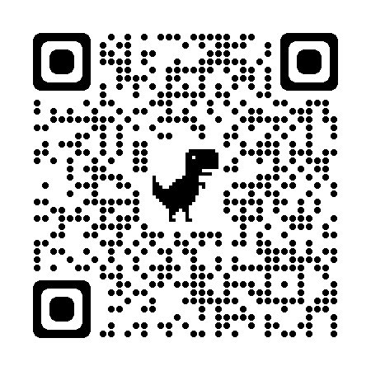 | 2D Shape  Can you draw some 2d shapes?  Circle, Triangle, Rectangle, Square and describe them, how many sides do they have? | Problem Solving  Collect some small objects from around your home- can you order them from smallest to biggest? By height and weight. | Estimating  Estimate the number of objects in a group of up to 20 objects and count to check.  Use any items you have at home from teddies to marbles, counters and pencils!
HWB | HWB- PE  Join in with dance and videos through https://family.gonoodle.com  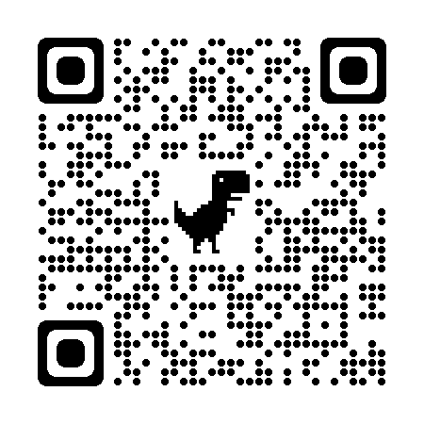 | HWB- Food  Prepare and eat a healthy snack. | HWB- Mindfulness  Have some relaxation time listening to your favourite song. | HWB- Connect  Draw a picture to give to your friend.
Other | STEM  Beebot online-  https://beebot.terrapinlogo.com/  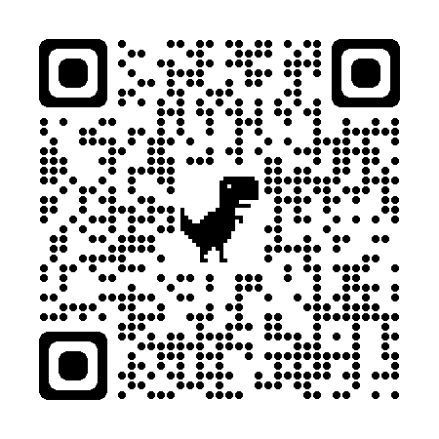 | STEM  Design and make a model- draw a picture of what you have made. | RME  Draw a picture of people who are important to you, can you think about why? | French  Listen and join in with colours in French:  https://www.youtube.com/watch?v=fZR66TjjrDc  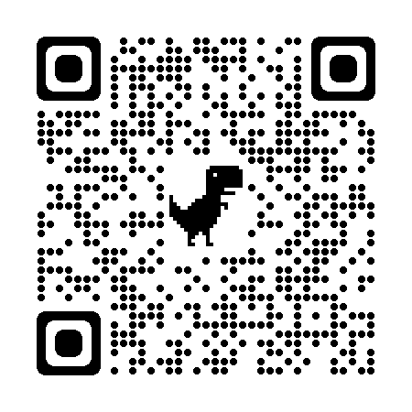

Early Level (P1) Wednesday 27th September 2023

Literacy | Reading  Pick your favourite book, can you find some of your initial sounds in the book? | Writing  Can you write your full name? | Phonics  Sounds scavenger hunt- pick 6 sounds that you already know, go on a scavenger hunt in your house to find something that begins with each sound. | Handwriting  Use doorway online or paper to practice your letter formation:  Letter and Number Formation | Doorway Online
Maths | Numeracy  Counting  Count out a requested number of items. E.g. please put 4 red buttons on the table (up to 20). | Shape hunt  Go on a shape hunt around your house. What different shapes can you find and can you name them all? | Problem Solving  Draw a picture of a house that uses all of these shapes:  Rectangle, circle, square and triangle. | Sequence the numbers 0-20:  https://www.topmarks.co.uk/ordering-and-sequencing/chinese-dragon-ordering  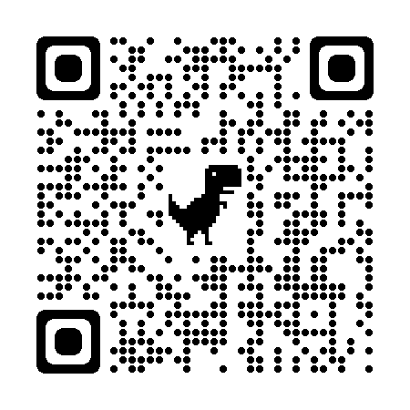
HWB | HWB- PE  Do some yoga with Jaime:  https://cosmickids.com  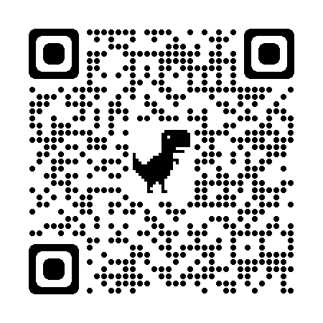 | HWB- Food  Help prepare and eat a healthy balanced meal. | HWB- Mindfulness  Calm Breathing- Put a teddy on your tummy and slowly breathe in and out 10 times- don’t let the teddy fall off your tummy! | HWB- Connect  Play a board game with someone.
Other | STEM  Senses walk  Go for a walk and think about the things that you can see, hear, smell and touch. | STEM  Design and make a bridge that will hold a toy car, draw a picture of your bridge. | Music  Play your favourite music, can you tap or clap along to the beat? | Art  Create a piece of seasonal art for Autumn.
Early Level (P1) Thursday 28th September 2023

Literacy | Reading  Can you retell your favourite story in the right order? | Writing  Draw a picture of your favourite character in your book and write a sentence about them. | Phonics  Play a game of ‘i-spy’- Look for items around your home or on a walk that begin with one of your initial sounds. | Spelling  Sound out and write words that use your sounds:  Pin, sat, pat, ant, pan
Maths | Numeracy  Number hunt  Go on a number hunt around your house. Where can you find numbers, what do they say and why are they there? | Shape Patterns  Can you make a shape pattern? | Problem Solving  Collect a range of toys from around your house can you organise and sort them into groups? E.g All the red cars, all the green cars.  All the pencils, all the crayons. | Pattern  Can you make a pattern using some of your toys at home? E.g- Lego bricks.
HWB | HWB- PE  Join Joe Wicks for a ‘Spin the wheel’ workout:  https://www.youtube.com/watch?v=Qjcw2Vov_5k&t=258s | HWB- Food  Draw a picture of your favourite balanced meal. | HWB- Mindfulness  Flower and Candle – Relaxation Breathing  Pretend you have a nice smelling flower in one hand and a slow burning candle in the other.  - Breathe in slowly through your nose as you smell the flower.  - Breathe out slowly through your mouth as you blow out the candle.  - Repeat a few times. | HWB- Connect  Eat a snack or meal with someone in your home- ask them how they are feeling today?
Other | STEM  Floating and Sinking  In a basin or tub of water pick some waterproof objects around your home and find out what floats and sinks. | STEM  Design and build a house for small world toy or small teddy, draw a picture of what you have made. | Drama  Pretend you are a character from your favourite book- how do you think they would walk? What might they say or do? | Creative Dance  Create your own dance to a piece of music.

