BLAIRHALL PRIMARY SCHOOL
PARENT COUNCIL MEETING
SESSION 2023
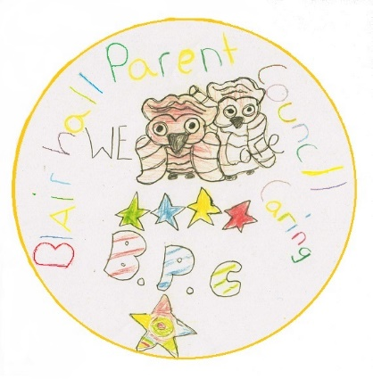
ACTION POINTS
Minutes from Parent Council Meeting held on Thursday 13th September 2023 @ 6pm.

Blairhall Primary twitter page @Blairhallps

PRESENT: William Laing (Former Chairperson), Paul Hayter (Chairperson) Louise Scott (Treasurer), Anitta Jeffs-Watts (Secretary). Nicola Bow, Ashley Wyse & Paulina Sevasyanove

APOLOGISES: N/A

Willie welcomed everyone for attending and the following was discussed:

TOPIC | ACTION | DEADLINE | INITIALS
School  Update | - Mrs Bow advised all children have settled in well.  - Nursey currently have a vacancy – they currently have temp cover from Erin wood. The post has been advertised and closes on Sunday 17th September. Interviews are scheduled for 26th September.  - There has been one ‘Open Doors’ which went well and the next one scheduled for Wednesday 20th September 09:15 – 10:00. Would be great if you could pop along and see how your child/ren are getting on.  - Improvement Goals have been set from the feedback from the questionnaire which was sent out to Parents/carers in April. STEM was a priority and there shall be more digital Learning for children at home. Children looking for Leadership opportunities by setting up committees such as: Eco Committee, The Health Committee, STEM Leaders, Blairhall Bakes and Blairhall Books.  - All committees shall be meeting in the afternoon of Monday 25th September. If you are free and wish to attend, please let the office know.  - Christmas Pantomime – children have would have brought home a consent slip for them to attend the Christmas Pantomime at the Alhambra in December at the cost of £10 per child.  The Parent Council shall make a donation of £100 towards the cost, a cheque shall be handed into the school in due course.  - The teachers are organising a Christmas Fayre on Tuesday 12th December in the afternoon – this is to help raise funds for the school playground. More details to follow. |  | FOR INFO ONLY
Treasurer Report | TSB account - Closed  B.O.S account £1244.73  TSB account has now been closed and the balance of £41.60 shall be put into the Bank of Scotland account.  Willie Laing to be removed from BoS and Paul to be added. Address for correspondence also to be changed to Louise Scott’s address |  | FOR INFO ONLY
Other Business | - W Laing (former Chairperson) gave Paul Hayter (Chairperson) a handover of the chairperson’s responsibilities.  - Halloween Party shall take place on Thursday 26th October:  Timings are as follows:  Nursery – P3 4:30pm - 5:30pm  P4 – P7 6:00pm – 7:00pm  Flyer shall be sent home with all details shortly.  We will be requiring some carers/parents to help at the party/parties – if you are interested please get in touch with either one of the parent council members.  - As per our notification on Facebook we are trying to gather numbers of children who would use the breakfast club, once we have collated all the numbers, we then can make an official application to the school to see if we can get this service reinstated.  Please note: If you are not on face book and are interested contact the school, spread the word if you can the more kids the better the chances of success  - Thank you to the two mums who attended the meeting it was nice to see new faces, if you are interested in becoming a committee member or just wish to volunteer at any event, please get in touch or even better pop along to our next meeting. |  | FOR INFO ONLY  ACTION  ACTION
Next Meeting | Easy Fund Raising  Please can we encourage parents/guardians to use www.easyfundraising.org.uk especially this time of year if they are shopping online.  Next meeting shall be held in October date to be confirmed. |  | INFO ONLY  INFO ONLY

